South Tyneside Level 2 SFRA - Modelling Technical Note

Draft

July 2024

Prepared for:
South Tyneside Council

www.jbaconsulting.com

Contents
1 Introduction 1
2 LIDAR comparisons at each impacted site 2
2.1 Site E16 2
2.2 Site E19 4
2.3 Sites E30 and E34 5
2.4 Site E31 7
2.5 Site E32 10

List of Figures
Figure 2-1: modelled present day risk to the site 2
Figure 2-2: modelled functional floodplain level and LIDAR elevation comparison at Site E16 3
Figure 2-3: modelled future functional floodplain level and LIDAR elevation comparison at Site E16 4
Figure 2-4: modelled future functional floodplain risk to the site 5
Figure 2-5: modelled future functional floodplain modelled risk to site E30 6
Figure 2-6: modelled future functional floodplain modelled risk to site E34 7
Figure 2-7: modelled present day risk to the site 8
Figure 2-8: modelled functional floodplain level and LIDAR elevation comparison at Site E31 9
Figure 2-9: modelled future functional floodplain level and LIDAR elevation comparison at Site E31 9
Figure 2-10: modelled present day risk to the site 10
Figure 2-11: modelled functional floodplain level and elevation comparison at Site E32 11
Figure 2-12: modelled future functional floodplain level and LIDAR elevation comparison at Site E32 12

Introduction
This technical note accompanies the main South Tyneside Level 2 SFRA report and modelling method statement (Appendix B). The existing Environment Agency (EA) River Tyne Reach 1 and 2 (2008) model covering the Tyne Estuary is based on 2008 LIDAR elevation data that does not account for the infilling of the Tyne Dock, which occurred in 2010, or any other local changes in topography.
The modelling shows there to be three employment sites of significant importance to the development of the Port of Tyne modelled to be within the functional floodplain. However, when comparing the 2008 LIDAR in the model to LIDAR flown in 2021 (the most recent available LIDAR dataset), it is clear there are differences in elevations which would affect the outcome of the modelling of the lower probability events, including the 3.3% annual exceedance probability (AEP) event which is used to define the functional floodplain. The 2021 LIDAR is also of a higher resolution of 1 metre compared to 2 metre for the 2008 LIDAR therefore provides a more robust, up to date representation of current ground conditions.
Elevation and water level profiles taken at the sites show that the three sites modelled to be within the functional floodplain, namely sites E16, E31, and E32, would not be in the functional floodplain were the 2021 LIDAR used within the model. Remodelling of the Tyne Estuary using the 2021 LIDAR would therefore show the functional floodplain to remain in channel. Section 2 of this technical note summarises the risk to each site currently within the functional floodplain and/or the future functional floodplain (accounting for climate change), were the Tyne Estuary model to be updated using the latest available 2021 LIDAR elevation data.

LIDAR comparisons at each impacted site

Site E16
Site E16 is located on the Tyne Dock area. As stated in Section 1, the Tyne Dock was infilled in 2010. Therefore the 2008 LIDAR used in the Tyne Estuary model does not account for the infilling of the dock, or other local changes in topography. Consequently, the site is currently modelled to be almost entirely within the functional floodplain and future functional floodplain extents. Figure 2-1 shows the modelled present day risk to the site, as presented in the main report.
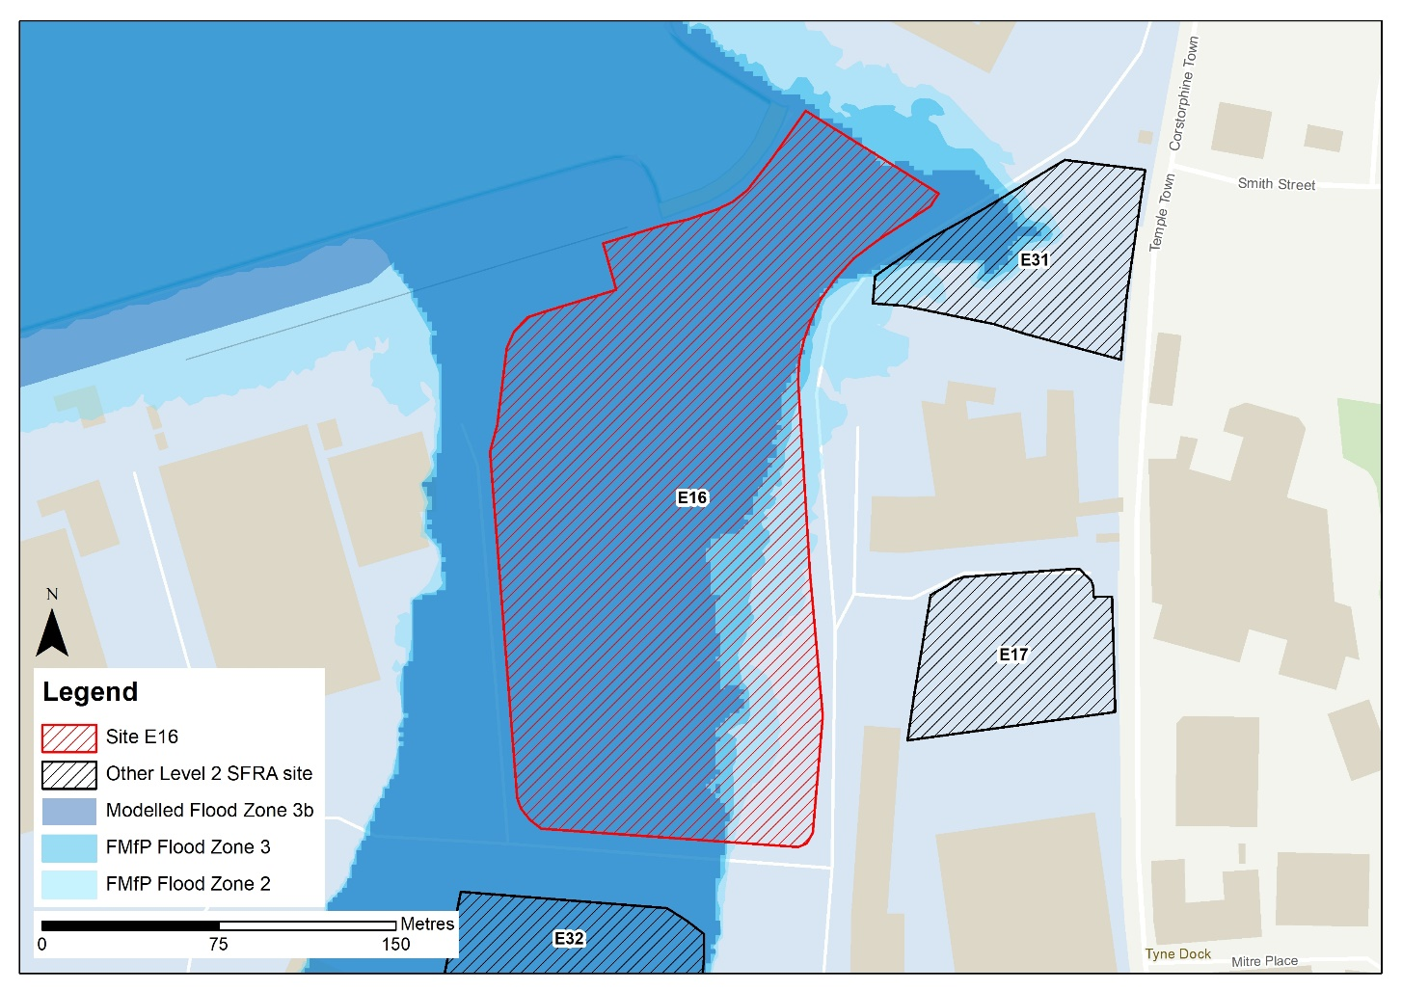
Profile line (Figure 2-2)
Figure 2-1: modelled present day risk to the site
Figure 2-2 presents elevation profiles at the site of the model LIDAR from 2008 (purple line), the 2021 LIDAR (blue line), and the modelled water level for the 3.3% AEP event i.e. the functional floodplain (red line).
There is a difference in elevation of approximately 4m along the bank of the Tyne Estuary at the site, which is ~600mm above the modelled flood level for the functional floodplain. From comparing the functional floodplain flood level with the 2021 LIDAR, it would appear that this site would no longer be within the functional floodplain and would be suitable for less vulnerable development, assuming suitable mitigation can be applied. As discussed in the main report, this would likely involve land raising and finished floor levels set at 600mm above the design event flood level, as recommended in EA standing advice on flood risk assessments. However, for increased certainty on water levels and subsequent finished floor levels, the model should be re-run with the 2021 LIDAR. The design event should be the 0.5% AEP plus an allowance for climate change. Given the risk is tidal, compensatory storage is unlikely to be required. The EA must be consulted on this.
The site-specific FRA should update the existing model with the latest LIDAR to robustly set the finished floor levels required to reduce the probability of tidal flooding to the development. 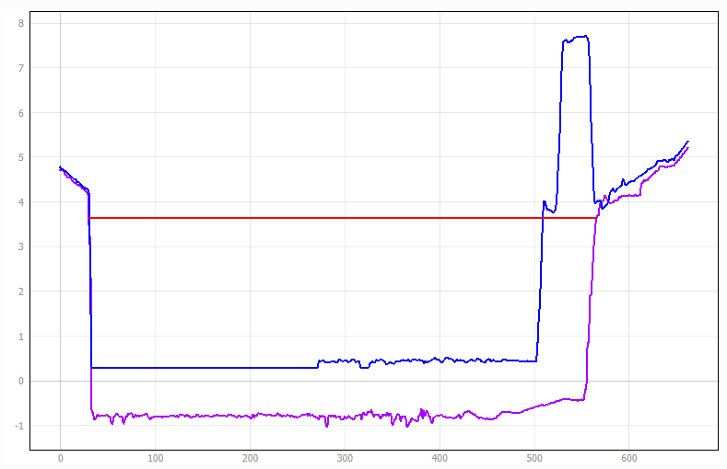
2008 LIDAR bank level at the dock
2021 LIDAR bank level at the dock
Functional floodplain water level
Figure 2-2: modelled functional floodplain level and LIDAR elevation comparison at Site E16
Figure 2-3 indicates the future functional floodplain modelled water level in comparison to both the 2008 and 2021 LIDAR levels. The future functional floodplain water level is approximately 1m higher than the 2021 LIDAR bank levels. Therefore, the site is likely to remain at risk within the future functional floodplain modelled extent if it were to be updated with the 2021 LIDAR.
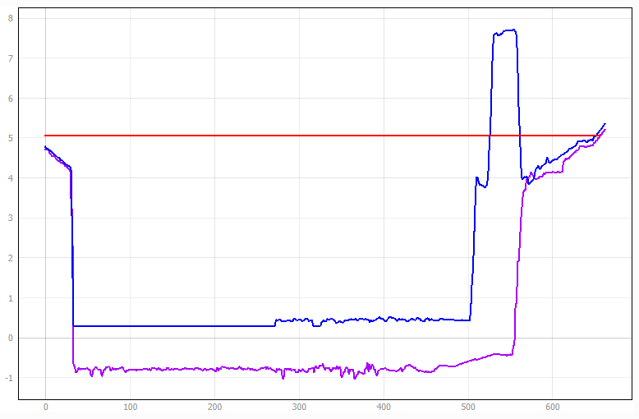
2008 LIDAR bank level at the dock
2021 LIDAR bank level at the dock
Future functional floodplain water level
Figure 2-3: modelled future functional floodplain level and LIDAR elevation comparison at Site E16

Site E19
Site E19 is not modelled to be within the present day functional floodplain extent. Elevation levels at this site are largely the same between the 2008 and 2021 LIDAR datasets, meaning that it is likely that this site would remain outside of the functional floodplain extent.
However, the site is modelled to be within the future functional floodplain extent (Figure 2-4). Given the elevation would remain similar between the 2008 and 2021 LIDAR datasets, the site would likely remain flooded to a similar depth were the model to be updated with the 2021 LIDAR.
Land raising would be required at the site with finished floor levels set at 600mm above the design event flood level, as recommended in EA standing advice on flood risk assessments. The design event should be the 0.5% AEP plus an allowance for climate change. Given the risk is tidal, compensatory storage is unlikely to be required. The EA must be consulted on this.
The site-specific FRA should update the existing model with the latest LIDAR to robustly set the finished floor levels required to reduce the probability of tidal flooding to the development.

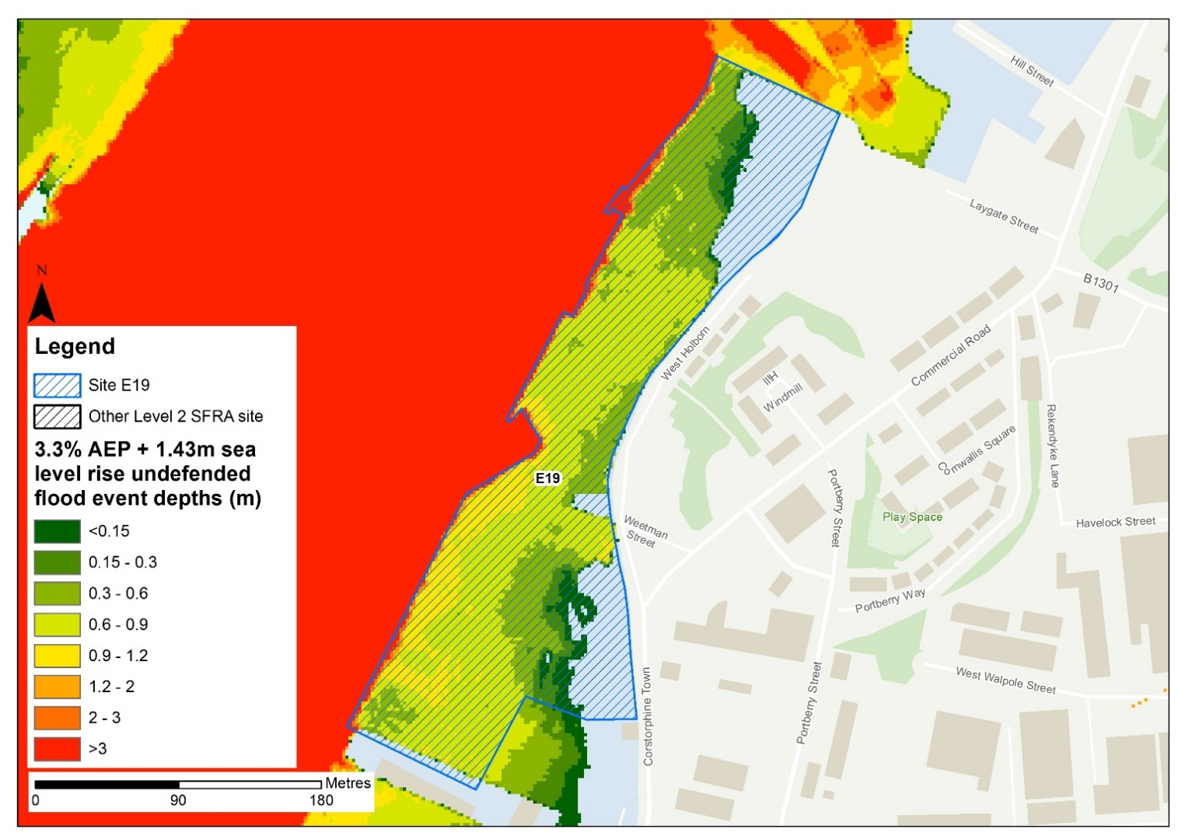
Figure 2-4: modelled future functional floodplain risk to the site

Sites E30 and E34
Sites E30 and E34 are not modelled to be within the present day functional floodplain extent. Elevation levels along the bank of the Tyne to the north west of this site are largely consistent between the 2008 and 2021 LIDAR datasets, meaning that it is likely that these sites would remain outside of the functional floodplain extent.
However, the sites are modelled to be within the future functional floodplain extent (Figure 2-5 and Figure 2-6). Water is modelled to overtop the bank of the Tyne at NGR 434875, 565799 in the future functional floodplain event. Given the nominal difference in elevation between the LIDAR datasets, the site would likely remain flooded to a similar depth were the model to be updated with the 2021 LIDAR.
As discussed in the main report, this would likely involve land raising and finished floor levels set at 600mm above the design event flood level, as recommended in EA standing advice on flood risk assessments. The design event should be the 0.5% AEP plus an allowance for climate change.
The site-specific FRA should update the existing model with the latest LIDAR to robustly set the finished floor levels required to reduce the probability of tidal flooding to the development.

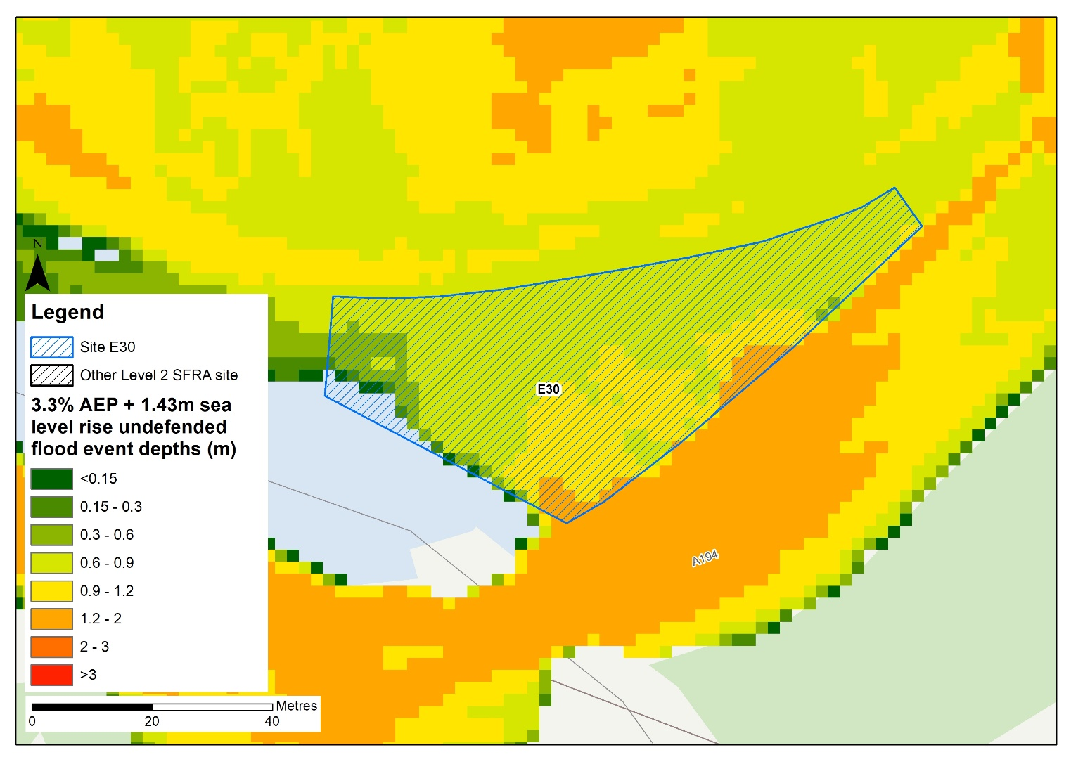
Figure 2-5: modelled future functional floodplain modelled risk to site E30
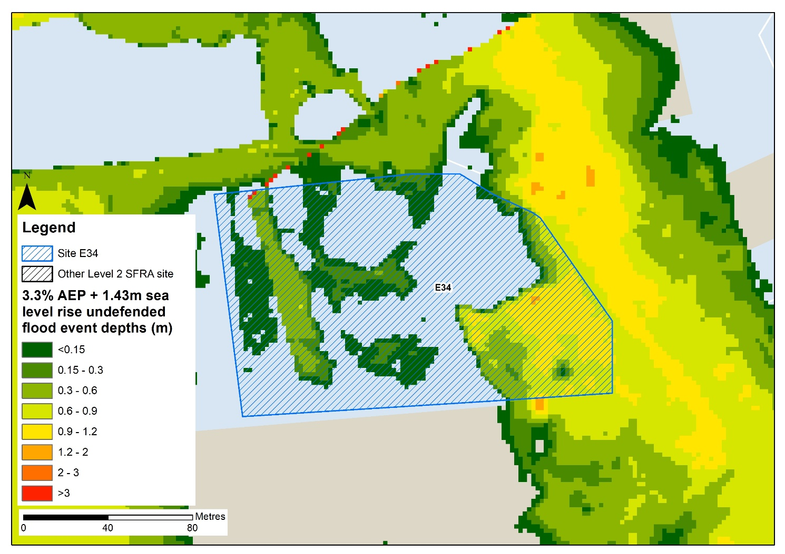
Figure 2-6: modelled future functional floodplain modelled risk to site E34

Site E31
Site E31 is adjacent to the infilled Tyne Dock area and is currently modelled to be partially within the functional floodplain and almost entirely within the future functional floodplain extents. Figure 2-7 shows the modelled present day risk to the site.

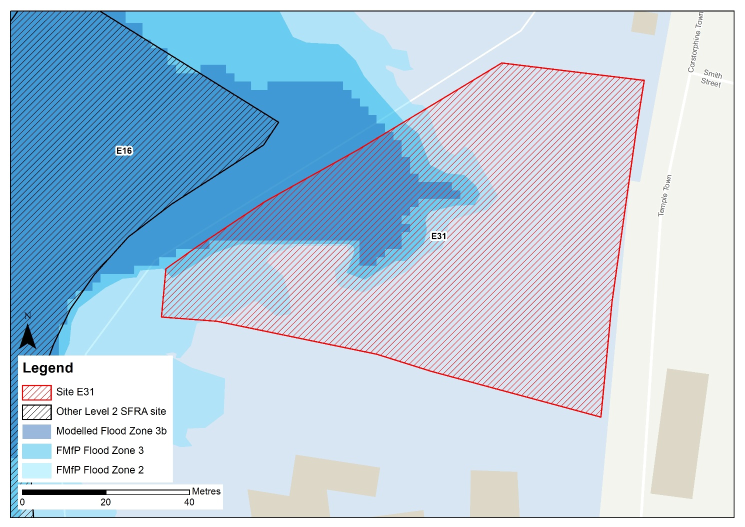
Profile line (Figure 2-8)
Figure 2-7: modelled present day risk to the site
Figure 2-8 presents elevation profiles at the site of the model LIDAR from 2008 (purple line), the 2021 LIDAR (blue line), and the modelled water level for the 3.3% AEP event i.e. the functional floodplain.
The site is modelled to be ~600mm above the modelled flood level for the functional floodplain. From comparing the functional floodplain flood level the 2021 LIDAR, it would appear that this site would no longer be within the functional floodplain and would be suitable for less vulnerable development, assuming suitable mitigation can be applied. As discussed in the main report, this would likely involve land raising and finished floor levels set at 600mm above the design event flood level, as recommended in EA standing advice on flood risk assessments. However, for increased certainty on water levels and subsequent finished floor levels, the model should be re-run with the 2021 LIDAR. The design event should be the 0.5% AEP plus an allowance for climate change. Given the risk is tidal, compensatory storage is unlikely to be required. The EA must be consulted on this.
The site-specific FRA should update the existing model with the latest LIDAR to robustly set the finished floor levels required to reduce the probability of tidal flooding to the development.
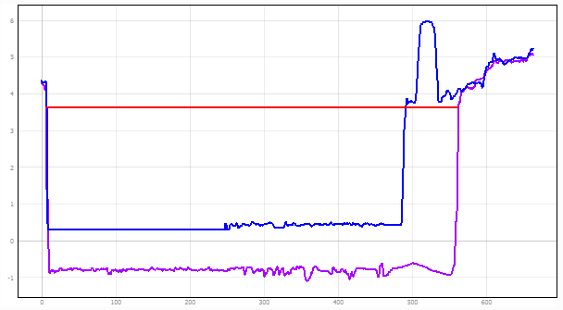
Elevation at Site 31
Functional floodplain level within the Tyne Estuary
Figure 2-8: modelled functional floodplain level and LIDAR elevation comparison at Site E31
Figure 2-9 indicates the future functional floodplain modelled water level in comparison to both the 2008 and 2021 LIDAR levels. The future functional floodplain water level is approximately 100mm higher than the 2021 LIDAR bank levels. Therefore, the site is likely to remain at risk within the future functional floodplain modelled extent if it were to be updated with the 2021 LIDAR.
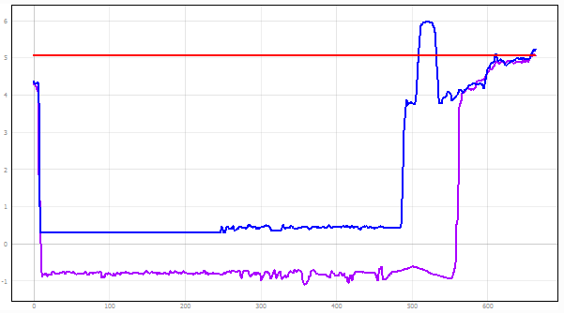
Elevation at Site 31
Future functional floodplain level within the Tyne Estuary
Figure 2-9: modelled future functional floodplain level and LIDAR elevation comparison at Site E31

Site E32
Site E32 is located within the infilled dock area and is currently modelled to be entirely within the functional floodplain and future functional floodplain extents. Figure 2-10 shows the modelled present day risk to the site.
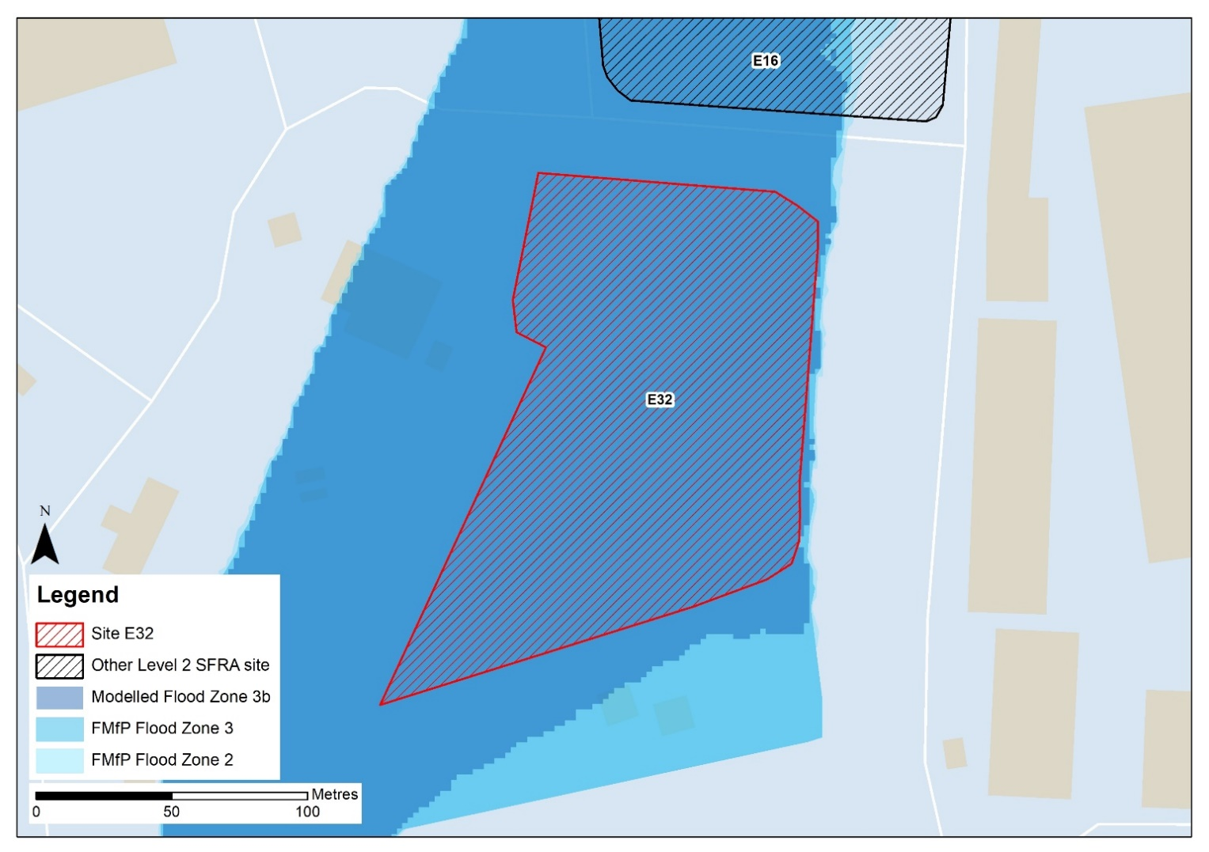
Profile line (Figure 2-11)
Figure 2-10: modelled present day risk to the site
Figure 2-11 presents elevation profiles at the site of the model LIDAR from 2008 (purple line), the 2021 LIDAR (blue line), and the modelled water level for the 3.3% AEP event i.e. the functional floodplain (red line).
There is a difference in elevation of approximately 4m along the bank of the Tyne Estuary at the site, which is ~600mm above the modelled flood level for the functional floodplain. In comparison to the 2021 LIDAR, the site is situated approximately 1.3m above the modelled flood levels for the functional floodplain. From comparing the functional floodplain flood level the 2021 LIDAR, it would appear that this site would no longer be within the functional floodplain and would be suitable for less vulnerable development, assuming suitable mitigation can be applied.
As discussed in the main report, this would likely involve land raising and finished floor levels set at 600mm above the design event flood level, as recommended in EA standing advice on flood risk assessments. However, for increased certainty on water levels and subsequent finished floor levels, the model should be re-run with the 2021 LIDAR. The design event should be the 0.5% AEP plus an allowance for climate change. Given the risk is tidal, compensatory storage is unlikely to be required. The EA must be consulted on this.
The site-specific FRA should update the existing model with the latest LIDAR to robustly set the finished floor levels required to reduce the probability of tidal flooding to the development.
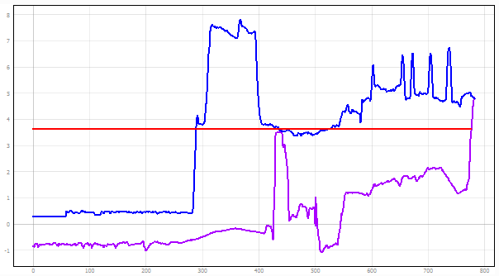
Elevation at the site based on 2008 LIDAR
Elevation at the site based on 2021 LIDAR
2021 LIDAR bank level at the dock
Functional floodplain level within the Tyne Estuary
Figure 2-11: modelled functional floodplain level and elevation comparison at Site E32
Figure 2-12 indicates the future functional floodplain modelled water level in comparison to both the 2008 and 2021 LIDAR levels. The future functional floodplain water level is approximately 1m higher than the 2021 LIDAR bank levels. Therefore, the site is likely to remain at risk within the future functional floodplain modelled extent if it were to be updated with the 2021 LIDAR.
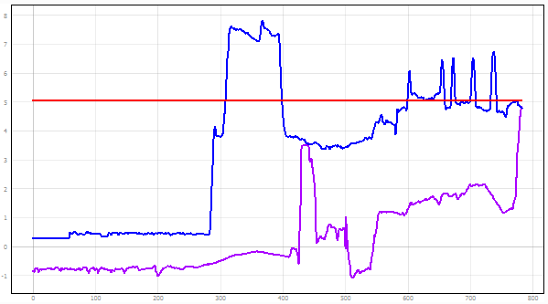
Elevation at the site based on 2021 LIDAR

Elevation at the site based on 2008 LIDAR
2021 LIDAR bank level at the dock

Future functional floodplain level within the Tyne Estuary
Figure 2-12: modelled future functional floodplain level and LIDAR elevation comparison at Site E32

Offices at
Bristol
Coleshill
Doncaster
Dublin
Edinburgh
Exeter
Glasgow
Haywards Heath
Isle of Man
Leeds
Limerick
Newcastle upon Tyne
Newport
Peterborough
Portsmouth
Saltaire
Skipton
Tadcaster
Thirsk
Wallingford
Warrington

Registered Office
1 Broughton Park
Old Lane North
Broughton
SKIPTON
North Yorkshire
BD23 3FD
United Kingdom

+44(0)1756 799919
info@jbaconsulting.com

www.jbaconsulting.com
Follow us:

Jeremy Benn Associates Limited
Registered in England 3246693

JBA Group Ltd is certified to:
ISO 9001:2015
ISO 14001:2015
ISO 27001:2013
ISO 45001:2018

