South Tyneside Level 2 SFRA - Modelling Method Statement
Draft

July 2024

Prepared for:
South Tyneside Council

www.jbaconsulting.com

Contents
1 Introduction 2
2 Methodology 3
2.1 Climate change uplifts 3
2.2 The higher central and upper end cumulative sea level rise figures were applied to the 3.3% AEP (30-year), 0.5% AEP (200-year) and 0.1% AEP (1,000-year) tidal event hydrographs to represent the effects of climate change. 3
2.3 Model simulation methodology 3

List of Tables
Table 2-1: Sea level rise allowances for Northumbria RBD 3

Introduction
In 2024, JBA were commissioned by South Tyneside Council to produce updated model outputs in line with current Environment Agency (EA) climate change guidance.
Current guidance requires the impacts of climate change to be assessed using the EA sea level rise allowances, which indicate the anticipated changes to sea level rise for coastal areas of England.
Flood outlines for the River Tyne were originally mapped by an S105 study, undertaken by JBA Consulting in 2004. More recently, JBA carried out a flood mapping update in 2015 which used the same three models as used in this study. However, new methodologies and more recent event data have since changed estimates of extreme tides.
This project re-ran existing hydraulic models with the most up to date estimates of future sea levels to update predictions of future flood extent. Extended cross sections of the River Don are included within the Tidal River Tyne HEC-RAS model. Note, new model development was outside of the scope of this work
Three models were selected to be re-run with climate change uplifts:
- Gateshead SFRA (2015) - Flood Modeller-TUFLOW model, used to derive flood outlines on the southern floodplain between Scotswood Bridge and Felling;
- Ouseburn Barrage (2007) - HEC-RAS model of the River Ouseburn, used to map flood outlines between the city stadium and the Ouseburn Barrage;
- River Tyne Reach 1 and 2 (2008) - HEC-RAS model with full coverage of the study reach used where neither of the other models were available.
The relevant model which covers the South Tyneside Level 2 SFRA sites at the Port of Tyne is the River Tyne Reach 1 and 2 (2008) HEC-RAS model.
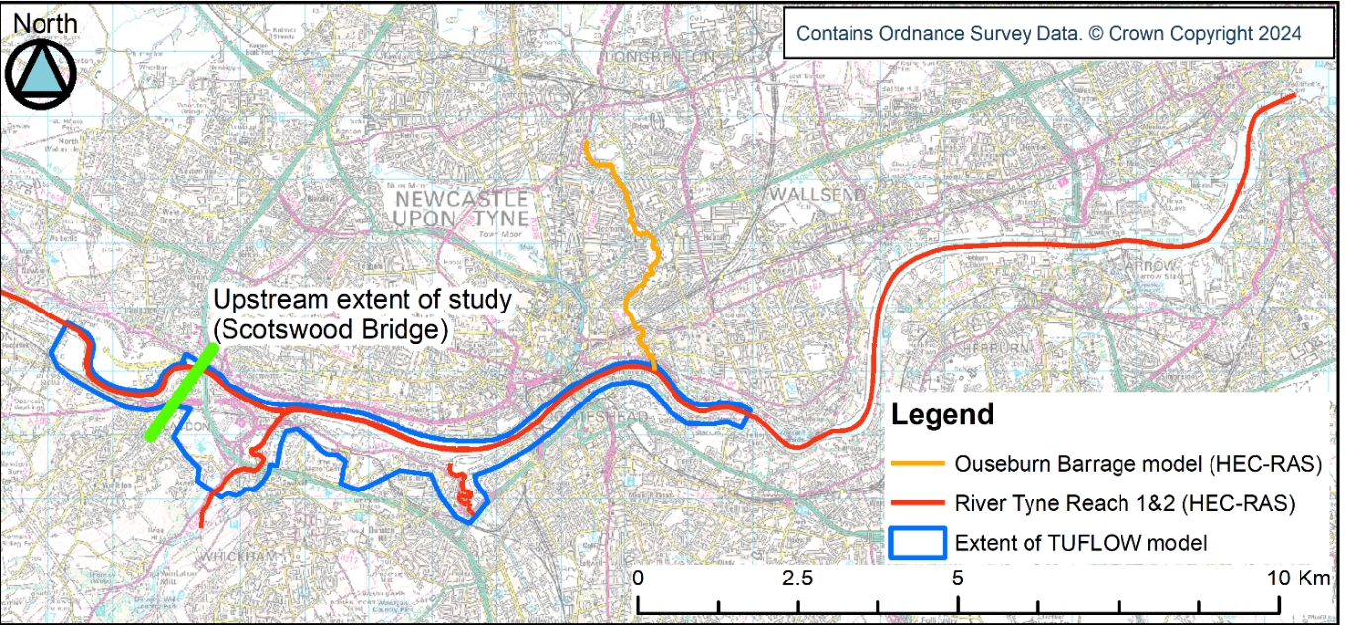
Location of Level 2 sites
Figure 1-1: Tyne Estuary model domains

Methodology

Climate change uplifts
The EA's SFRA guidance 2024 states that the SFRA should assess the effects of climate change on all sources of flooding. Based on the EA's climate change guidance1, the higher central and upper end allowances for sea level rise should be modelled for SFRAs.
The River Tyne is tidally influenced up to Wylam, which is the westernmost boundary of Gateshead local authority to the west of South Tyneside authority area. Climate change modelling for the Tyne must therefore be based on the allowances for sea level rise for the Northumbria river basin district, as listed in Table 2-1.
Table 2-1: Sea level rise allowances for Northumbria RBD
Allowance | Cumulative rise 2000 to 2125 (metres)
Higher Central | 1.03
Upper End | 1.43

The higher central and upper end cumulative sea level rise figures were applied to the 3.3% AEP (30-year), 0.5% AEP (200-year) and 0.1% AEP (1,000-year) tidal event hydrographs to represent the effects of climate change.

Model simulation methodology
The following methodology was used to create updated flood outlines for the Tyne Estuary:
The 2008 Tidal Tyne model was updated with new coastal flood boundary levels for 2024
The 2008 Tidal Tyne model was then re-run for the following events:
  - Defended 3.3% AEP
  - 3.3% AEP + Higher Central sea level rise allowance
  - 0.5% AEP
  - 0.5% AEP + Higher Central sea level rise allowance
  - 0.5% AEP + Upper End sea level rise allowance
  - 0.1% AEP
  - 0.1% AEP + Higher Central sea level rise allowance
  - 0.1% AEP + Upper End sea level rise allowance
The level time series at the node at the confluence with the Ouseburn Barrage (node 14087) was extracted from the 2008 Tidal Tyne model
That level series was applied as the new downstream boundary for the Ouseburn Barrage model
The Ouseburn Barrage was re-run for all of the events (as listed above)
The level time series at the downstream boundary location for the Gateshead Tyne model was extracted from the 2008 Tidal Tyne model (node 10011).
That level time series was applied as a new downstream boundary for the 2015 Gateshead model
The Gateshead model was re-run for all of the events (as listed above)
All modelled flood extent outputs were merged and outlines were cleaned.

Offices at
Bristol
Coleshill
Doncaster
Dublin
Edinburgh
Exeter
Glasgow
Haywards Heath
Leeds
Limerick
Newcastle upon Tyne
Newport
Peterborough
Portsmouth
Saltaire
Skipton
Tadcaster
Thirsk
Wallingford
Warrington

Registered Office
1 Broughton Park
Old Lane North
Broughton
SKIPTON
North Yorkshire
BD23 3FD
United Kingdom

+44(0)1756 799919
info@jbaconsulting.com

www.jbaconsulting.com
Follow us:

Jeremy Benn Associates Limited

Registered in England 3246693

JBA Group Ltd is certified to:
ISO 9001:2015
ISO 14001:2015
ISO 27001:2013
ISO 45001:2018

Flood risk assessments: climate change allowances
How to prepare a strategic flood risk assessment - GOV.UK (www.gov.uk)

