South Tyneside Level 2
Strategic Flood Risk Assessment Main Report
Final
December 2024

Prepared for:
South Tyneside Council


www.jbaconsulting.com

Document Status
Issue date 04 December 2024
Issued to Matthew Clifford
BIM reference LSH-JBA-XX-XX-RP-Z-0001
Revision P03

Prepared by Laura Thompson BSc
Analyst
Freya Nation BSc
Analyst

Reviewed by Mike Williamson BSc MSc CGeog FRGS EADA
Principal Analyst

Authorised by Krista Keating BSc MSc CEnv CSci MCIWEM C.WEM
Associate Director
___________________________________________________________________
Carbon Footprint
The format of this report is optimised for reading digitally in pdf format. Paper consumption produces substantial carbon emissions and other environmental impacts through the extraction, production and transportation of paper. Printing also generates emissions and impacts from the manufacture of printers and inks and from the energy used to power a printer. Please consider the environment before printing.
___________________________________________________________________

Contract
JBA Project Manager Mike Williamson
Address JBA Consulting, Phoenix House, Lakeside Drive, Centre Park, Warrington. WA1 1RX
JBA Project Code 2023s1442

This report describes work commissioned by South Tyneside Council by an instruction dated 25th January 2024. The Client’s representative for the contract was Matthew Clifford of South Tyneside Council. Laura Thompson and Freya Nation of JBA Consulting carried out this work.
Purpose and Disclaimer
Jeremy Benn Associates Limited (“JBA”) has prepared this Report for the sole use of South Tyneside Council and its appointed agents in accordance with the Agreement under which our services were performed.
JBA has no liability for any use that is made of this Report except to South Tyneside Council for the purposes for which it was originally commissioned and prepared.
No other warranty, expressed or implied, is made as to the professional advice included in this Report or any other services provided by JBA. This Report cannot be relied upon by any other party without the prior and express written agreement of JBA.
The conclusions and recommendations contained in this Report are based upon information provided by others and upon the assumption that all relevant information has been provided by those parties from whom it has been requested and that such information is accurate. Information obtained by JBA has not been independently verified by JBA, unless otherwise stated in the Report.
The methodology adopted and the sources of information used by JBA in providing its services are outlined in this Report. The work described in this Report was undertaken between January and December 2024 and is based on the conditions encountered and the information available during the said period. The scope of this Report and the services are accordingly factually limited by these circumstances.
Where assessments of works or costs identified in this Report are made, such assessments are based upon the information available at the time and where appropriate are subject to further investigations or information which may become available.
JBA disclaims any undertaking or obligation to advise any person of any change in any matter affecting the Report, which may come or be brought to JBA’s attention after the date of the Report.
Certain statements made in the Report that are not historical facts may constitute estimates, projections or other forward-looking statements and even though they are based on reasonable assumptions as of the date of the Report, such forward-looking statements by their nature involve risks and uncertainties that could cause actual results to differ materially from the results predicted. JBA specifically does not guarantee or warrant any estimates or projections contained in this Report.
Unless otherwise stated in this Report, the assessments made assume that the sites and facilities will continue to be used for their current purpose without significant changes.
___________________________________________________________________
Copyright
© Jeremy Benn Associates Limited 2024
___________________________________________________________________

Contents
1 Introduction xviii
2 Limitations 1
3 Level 2 SFRA requirements 2
3.1 Objectives 2
4 Available data and information 4
4.1 EA models 4
4.2 EA Open Data 4
4.3 Other datasets 5
5 Methodology 6
5.1 Functional floodplain update 6
5.2 Climate change allowance modelling 7
5.3 Residual risk 9
5.4 Assessing flood risk from groundwater 10
5.5 Assessing flood risk from sewers 11
5.6 Access and escape routes, and emergency planning 11
5.7 Cumulative impacts 11
5.8 Working with Natural Processes 11
6 Level 2 sites assessments 12
6.1 Summary of Level 2 outcomes 13
7 Site E16 17
7.1 Flood risk from rivers and sea 20
7.2 Flood risk management 28
7.3 Residual risk 28
7.4 Historic flood incidents 29
7.5 Flood warning and access and escape routes 30
7.6 Observations, mitigation options and site suitability - tidal 31
7.7 Flood risk from surface water 32
7.8 Risk of runoff from site post development 36
7.9 Observations, mitigation options and site suitability - surface water 37
7.10 Flood risk from groundwater 38
7.11 Overall site assessment 40
8 Site E17 42
8.1 Flood risk from rivers and sea 45
8.2 Flood risk management 48
8.3 Residual risk 48
8.4 Historic flood incidents 50
8.5 Flood warning and access and escape routes 50
8.6 Observations, mitigation options and site suitability - tidal 50
8.7 Flood risk from surface water 51
8.8 Risk of runoff from site post development 54
8.9 Observations, mitigation options and site suitability - surface water 55
8.10 Flood risk from groundwater 56
8.11 Overall site assessment 58
9 Site E19 60
9.1 Flood risk from rivers and sea 63
9.2 Flood risk management 70
9.3 Residual risk 70
9.4 Historic flood incidents 72
9.5 Flood warning and access and escape routes 72
9.6 Observations, mitigation options and site suitability - tidal 73
9.7 Flood risk from surface water 74
9.8 Risk of runoff from site post development 77
9.9 Observations, mitigation options and site suitability - surface water 78
9.10 Flood risk from groundwater 79
9.11 Overall site assessment 81
10 Site E30 83
10.1 Flood risk from rivers and sea 86
10.2 Flood risk management 90
10.3 Residual risk 90
10.4 Historic flood incidents 92
10.5 Flood warning and access and escape routes 92
10.6 Observations, mitigation options and site suitability - tidal 92
10.7 Flood risk from surface water 93
10.8 Risk of runoff from site post development 97
10.9 Observations, mitigation options and site suitability - surface water 98
10.10 Flood risk from groundwater 99
10.11 Overall site assessment 101
11 Site E31 103
11.1 Flood risk from rivers and sea 106
11.2 Flood risk management 114
11.3 Residual risk 114
11.4 Historic flood incidents 116
11.5 Flood warning and access and escape routes 116
11.6 Observations, mitigation options and site suitability - tidal 117
11.7 Flood risk from surface water 118
11.8 Risk of runoff from site post development 122
11.9 Observations, mitigation options and site suitability - surface water 123
11.10 Flood risk from groundwater 124
11.11 Overall site assessment 126
12 Site E32 128
12.1 Flood risk from rivers and sea 131
12.2 Flood risk management 135
12.3 Residual risk 136
12.4 Historic flood incidents 137
12.5 Flood warning and access and escape routes 138
12.6 Observations, mitigation options and site suitability - tidal 138
12.7 Flood risk from surface water 139
12.8 Risk of runoff from site post development 143
12.9 Observations, mitigation options and site suitability - surface water 144
12.10 Flood risk from groundwater 146
12.11 Overall site assessment 147
13 Site E33 149
13.1 Flood risk from rivers and sea 152
13.2 Flood risk management 155
13.3 Residual risk 155
13.4 Historic flood incidents 157
13.5 Flood warning and access and escape routes 157
13.6 Observations, mitigation options and site suitability - tidal 157
13.7 Flood risk from surface water 158
13.8 Risk of runoff from site post development 161
13.9 Observations, mitigation options and site suitability - surface water 162
13.10 Flood risk from groundwater 163
13.11 Overall site assessment 166
14 Site E34 167
14.1 Flood risk from rivers and sea 170
14.2 Flood risk management 175
14.3 Residual risk 175
14.4 Historic flood incidents 177
14.5 Flood warning and access and escape routes 177
14.6 Observations, mitigation options and site suitability - tidal 177
14.7 Flood risk from surface water 178
14.8 Risk of runoff from site post development 181
14.9 Observations, mitigation options and site suitability - surface water 182
14.10 Flood risk from groundwater 183
14.11 Overall site assessment 185
15 Site E35 187
15.1 Flood risk from rivers and sea 190
15.2 Flood risk management 194
15.3 Residual risk 195
15.4 Historic flood incidents 196
15.5 Flood warning and access and escape routes 197
15.6 Observations, mitigation options and site suitability - tidal 197
15.7 Flood risk from surface water 198
15.8 Risk of runoff from site post development 202
15.9 Observations, mitigation options and site suitability - surface water 203
15.10 Flood risk from groundwater 204
15.11 Overall site assessment 206
16 Licensing 208

List of Figures
Figure 1-1: Level 2 SFRA sites xix
Figure 5-1: Risk of Flooding from Surface Water input model details 9
Figure 7-1: Existing site location boundary 18
Figure 7-2: Topography 19
Figure 7-3: Existing risk from rivers and sea to the site 20
Figure 7-4: Flood depths for 0.5% AEP undefended flood event 21
Figure 7-5: Flood hazard for 0.5% AEP undefended flood event 22
Figure 7-6: Flood depths for 3.3% AEP undefended flood event +1.43m upper end sea level rise allowance 25
Figure 7-7: Flood hazard⁷ for 3.3% AEP undefended flood event +1.43m upper end sea level rise allowance 26
Figure 7-8: Flood depths for 0.5% AEP undefended flood event +1.03m higher central sea level rise allowance 27
Figure 7-9: Flood hazard⁷ for 0.5% AEP undefended flood event +1.03m higher central sea level rise allowance 28
Figure 7-10: Flood risk from reservoirs 29
Figure 7-11: Recorded historic flood events onsite and around the site 30
Figure 7-12: EA Flood Warning Areas 31
Figure 7-13: Medium risk event surface water flood depths (Risk of Flooding from Surface Water map) 33
Figure 7-14: Medium risk event surface water flood hazard (Risk of Flooding from Surface Water map) 34
Figure 7-15: Medium risk event surface water flood depths plus 45% climate change (based on Risk of Flooding from Surface Water map) 35
Figure 7-16: Medium risk event surface water flood hazard plus 45% climate change (based on Risk of Flooding from Surface Water map) 36
Figure 7-17: JBA 5m Groundwater Flood Map 39
Figure 8-1: Existing site location boundary 43
Figure 8-2: Topography 44
Figure 8-3: Existing risk from rivers and sea to the site 45
Figure 8-4: Flood depths for 0.1% AEP undefended flood event +1.43m upper end sea level rise allowance 47
Figure 8-5: Flood hazard⁷ for 0.1% AEP undefended flood event +1.43m upper end sea level rise allowance 48
Figure 8-6: Flood risk from reservoirs 49
Figure 8-7: Low risk event surface water flood depths (Risk of Flooding from Surface Water map) 51
Figure 8-8: Low risk event surface water flood hazard⁸ (Risk of Flooding from Surface Water map) 52
Figure 8-9: Medium risk event surface water flood depths plus 45% climate change (based on Risk of Flooding from Surface Water map) 53
Figure 8-10: Medium risk event surface water flood hazard plus 45% climate change (based on Risk of Flooding from Surface Water map) 54
Figure 8-11: JBA 5m Groundwater Flood Map 57
Figure 9-1: Existing site location boundary 61
Figure 9-2: Topography 62
Figure 9-3: Existing risk from rivers and sea to the site 63
Figure 9-4: Flood depths for 0.5% AEP undefended flood event 64
Figure 9-5: Flood hazard⁷ for 0.5% AEP undefended flood event 65
Figure 9-6: Flood depths for 3.3% AEP undefended flood event +1.43m upper end sea level rise allowance 67
Figure 9-7: Flood hazard⁷ for 3.3% AEP undefended flood event +1.43m upper end sea level rise allowance 68
Figure 9-8: Flood depths for 0.5% AEP undefended flood event +1.03m higher central sea level rise allowance 69
Figure 9-9: Flood hazard⁷ for 0.5% AEP undefended flood event +1.03m higher central sea level rise allowance 70
Figure 9-10: Flood risk from reservoirs 71
Figure 9-11: Recorded historic flood events onsite and around the site 72
Figure 9-12: Medium risk event surface water flood depths (Risk of Flooding from Surface Water map) 74
Figure 9-13: Medium risk event surface water flood hazard⁸ (Risk of Flooding from Surface Water map) 75
Figure 9-14: Medium risk event surface water flood depths plus 45% climate change (based on Risk of Flooding from Surface Water map) 76
Figure 9-15: Medium risk event surface water flood hazard plus 45% climate change (based on Risk of Flooding from Surface Water map) 77
Figure 9-16: JBA 5m Groundwater Flood Map 80
Figure 10-1: Existing site location boundary 84
Figure 10-2: Topography 85
Figure 10-3: Flood depths for 3.3% AEP undefended flood event +1.43m upper end sea level rise allowance 87
Figure 10-4: Flood hazard⁷ for 3.3% AEP undefended flood event +1.43m upper end sea level rise allowance 88
Figure 10-5: Flood depths for 0.5% AEP undefended flood event +1.03m higher central sea level rise allowance 89
Figure 10-6: Flood hazard⁷ for 0.5% AEP undefended flood event +1.03m higher central sea level rise allowance 90
Figure 10-7: Flood risk from reservoirs 91
Figure 10-8: Medium risk event surface water flood depths (Risk of Flooding from Surface Water map) 94
Figure 10-9: Medium risk event surface water flood hazard⁸ (Risk of Flooding from Surface Water map) 95
Figure 10-10: Medium risk event surface water flood depths plus 45% climate change (based on Risk of Flooding from Surface Water map) 96
Figure 10-11: Medium risk event surface water flood depths plus 45% climate change (based on Risk of Flooding from Surface Water map) 97
Figure 10-12: JBA 5m Groundwater Flood Map 100
Figure 11-1: Existing site location boundary 104
Figure 11-2: Topography 105
Figure 11-3: Existing risk from rivers and sea to the site 106
Figure 11-4: Flood depths for 0.5% AEP undefended flood event 107
Figure 11-5: Flood hazard⁷ for 0.5% AEP undefended flood event 108
Figure 11-6: Flood depths for the 3.3% AEP undefended flood event +1.43m upper end sea level rise allowance 111
Figure 11-7: Flood hazard⁷ for the 3.3% AEP undefended flood event +1.43m upper end sea level rise allowance 112
Figure 11-8: Flood depths for the 0.5% AEP undefended flood event +1.03m higher central sea level rise allowance 113
Figure 11-9: Flood hazard⁷ for the 0.5% AEP undefended flood event +1.03m higher central sea level rise allowance 114
Figure 11-10: Flood risk from reservoirs 115
Figure 11-11: Recorded historic flood events onsite and around the site 116
Figure 11-12: EA Flood Warning Areas 117
Figure 11-13: Medium risk event surface water flood depths (Risk of Flooding from Surface Water map) 119
Figure 11-14: Medium risk event surface water flood hazard⁸ (Risk of Flooding from Surface Water map) 120
Figure 11-15: Medium risk event surface water flood depths plus 45% climate change (based on Risk of Flooding from Surface Water map) 121
Figure 11-16: Medium risk event surface water flood hazard plus 45% climate change (based on Risk of Flooding from Surface Water map) 122
Figure 11-17: JBA 5m Groundwater Flood Map 125
Figure 12-1: Existing site location boundary 129
Figure 12-2: Topography 130
Figure 12-3: Existing risk from rivers and sea to the site 131
Figure 12-4: Flood depths for the 0.5% AEP undefended flood event +1.03m higher central sea level rise allowance 134
Figure 12-5: Flood hazard⁷ for the 0.5% AEP undefended flood event +1.03m higher central sea level rise allowance 135
Figure 12-6: Flood risk from reservoirs 137
Figure 12-7: Recorded historic flood events onsite and around the site 138
Figure 12-8: Low risk event surface water flood depths (Risk of Flooding from Surface Water map) 140
Figure 12-9: Low risk event surface water flood hazard⁸ (Risk of Flooding from Surface Water map) 141
Figure 12-10: Medium risk event surface water flood depths plus 45% climate change (based on Risk of Flooding from Surface Water map) 142
Figure 12-11: Medium risk event surface water flood hazard plus 45% climate change (based on Risk of Flooding from Surface Water map) 143
Figure 12-12: JBA 5m Groundwater Flood Map 146
Figure 13-1: Existing site location boundary 150
Figure 13-2: Topography 151
Figure 13-3: Existing risk from rivers to the site 152
Figure 13-4: Flood depths for 0.1% AEP undefended flood event + 1.43m upper end sea level rise allowance depths (m) 154
Figure 13-5: Flood hazard⁷ for 0.1% AEP undefended flood event +1.43m upper end sea level rise allowance 155
Figure 13-6: Flood risk from reservoirs 156
Figure 13-7: Medium risk event surface water flood depths (Risk of Flooding from Surface Water map) 158
Figure 13-8: Medium risk event surface water flood hazard⁸ (Risk of Flooding from Surface Water map) 159
Figure 13-9: Medium risk event surface water flood depths plus 45% climate change (based on Risk of Flooding from Surface Water map) 160
Figure 13-10: Medium risk event surface water flood hazard plus 45% climate change (based on Risk of Flooding from Surface Water map) 161
Figure 13-11: JBA 5m Groundwater Flood Map 164
Figure 14-1: Existing site location boundary 168
Figure 14-2: Topography 169
Figure 14-3: Flood depths for 3.3% AEP undefended flood event +1.43m upper end sea level rise allowance 172
Figure 14-4: Flood hazard⁷ for 3.3% AEP undefended flood event +1.43m upper end sea level rise allowance 173
Figure 14-5: Flood depths for 0.5% AEP undefended flood event +1.03m higher central sea level rise allowance 174
Figure 14-6: Flood hazard⁷ for 0.5% AEP undefended flood event +1.03m higher central sea level rise allowance 175
Figure 14-7: Flood risk from reservoirs 176
Figure 14-8: Medium risk event surface water flood depths (Risk of Flooding from Surface Water map) 178
Figure 14-9: Medium risk event surface water flood hazard⁸ (Risk of Flooding from Surface Water map) 179
Figure 14-10: Medium risk event surface water flood depths plus 45% climate change (based on Risk of Flooding from Surface Water map) 180
Figure 14-11: Medium risk event surface water flood hazard plus 45% climate change (based on Risk of Flooding from Surface Water map) 181
Figure 14-12: JBA 5m Groundwater Flood Map 184
Figure 15-1: Existing site location boundary 188
Figure 15-2: Topography 189
Figure 15-3: Existing risk from rivers to the site 190
Figure 15-4: Flood depths for 0.5% AEP undefended flood event 191
Figure 15-5: Flood hazard⁷ for 0.5% AEP undefended flood event 192
Figure 15-6: Flood depths for the 3.3% AEP undefended flood event +1.43m upper end sea level rise allowance 193
Figure 15-7: Flood hazard for the 3.3% AEP undefended flood event +1.43m upper end sea level rise allowance 194
Figure 15-8: Natural Flood Management (NFM) opportunities 195
Figure 15-9: Flood risk from reservoirs 196
Figure 15-10: Recorded historic flood events onsite and around the site 197
Figure 15-11: High risk event surface water flood depths (Risk of Flooding from Surface Water map) 199
Figure 15-12: High risk event surface water flood hazard⁸ (Risk of Flooding from Surface Water map) 200
Figure 15-13: High risk event surface water flood depths plus 40% climate change (based on Risk of Flooding from Surface Water map) 201
Figure 15-14: High risk event surface water flood hazard plus 40% climate change (based on Risk of Flooding from Surface Water map) 202
Figure 15-15: JBA 5m Groundwater Flood Map 205

List of Tables
Table 5-1: Sea level rise allowances for Northumbria RBD 7
Table 6-1: Level 2 site assessment outcomes 13
Table 7-1: Existing flood risk from rivers and sea 20
Table 7-2: Modelled sea level rise allowances for the Northumbria River Basin District 23
Table 7-3: Existing surface water flood risk based on the RoFSW map 32
Table 7-4: Modelled climate change allowances for rainfall for the Tyne management catchment 34
Table 7-5: Surface water flood risk from proposed development 37
Table 7-6: Groundwater Flood Hazard Classification 40
Table 8-1: Existing flood risk from rivers and sea 45
Table 8-2: Modelled sea level rise allowances for the Northumbria River Basin District 46
Table 8-3: Existing surface water flood risk based on the RoFSW map 51
Table 8-4: Modelled climate change allowances for rainfall for the Tyne management catchment 52
Table 8-5: Surface water flood risk from proposed development 55
Table 8-6: Groundwater Flood Hazard Classification 58
Table 9-1: Existing flood risk from rivers and sea 63
Table 9-2: Modelled sea level rise allowances for the Northumbria River Basin District 65
Table 9-3: Existing surface water flood risk based on the RoFSW map 74
Table 9-4: Modelled climate change allowances for rainfall for the Tyne management catchment 75
Table 9-5: Surface water flood risk from proposed development 78
Table 9-6: Groundwater Flood Hazard Classification 81
Table 10-1: Existing flood risk from rivers and sea 86
Table 10-2: Modelled sea level rise allowances for the Northumbria River Basin District 86
Table 10-3: Existing surface water flood risk based on the RoFSW map 93
Table 10-4: Modelled climate change allowances for rainfall for the Tyne management catchment 95
Table 10-5: Surface water flood risk from proposed development 98
Table 10-6: Groundwater Flood Hazard Classification 101
Table 11-1: Existing flood risk from rivers and sea 106
Table 11-2: Modelled sea level rise allowances for the Northumbria River Basin District 109
Table 11-3: Existing surface water flood risk based on the RoFSW map 118
Table 11-4: Modelled climate change allowances for rainfall for the Tyne management catchment 120
Table 11-5: Surface water flood risk from proposed development 123
Table 11-6: Groundwater Flood Hazard Classification 126
Table 12-1: Existing flood risk from rivers and sea 131
Table 12-2: Modelled sea level rise allowances for the Northumbria River Basin District 133
Table 12-3: Existing surface water flood risk based on the RoFSW map 139
Table 12-4: Modelled climate change allowances for rainfall for the Tyne management catchment 141
Table 12-5: Surface water flood risk from proposed development 144
Table 12-6: Groundwater Flood Hazard Classification 147
Table 13-1: Existing flood risk from rivers and sea 152
Table 13-2: Modelled sea level rise allowances for the Northumbria River Basin District 153
Table 13-3: Existing surface water flood risk based on the RoFSW map 158
Table 13-4: Modelled climate change allowances for rainfall for the Tyne management catchment 159
Table 13-5: Surface water flood risk from proposed development 162
Table 13-6: Groundwater Flood Hazard Classification 165
Table 14-1: Existing flood risk from rivers and sea 170
Table 14-2: Modelled sea level rise allowances for the Northumbria River Basin District 170
Table 14-3: Existing surface water flood risk based on the RoFSW map 178
Table 14-4: Modelled climate change allowances for rainfall for the Tyne management catchment 179
Table 14-5: Surface water flood risk from proposed development 182
Table 14-6: Groundwater Flood Hazard Classification 185
Table 15-1: Existing tidal flood risk 190
Table 15-2: Modelled sea level rise allowances for the Northumbria River Basin District 192
Table 15-3: Existing surface water flood risk based on the RoFSW map 198
Table 15-4: Modelled climate change allowances for rainfall for the Tyne management catchment 200
Table 15-5: Surface water flood risk from proposed development 203
Table 15-6: Groundwater Flood Hazard Classification 206

Abbreviations
AEP Annual Exceedance Probability
BGS British Geological Survey
DTM Digital Terrain Model
EA Environment Agency
FEH Flood Estimation Handbook
FRA Flood Risk Assessment
FRCC-PPG Flood Risk and Coastal Change Planning Practice Guidance
FWA Flood Warning Area
HFM Historic Flood Map
LIDAR Light Detection and Ranging
LLFA Lead Local Flood Authority
LPA Local Planning Authority
NFM Natural Flood Management
NPPF National Planning Policy Framework
NWL Northumbrian Water Ltd
OS Ordnance Survey
RBD River Basin District
RFM Reservoir Flood Mapping
RoFSW Risk of Flooding from Surface Water
RFO Recorded Flood Outline
SFRA Strategic Flood Risk Assessment
STC South Tyneside Council
SuDS Sustainable Drainage Systems
SWMP Surface Water Management Plan
WwNP Working with Natural Processes

Introduction
A Level 2 Strategic Flood Risk Assessment (SFRA) is required by South Tyneside Council (STC) for nine potential development sites located at the Port of Tyne (shown in Figure 1-1). As identified through the South Tyneside Level 1 SFRA addendum prepared in September 2023, these sites cannot be allocated outside of areas of flood risk. A Level 2 SFRA is therefore required to help determine whether these sites can be safe for their lifetime and subsequently be allocated in STC's local plan.
Using the outputs from the latest Level 1 SFRA (2022) and 2023 addendum, STC has performed the sequential test on all available sites using the administrative area of South Tyneside as the search area. The outcomes of the sequential test found that there were no reasonably alternative sites, within the search area, at lower risk of flooding. Hence the necessity for a more detailed assessment of flood risk through this Level 2 SFRA.
This Level 2 SFRA consists of the following documents:
- This main report summarising the Level 2 SFRA process, methodologies, and site summaries,
- A technical report on the delineation of the functional floodplain and future functional floodplain (Appendix A),
- A technical report on the flood modelling carried out as part of the Level 2 SFRA (Appendix B).
This Level 2 SFRA has been prepared with full consideration of the latest government and Environment Agency (EA) guidance on flood risk and planning policy, namely:
- National Planning Policy Framework (NPPF) 2021,
- Flood Risk and Coastal Change Planning Practice Guidance (FRCC-PPG) 2022,
- How to prepare a Strategic Flood Risk Assessment guidance 2024,
- Strategic Flood Risk Assessment Good Practice Guide 2021, and
- Flood Risk Assessments: Climate Change Allowances 2022.
At the time of writing, this Level 2 SFRA has assessed and considered risk at the Port of Tyne in the South Tyneside authority area at a specific point in time. It would be prudent to update the SFRA were there to be any updates to the modelling of the Tyne Estuary or the River Don tributary.

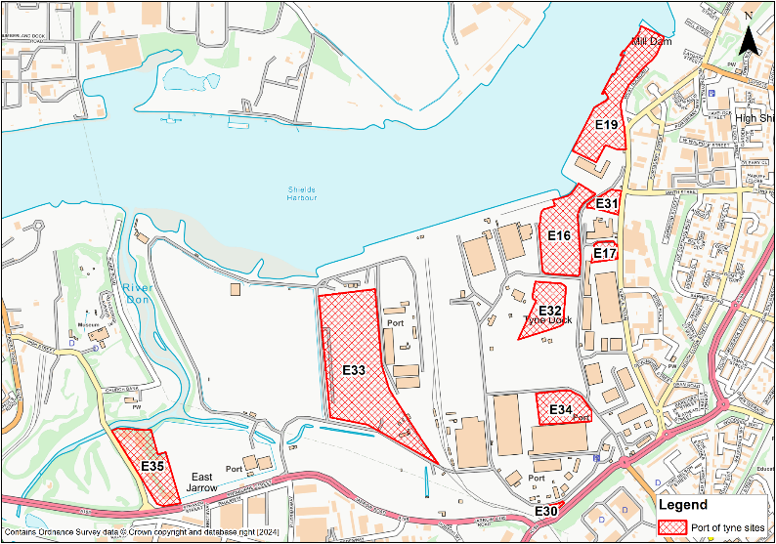
Figure 1-1: Level 2 SFRA sites

Limitations
This Level 2 SFRA has been prepared with several limitations associated with the availability and quality of data. The limitations include the following:
- The EA's Tidal Tyne HEC-RAS model, used in this SFRA to represent risk to the Port of Tyne sites, is from 2015. The 2m resolution LIDAR digital terrain model (DTM) used to generate the flood mapping for the Port of Tyne and the Tyne Estuary is from 2008 and therefore not fully representative of present-day ground conditions. For example, the DTM does not represent the now infilled Tyne dock within site E16. In order to provide a more robust representation of risk to the Port of Tyne sites, particularly sites E16, E31, and E32, the model should be updated with the most up to date LIDAR available, currently from 2021, which accounts for the infilled dock and any other topographical changes in the area. The appropriate sites assessments in this report summarise the potential impacts that updating the model may have on flood risk at the impacted sites.
- The modelled flood depth and hazard information for the Port of Tyne sites was derived through a 1D mapping process, which involves projecting 1D flood depths within the channel across a 2D LIDAR surface. 1D flood mapping introduces small patches of isolated flooding due to its simplified representation of the terrain and water flow dynamics. In a 1D flood model, the floodplain is represented as a series of cross-sections along a river or channel, which primarily captures the flow in one dimension, longitudinally along the channel. This method assumes uniformity across each cross-section and does not account for the detailed variations in topography and flow behaviour that occur laterally. Consequently, when the model extrapolates flood extents, it may inaccurately predict areas of flooding, leading to the appearance of erroneous isolated patches of flooding independent of the watercourse. Small-scale topographical features, such as depressions and minor elevations, may not be adequately resolved in the model, resulting in misrepresentations of where water might pool or flow. Such isolated localised patches of flooding in reality would not occur. Therefore, patches of isolated flooding within the mapping should be ignored. E.g. small areas of ponding that appear disconnected from the main body of floodwater and are not continuous with the primary flood extent.
- Due to inherent stability issues within the 2015 Tidal Tyne model, the 0.5% AEP (1 in 200-year) event could not be modelled for the upper end sea level rise climate change allowance scenario.

Level 2 SFRA requirements
The aim of a Level 2 assessment is to build on the findings of the Level 1 SFRA, focussing on identified sites or communities at high and medium flood risk that are considered important to local plan development. This allows the SFRA process to be time efficient using detailed modelling techniques only where they are required in the Level 2 assessment. These locations usually include significant development and / or regeneration areas that are at medium or high risk of flooding from main rivers, ordinary watercourses, or surface water whilst also accounting for the impacts of climate change. Flood risk data such as modelled flood extents, depths, velocities, and hazards are used to assess the sustainability of these areas. Appropriate mitigation techniques and achievable site layouts can then be informed.
This detailed information should support further application of the sequential test, the sequential approach to development management, inform on whether sites can pass the exception test, where applicable, and allow for flood risk indicators to be produced for use in the Sustainability Appraisal of the Local Plan.
EA guidance3 states a Level 2 SFRA should:
- Be detailed enough for the LPA to identify which potential development allocation sites have the least risk of flooding,
- Contain the information needed to apply the exception test, if relevant,
- Enable the LPA to decide if development can be made safe without increasing flood risk elsewhere.
It should enable the LPA to:
- Apply the sequential approach by identifying the severity and variation in risk within medium and high flood risk areas,
- Establish whether proposed allocations or windfall sites, on which your Local Plan will rely, are capable of being made safe throughout their lifetime without increasing flood risk elsewhere,
- Apply the exception test, where relevant.
A site-specific FRA will be required at the development planning stage which will assess risk to each site in greater detail than this Level 2 SFRA. The Level 2 SFRA is a strategic assessment that is not intended to replace the requirement of a site-specific FRA.

Objectives
In accordance with the latest national policy and guidance, and the individual requirements of STC, the key objectives of this Level 2 SFRA are to:
- Assess present day flood risk from all sources (tidal, fluvial, surface water, groundwater, and reservoirs),
- Update the EA's models for the Tyne Estuary with the latest climate change allowances for sea level rise,
- Update the EA's Risk of Flooding from Surface Water dataset with the EA's latest climate change allowances for peak rainfall,
- Update the functional floodplain (Flood Zone 3b) utilising the EA's 2015 Tidal Tyne model for the Port of Tyne,
- Assess detailed modelled outputs for surface water and tidal sources including flood depths, velocities and hazards,
- Assess existing flood warning, emergency planning procedures and safety of site access and escape routes in times of flood,
- Assess potential cumulative impacts of development,
- Provide site-specific surface water flood risk screening / drainage calculations including recommendations on the requirements for drainage control; surface water runoff rates and impact mitigation, including Sustainable Drainage Systems (SuDS); and design solutions that could reduce flood risk,
- Provide site-specific advice on mitigation options i.e. developable / non-developable areas; blue / green infrastructure and open spaces; maintenance of surface water flow routes; land raising and compensatory storage; and advice on likely minimum finished floor levels,
- Assess any catchment-wide or strategic solutions, e.g. upstream opportunity area for flood management (storage solutions) to mitigate against the risk of flooding downstream and elsewhere,
- Assess the potential effects from Natural Flood Management (NFM) and Working with Natural Processes (WwNP) schemes on mitigating flood risk,
- Demonstrate whether each site can be made safe throughout its lifetime, without increasing flood risk elsewhere,
- Provide recommendations for additional and future works required following on from or to supplement the Level 2 SFRA i.e. further tidal or surface water modelling, modelling of site layout / design options including provisions for safe access and escape routes, development optioneering (land raising, compensatory storage, flow routes / rates), drainage strategies, site-specific Flood Risk Assessment requirements.

Available data and information
The data and information described in this chapter has been used in the Level 2 SFRA to assess the risk to each Port of Tyne site as required, as described in Chapter 5.

EA models
The following EA hydraulic models have been used and updated in the assessment:
- 2015 Tidal Tyne model (HEC-RAS)
- 2007 Ouseburn Barrage model (HEC-RAS)
- 2015 Gateshead Tyne model (Flood Modeller - TUFLOW)
The EA Tidal Tyne HEC-RAS (2015) model covers the Port of Tyne. The outputs from this model are based on 1D modelling that is deemed to be the best available information to inform risk to the Port of Tyne. Flood levels, depths and velocities have been interpolated across the floodplain using extended 1D cross sections and 2m resolution LIDAR from the original model.

EA Open Data
Additional to the EA modelling information, the following datasets, available from the EA's Open Data online portal, have been reviewed and considered:
- 2021 LIDAR DTM dataset,
- Flood Map for Planning (Rivers and Sea) Flood Zones 2 and 3,
- Flood Storage Areas,
- Risk of Flooding from Surface Water extents, depths, and hazards for 3.3%, 1% and 0.1% AEP events,
- Spatial Flood Defences,
- Historic Flood Map,
- Recorded Flood Outlines,
- Flood Warning Areas,
- Flood Alert Areas,
- Reservoir Flood Map,
- Working with Natural Processes,
  - Riparian Woodland Potential
  - Wider Catchment Woodland Potential
  - Floodplain Woodland Potential
  - Floodplain Reconnection Potential
  - Runoff Attenuation Features 3.3% AEP
  - Runoff Attenuation Features 1% AEP

Other datasets
Other datasets and information used in the Level 2 SFRA include:
- JBA's 5m Groundwater Flood Risk Map,
- Functional floodplain dataset - this dataset has been updated for the Port of Tyne area. For all other locations in South Tyneside, refer to the Level 1 SFRA (see Appendix A), and
- OS Open Data Zoomstack base mapping.

Methodology
This chapter presents the methodology used in each stage of the Level 2 SFRA. The site-specific assessments within this report contain further information.

Functional floodplain update
Table 1 of the FRCC-PPG2 states the following regarding the definition of the functional floodplain:
- This zone comprises land where water from rivers or the sea has to flow or be stored in times of flood. The identification of functional floodplain should take into account local circumstances and not be defined solely on rigid probability parameters.
- Functional floodplain will normally comprise:
  - Land having a 3.3% or greater annual probability of flooding, with any existing flood risk management infrastructure operating effectively; or
  - Land that is designed to flood (such as a flood attenuation scheme), even if it would only flood in more extreme events (such as 0.1% annual probability of flooding).
The EA's SFRA guidance3 also states the following:
- You may not need to designate the functional floodplain in locations where evidence shows flooding would be prevented by existing:
  - Flood defences,
  - Flood risk management features or structures,
  - Solid buildings.
- The functional floodplain should show land that would normally form the river channel.
- The footprints of existing buildings may be removed from functional floodplain extents. However, it may be simpler to include existing buildings and use local policies to control the redevelopment or changes of use that may be acceptable.
- Use local policies or guidance to explain the approach you will take when buildings are demolished in functional floodplain. It may be reasonable to assume that sites revert to functional floodplain when buildings have been demolished for more than a year.
With consideration of the above guidance, the functional floodplain has been updated for the Tyne Estuary area of South Tyneside, using the 2015 Tidal Tyne model, Gateshead Tyne model and Ouseburn Barrage model listed above. In summary, this has entailed:
- Updating the existing 2022 flood extent for the Tyne Estuary at the Port of Tyne only (which is currently based on the 1 in 20 year flood extent (5% AEP) as delineated through the 2022 Level 1 SFRA update for South Tyneside) with the 1 in 30 year (3.3% AEP) undefended modelled flood event from the 2015 Tidal Tyne model. There is no defended scenario therefore the undefended scenario has been used,
- Reviewing EA Flood Storage Areas dataset for inclusion in the functional floodplain extent,
- Using the OS Open Data watercourse mapping to enable the inclusion of river channels as a 16 metre buffer zone of the channel (8 metres either side of the channel centreline).
The updated functional floodplain for the Port of Tyne should be reviewed and agreed upon between the LPA, EA and LLFA. The technical note in Appendix A details the modelled events, datasets and scenarios used to define Flood Zone 3b.

Climate change allowance modelling
EA SFRA guidance states that the SFRA should assess the effects of climate change on all sources of flooding, including the functional floodplain, to help inform the sequential approach to development. The potential impacts of climate change on the functional floodplain have therefore been assessed to produce a 'future functional floodplain' flood extent. There are no datasets available to account for the impacts of climate change on flooding from reservoirs, groundwater, and sewers.

Tidal
The River Tyne is tidally influenced up to Wylam, which is the westernmost boundary of Gateshead local authority to the west of South Tyneside authority area and is located within the Northumbria River Basin District (RBD). The scoping stage of the Level 2 SFRA found that the tidal Tyne models required updating with the latest EA climate change allowances for sea level rise. Table 5-1 lists the sea level rise allowances for the Northumbria RBD.
Table 5-1: Sea level rise allowances for Northumbria RBD
Allowance | Cumulative rise 2000 to 2125 (metres)
Higher Central | 1.03
Upper End | 1.43

The higher central and upper end climate change sea level rise allowances have been modelled for the Tidal Tyne model, Gateshead Tyne model and Ouseburn Barrage model. These results have then been combined to create outlines for the Tyne Estuary. The 3.3% AEP (1 in 30-year) and 0.1% AEP (1 in 1000-year) events have been modelled for the latest higher central and upper end sea level rise allowance scenarios. Due to inherent stability issues within the models, the 0.5% AEP (1 in 200-year) event has not been modelled for the upper end sea level rise climate change allowance scenario.

Surface water
EA climate change guidance5 states that, for SFRAs, the upper end allowance on peak rainfall for the 2070s should be modelled for the 3.3% and 1% AEP events.
For the Tyne Management Catchment, this entails:
- 3.3% AEP rainfall event +40%
- 1% AEP rainfall event +45%
Both scenarios have been modelled for this SFRA and assessed appropriately against the Port of Tyne sites.
Note: The national Risk of Flooding from Surface Water map is, at the time of writing, undergoing a significant update. However, the updated map is unlikely to made available until late 2024 / early 2025.

Surface water climate change modelling inconsistencies
It is important to note that the hydraulic models run as part of this Level 2 SFRA are the original national generalised models developed as part of the RoFSW in 2013. This is the case for South Tyneside which is largely based on local surface water models (as shown in Figure 5-1). Therefore, in areas where the outputs from a local surface water model have been supplied to the EA for inclusion in the RoFSW mapping, it is likely that these climate change results will be inconsistent with the published data.
The reasons for these inconsistencies are summarised below:
- Differing post-processing methods - there may be instances where there are small, isolated patches of surface water flood risk in the present day local modelled extents that are not present in the modelled climate change scenarios. This is a result of the 'cleaning' of the local modelling to remove very small shallow patches of flooding being done to a differing specification to the national generalised mapping used to inform the impact of climate change on surface water.
- Updated DTM - the climate change modelling completed for this Level 2 SFRA uses a DTM with incisions through key raised embankments to represent a channel flowing beneath, whereas it doesn't appear the local mapping has used the same approach. Therefore, there are instances where ponding behind embankments is greater within the present-day scenario than the climate change scenarios.
- Channel draining - the local modelling used in the RoFSW map utilises a drainage rate within the channels to remove the fluvial influence on predicted flood risk. This approach was not applied within the national mapping, and therefore is not represented within the climate change modelling.
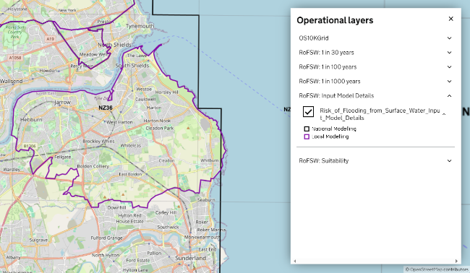
Figure 5-1: Risk of Flooding from Surface Water input model details

Residual risk

Modelling of defence breach and structural blockage scenarios
Para 004 of the FRCC-PPG2 states the requirement in plan making to account for residual flood risks from flood risk management infrastructure. The EA's SFRA guidance3 states that if specific breach models are not available from the EA, then the EA should be consulted on how to assess the potential effect and reach of floodwater if a defence is breached.
For this Level 2 SFRA, it is our understanding from the 2015 Tidal Tyne model and from EA datasets that there are not any formal defences, structures or culverts that could present a residual risk to the Port of Tyne sites.

Assessing flood risk from reservoirs
The EA's SFRA guidance3 requests for the assessment of risk from reservoir dam failure using the EA's Reservoir Flood Map (RFM). The RFM shows the credible worst-case scenarios from dam failure in a dry day scenario. Para 046 of the FRCC-PPG states the following in relation to the risk of flooding from a reservoir:
The local planning authority will need to evaluate the potential damage to buildings or loss of life in the event of dam failure, compared to other risks, when considering development downstream of a reservoir. Local planning authorities are also advised to consult with the owners/operators of raised reservoirs, to establish constraints upon safe development.
Local planning authorities should also consider any implications for reservoir safety and reservoir owners and operators caused by new development located downstream of a reservoir, such as the cost of measures to improve the design of the dam to reduce flood risk, the operation of the reservoir, and general maintenance costs, by consulting with reservoir owners and operators on plan and development proposals. Local authorities, as category 1 responders, can access more information about reservoir risk and reservoir owners using the Resilience Direct system. Developers should be expected to cover any additional costs incurred, as required by the National Planning Policy Framework’s ‘agent of change’ policy (paragraph 187). This could be through Community Infrastructure Levy or section 106 obligations for example.
Applications will need to include any evidence local planning authorities need to understand the impact of individual developments on reservoirs. In doing so, they need to refer to relevant guidance in the Institution of Civil Engineers publication Floods and Reservoir Safety (4th edition) and the Environment Agency’s Guide to risk assessment for reservoir safety management. It may be necessary to seek expert advice, such as from an All Reservoirs Panel Engineer, from the government accredited list under How to appoint a panel engineer.
Consideration should also be given to the potential impacts of development on the operation of reservoirs. This is particularly important where impacts could affect the management of flood risk or the supply of water.
The site reports in Section's 7 to 15 show there to be several sites at risk from reservoir flooding according to the RFM. The LPA may wish to follow the above guidance for those sites identified as being at risk from reservoir flooding. However, this is for wider consideration within the local planning authority and emergency planning teams outside of the Level 2 SFRA.

Assessing flood risk from groundwater
Susceptibility of areas to groundwater flooding has been appraised at each Port of Tyne site using JBA's national 5m resolution Groundwater Flood Map which is much more refined than the British Geological Survey (BGS) datasets.
In creating this map, a team of hydrogeologists and flood risk specialists modelled how and where groundwater levels would rise following prolonged periods of rainfall, considering factors such as topography, groundwater recharge volumes and spatial variations in aquifer storage and transmission properties.
The model outputs were validated against recorded groundwater levels for past events and checked against areas historically affected by groundwater flooding. The high-resolution maps make it easier for users to pinpoint and report risks from groundwater flooding.
See the site-specific reports for groundwater flood risk to each potential site.

Assessing flood risk from sewers
To inform the 2022 South Tyneside Level 1 SFRA, Northumbrian Water Ltd (NWL) provided a list of 100m2 grid squares which contained areas of possible hydraulic incapacity in the public sewer network. These grid squares have been interrogated as part of this Level 2 SFRA however, the grid squares of areas with possible drainage issues do not impact the nine potential development sites located at the Port of Tyne.
The South Tyneside Surface Water Management Plan (SWMP), published in 2014 highlighted Tyne Dock, as an area where surface water flooding has historically occurred. However, NWL have previously carried out a study to reduce flood risk in the area and property flood resilience measures have been installed at some properties in the locality.

Access and escape routes, and emergency planning
EA Flood Warning Areas and Flood Alert Areas have been mapped and reviewed against the Port of Tyne sites along with potential safe access and escape routes for each site during a flood event. See the site reports in Sections 7 to 15.

Cumulative impacts
Cumulative impacts of development and land use change were assessed in the Level 1 SFRA. A joined-up approach should be adopted between developers at the FRA stage for any clusters of sites to ensure possible flood risk mitigation at one site does not increase risk to a neighbouring or downstream site as a result of loss of floodplain storage, the deflection or constriction of flood flow route, or through inadequate management of surface water. Para 049 of the FRCC-PPG states that site-specific flood risk assessments should assess cumulative impacts and demonstrate how mitigation measures have addressed them.

Working with Natural Processes
The national Working with Natural Processes (WwNP) mapping dataset has been assessed as to whether there is any potential for WwNP techniques, such as flood storage, that could benefit the Port of Tyne sites. See site reports in Sections 7 to 15 for any potential areas.

Level 2 sites assessments
Nine individual detailed Level 2 site assessments have been produced, detailing the site-specific assessments carried out through this Level 2 SFRA. Table 6-1 summarises the outcomes from the Level 2 assessment at each site.
Sections 7 to 15 of this report contain the Level 2 SFRA site reports for the Port of Tyne sites. The content of these Level 2 SFRA site screening reports assumes the reader has already consulted the 2022 South Tyneside Level 1 SFRA and read Sections 1 to 5 of this report and is therefore familiar with the terminology used.

Summary of Level 2 outcomes
Table 6-1: Level 2 site assessment outcomes
Site reference | Site name | How has main risk been identified? | Summary of Level 2 assessment | Main barriers to development | Further work / next steps
E16 | Tyne Dock Enterprise Park South (Dock infill) | Tidal Tyne | Comparisons of elevations between the model LIDAR and 2021 LIDAR show the site would not be within the functional floodplain as modelled.  However, the site is within the future functional floodplain and can therefore not be considered to be safe for its lifetime.  Mitigation through land raising and appropriate finished floor levels should enable safe less vulnerable development.  However, it may be prudent to fully update the tidal modelling to account for up to date terrain data. | Future functional floodplain | FRA including fully up to date modelling to inform finished floor levels
E17 | Hill 60 | Tidal Tyne | Based on current modelling, it should be appropriate to develop this site given the modelled low tidal risk to the site.  However, it may be prudent to fully update the tidal modelling to account for up to date terrain data. | - | FRA including fully up to date modelling
E19 | Tyne Dock Enterprise Park (former McNulty Offshore), Commercial Road | Tidal Tyne | Based on current modelling, the site is partially within the functional floodplain and the majority of this site is within the future functional floodplain, therefore cannot be considered to be safe for its lifetime.  Mitigation through land raising and appropriate finished floor levels should enable safe less vulnerable development  It may be prudent to fully update the tidal modelling to account for up to date terrain data. | Functional floodplain and future functional floodplain | FRA including fully up to date modelling to inform finished floor levels
E30 | Compound beside Jarrow Road | Tidal Tyne | Based on current modelling, the majority of this site is within the future functional floodplain, therefore cannot be considered to be safe for its lifetime.  Mitigation through land raising and appropriate finished floor levels should enable safe less vulnerable development  It may be prudent to fully update the tidal modelling to account for up to date terrain data. | Future functional floodplain | FRA including fully up to date modelling to inform finished floor levels
E31 | Tyne Dock Enterprise Park (SE), Commercial Road | Tidal Tyne | Comparisons of elevations between the model LIDAR and 2021 LIDAR show the site would not be within the functional floodplain as modelled.  However, the site is within the future functional floodplain and can therefore not be considered to be safe for its lifetime.  Mitigation through land raising and appropriate finished floor levels should enable safe less vulnerable development.  However, it may be prudent to fully update the tidal modelling to account for up to date terrain data. | Future functional floodplain | FRA including fully up to date modelling to inform finished floor levels
E32 | East of wood pellet silos | Tidal Tyne | Comparisons of elevations between the model LIDAR and 2021 LIDAR show the site would not be within the functional floodplain as modelled.  However, the site is within the future functional floodplain and can therefore not be considered to be safe for its lifetime.  Mitigation through land raising and appropriate finished floor levels should enable safe less vulnerable development.  However, it may be prudent to fully update the tidal modelling to account for up to date terrain data. | Future functional floodplain | FRA including fully up to date modelling to inform finished floor levels
E33 | Tyne Renewables Quay | Tidal Tyne | Based on current modelling, it should be appropriate to develop this site given the modelled low tidal risk to the site.  However, it may be prudent to fully update the tidal modelling to account for up to date terrain data.  A detailed drainage strategy would be required at the FRA stage to fully account for surface water risk. | - | FRA including fully up to date modelling
E34 | North of Warehouse 21 | Tidal Tyne | Based on current modelling, the majority of this site is within the future functional floodplain, therefore cannot be considered to be safe for its lifetime.  Mitigation through land raising and appropriate finished floor levels should enable safe less vulnerable development.  It may be prudent to fully update the tidal modelling to account for up to date terrain data. | Future functional floodplain | FRA including fully up to date modelling to inform finished floor levels
E35 | Former M H Southern | Tidal Tyne | Based on current modelling, the site is partially within the functional floodplain along a drainage ditch onsite.  The ditch should be left free of obstruction and allowed to flow naturally.  It may be prudent to fully update the tidal modelling to account for up to date terrain data. | Functional floodplain | FRA including fully up to date modelling

Site E16
- Location: Tyne Dock Enterprise Park South (Dock infill)
- Existing site use: brownfield
- Existing site use vulnerability: less vulnerable
- Proposed site use: employment
- Proposed site use vulnerability: less vulnerable
- Site area: 3.5 hectares
- Proposed development impermeable area: 3 hectares (assumed 85% of total site area)
- Watercourse: River Tyne
- Summary of requirements from scoping stage:
  - Level 1 SFRA recommendation was for withdrawal from allocation or more detailed assessment through Level 2 SFRA
  - Assessment of modelled tidal flood depths and hazards
  - Assessment of surface water flood depths and hazards
  - Modelling of latest EA climate change allowances for sea level rise and peak rainfall intensities
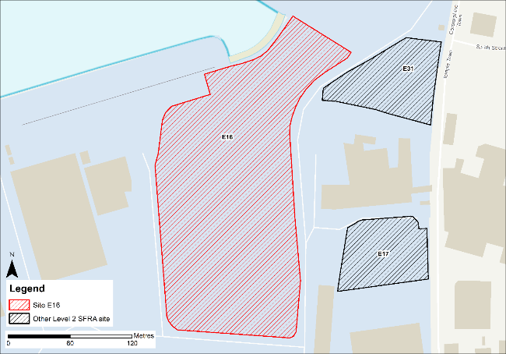
Figure 7-1: Existing site location boundary

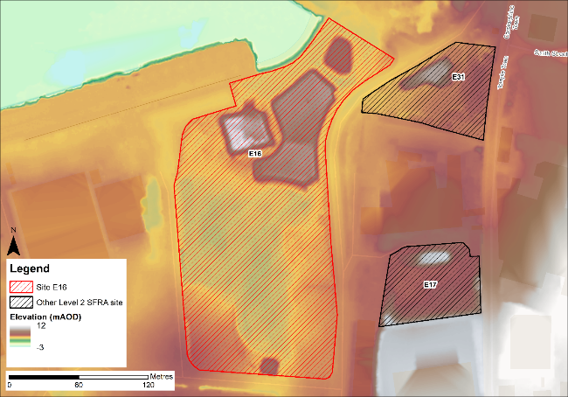
Figure 7-2: Topography

Flood risk from rivers and sea

Existing risk - Flood Map for Planning and functional floodplain
Based on the EA's Flood Map for Planning and Flood Zone 3b (functional floodplain) as updated in this Level 2 SFRA, the percentage areas of the site within each flood zone are stated in Table 7-1 and can be viewed on Figure 7-3. The Flood Map for Planning does not consider flood defence infrastructure or the impacts of climate change (Section 7.1.2).
Almost the entire site and the surrounding areas are modelled to be within Flood Zone 3b. However, as stated as a limitation in Section 2, the DTM used to represent the Tyne Estuary floodplain is from 2008 and does not include the infilled Tyne dock. Therefore, the extent of flooding to this site is not based on current topographical conditions.
Table 7-1: Existing flood risk from rivers and sea
Flood Zone 1 (%) | Flood Zone 2 (%) | Flood Zone 3a (%) | Flood Zone 3b (%)
7 | 6 | 5 | 82

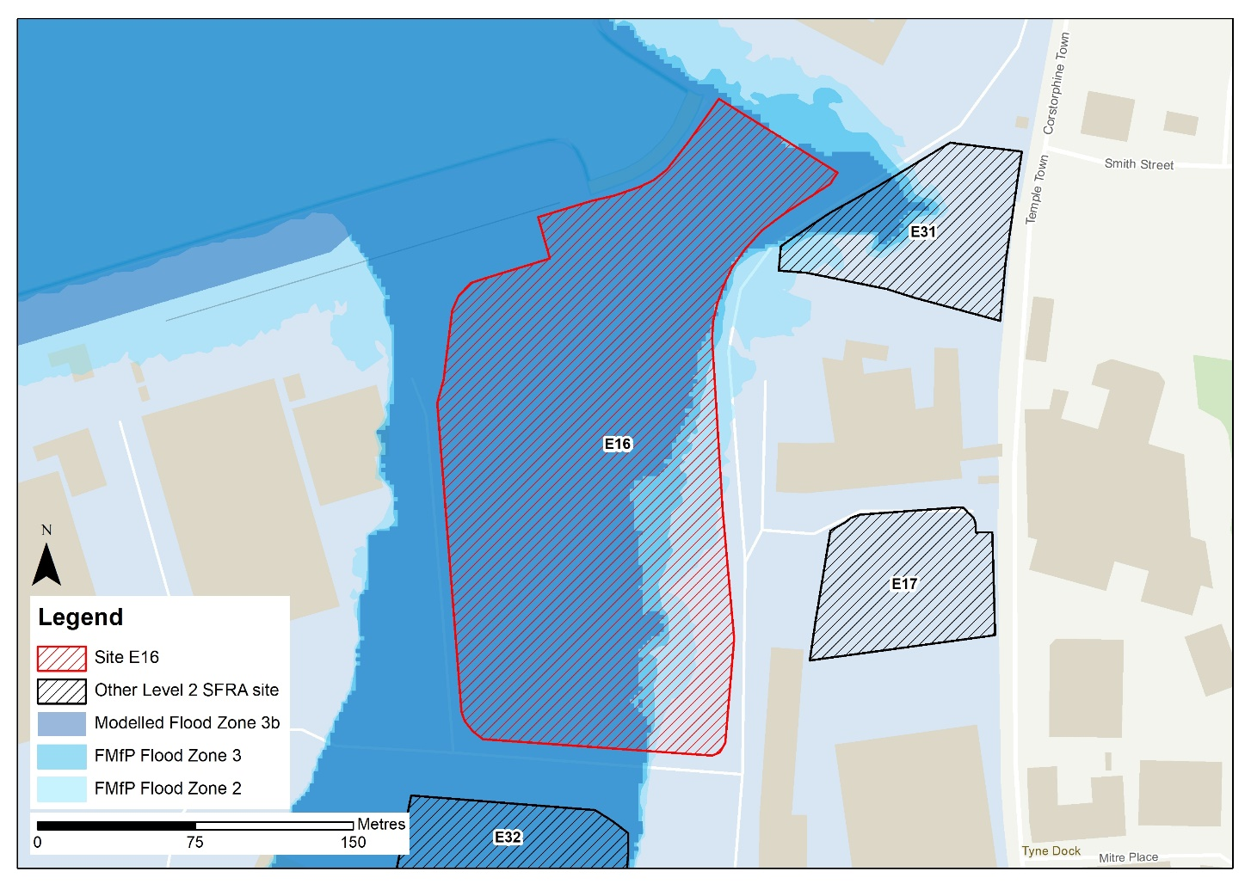
Profile line
Figure 7-3: Existing risk from rivers and sea to the site

Tidal Tyne HEC-RAS model outputs
Figure 7-4 shows the modelled flood depths for the 0.5% AEP undefended event. Modelling shows flooding of various depths across the majority of the site. Greatest flood depths are >3m through the centre of the site. Flood hazards within this area are categorised as 'Danger for all' (Figure 7-5). Safe access and escape should be possible via the unnamed road to the east of the site.
As the DTM used to map the modelled outputs does not reflect the infilled Tyne Dock, the extents, depths and hazards of flooding to this site are not fully representative of current conditions. Any site-specific FRA for this site should update the existing model to include the latest DTM for the site and surrounding area.
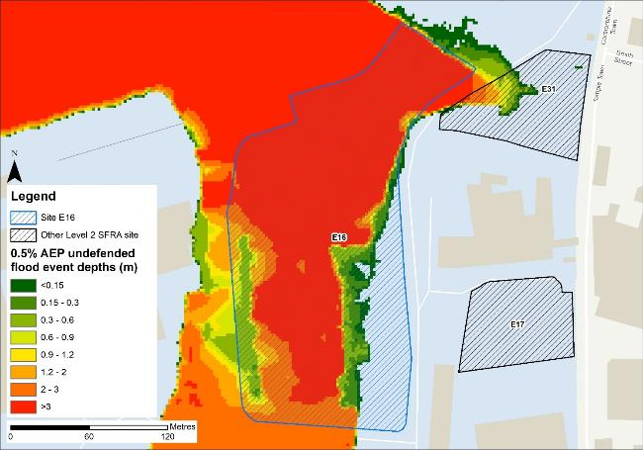
Figure 7-4: Flood depths for 0.5% AEP undefended flood event

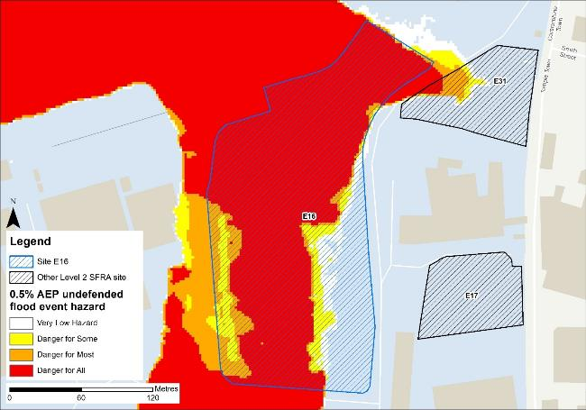
Figure 7-5: Flood hazard for 0.5% AEP undefended flood event
In order to gauge what differences in risk to the site may emerge from updating the existing model to include the latest 2021 DTM, modelled flood levels have been compared to the 2008 DTM (as used in the 2015 model) and the 2021 DTM using a profiling GIS tool. The green line shown on Figure 7-3 is the profile line location which produced profile chart below.
The profile chart shows the elevations for the 2008 DTM, as used in the 2015 model (purple line), the 2021 LIDAR (blue line), and the modelled water level for the 3.3% AEP event i.e. the functional floodplain (red line).

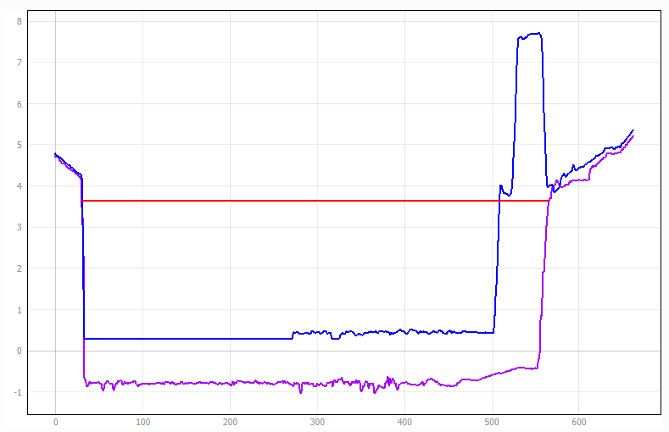
Isolated high ground
2021 LIDAR DTM bank level at the dock
Functional floodplain water level
2008 LIDAR DTM bank level at the dock
There is a difference in elevation of approximately 4m along the bank of the Tyne Estuary at the site, which is ~600mm above the modelled flood level for the functional floodplain. From comparing the functional floodplain flood level with the 2021 LIDAR, this site would no longer be within the functional floodplain and would therefore be considered suitable for less vulnerable development, assuming appropriate mitigation can be applied. Updating the model with the 2021 LIDAR DTM would be required to confirm this.
Appropriate mitigation would likely involve land raising and finished floor levels set at 600mm above the design event flood level, as recommended in EA standing advice on flood risk assessments. The design event should be the 0.5% AEP plus an allowance for climate change. Given the risk is tidal, compensatory storage is unlikely to be required, though the EA must be consulted on this. However, for increased certainty on water levels and subsequent finished floor levels, the model should be re-run with the 2021 LIDAR.

Impacts from climate change
Based on the EA's SFRA guidance, the latest sea level rise allowances have been modelled as shown in Table 7-2.
Table 7-2: Modelled sea level rise allowances for the Northumbria River Basin District
Return period | Higher Central (m) | Upper End (m)
3.3% (functional floodplain) | 1.03 | 1.43
0.5% | 1.03 | 1.43
0.1% | 1.03 | 1.43
Based on cumulative sea level rise from 2000 to 2125

Figure 7-6 shows the modelled flood depths for the 3.3% AEP undefended event + 1.43m of sea level rise allowance for climate change (the future functional floodplain). Risk is modelled to be greater than present day conditions with flooding modelled to extend across the entire site. Maximum flood depths across large areas of the site are modelled to be >3m. The resulting flood hazard is predominantly danger for all with eastern parts of the site having a flood hazard rating of danger for most (Figure 7-7). Safe access and escape routes would be challenging to achieve. This modelled risk potentially rules out safe development of the site.
Figure 7-8 shows the modelled flood depths for the 0.5% AEP undefended event + 1.03m of sea level rise allowance for climate change. Risk is modelled to be significant across the majority of the site, with maximum depths of > 3m and areas of hazard classified as 'Danger for all' (Figure 7-9).
The profile chart below indicates the future functional floodplain modelled water level in comparison to both the 2008 and 2021 LIDAR DTM levels. The future functional floodplain water level is approximately 1m higher than the 2021 LIDAR bank levels. Therefore, the site is likely to remain at risk within the future functional floodplain modelled extent were the model to be updated to include the 2021 LIDAR DTM.
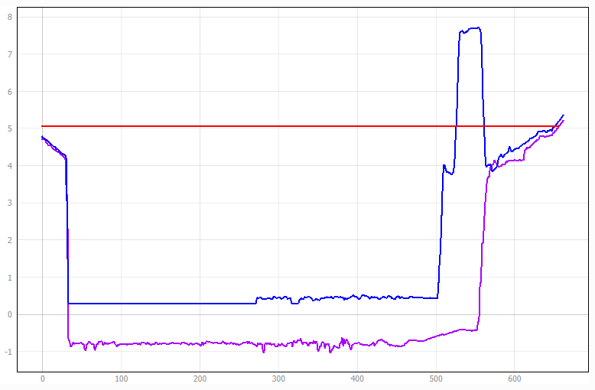
Isolated high ground
2021 LIDAR DTM bank level at the dock
2008 LIDAR DTM bank level at the dock
Future functional floodplain water level
NOTE: There are isolated areas of raised ground within the site boundary of E16, approximately 4m above the bank level of the River Tyne and visible within the 2021 LIDAR. This raised ground is not continuous and would therefore not prevent flooding to the site in the 3.3% AEP plus climate change event.
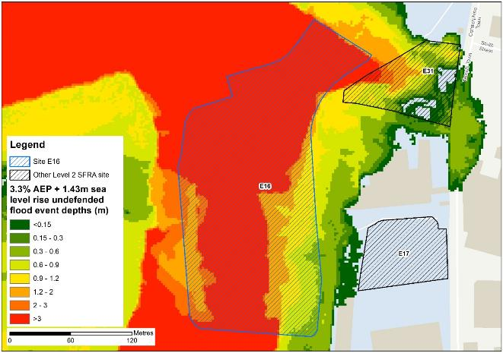
Figure 7-6: Flood depths for 3.3% AEP undefended flood event +1.43m upper end sea level rise allowance
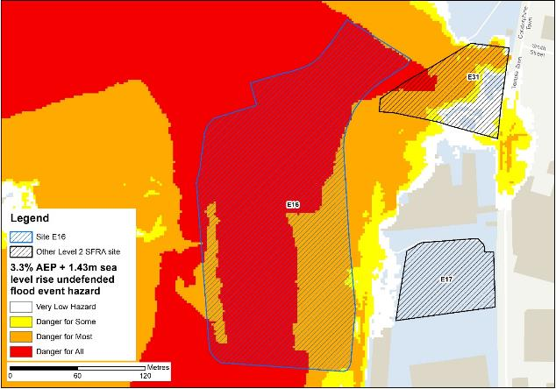
Figure 7-7: Flood hazard7 for 3.3% AEP undefended flood event +1.43m upper end sea level rise allowance
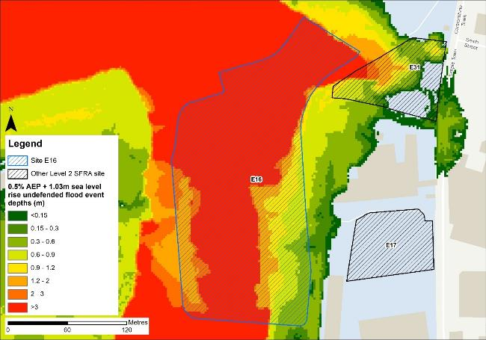
Figure 7-8: Flood depths for 0.5% AEP undefended flood event +1.03m higher central sea level rise allowance
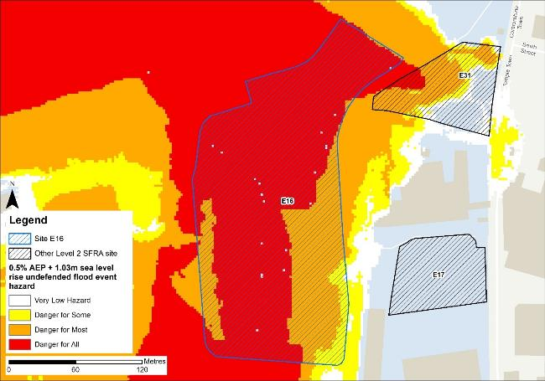
Figure 7-9: Flood hazard7 for 0.5% AEP undefended flood event +1.03m higher central sea level rise allowance

Flood risk management
The site does not benefit from any formal engineered flood defences.

Working with Natural Processes
The EA's Working with Natural Processes (WwNP) dataset has been interrogated, however there are not any applicable areas that could benefit this site.

Residual risk
The 2015 Tidal Tyne model and EA spatial flood defences datasets indicate that there are no formal defences, structures or culverts that could present a residual risk to the Port of Tyne sites.

Flood risk from reservoirs
The EA's Reservoir Flood Maps (RFM) (2021) show where water may go in the unlikely event of a reservoir or dam failure. Figure 7-10 shows the RFM in a 'dry-day' scenario. A dry-day scenario assumes that the water level in the reservoir is the same as the spillway level or the underside of the roof for a service reservoir and the watercourses upstream and downstream of the reservoir are at a normal level.
This site is potentially at risk from one reservoir, located outside of the South Tyneside authority area in Northumberland.
The EA's SFRA guidance states that where a proposed development site is at flood risk from a reservoir, then an assessment into whether the reservoir design or maintenance schedule needs improving should be carried out. Expert advice may be required from an all-reservoirs panel engineer. At the FRA stage, the reservoir owner, should be contacted to ascertain the flood risk in more detail and whether the proposed development could affect the reservoir’s risk designation, it’s design category or how it is operated. The council, as category 1 responders, can access more detailed information about reservoir risk and reservoir owners using the Resilience Direct system.
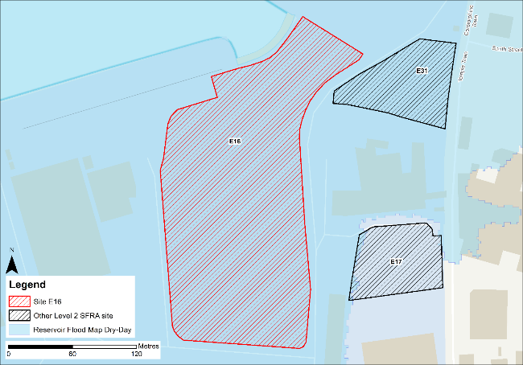
Figure 7-10: Flood risk from reservoirs

Historic flood incidents
The EA's Historic Flood Map (HFM) and Recorded Flood Outlines (RFO) datasets have been considered. Historic risk to the site is shown in Figure 7-11 which shows that the majority of the site has been subject to flooding in the past. The RFO datasets references that the historic event occurred in December 1978 due to flooding from the River Tyne.
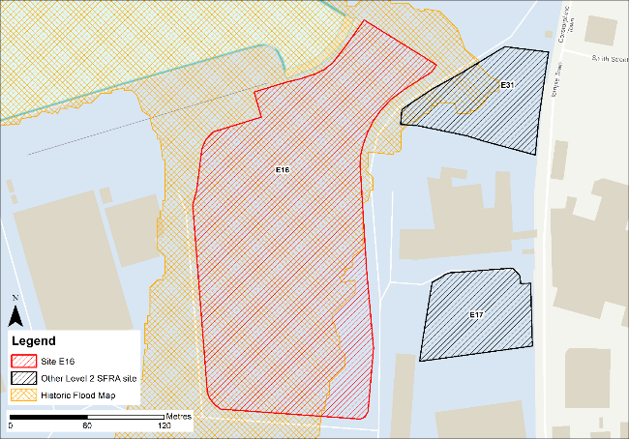
Figure 7-11: Recorded historic flood events onsite and around the site

Flood warning and access and escape routes
The EA operates a Flood Warning Service for properties located within a Flood Warning Area (FWA) for when a flood event is expected to occur. Site E16 is located within FWA 121FWT544 - Tyne estuary at North Shields, South Shields and Howdon Pans, as shown on Figure 7-12.
Flood alerts may be issued before a flood warning for properties located within a Flood Alert Area (FAA) to provide advance notice of the possibility of flooding. A flood alert may be issued when there is less confidence that flooding will occur in a FWA. The site is also located within a FAA, namely 121WAT913 - Tyne estuary from Wylam to the North Sea coast, including Watergate Car Park at Newcastle Quayside.
Safe access and escape routes are achievable in the modelled present day flood events on the Tidal Tyne via the unnamed road to the east of the site though not in the longer term. However, rerunning the model with the latest LIDAR data may alter the risk at this site and to the surrounding areas.
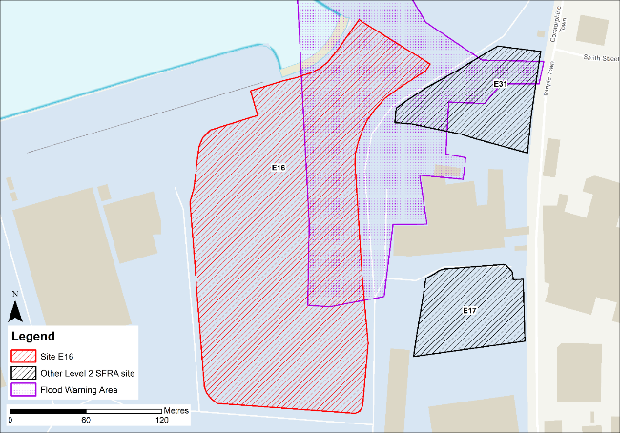
Figure 7-12: EA Flood Warning Areas

Observations, mitigation options and site suitability - tidal
- The DTM used in the model to represent the Tyne Estuary floodplain is from 2008 and does not include the infilled Tyne dock located on this site. Therefore, the modelled extent of flooding to this site is not representative of current conditions with the functional floodplain extent being overestimated, as shown by elevation and water level profiles.
- The model should be updated with the most up to date LIDAR and rerun to provide a fully robust modelled representation of risk for the site and the Port of Tyne.
- Any area of functional floodplain should be left free of development that can be left as open space that can flood when required.
- Modelled risk from climate change increases the risk to the site and surrounding areas, with the entire site modelled to be within the future functional floodplain.
- Mitigation by way of land raising should be possible at this site with finished floor levels set 600mm above the 0.5% AEP plus climate change flood level. Investigations should ensure flood risk is not worsened elsewhere and given the risk is tidal, compensatory storage is unlikely to be required, though the EA must be consulted.
- The FRA must show that development will be safe for its lifetime taking account of the vulnerability of its users, including for appropriate evacuation procedures and flood response infrastructure are in place to manage the residual risk associated with the extreme flood event.
- EA flood warnings should continue to be in place to ensure early evacuation of site users in advance of a flood event.
- Safe access and escape routes will be challenging to achieve in an extreme event, based on current modelling. There must be an emergency plan in place to ensure site users can be safely evacuated.
- Were development of this site to proceed, given the proximity of this site to neighbouring sites E17, E19, E31 and E32, it would be prudent to formulate a strategy to develop these sites in tandem and for consultation between each developer to take place to ensure a joined-up approach for sustainable development is in place.

Flood risk from surface water

Existing risk
Based on the EA's national scale Risk of Flooding from Surface Water (RoFSW) map, the site is at very low risk of surface water flooding. Only 1% of the site is within the low risk surface water flood zone, as shown in Table 7-3. The area at risk is mainly confined to a low spot within the south of the site. Greatest flood depths range between 0.3 and 0.6 m (Figure 7-13 with areas of significant hazard (Figure 7-14). Safe access and escape routes should be possible via the unnamed road to the east of the site.
Table 7-3: Existing surface water flood risk based on the RoFSW map
Very low risk (%) | Low risk (%) | Medium risk (%) | High risk (%)
99 | 0 | 1 | 0

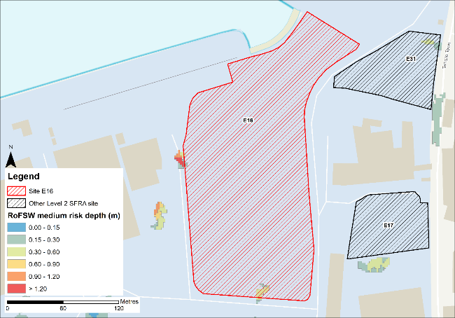
Figure 7-13: Medium risk event surface water flood depths (Risk of Flooding from Surface Water map)
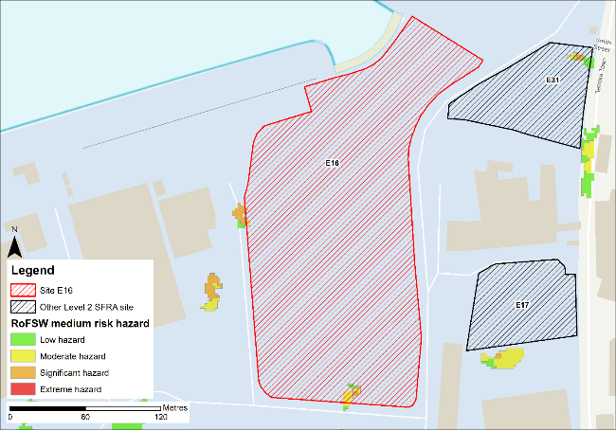
Figure 7-14: Medium risk event surface water flood hazard (Risk of Flooding from Surface Water map)

Impacts from climate change
The impact of climate change on surface water flood risk has been modelled. This allows for direct comparison with the RoFSW map. With consideration of the EA’s SFRA guidance, the latest climate change allowances have been modelled as shown in Table 7-4.
Table 7-4: Modelled climate change allowances for rainfall for the Tyne management catchment
Return period | Central allowance 2070s | Upper end allowance 2070s
3.3% | 30% | 40%
1% | 35% | 45%

Figure 7-15 shows the modelled surface water flood depths for the medium risk event +45% climate change. Risk is modelled to be greater than the medium risk event in present day conditions with ponding within the site increasing at the north of the site and at the southern site boundary. In addition, a flow path along the road east of the site enters the southern half of the site.
Maximum depths are between 0.3 and 0.6m with areas of moderate hazard within the flow path which enters the site from the east (Figure 7-16). There is ponding along the roads east and south of the site during the medium risk +45% climate change event, however hazard along these roads is predominantly classed as 'low', so safe access and escape is likely to be possible, though should be directed to the west.
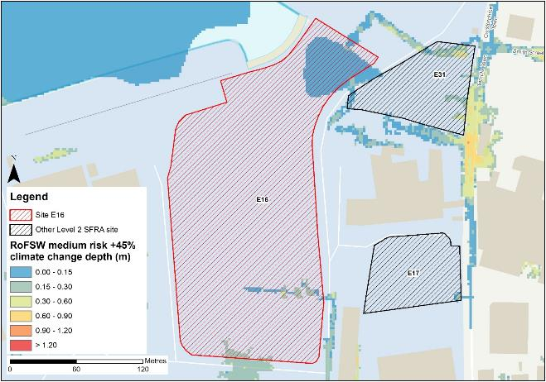
Figure 7-15: Medium risk event surface water flood depths plus 45% climate change (based on Risk of Flooding from Surface Water map)
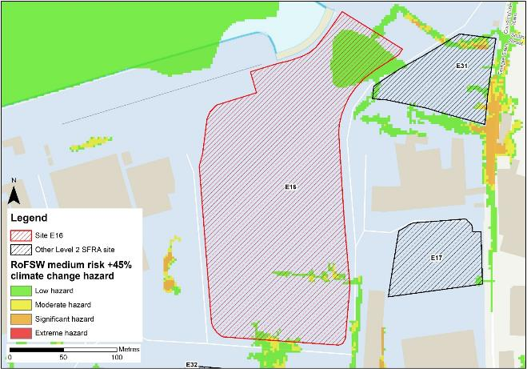
Figure 7-16: Medium risk event surface water flood hazard plus 45% climate change (based on Risk of Flooding from Surface Water map)

Risk of runoff from site post development
Runoff rates should not exceed current rates and if possible, betterment of existing rates should be aimed for. For the purposes of this assessment, the required volumes of attenuation have been calculated below based on the estimated impermeable area (assumed 85% of total area) and limiting greenfield runoff rate of Qbar (l/s).

Table 7-5: Surface water flood risk from proposed development
Design flood event  (incl climate change) | Critical storm duration Hrs | Inflow volume m3 | Outflow volume m3 | Attenuation required  m3 | Time to empty (assuming no infiltration) Hrs | Total storage required: Area (Ha) and % of site area
30yr Rainfall+30% | 12 | 2196 | 390 | 1806 | 55.5 | 0.12 Ha 3.4%
30yr Rainfall+40% | 12 | 2365 | 390 | 1975 | 60.6 | 0.13 Ha 3.7%
100yr Rainfall+35% | 12* | 3522 | 974 | 2547 (741 exceedance storage) | 78.2 | 0.17 Ha 4.8%
100yr Rainfall+45% | 12* | 3985 | 1169 | 2816 (841 exceedance storage) | 86.4 | 0.19 Ha 5.3%
Surface water flood risk impacts from development site, mitigation & SuDS options | As part of this Level 2 SFRA we have included calculations to provide an estimated land take if a pond with an assumed depth of 1.5m was included as part of the development.  Attenuation volumes are presented for the critical storm duration for the 3.33% AEP event with exceedance flows quantified up to the 1% event. To prevent development worsening flood risk elsewhere, surface water runoff must be managed on site.
*Critical storm duration limited to 12 hours
Note: Proposed development limiting runoff rate: (l/sec). Qbar (FEH Statistical) – 12.89, Q30 – 22.55, Q100 – 26.81

Observations, mitigation options and site suitability - surface water
- Current risk to the site is predominantly very low, with 99% of the site being at very low risk of surface water flooding. Surface water flood risk is confined to low-lying areas along the boundary of the site.
- The modelled medium risk climate change outputs indicate a significantly greater level of risk to present day with further flooding to the north of the site. However, safe access and escape routes should be possible via the unnamed road west of the site.
- For the 1% AEP event plus 45% climate change, approximately 5.3% of the total area of the site would be required for flood storage based on a 1.5m deep pond to ensure runoff volumes do not exceed existing rates.
- Assessment of the current drainage system in place should be carried out to ascertain any current capacity issues and whether the current system could accommodate the proposed development or whether further capacity will be required
- The Groundwater Flood Map (Figure 7-17) indicates that ground conditions in the northern half of the site may be suitable for infiltration SuDS. This should be further explored through appropriate ground survey as part of the FRA and drainage strategy.
- A full drainage strategy would be required to ensure there is no increase in surface water flood risk elsewhere as a result of new development. This will require surface water modelling based on layout plans and detailed design and full consultation with the LLFA.
- The RoFSW map is not suitable for identifying whether an individual property will flood and is therefore indicative. The RoFSW map is not appropriate to act as the sole evidence for any specific planning or regulatory decision or assessment of risk in relation to flooding at any scale without further supporting studies or evidence.

Flood risk from groundwater
Flood risk from groundwater sources is assessed in this SFRA using JBA's 5m Groundwater Flood Map. This dataset is recommended for use by the EA in the SFRA Good Practice Guide. Figure 7-17 shows the map for Site E16 and the surrounding areas and Table 7-6 explains the risk classifications.
The majority of the site is within an area where there is a negligible risk from groundwater flooding due to the nature of the local geological deposits. Use of infiltration SuDS should therefore be appropriate in the northern half of the site, if required.
Within the centre of the site, there is a risk of groundwater flooding to both surface and subsurface assets. Groundwater may emerge at significant rates and has the capacity to flow overland and/or pond within any topographic low spots.
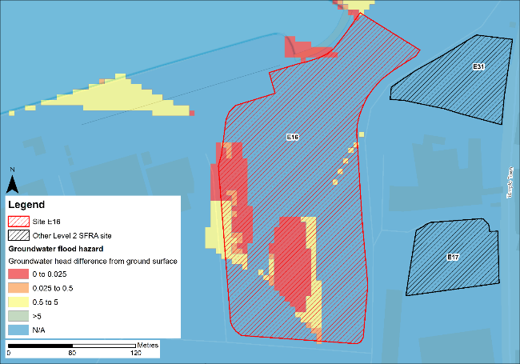
Figure 7-17: JBA 5m Groundwater Flood Map

Table 7-6: Groundwater Flood Hazard Classification
Groundwater head difference (m)* | Class label
0 to 0.025 | Groundwater levels are either at very near (within 0.025m of) the ground surface in the 100-year return period flood event.  Within this zone there is a risk of groundwater flooding to both surface and subsurface assets. Groundwater may emerge at significant rates and has the capacity to flow overland and/or pond within any topographic low spots.
0.025 to 0.5 | Groundwater levels are between 0.025m and 0.5m below the ground surface in the 100-year return period flood event.  Within this zone there is a risk of groundwater flooding to surface and subsurface assets. There is the possibility of groundwater emerging at the surface locally.
0.5 to 5 | Groundwater levels are between 0.5m and 5m below the ground surface in the 100-year return period flood event  There is a risk of flooding to subsurface assets, but surface manifestation of groundwater is unlikely.
>5 | Groundwater levels are at least 5m below the ground surface in the 100-year return period flood event.  Flooding from groundwater is not likely.
N/A | No risk.  This zone is deemed as having a negligible risk from groundwater flooding due to the nature of the local geological deposits.

Overall site assessment

Can part b) of the exception test be passed?
To pass part b) of the exception test, it must be proven that the development can be safe for its lifetime, which is 100 years for residential development, taking account of the vulnerability of its users, without increasing risk elsewhere, and, where possible, will reduce flood risk overall.
- The site is not required to pass the exception test as it is proposed for less vulnerable uses.

Recommendation summary
Based on the evidence presented in this Level 2 SFRA:
- It should be possible to develop this site for less vulnerable uses. However, mitigation by way of land raising would be required.
- Finished floor levels should place the development 600mm above the 0.5% AEP plus climate change flood level without increasing risk elsewhere.
- Updating and rerunning the model with the latest LIDAR data before finalising finished floor levels and planning development is recommended.

FRA requirements and further work
- The site-specific FRA should update the existing model to include the latest DTM for the site and surrounding area.
- Mitigation by way of land raising should be assessed and finished floor levels set 600mm above the 0.5% AEP plus climate change flood level. Investigations should ensure flood risk is not worsened elsewhere.
- Safe access and escape routes should be assessed with appropriate emergency plans and evacuation procedures in place as part of the FRA.
- Any FRA should be carried out in line with the NPPF; FRCC-PPG; EA guidance; South Tyneside Local Plan and LLFA policies; and national and local SuDS policy and guidelines.
- Throughout the FRA process, consultation should be carried out with the following, where applicable, the LPA; LLFA; emergency planning officers; EA; NWL; the highways authorities; and the emergency services.

Site E17
- Location: Hill 60
- Existing site use: brownfield
- Existing site use vulnerability: less vulnerable
- Proposed site use: employment
- Proposed site use vulnerability: less vulnerable
- Site area: 0.5 hectares
- Proposed development impermeable area: 0.43 hectares (assumed 85% of total site area)
- Watercourse: River Tyne
- Summary of requirements from scoping stage:
  - Level 1 SFRA recommendation was for withdrawal from allocation or more detailed assessment through Level 2 SFRA
  - Assessment of modelled tidal flood depths and hazards
  - Assessment of surface water flood depths and hazards
  - Modelling of latest EA climate change allowances for sea level rise and peak rainfall intensities
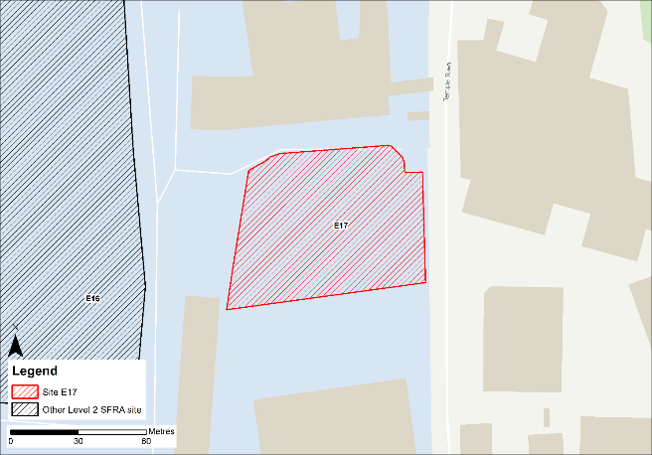
Figure 8-1: Existing site location boundary
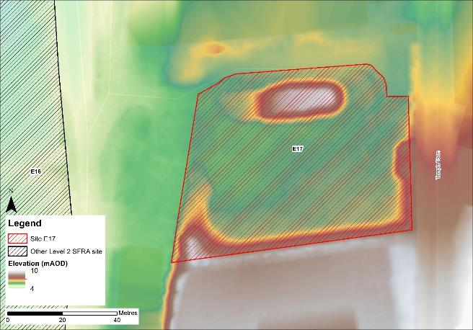
Figure 8-2: Topography

Flood risk from rivers and sea

Existing risk - Flood Map for Planning and functional floodplain
Based on the EA's Flood Map for Planning and Flood Zone 3b (functional floodplain) as updated in this Level 2 SFRA, the percentage areas of the site within each flood zone are stated in Table 8-1 and can be viewed on Figure 8-3. The Flood Map for Planning does not consider flood defence infrastructure or the impacts of climate change (Section 8.1.3).
The entire site and the surrounding areas are modelled to be within Flood Zone 1. However, as discussed, the extent of flooding to this site may not be fully representative of current conditions given the model LIDAR DTM is from 2008.
Table 8-1: Existing flood risk from rivers and sea
Flood Zone 1 (%) | Flood Zone 2 (%) | Flood Zone 3a (%) | Flood Zone 3b (%)
100 | 0 | 0 | 0

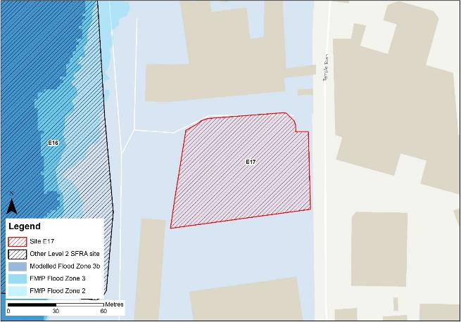
Figure 8-3: Existing risk from rivers and sea to the site

Tidal Tyne HEC-RAS model outputs
The present day Tidal Tyne model outputs for both the 0.5% AEP event and 0.1% AEP events are not modelled to impact the site or surrounding areas. However, the DTM used to map the modelled outputs does not robustly reflect current ground conditions at the Port of Tyne. Therefore, the modelled extents, depths and hazards of flooding to this site may not be fully representative of current conditions. Any site-specific FRA for this site should update the existing model to include the latest DTM for the site and surrounding area.

Impacts from climate change
Based on the EA's SFRA guidance, the latest sea level rise allowances have been modelled as shown in Table 8-2.
Table 8-2: Modelled sea level rise allowances for the Northumbria River Basin District
Return period | Higher Central (m) | Upper End (m)
3.3% (functional floodplain) | 1.03 | 1.43
0.5% | 1.03 | 1.43
0.1% | 1.03 | 1.43
Based on cumulative sea level rise from 2000 to 2125

Figure 8-4 shows the modelled flood depths for the 0.1% AEP undefended event + 1.43m of sea level rise allowance for climate change. Risk is modelled to be greater than present day conditions with flooding modelled to impact the site, however this is constrained to the western boundary. Maximum flood depths along the western boundary of the site are between 0.15 and 0.3m. The resulting flood hazard is very low (Figure 8-5). Safe access and escape routes are likely to be achievable via Temple Town to the east of the site.
However, rerunning the model with the latest LIDAR data may alter the risk at this site and to the surrounding areas.
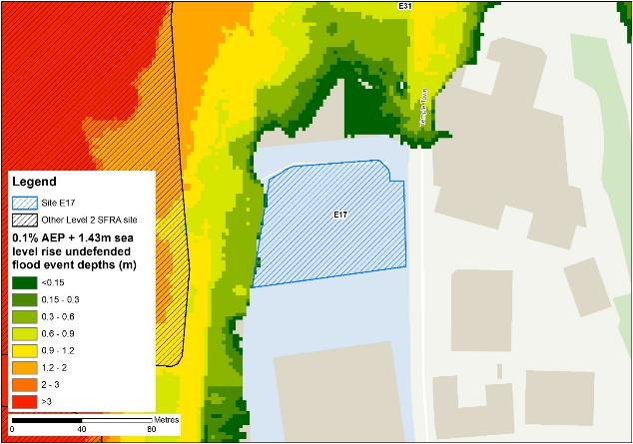
Figure 8-4: Flood depths for 0.1% AEP undefended flood event +1.43m upper end sea level rise allowance
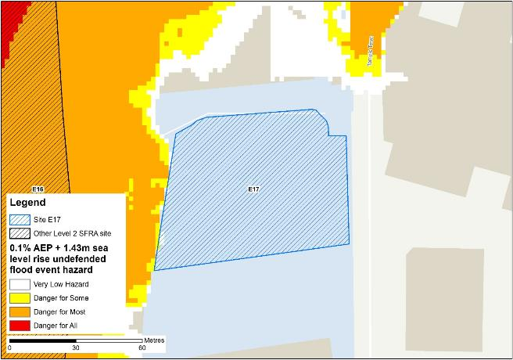
Figure 8-5: Flood hazard7 for 0.1% AEP undefended flood event +1.43m upper end sea level rise allowance

Flood risk management
The site does not benefit from any formal engineered flood defences.

Working with Natural Processes
The EA's Working with Natural Processes (WwNP) dataset has been interrogated, however there are not any applicable areas that could benefit this site.

Residual risk
Although a site may be afforded some protection from defences, there is always a residual risk of flooding from asset failure i.e. breaching / overtopping of flood defences, blockages of culverts or bridge openings.
The 2015 Tidal Tyne model and EA spatial flood defences datasets indicate that there are no formal defences, structures or culverts that could present a residual risk to the Port of Tyne sites.

Flood risk from reservoirs
The EA's Reservoir Flood Maps (RFM) (2021) show where water may go in the unlikely event of a reservoir or dam failure. Figure 8-6 shows the RFM in a 'dry-day' scenario. A dry-day scenario assumes that the water level in the reservoir is the same as the spillway level or the underside of the roof for a service reservoir and the watercourses upstream and downstream of the reservoir are at a normal level.
This site is potentially at risk from one reservoir, located outside of the South Tyneside authority area in Northumberland.
The EA's SFRA guidance states that where a proposed development site is at flood risk from a reservoir, then an assessment into whether the reservoir design or maintenance schedule needs improving should be carried out. Expert advice may be required from an all-reservoirs panel engineer. At the FRA stage, the reservoir owner, should be contacted to ascertain the flood risk in more detail and whether the proposed development could affect the reservoir’s risk designation, it’s design category or how it is operated. The council, as category 1 responders, can access more detailed information about reservoir risk and reservoir owners using the Resilience Direct system.
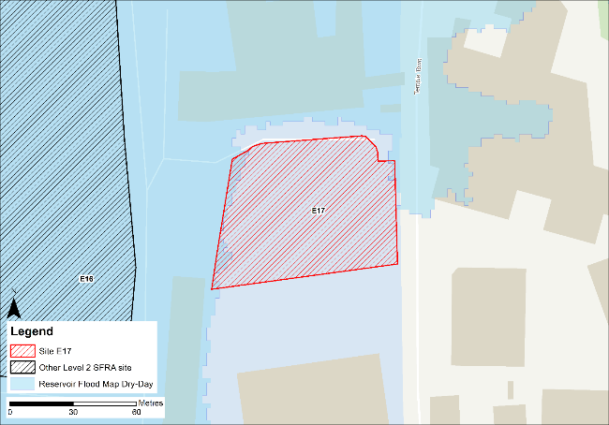
Figure 8-6: Flood risk from reservoirs

Historic flood incidents
The EA's Historic Flood Map (HFM) and Recorded Flood Outlines (RFO) datasets have been considered, and it was found that there were no recorded historic flooding incidents within the vicinity of the site.

Flood warning and access and escape routes
The EA operates a Flood Warning Service for properties located within a Flood Warning Area (FWA) for when a flood event is expected to occur. The site is not located within a FWA.
Flood alerts may be issued before a flood warning for properties located within a Flood Alert Area (FAA) to provide advance notice of the possibility of flooding. A flood alert may be issued when there is less confidence that flooding will occur in a FWA. The site is also not located within a FAA.
Safe access and escape routes can be achieved based on tidal risk to the site via Temple Town to the east of the site. However, rerunning the model with the latest LIDAR data may alter the risk at this site and to the surrounding areas.

Observations, mitigation options and site suitability - tidal
- The DTM used in the model to represent the Tyne Estuary floodplain is from 2008 and does not robustly represent current ground conditions. Therefore, the modelled extent of flooding to this site may not be fully representative of current conditions.
- The model should be updated with the most up to date LIDAR and rerun to provide a fully robust modelled representation of risk for the site and the Port of Tyne.
- Based on the modelling, the site is not modelled to be at risk of flooding from tidal sources (according to the Tidal Tyne model) in the present day 0.5% AEP and 0.1% AEP undefended scenarios.
- There is no modelled significant additional risk to the site during the 0.5% AEP undefended event + 1.03m sea level allowance for climate change that would impact the ability to develop the site. The western boundary is marginally impacted by the 0.1% AEP undefended event + 1.43m sea level allowance for climate change, although this is unlikely to impact the ability to develop the site.
- Site access and escape routes can be achieved based on tidal risk to the site via Temple Town to the east of the site in the extreme 0.1% AEP undefended event + 1.43m sea level allowance for climate change.
- Were development of this site to proceed, given the proximity of this site to neighbouring sites E16, E19, E31 and E32, it would be prudent to formulate a strategy to develop these sites in tandem and for consultation between each developer to take place to ensure a joined-up approach for sustainable development is in place.

Flood risk from surface water

Existing risk
Based on the EA's national scale Risk of Flooding from Surface Water (RoFSW) map, the site is at very low risk of surface water flooding. Almost 100% of the site is within the very low risk surface water flood zone, as shown in Table 8-3. There is a very small area to the south of the site within the low risk surface water flood zone, covering less than 1% of the site. Greatest flood depths range between 0.15 and 0.3 m (Figure 8-7). Safe access and escape routes should be possible via Temple Town to the east of the site.
Table 8-3: Existing surface water flood risk based on the RoFSW map
Very low risk (%) | Low risk (%) | Medium risk (%) | High risk (%)
99 | 1 | 0 | 0

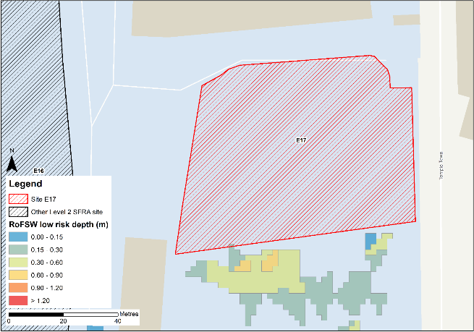
Figure 8-7: Low risk event surface water flood depths (Risk of Flooding from Surface Water map)
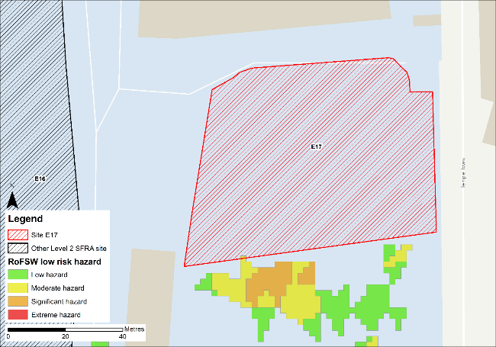
Figure 8-8: Low risk event surface water flood hazard8 (Risk of Flooding from Surface Water map)

Impacts from climate change
The impact of climate change on surface water flood risk has been modelled. This allows for direct comparison with the RoFSW map. With consideration of the EA’s SFRA guidance, the latest climate change allowances have been modelled as shown in Table 8-4.
Table 8-4: Modelled climate change allowances for rainfall for the Tyne management catchment
Return period | Central allowance 2070s | Upper end allowance 2070s
3.3% | 30% | 40%
1% | 35% | 45%

Risk is modelled to be slightly greater than the low risk event in present day conditions with ponding within the site increasing at the south-eastern corner. Figure 8-9 shows the modelled surface water flood depths for the medium risk event +45% climate change. Maximum depths are between 0.15 and 0.3m with a low hazard rating (Figure 8-10). There is a flow path along Temple Town, east of the site, during the medium risk +45% climate change event, however hazard along the roads is predominantly classed as 'low', so safe access and escape is likely to be possible, though should preferentially be directed to the north of the site.
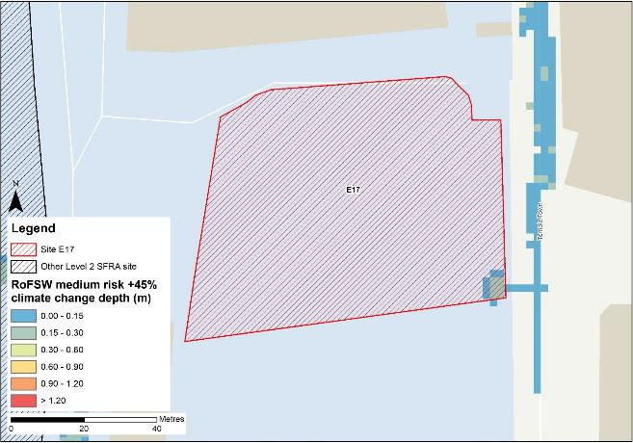
Figure 8-9: Medium risk event surface water flood depths plus 45% climate change (based on Risk of Flooding from Surface Water map)
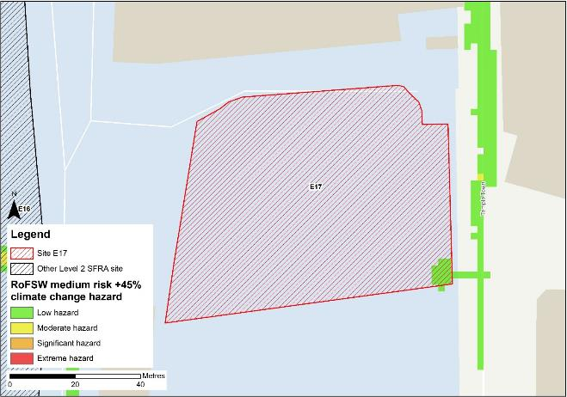
Figure 8-10: Medium risk event surface water flood hazard plus 45% climate change (based on Risk of Flooding from Surface Water map)

Risk of runoff from site post development
Runoff rates should not exceed current rates and if possible, betterment of existing rates should be aimed for. For the purposes of this assessment, the required volumes of attenuation have been calculated below based on the estimated impermeable area (assumed 85% of total area) and limiting greenfield runoff rate of Qbar (l/s).

Table 8-5: Surface water flood risk from proposed development
Design flood event  (incl climate change) | Critical storm duration Hrs | Inflow volume m3 | Outflow volume m3 | Attenuation required  m3 | Time to empty (assuming no infiltration) Hrs | Total storage required: Area (Ha) and % of site area
30yr Rainfall+30% | 5 | 260 | 63 | 197 | 15.6 | 0.01 Ha 2.6%
30yr Rainfall+40% | 5 | 287 | 69 | 218 | 17.2 | 0.01 Ha 2.87%
100yr Rainfall+35% | 6.25 | 350 | 79 | 272 (74 exceedance storage) | 21.5 | 0.02 Ha 3.5%
100yr Rainfall+45% | 6..25 | 386 | 88 | 298 (80 exceedance storage) | 23.6 | 0.02 Ha 3.9%
Surface water flood risk impacts from development site, mitigation & SuDS options | As part of this Level 2 SFRA we have included calculations to provide an estimated land take if a pond with an assumed depth of 1.5m was included as part of the development.  Attenuation volumes are presented for the critical storm duration for the 3.33% AEP event with exceedance flows quantified up to the 1% event. To prevent development worsening flood risk elsewhere, surface water runoff must be managed on site.
*Critical storm duration limited to 12 hours
Note: Proposed development limiting runoff rate: (l/sec). Qbar (FEH Statistical) – 1.88 (assumed 5l/s minimum discharge), Q30 – 3.29, Q100 – 3.91.

Observations, mitigation options and site suitability - surface water
- Current risk to the site is predominantly very low, with 99% of the site being at very low risk of surface water flooding. Surface water flood risk is confined to a low-lying area along the southern boundary of the site.
- The modelled medium risk climate change outputs indicate a marginally greater level of risk to present day, with some ponding at the south-eastern corner of the site and flooding to Temple Town. However, safe access and escape routes should remain possible via the Temple Town given the low hazard of the flooding.
- For the 1% AEP event plus 45% climate change, approximately 3.9% of the total area of the site would be required for flood storage based on a 1.5m deep pond to ensure runoff volumes do not exceed existing rates.
- Assessment of the current drainage system in place should be carried out to ascertain any current capacity issues and whether the current system could accommodate the proposed development or whether further capacity will be required
- The Groundwater Flood Map (Figure 8-11) indicates that ground conditions may be suitable for infiltration SuDS. This should be further explored through appropriate ground survey as part of the FRA and drainage strategy.
- A full drainage strategy would be required to ensure there is no increase in surface water flood risk elsewhere as a result of new development. This will require surface water modelling based on layout plans and detailed design and full consultation with the LLFA.
- The RoFSW map is not suitable for identifying whether an individual property will flood and is therefore indicative. The RoFSW map is not appropriate to act as the sole evidence for any specific planning or regulatory decision or assessment of risk in relation to flooding at any scale without further supporting studies or evidence.

Flood risk from groundwater
Flood risk from groundwater sources is assessed in this SFRA using JBA's 5m Groundwater Flood Map. This dataset is recommended for use by the EA in the SFRA Good Practice Guide9. Figure 8-11 shows the map for Site E17 and the surrounding areas and Table 8-6 explains the risk classifications.
The entirety of the site is within an area where there is a negligible risk from groundwater flooding due to the nature of the local geological deposits. Use of infiltration SuDS should therefore be appropriate, if required.

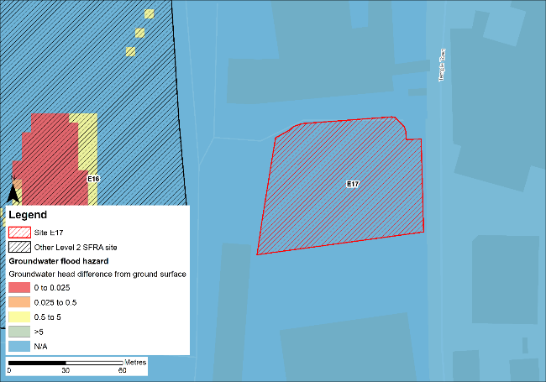
Figure 8-11: JBA 5m Groundwater Flood Map

Table 8-6: Groundwater Flood Hazard Classification
Groundwater head difference (m)* | Class label
0 to 0.025 | Groundwater levels are either at very near (within 0.025m of) the ground surface in the 100-year return period flood event.  Within this zone there is a risk of groundwater flooding to both surface and subsurface assets. Groundwater may emerge at significant rates and has the capacity to flow overland and/or pond within any topographic low spots.
0.025 to 0.5 | Groundwater levels are between 0.025m and 0.5m below the ground surface in the 100-year return period flood event.  Within this zone there is a risk of groundwater flooding to surface and subsurface assets. There is the possibility of groundwater emerging at the surface locally.
0.5 to 5 | Groundwater levels are between 0.5m and 5m below the ground surface in the 100-year return period flood event  There is a risk of flooding to subsurface assets, but surface manifestation of groundwater is unlikely.
>5 | Groundwater levels are at least 5m below the ground surface in the 100-year return period flood event.  Flooding from groundwater is not likely.
N/A | No risk.  This zone is deemed as having a negligible risk from groundwater flooding due to the nature of the local geological deposits.

Overall site assessment

Can part b) of the exception test be passed?
To pass part b) of the exception test10, it must be proven that the development can be safe for its lifetime, which is 100 years for residential development, taking account of the vulnerability of its users, without increasing risk elsewhere, and, where possible, will reduce flood risk overall.
- The site is not required to pass the exception test as it is proposed for less vulnerable uses.

Recommendation summary
Based on the evidence presented in this Level 2 SFRA:
- It should be appropriate to develop this site for less vulnerable uses, given the low risk to the site during the 0.5% AEP undefended event + 1.03m sea level allowance for climate change.
- The model should be updated with the latest LIDAR data before planning development.

FRA requirements and further work
- The site-specific FRA for this site should update the existing model to include the latest DTM for the site and surrounding area.
- The FRA should be carried out in line with the NPPF; FRCC-PPG; EA guidance; South Tyneside Local Plan and LLFA policies; and national and local SuDS policy and guidelines.
- Throughout the FRA process, consultation should be carried out with the following, where applicable, the LPA; LLFA; emergency planning officers; EA; NWL; the highways authorities; and the emergency services.

Site E19
- Location: Tyne Dock Enterprise Park (former NcNulty Offshore), Commercial Road
- Existing site use: brownfield
- Existing site use vulnerability: less vulnerable
- Proposed site use: employment
- Proposed site use vulnerability: less vulnerable
- Site area: 4.4 hectares
- Proposed development impermeable area: 3.7 hectares (assumed 85% of total site area)
- Watercourse: River Tyne
- Summary of requirements from scoping stage:
  - Level 1 SFRA recommendation was for withdrawal from allocation or more detailed assessment through Level 2 SFRA
  - Assessment of modelled tidal flood depths and hazards
  - Assessment of surface water flood depths and hazards
  - Modelling of latest EA climate change allowances for sea level rise and peak rainfall intensities
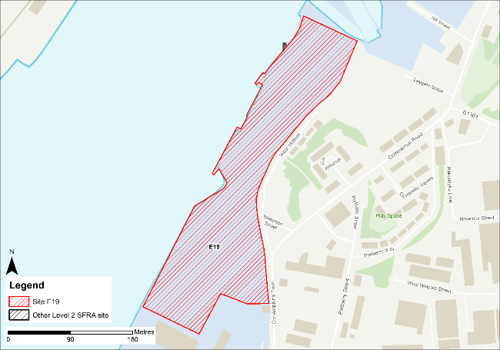
Figure 9-1: Existing site location boundary

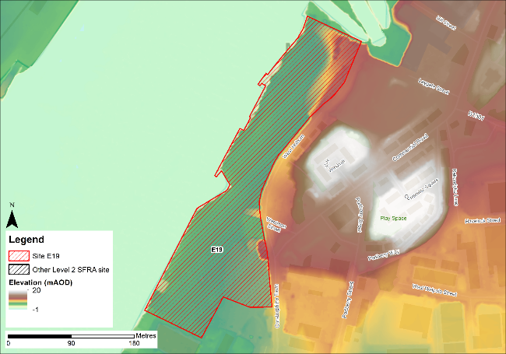
Figure 9-2: Topography

Flood risk from rivers and sea

Existing risk - Flood Map for Planning and functional floodplain
Based on the EA's Flood Map for Planning and Flood Zone 3b (functional floodplain) as updated in this Level 2 SFRA, the percentage areas of the site within each flood zone are stated in Table 9-1 and can be viewed on Figure 9-3. The Flood Map for Planning does not consider flood defence infrastructure or the impacts of climate change (Section 9.1.3).
Fluvial risk to the site is confined to the western boundary, adjacent to the River Tyne. However, as discussed, the extent of flooding to this site may not be fully representative of current conditions given the model LIDAR DTM is from 2008.
Table 9-1: Existing flood risk from rivers and sea
Flood Zone 1 (%) | Flood Zone 2 (%) | Flood Zone 3a (%) | Flood Zone 3b (%)
74 | 11 | 0 | 15

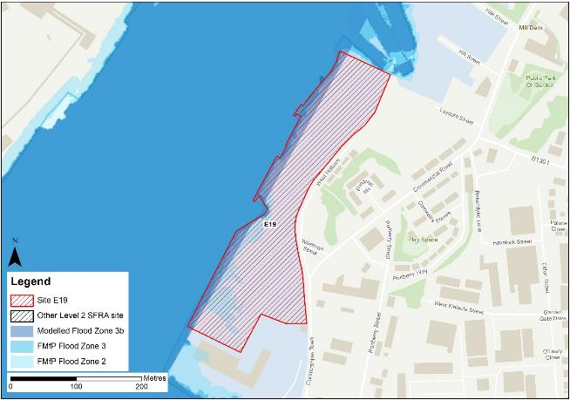
Figure 9-3: Existing risk from rivers and sea to the site

Tyne Tidal HEC-RAS model outputs
Figure 9-4 shows the modelled flood depths for the 0.5% AEP undefended event. Modelling shows flooding of various depths along the western site boundary (adjacent to the Tyne). Greatest flood depths are > 3m and are within the lower lying parts of the western site boundary. Flood hazards within this area are categorised as 'Danger for all' (Figure 9-5). Safe access and escape should be possible via Corstorphine Town and West Holborn to the east of the site.
However, the DTM used to map the modelled outputs does not robustly reflect current ground conditions at the Port of Tyne. Therefore, the modelled extents, depths and hazards of flooding to this site may not be fully representative of current conditions. Any site-specific FRA for this site should update the existing model to include the latest DTM for the site and surrounding area.
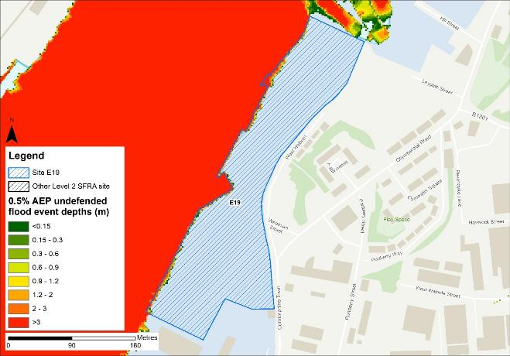
Figure 9-4: Flood depths for 0.5% AEP undefended flood event
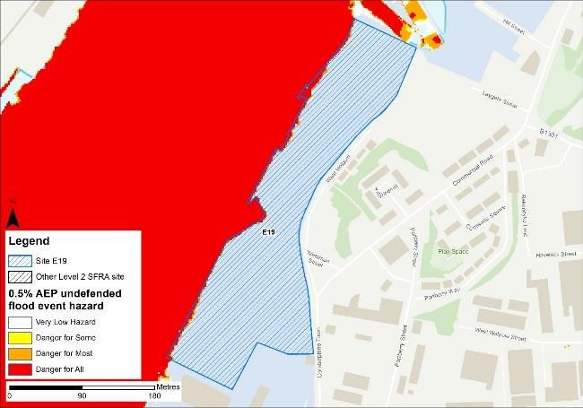
Figure 9-5: Flood hazard7 for 0.5% AEP undefended flood event

Impacts from climate change
Based on the EA's SFRA guidance, the latest sea level rise allowances have been modelled as shown in Table 9-2.
Table 9-2: Modelled sea level rise allowances for the Northumbria River Basin District
Return period | Higher Central (m) | Upper End (m)
3.3% (functional floodplain) | 1.03 | 1.43
0.5% | 1.03 | 1.43
0.1% | 1.03 | 1.43
Based on cumulative sea level rise from 2000 to 2125

Figure 9-6 shows the modelled flood depths for the 3.3% AEP undefended event + 1.43m of sea level rise allowance for climate change. Risk is modelled to be greater than present day conditions with flooding modelled to encroach onto a large proportion of the site. Modelled flood depths across the majority of the site are between 0.9 and 1.2m, with some areas of >3m along the western site boundary. The resulting flood hazard is predominantly danger for most with an area of danger for all at the western site boundary. Within the eastern half of the site, flooding has a hazard rating of danger for some and danger for most (Figure 9-7). Safe access and escape routes are likely to be achievable via Corstorphine Town and West Holborn to the east of the site.
Figure 9-8 shows the modelled flood depths for the 0.5% AEP undefended event + 1.03m of sea level rise allowance for climate change. Risk is modelled to be significant across the majority of the site, with maximum depths of between 0.9 and 1.2m and areas of hazard classified as 'Danger for most' (Figure 9-9).
However, rerunning the model with the latest LIDAR data may alter the risk at this site and to the surrounding areas. Although, differences in bank elevations on the River Tyne in this location between the 2008 LIDAR and 2021 LIDAR are nominal, therefore changes in risk are likely to be minimal.
Land raising would be required at the site with finished floor levels set at 600mm above the design event flood level, once re-run using the latest LIDAR data, as recommended in EA standing advice on flood risk assessments. The design event should be the 0.5% AEP plus an allowance for climate change. Given the risk is tidal, compensatory storage is unlikely to be required, though risk must not be increased elsewhere. However, the EA must be consulted on any mitigation measures at this site.
The site-specific FRA should update the existing model with the latest LIDAR to robustly set the finished floor levels required to reduce the probability of tidal flooding to the development.

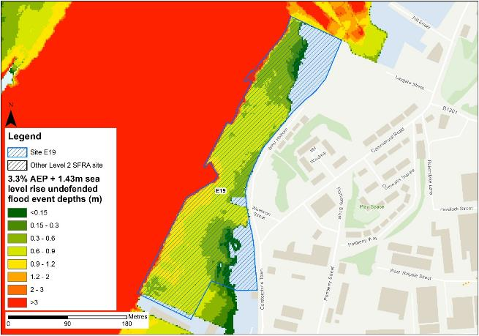
Figure 9-6: Flood depths for 3.3% AEP undefended flood event +1.43m upper end sea level rise allowance
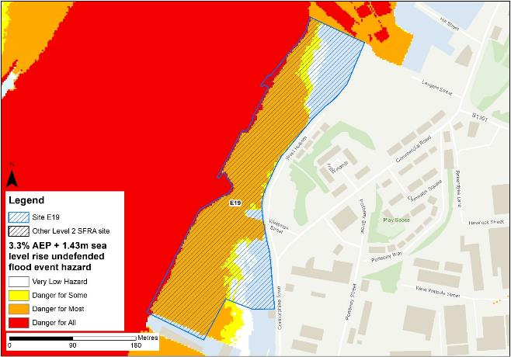
Figure 9-7: Flood hazard7 for 3.3% AEP undefended flood event +1.43m upper end sea level rise allowance
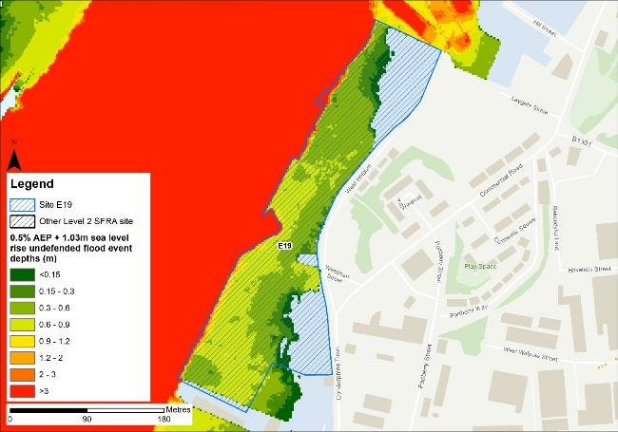
Figure 9-8: Flood depths for 0.5% AEP undefended flood event +1.03m higher central sea level rise allowance
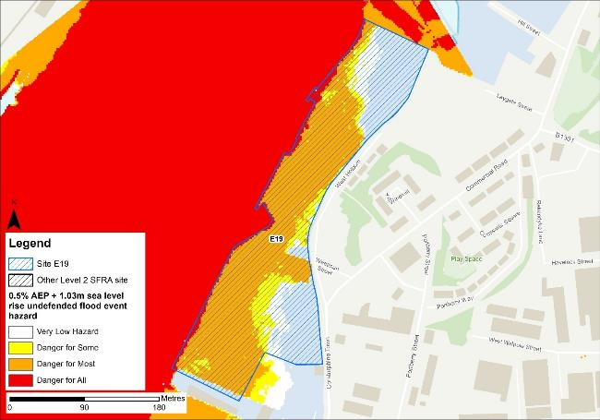
Figure 9-9: Flood hazard7 for 0.5% AEP undefended flood event +1.03m higher central sea level rise allowance

Flood risk management
The site does not benefit from any formal engineered flood defences.

Working with Natural Processes
The EA's Working with Natural Processes (WwNP) dataset has been interrogated, however there are not any applicable areas that could benefit this site.

Residual risk
Although a site may be afforded some protection from defences, there is always a residual risk of flooding from asset failure i.e. breaching / overtopping of flood defences, blockages of culverts or bridge openings.
The 2015 Tidal Tyne model and EA spatial flood defences datasets indicate that there are no formal defences, structures or culverts that could present a residual risk to the Port of Tyne sites.

Flood risk from reservoirs
The EA's Reservoir Flood Maps (RFM) (2021) show where water may go in the unlikely event of a reservoir or dam failure. Figure 9-10 shows the RFM in a 'dry-day' scenario. A dry-day scenario assumes that the water level in the reservoir is the same as the spillway level or the underside of the roof for a service reservoir and the watercourses upstream and downstream of the reservoir are at a normal level.
This site is potentially at risk from one reservoir, located outside of the South Tyneside authority area in Northumberland.
The EA's SFRA guidance states that where a proposed development site is at flood risk from a reservoir, then an assessment into whether the reservoir design or maintenance schedule needs improving should be carried out. Expert advice may be required from an all-reservoirs panel engineer. At the FRA stage, the reservoir owner, should be contacted to ascertain the flood risk in more detail and whether the proposed development could affect the reservoir’s risk designation, it’s design category or how it is operated. The council, as category 1 responders, can access more detailed information about reservoir risk and reservoir owners using the Resilience Direct system.
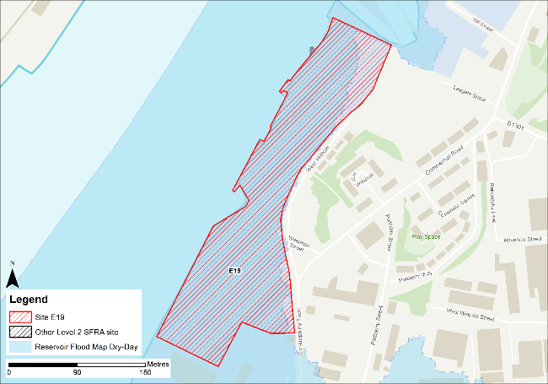
Figure 9-10: Flood risk from reservoirs

Historic flood incidents
The EA's Historic Flood Map (HFM) and Recorded Flood Outlines (RFO) datasets have been considered. Historic risk to the site is shown in Figure 9-11 which shows that the western boundary of the site has been subject to flooding in the past. The RFO datasets references that the historic event occurred in December 1978 due to flooding from the River Tyne.
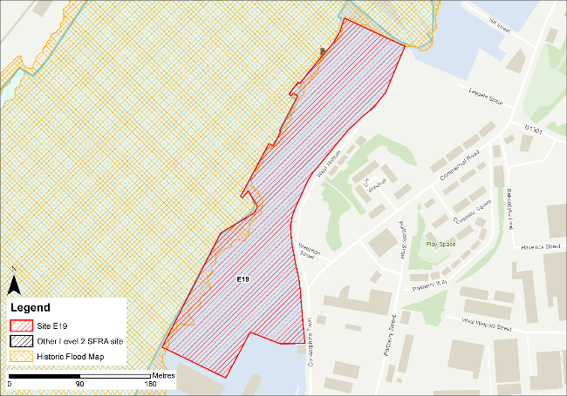
Figure 9-11: Recorded historic flood events onsite and around the site

Flood warning and access and escape routes
The EA operates a Flood Warning Service for properties located within a Flood Warning Area (FWA) for when a flood event is expected to occur. Site E19 is not located within any FWA.
Flood alerts may be issued before a flood warning for properties located within a Flood Alert Area (FAA) to provide advance notice of the possibility of flooding. A flood alert may be issued when there is less confidence that flooding will occur in a FWA. The site is located within a FAA, namely 121WAT913 - Tyne estuary from Wylam to the North Sea coast, including Watergate Car Park at Newcastle Quayside.
Safe access and escape routes can be achieved based on tidal risk to the site via Corstorphine Town and West Holborn to the east of the site. However, rerunning the model with the latest LIDAR data may alter the risk at this site and to the surrounding areas.

Observations, mitigation options and site suitability - tidal
- The DTM used in the model to represent the Tyne Estuary floodplain is from 2008 and does not robustly represent current ground conditions. Therefore, the modelled extent of flooding to this site may not be fully representative of current conditions.
- The model should be updated with the most up to date LIDAR and rerun to provide a fully robust modelled representation of risk for the site and the Port of Tyne.
- The site is currently modelled to be within the functional floodplain along the boundary of the site adjacent to the River Tyne. Development is not permitted within the functional floodplain.
- Any area of functional floodplain should be left free of development that can flood when required.
- Modelled risk from climate change increases the undefended risk to the site and surrounding areas, with a large proportion of the site becoming inundated during the 3.3% AEP + 1.43m sea level rise climate change event.
- The 0.5% AEP event with an allowance for climate change is what the EA considers to be the design event for a development to mitigate tidal flood risk. The majority of the site is shown to be at risk in the 0.5% AEP undefended event + 1.03m sea level rise for climate change. This is also reflected in the flood hazard ratings for this event with most of the site categorised as 'Danger for all'.
- Mitigation by way of land raising should be possible at this site with finished floor levels set 600mm above the 0.5% AEP plus climate change flood level. Investigations should ensure flood risk is not worsened elsewhere and given the risk is tidal, compensatory storage is unlikely to be required, though the EA must be consulted.
- The FRA must show that development will be safe for its lifetime taking account of the vulnerability of its users, including for appropriate evacuation procedures and flood response infrastructure are in place to manage the residual risk associated with the extreme flood event.
- A flood risk activity permit may be required if development is planned within 16m of the riverbank. The EA can advise on whether a permit will be required.
- Were development of this site to proceed, given the proximity of this site to neighbouring sites E16, E17, E31 and E32, it would be prudent to formulate a strategy to develop these sites in tandem and for consultation between each developer to take place to ensure a joined-up approach for sustainable development is in place.

Flood risk from surface water

Existing risk
Based on the EA's national scale Risk of Flooding from Surface Water (RoFSW) map, the site is at very low risk of surface water flooding. Almost 100% of the site is within the very low risk surface water flood zone, as shown in Table 9-3. There is a very small area along the eastern boundary of the site within the low risk surface water flood zone, covering less than 1% of the site. Greatest flood depths range between 0.15 and 0.3 m (Figure 9-12) with areas of moderate hazard (Figure 9-13). Safe access and escape routes should be possible via West Holborn to the east of the site.
Table 9-3: Existing surface water flood risk based on the RoFSW map
Very low risk (%) | Low risk (%) | Medium risk (%) | High risk (%)
99 | 0 | 1 | 0

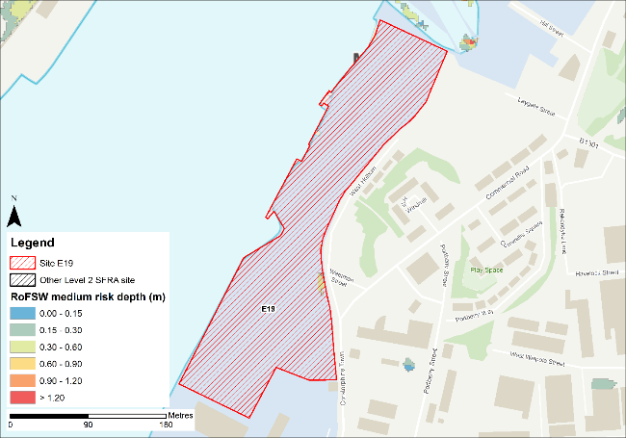
Figure 9-12: Medium risk event surface water flood depths (Risk of Flooding from Surface Water map)
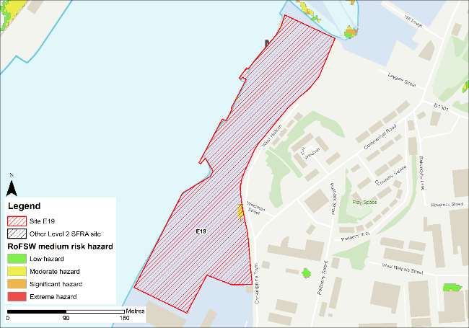
Figure 9-13: Medium risk event surface water flood hazard8 (Risk of Flooding from Surface Water map)

Impacts from climate change
The impact of climate change on surface water flood risk has been modelled. This allows for direct comparison with the RoFSW map. With consideration of the EA’s SFRA guidance, the latest climate change allowances have been modelled as shown in Table 9-4.
Table 9-4: Modelled climate change allowances for rainfall for the Tyne management catchment
Return period | Central allowance 2070s | Upper end allowance 2070s
3.3% | 30% | 40%
1% | 35% | 45%

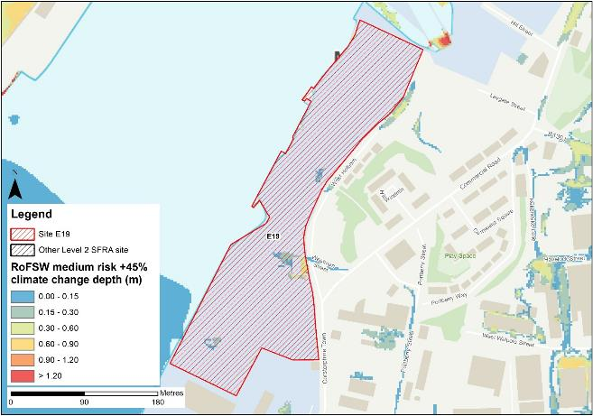
Figure 9-14: Medium risk event surface water flood depths plus 45% climate change (based on Risk of Flooding from Surface Water map)
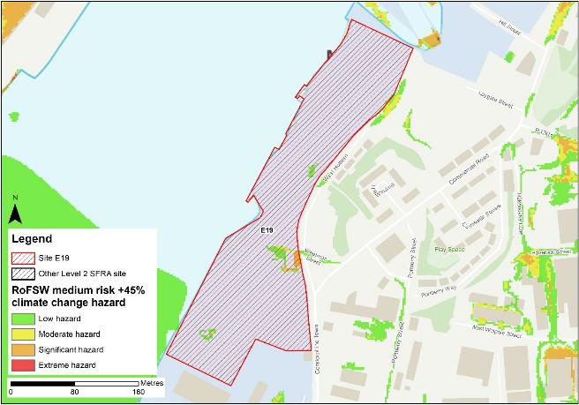
Figure 9-15: Medium risk event surface water flood hazard plus 45% climate change (based on Risk of Flooding from Surface Water map)
Figure 9-14 shows the modelled surface water flood depths for the medium risk event +45% climate change. Risk is modelled to be greater than the medium risk event in present day conditions with ponding within the site increasing along the eastern site boundary and at the south-western corner of the site.
Maximum depths are between 0.6 and 0.9m with areas of significant hazard within the ponding along the eastern site boundary (Figure 9-15). There is also ponding along the West Holborn and Weetman Street during the medium risk +45% climate change event, however hazard along these roads is classed as low, so safe access and escape is likely to be possible, though should be directed towards Corstorphine Town and Commercial Road.

Risk of runoff from site post development
Runoff rates should not exceed current rates and if possible, betterment of existing rates should be aimed for. For the purposes of this assessment, the required volumes of attenuation have been calculated below based on the estimated impermeable area (assumed 85% of total area) and limiting greenfield runoff rate of Qbar (l/s).

Table 9-5: Surface water flood risk from proposed development
Design flood event  (incl climate change) | Critical storm duration Hrs | Inflow volume m3 | Outflow volume m3 | Attenuation required  m3 | Time to empty (assuming no infiltration) Hrs | Total storage required: Area (Ha) and % of site area
30yr Rainfall+30% | 12 | 2729 | 481 | 2248 | 56.0 | 0.15 Ha 3.4%
30yr Rainfall+40% | 12 | 2939 | 481 | 2458 | 61.2 | 0.16 Ha 3.7%
100yr Rainfall+35% | 12* | 4368 | 1201 | 3167 (919 exceedance storage) | 78.9 | 0.21 Ha 4.8%
100yr Rainfall+45% | 12* | 4941 | 1442 | 3499 (1041 exceedance storage) | 87.1 | 0.23 Ha 5.3%
Surface water flood risk impacts from development site, mitigation & SuDS options | As part of this Level 2 SFRA we have included calculations to provide an estimated land take if a pond with an assumed depth of 1.5m was included as part of the development.  Attenuation volumes are presented for the critical storm duration for the 3.33% AEP event with exceedance flows quantified up to the 1% event. To prevent development worsening flood risk elsewhere, surface water runoff must be managed on site.
*critical storm duration limited to 12 hours
Note: Proposed development limiting runoff rate: (l/sec). Qbar (FEH Statistical) – 15.89, Q30 – 27.8, Q100 – 33.04.

Observations, mitigation options and site suitability - surface water
- Current risk to the site is predominantly very low, with 99% of the site being at very low risk of surface water flooding. Surface water flood risk is confined to a small area along the eastern site boundary.
- The modelled medium risk climate change outputs indicate a greater level of risk to present day, expanding in the same area and within a small part of the north and south of the site. Safe access and escape routes should be possible via Corstorphine Town and West Holborn to the east of the site.
- The risk areas should be left free of development and converted to open green space.
- For the 1% AEP event plus 45% climate change, approximately 5.3% of the total area of the site would be required for flood storage based on a 1.5m deep pond to ensure runoff volumes do not exceed existing rates.
- Assessment of the current drainage system in place should be carried out to ascertain any current capacity issues and whether the current system could accommodate the proposed development or whether further capacity will be required
- The Groundwater Flood Map (Figure 9-16) indicates that ground conditions may be suitable for infiltration SuDS. This should be further explored through appropriate ground survey as part of the FRA and drainage strategy.
- A full drainage strategy would be required to ensure there is no increase in surface water flood risk elsewhere as a result of new development. This will require surface water modelling based on layout plans and detailed design and full consultation with the LLFA.
- The RoFSW map is not suitable for identifying whether an individual property will flood and is therefore indicative. The RoFSW map is not appropriate to act as the sole evidence for any specific planning or regulatory decision or assessment of risk in relation to flooding at any scale without further supporting studies or evidence.

Flood risk from groundwater
Flood risk from groundwater sources is assessed in this SFRA using JBA's 5m Groundwater Flood Map. This dataset is recommended for use by the EA in the SFRA Good Practice Guide9. Figure 9-16 shows the map for Site E17 and the surrounding areas and Table 9-6 explains the risk classifications.
The majority of the site is within an area where there is a negligible risk from groundwater flooding due to the nature of the local geological deposits. There are some areas along the boundary of the site where there is a risk of flooding to subsurface assets, but surface manifestation of groundwater is unlikely.
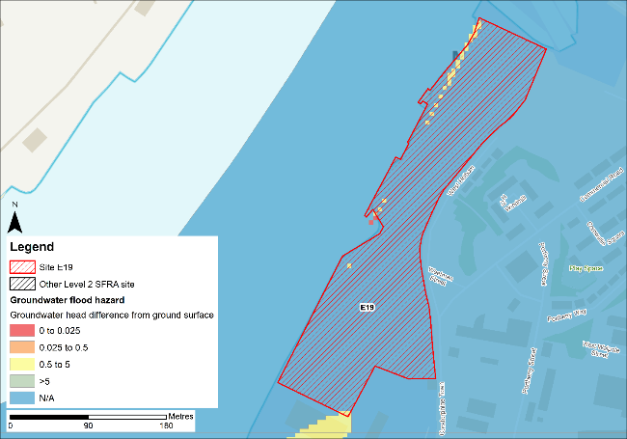
Figure 9-16: JBA 5m Groundwater Flood Map

Table 9-6: Groundwater Flood Hazard Classification
Groundwater head difference (m)* | Class label
0 to 0.025 | Groundwater levels are either at very near (within 0.025m of) the ground surface in the 100-year return period flood event.  Within this zone there is a risk of groundwater flooding to both surface and subsurface assets. Groundwater may emerge at significant rates and has the capacity to flow overland and/or pond within any topographic low spots.
0.025 to 0.5 | Groundwater levels are between 0.025m and 0.5m below the ground surface in the 100-year return period flood event.  Within this zone there is a risk of groundwater flooding to surface and subsurface assets. There is the possibility of groundwater emerging at the surface locally.
0.5 to 5 | Groundwater levels are between 0.5m and 5m below the ground surface in the 100-year return period flood event  There is a risk of flooding to subsurface assets, but surface manifestation of groundwater is unlikely.
>5 | Groundwater levels are at least 5m below the ground surface in the 100-year return period flood event.  Flooding from groundwater is not likely.
N/A | No risk.  This zone is deemed as having a negligible risk from groundwater flooding due to the nature of the local geological deposits.

Overall site assessment

Can part b) of the exception test be passed?
To pass part b) of the exception test10, it must be proven that the development can be safe for its lifetime, which is 100 years for residential development, taking account of the vulnerability of its users, without increasing risk elsewhere, and, where possible, will reduce flood risk overall.
- The site is not required to pass the exception test as it is proposed for less vulnerable uses.

Recommendation summary
Based on the evidence presented in this Level 2 SFRA:
- It should be possible to develop this site for less vulnerable uses. However, mitigation by way of land raising would be required.
- Finished floor levels should place the development 600mm above the 0.5% AEP plus climate change flood level without increasing risk elsewhere.
- Updating and rerunning the model with the latest LIDAR data before finalising finished floor levels and planning development is recommended.
- A flood risk activity permit may be required if development is planned within 16m of the Tyne Estuary

FRA requirements and further work
- The site-specific FRA for this site should update the existing model to include the latest DTM for the site and surrounding area.
- The FRA should robustly set the finished floor levels required to reduce the probability of tidal flooding to the development.
- The FRA must further consider the inclusion of emergency plans and evacuation routes.
- Any FRA should be carried out in line with the NPPF; FRCC-PPG; EA guidance; South Tyneside Local Plan and LLFA policies; and national and local SuDS policy and guidelines.
- Throughout the FRA process, consultation should be carried out with the following, where applicable, the LPA; LLFA; emergency planning officers; EA; NWL; the highways authorities; and the emergency services.

Site E30
- Location: Compound beside Jarrow Road
- Existing site use: brownfield
- Existing site use vulnerability: less vulnerable
- Proposed site use: employment
- Proposed site use vulnerability: less vulnerable
- Site area: 0.3 hectares
- Proposed development impermeable area: 0.25 hectares (assumed 85% of total site area)
- Watercourse: River Tyne
- Summary of requirements from scoping stage:
  - Level 1 SFRA recommendation was for withdrawal from allocation or more detailed assessment through Level 2 SFRA
  - Assessment of modelled tidal flood depths and hazards
  - Assessment of surface water flood depths and hazards
  - Modelling of latest EA climate change allowances for sea level rise and peak rainfall intensities
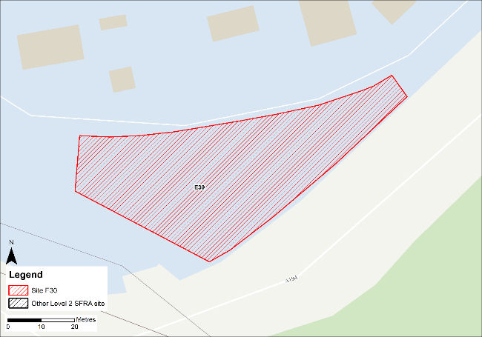
Figure 10-1: Existing site location boundary

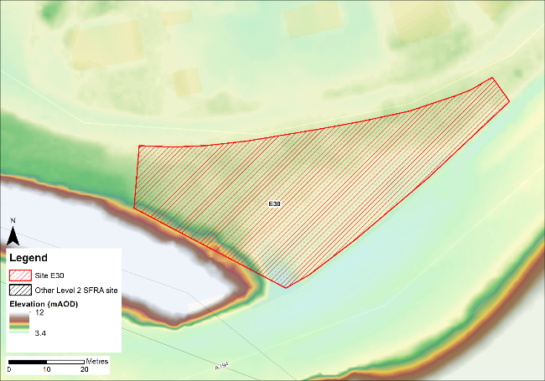
Figure 10-2: Topography

Flood risk from rivers and sea

Existing risk - Flood Map for Planning and functional floodplain
Based on the EA's Flood Map for Planning and Flood Zone 3b (functional floodplain) as updated in this Level 2 SFRA, the percentage areas of the site within each flood zone are stated in Table 10-1. The Flood Map for Planning does not consider flood defence infrastructure or the impacts of climate change (Section 10.7.2).
The entire site is modelled to be within Flood Zone 1. However, as discussed, the extent of flooding to this site may not be fully representative of current conditions given the model LIDAR DTM is from 2008.
Table 10-1: Existing flood risk from rivers and sea
Flood Zone 1 (%) | Flood Zone 2 (%) | Flood Zone 3a (%) | Flood Zone 3b (%)
100 | 0 | 0 | 0

Tyne Tidal HEC-RAS model outputs
The site is not modelled to be at risk during the extreme 0.1% AEP event. However, the modelled extents, depths and hazards of flooding to the Port of Tyne are not fully representative of current conditions. Any site-specific FRA for this site should update the existing model to include the latest DTM for the site and surrounding area.

Impacts from climate change
Based on the EA's SFRA guidance, the latest sea level rise allowances have been modelled as shown in Table 10-2.
Table 10-2: Modelled sea level rise allowances for the Northumbria River Basin District
Return period | Higher Central (m) | Upper End (m)
3.3% (functional floodplain) | 1.03 | 1.43
0.5% | 1.03 | 1.43
0.1% | 1.03 | 1.43
Based on cumulative sea level rise from 2000 to 2125

Figure 10-3 shows the modelled flood depths for the 3.3% AEP undefended event + 1.43m of sea level rise allowance for climate change. Risk is modelled to be significantly greater than present day conditions with flooding modelled to cover the majority of the site. Maximum flood depths are between 1.2 and 2m. Shallower flood depths are towards the north of the site. The resulting flood hazard is predominantly categorised as 'danger for most' with an area of 'danger for some' and 'very low hazard' within the western side of the site (Figure 10-4). Safe access and escape routes are unlikely to be achievable due to the flood depths on the unnamed road north of the site.
Figure 10-5 shows the modelled flood depths for the 0.5% AEP undefended event + 1.03m of sea level rise allowance for climate change. Risk is modelled to be significant across the majority of the site, with maximum depths of between 1.2 and 2m with areas of hazard classified as 'Danger for all' (Figure 10-6).
However, rerunning the model with the latest LIDAR data may alter the risk at this site and to the surrounding areas.
Land raising would be required at the site with finished floor levels set at 600mm above the design event flood level, once re-run using the latest LIDAR data, as recommended in EA standing advice on flood risk assessments. The design event should be the 0.5% AEP plus an allowance for climate change. Given the risk is tidal, compensatory storage is unlikely to be required. However, the EA must be consulted on any mitigation measures at this site.
The site-specific FRA should update the existing model with the latest LIDAR to robustly set the finished floor levels required to reduce the probability of tidal flooding to the development.
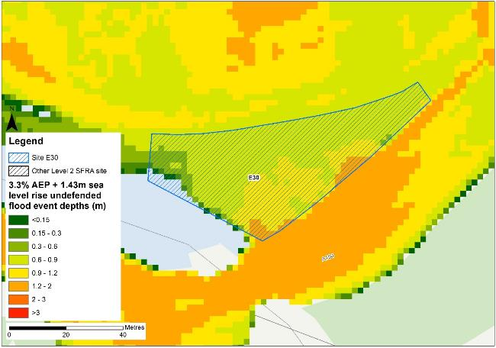
Figure 10-3: Flood depths for 3.3% AEP undefended flood event +1.43m upper end sea level rise allowance
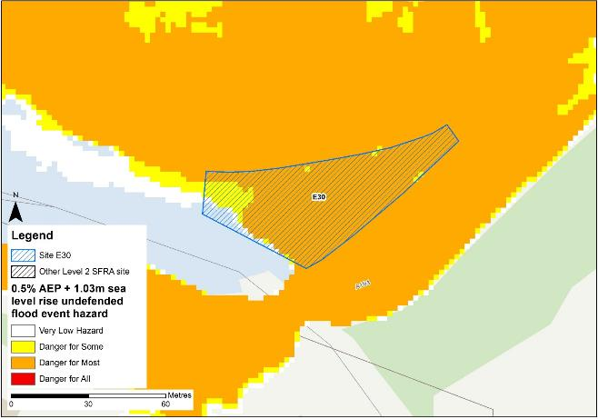
Figure 10-4: Flood hazard7 for 3.3% AEP undefended flood event +1.43m upper end sea level rise allowance
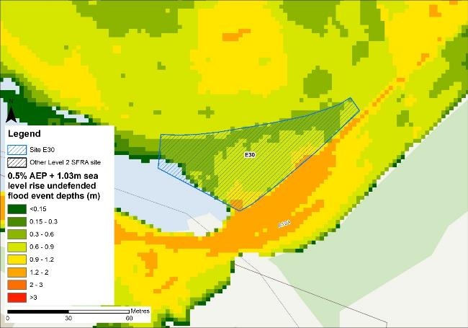
Figure 10-5: Flood depths for 0.5% AEP undefended flood event +1.03m higher central sea level rise allowance
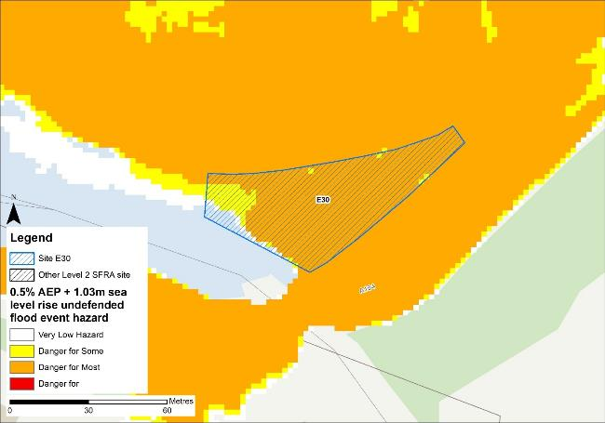
Figure 10-6: Flood hazard7 for 0.5% AEP undefended flood event +1.03m higher central sea level rise allowance

Flood risk management
The site does not benefit from any formal engineered flood defences.

Working with Natural Processes
The EA's Working with Natural Processes (WwNP) dataset has been interrogated, however there are not any applicable areas that could benefit this site.

Residual risk
Although a site may be afforded some protection from defences, there is always a residual risk of flooding from asset failure i.e. breaching / overtopping of flood defences, blockages of culverts or bridge openings.
The 2015 Tidal Tyne model and EA spatial flood defences datasets indicate that there are no formal defences, structures or culverts that could present a residual risk to the Port of Tyne sites.

Flood risk from reservoirs
The EA's Reservoir Flood Maps (RFM) (2021) show where water may go in the unlikely event of a reservoir or dam failure. Figure 10-7 shows the RFM in a 'dry-day' scenario. A dry-day scenario assumes that the water level in the reservoir is the same as the spillway level or the underside of the roof for a service reservoir and the watercourses upstream and downstream of the reservoir are at a normal level.
This site is potentially at risk from one reservoir, located outside of the South Tyneside authority area in Northumberland.
The EA's SFRA guidance states that where a proposed development site is at flood risk from a reservoir, then an assessment into whether the reservoir design or maintenance schedule needs improving should be carried out. Expert advice may be required from an all-reservoirs panel engineer. At the FRA stage, the reservoir owner, should be contacted to ascertain the flood risk in more detail and whether the proposed development could affect the reservoir’s risk designation, it’s design category or how it is operated. The council, as category 1 responders, can access more detailed information about reservoir risk and reservoir owners using the Resilience Direct system.
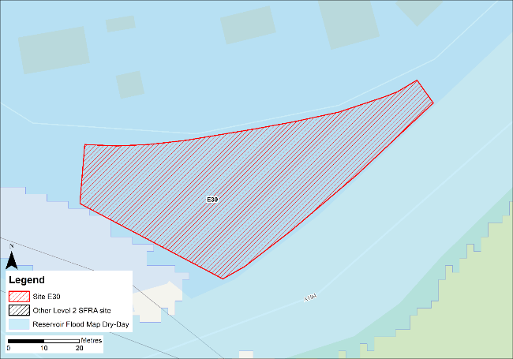
Figure 10-7: Flood risk from reservoirs

Historic flood incidents
The EA's Historic Flood Map (HFM) and Recorded Flood Outlines (RFO) datasets have been considered, and it was found that there were no recorded historic flooding incidents within the vicinity of the site.

Flood warning and access and escape routes
The EA operates a Flood Warning Service for properties located within a Flood Warning Area (FWA) for when a flood event is expected to occur. Site E30 is not located within any FWA.
Flood alerts may be issued before a flood warning for properties located within a Flood Alert Area (FAA) to provide advance notice of the possibility of flooding. A flood alert may be issued when there is less confidence that flooding will occur in a FWA. The site is not located within a FAA.
Safe access and escape routes can be achieved based on present day risk to the site. However, safe access and escape may be challenging to achieve based on tidal risk to the site during the future 0.5% AEP undefended event. However, rerunning the model with the latest LIDAR data may alter the risk at this site and to the surrounding areas.

Observations, mitigation options and site suitability - tidal
- The DTM used in the model to represent the Tyne Estuary floodplain is from 2008 and does not robustly represent current ground conditions. Therefore, the modelled extent of flooding to this site may not be fully representative of current conditions.
- The model should be updated with the most up to date LIDAR and rerun to provide a fully robust modelled representation of risk for the site and the Port of Tyne.
- The site is not modelled to be at risk from the 0.5% AEP undefended event. However, the site is at risk during the 0.5% AEP undefended event + 1.03m sea level rise for climate change which is considered to by the EA to be the design event for the site.
- Almost the entire site is modelled to be within the future functional floodplain.
- Mitigation by way of land raising should be possible at this site with finished floor levels set 600mm above the 0.5% AEP plus climate change flood level. Investigations should ensure flood risk is not worsened elsewhere and given the risk is tidal, compensatory storage is unlikely to be required, though the EA must be consulted.
- The FRA must show that development will be safe for its lifetime taking account of the vulnerability of its users, including for appropriate evacuation procedures and flood response infrastructure are in place to manage the residual risk associated with the extreme flood event.
- Safe access and escape routes may be challenging to achieve in the extreme flood event. Appropriate flood warning and emergency planning arrangements should ensure the site is evacuated ahead of an extreme flood event occurring.
- Were development of this site to proceed, given the proximity of this site to neighbouring site E34, it would be prudent to formulate a strategy to develop these sites in tandem and for consultation between each developer to take place to ensure a joined-up approach for sustainable development is in place.

Flood risk from surface water

Existing risk
Based on the EA's national scale Risk of Flooding from Surface Water (RoFSW) map, the site is predominantly at low risk of surface water flooding. Approximately 9% of the site is within the medium risk surface water extent, with an additional 3% within the high risk surface water extent, as shown in Table 10-3. The area at risk is confined to the south eastern boundary of the site. Greatest flood depths range between 0.3 and 0.6 m (Figure 10-8) with areas of significant hazard (Figure 10-9). Safe access and escape routes may be challenging to achieve.
Table 10-3: Existing surface water flood risk based on the RoFSW map
Very low risk (%) | Low risk (%) | Medium risk (%) | High risk (%)
21 | 67 | 9 | 3

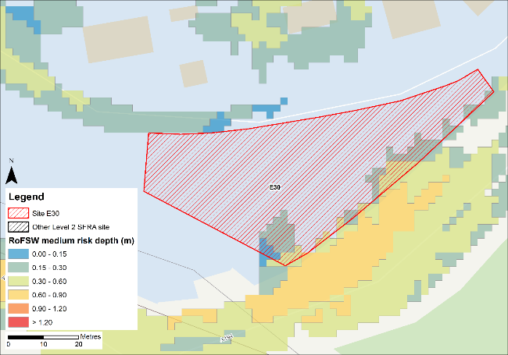
Figure 10-8: Medium risk event surface water flood depths (Risk of Flooding from Surface Water map)
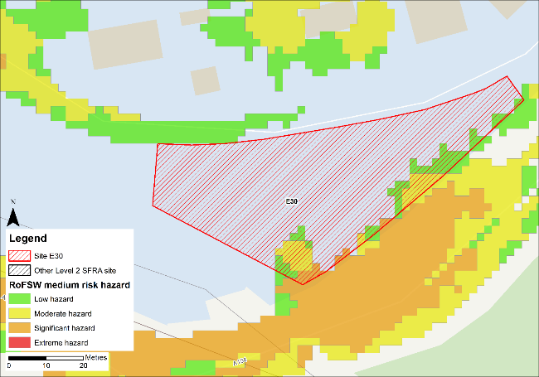
Figure 10-9: Medium risk event surface water flood hazard8 (Risk of Flooding from Surface Water map)

Impacts from climate change
The impact of climate change on surface water flood risk has been modelled. This allows for direct comparison with the RoFSW map. With consideration of the EA’s SFRA guidance, the latest climate change allowances have been modelled as shown in Table 10-4.
Table 10-4: Modelled climate change allowances for rainfall for the Tyne management catchment
Return period | Central allowance 2070s | Upper end allowance 2070s
3.3% | 30% | 40%
1% | 35% | 45%

Figure 10-10 shows the modelled surface water flood depths for the medium risk event +45% climate change. Risk is modelled to be greater than the medium risk event in present day conditions with ponding within the site increasing along the northern site boundary and a flow path forming which vertically bisects the site.
Maximum depths are between 0.6 and 0.9m with areas of significant hazard at the southern corner of the site (Figure 10-11). There is also ponding the roads surrounding the site during the medium risk +45% climate change event, which means safe access and escape routes may be challenging to achieve.
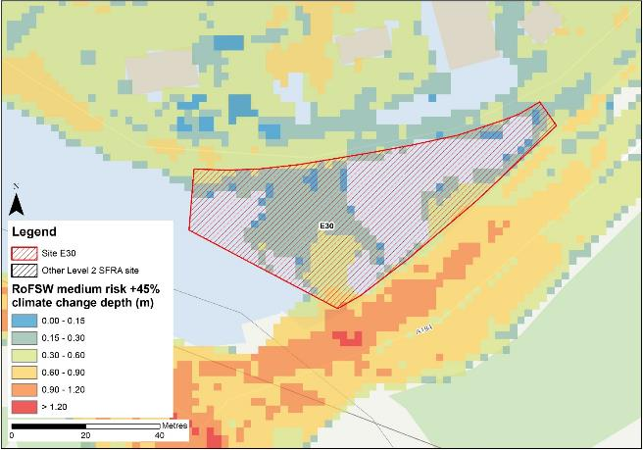
Figure 10-10: Medium risk event surface water flood depths plus 45% climate change (based on Risk of Flooding from Surface Water map)
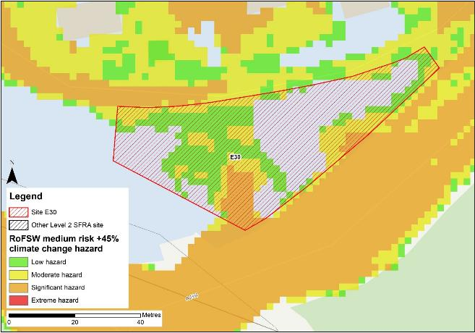
Figure 10-11: Medium risk event surface water flood depths plus 45% climate change (based on Risk of Flooding from Surface Water map)

Risk of runoff from site post development
Runoff rates should not exceed current rates and if possible, betterment of existing rates should be aimed for. For the purposes of this assessment, the required volumes of attenuation have been calculated below based on the estimated impermeable area (assumed 85% of total site area) and limiting greenfield runoff rate of Qbar (l/s).

Table 10-5: Surface water flood risk from proposed development
Design flood event  (incl climate change) | Critical storm duration Hrs | Inflow volume m3 | Outflow volume m3 | Attenuation required  m3 | Time to empty (assuming no infiltration) Hrs | Total storage required: Area (Ha) and % of site area
30yr Rainfall+30% | 2.25 | 104 | 28 | 76 | 6.0 | 0.01 Ha 2.0%
30yr Rainfall+40% | 2.25 | 112 | 28 | 84 | 6.6 | 0.01 Ha 2.0%
100yr Rainfall+35% | 2.5 | 139 | 32 | 108 (32 exceedance storage) | 8.5 | 0.01 Ha 2.9%
100yr Rainfall+45% | 2.5 | 153 | 35 | 118 (34 exceedance storage) | 9.4 | 0.01 Ha 3.1%
Surface water flood risk impacts from development site, mitigation & SuDS options | As part of this Level 2 SFRA we have included calculations to provide an estimated land take if a pond with an assumed depth of 1.5m was included as part of the development.  Attenuation volumes are presented for the critical storm duration for the 3.33% AEP event with exceedance flows quantified up to the 1% event. To prevent development worsening flood risk elsewhere, surface water runoff must be managed on site.
*critical storm duration limited to 12 hours
Note: Proposed development limiting runoff rate: (l/sec). Qbar (FEH Statistical) – 0.92 (assumed 5l/s minimum discharge), Q30 – 1.62, Q100 – 1.92.

Observations, mitigation options and site suitability - surface water
- Current risk to the site is predominantly low, with 67% of the site being at low risk of surface water flooding. 9% of the site is at medium risk and 3% of the site is at high risk of surface water flooding. During the medium risk event, the eastern boundary of the site is affected.
- The modelled medium risk climate change outputs indicate a greater level of risk to present day, expanding in the same area and forming a significant flow path through the centre of the site as well as along the roads to the north and south of the site. Safe access and escape are unlikely to be possible given the flood hazard on the roads north and south of the site.
- For the 1% AEP event plus 45% climate change, approximately 3.1% of the total area of the site would be required for flood storage based on a 1.5m deep pond to ensure runoff volumes do not exceed existing rates.
- Assessment of the current drainage system in place should be carried out to ascertain any current capacity issues and whether the current system could accommodate the proposed development or whether further capacity will be required
- The Groundwater Flood Map (Figure 10-12) indicates that ground conditions may be suitable for infiltration SuDS. This should be further explored through appropriate ground survey as part of the FRA and drainage strategy.
- A full drainage strategy would be required to ensure there is no increase in surface water flood risk elsewhere as a result of new development. This will require surface water modelling based on layout plans and detailed design and full consultation with the LLFA.
- The RoFSW map is not suitable for identifying whether an individual property will flood and is therefore indicative. The RoFSW map is not appropriate to act as the sole evidence for any specific planning or regulatory decision or assessment of risk in relation to flooding at any scale without further supporting studies or evidence.

Flood risk from groundwater
Flood risk from groundwater sources is assessed in this SFRA using JBA's 5m Groundwater Flood Map. This dataset is recommended for use by the EA in the SFRA Good Practice Guide9. Figure 10-12 shows the map for Site E30 and the surrounding areas and Table 10-6 explains the risk classifications.
The entirety of the site is within an area where there is a negligible risk from groundwater flooding due to the nature of the local geological deposits. Groundwater conditions may therefore be suited to infiltration SuDS.
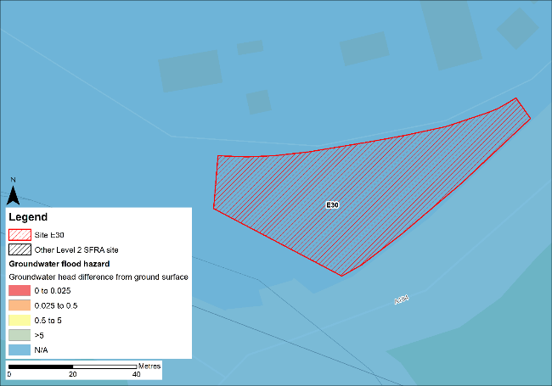
Figure 10-12: JBA 5m Groundwater Flood Map

Table 10-6: Groundwater Flood Hazard Classification
Groundwater head difference (m)* | Class label
0 to 0.025 | Groundwater levels are either at very near (within 0.025m of) the ground surface in the 100-year return period flood event.  Within this zone there is a risk of groundwater flooding to both surface and subsurface assets. Groundwater may emerge at significant rates and has the capacity to flow overland and/or pond within any topographic low spots.
0.025 to 0.5 | Groundwater levels are between 0.025m and 0.5m below the ground surface in the 100-year return period flood event.  Within this zone there is a risk of groundwater flooding to surface and subsurface assets. There is the possibility of groundwater emerging at the surface locally.
0.5 to 5 | Groundwater levels are between 0.5m and 5m below the ground surface in the 100-year return period flood event  There is a risk of flooding to subsurface assets, but surface manifestation of groundwater is unlikely.
>5 | Groundwater levels are at least 5m below the ground surface in the 100-year return period flood event.  Flooding from groundwater is not likely.
N/A | No risk.  This zone is deemed as having a negligible risk from groundwater flooding due to the nature of the local geological deposits.

Overall site assessment

Can part b) of the exception test be passed?
To pass part b) of the exception test10, it must be proven that the development can be safe for its lifetime, which is 100 years for residential development, taking account of the vulnerability of its users, without increasing risk elsewhere, and, where possible, will reduce flood risk overall.
- The site is not required to pass the exception test as it is proposed for less vulnerable uses.

Recommendation summary
Based on the evidence presented in this Level 2 SFRA:
- It should be possible to develop this site for less vulnerable uses. However, mitigation by way of land raising would be required.
- Finished floor levels should place the development 600mm above the 0.5% AEP plus climate change flood level without increasing risk elsewhere.
- Updating and rerunning the model with the latest LIDAR data before finalising finished floor levels and planning development is recommended.

FRA requirements and further work
- The site-specific FRA for this site should update the existing model to include the latest DTM for the site and surrounding area.
- The FRA should robustly set the finished floor levels required to reduce the probability of tidal flooding to the development.
- The FRA must further consider the inclusion of emergency plans and evacuation routes.
- Any FRA should be carried out in line with the NPPF; FRCC-PPG; EA guidance; South Tyneside Local Plan and LLFA policies; and national and local SuDS policy and guidelines.
- Throughout the FRA process, consultation should be carried out with the following, where applicable, the LPA; LLFA; emergency planning officers; EA; NWL; the highways authorities; and the emergency services.

Site E31
- Location: Tyne Dock Enterprise Park (SE), Commercial Road
- Existing site use: brownfield
- Existing site use vulnerability: less vulnerable
- Proposed site use: employment
- Proposed site use vulnerability: less vulnerable
- Site area: 0.6 hectares
- Proposed development impermeable area: 0.5 hectares
- Watercourse: River Tyne
- Summary of requirements from scoping stage:
  - Level 1 SFRA recommendation was for withdrawal from allocation or more detailed assessment through Level 2 SFRA
  - Assessment of modelled tidal flood depths and hazards
  - Assessment of surface water flood depths and hazards
  - Modelling of latest EA climate change allowances for sea level rise and peak rainfall intensities

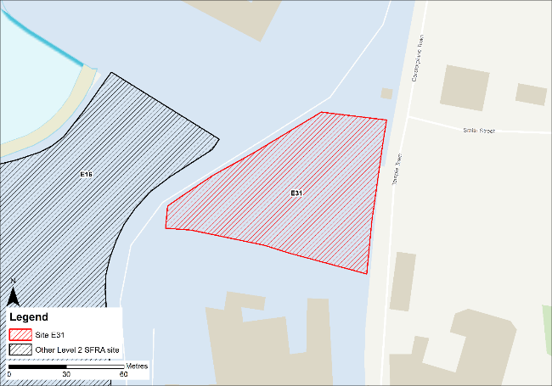
Figure 11-1: Existing site location boundary

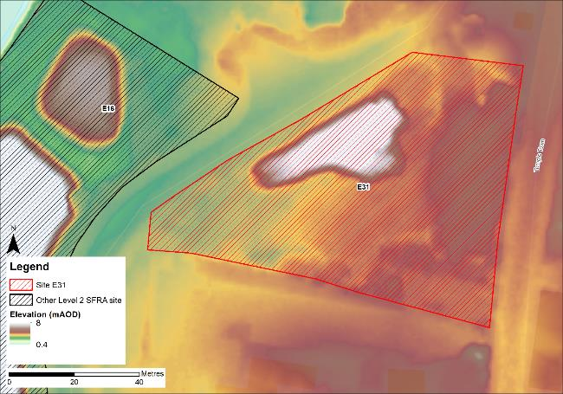
Figure 11-2: Topography

Flood risk from rivers and sea

Existing risk - Flood Map for Planning and functional floodplain
Based on the EA's Flood Map for Planning and Flood Zone 3b (functional floodplain) as updated in this Level 2 SFRA, the percentage areas of the site within each flood zone are stated in Table 11-1 and can be viewed on Figure 11-3. The Flood Map for Planning does not consider flood defence infrastructure or the impacts of climate change (Section 11.1.3).
Approximately 14% of the site is within Flood Zone 3b, along the north western boundary of the site. The majority of the eastern and southern areas of the site are located within Flood Zone 1. However, as discussed, the extent of flooding to this site may not be fully representative of current conditions given the model LIDAR DTM is from 2008.
Table 11-1: Existing flood risk from rivers and sea
Flood Zone 1 (%) | Flood Zone 2 (%) | Flood Zone 3a (%) | Flood Zone 3b (%)
69 | 12 | 5 | 14

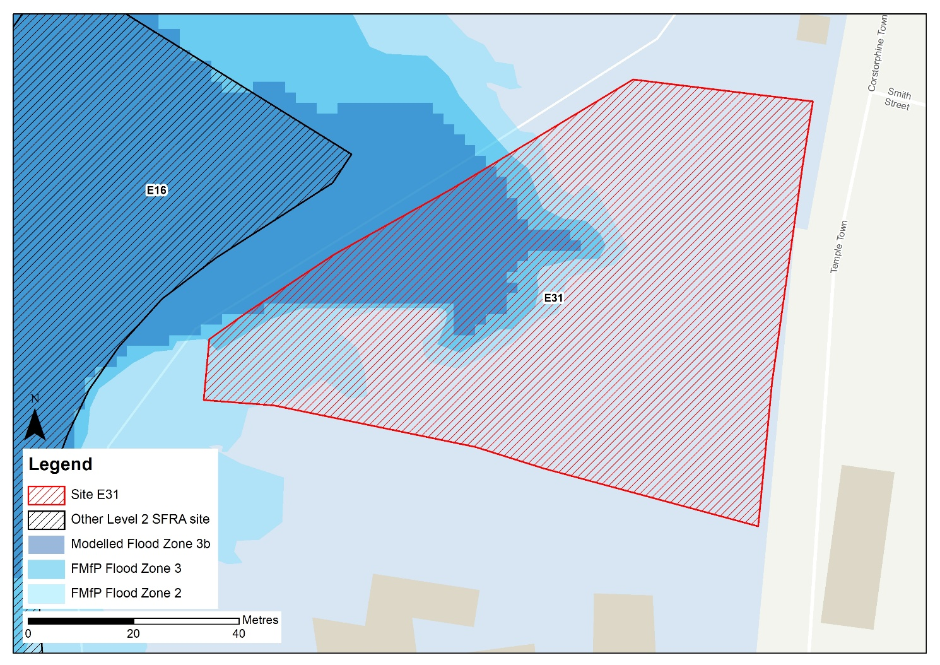
Profile line
Figure 11-3: Existing risk from rivers and sea to the site

Tyne Tidal HEC-RAS model outputs
Figure 11-4 shows the modelled flood depths for the 0.5% AEP undefended event. Flooding in this event is located along the north western boundary of the site. Maximum flood depths are between 2 and 3m, with areas of hazard categorised as 'Danger for all'. Safe access and escape should be possible via Temple Town to the east of the site.
However, the DTM used to map the modelled outputs does not robustly reflect current ground conditions at the Port of Tyne. Therefore, the modelled extents, depths and hazards of flooding to this site may not be fully representative of current conditions. Any site-specific FRA for this site should update the existing model to include the latest DTM for the site and surrounding area.

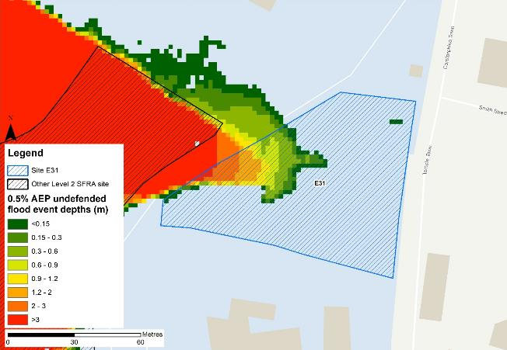
Figure 11-4: Flood depths for 0.5% AEP undefended flood event
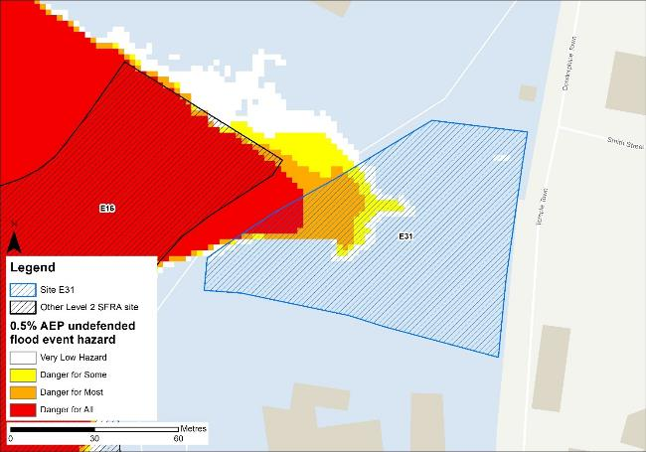
Figure 11-5: Flood hazard7 for 0.5% AEP undefended flood event
In order to gauge what differences in risk to the site may emerge from updating the existing model to include the latest 2021 DTM, modelled flood levels have been compared to the 2008 DTM (as used in the 2015 model) and the 2021 DTM using a profiling GIS tool. The green line shown on Figure 11-3 is the profile line location which produced profile chart below.
The profile chart shows the elevations for the 2008 DTM, as used in the 2015 model (purple line), the 2021 LIDAR (blue line), and the modelled water level for the 3.3% AEP event i.e. the functional floodplain (red line).
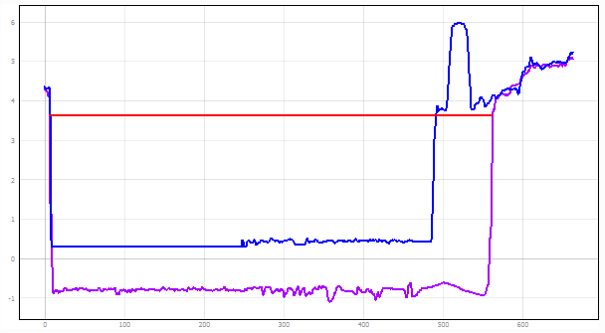
Isolated high ground
Elevation at Site 31
Functional floodplain level within the Tyne Estuary
The site is modelled to be ~600mm above the modelled flood level for the functional floodplain. From comparing the functional floodplain flood level with the 2021 LIDAR, this site would no longer be within the functional floodplain and would therefore be considered suitable for less vulnerable development, assuming appropriate mitigation can be applied. Updating the model with the 2021 LIDAR DTM would be required to confirm this.
Appropriate mitigation would likely involve land raising and finished floor levels set at 600mm above the design event flood level, as recommended in EA standing advice on flood risk assessments. The design event should be the 0.5% AEP plus an allowance for climate change. Given the risk is tidal, compensatory storage is unlikely to be required, though the EA must be consulted on this. However, for increased certainty on water levels and subsequent finished floor levels, the model should be re-run with the 2021 LIDAR.

Impacts from climate change
Based on the EA's SFRA guidance, the latest sea level rise allowances have been modelled as shown in Table 11-2.
Table 11-2: Modelled sea level rise allowances for the Northumbria River Basin District
Return period | Higher Central (m) | Upper End (m)
3.3% (functional floodplain) | 1.03 | 1.43
0.5% | 1.03 | 1.43
0.1% | 1.03 | 1.43
Based on cumulative sea level rise from 2000 to 2125

Figure 11-6 shows the modelled flood depths for the 3.3% AEP undefended event + 1.43m of sea level rise allowance for climate change. Risk is modelled to be significantly greater than present day conditions with flooding modelled to cover the majority of the site. Maximum depths are >3m with areas of hazard classified as 'Danger for all'. Safe access and escape routes would likely be difficult to achieve. This modelled risk potentially rules out development of the site.
Figure 11-8 shows the modelled flood depths for the 0.5% AEP undefended event + 1.03m of sea level rise allowance for climate change. Risk is modelled to be significant across the majority of the site, with maximum depths of > 3m and areas of hazard classified as 'Danger for all' (Figure 11-9).
The profile chart below indicates the future functional floodplain modelled water level in comparison to both the 2008 and 2021 LIDAR DTM levels. The future functional floodplain water level is approximately 100mm higher than the 2021 LIDAR bank levels. Therefore, the site is likely to remain at risk within the future functional floodplain modelled extent were the model to be updated to include the 2021 LIDAR DTM.
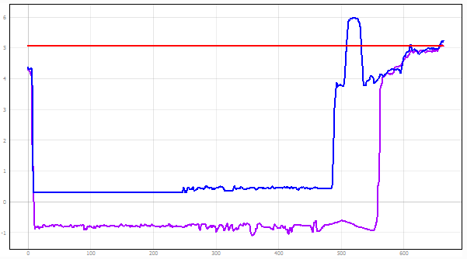
Isolated high ground
Elevation at Site 31
Future functional floodplain level within the Tyne Estuary
NOTE: There are isolated areas of raised ground within the site boundary of E16, approximately 4m above the bank level of the River Tyne and visible within the 2021 LIDAR. This raised ground is not continuous and would therefore not prevent flooding to the site in the 3.3% AEP plus climate change event.
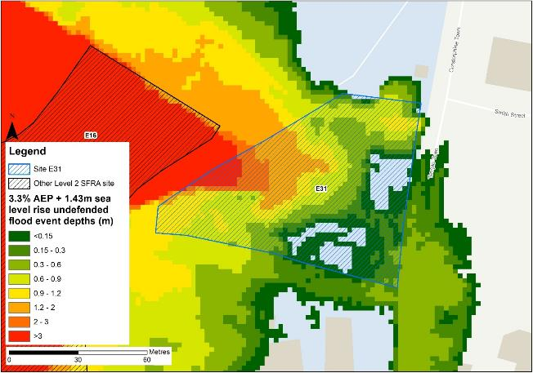
Figure 11-6: Flood depths for the 3.3% AEP undefended flood event +1.43m upper end sea level rise allowance

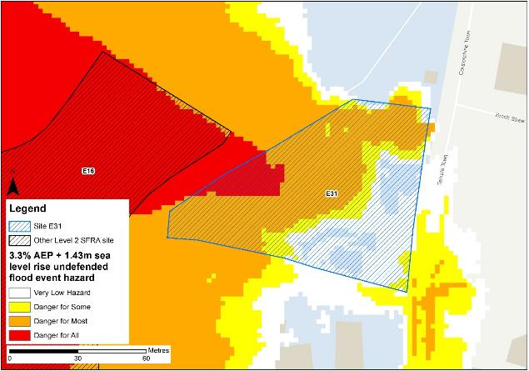
Figure 11-7: Flood hazard7 for the 3.3% AEP undefended flood event +1.43m upper end sea level rise allowance
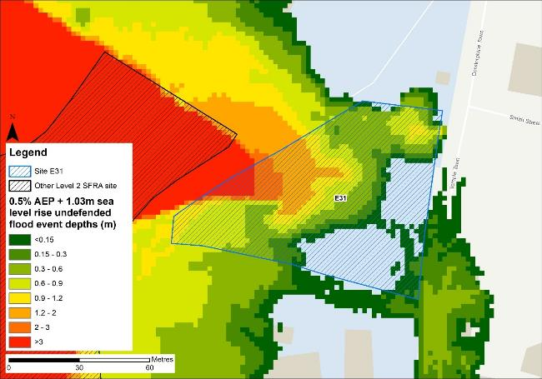
Figure 11-8: Flood depths for the 0.5% AEP undefended flood event +1.03m higher central sea level rise allowance
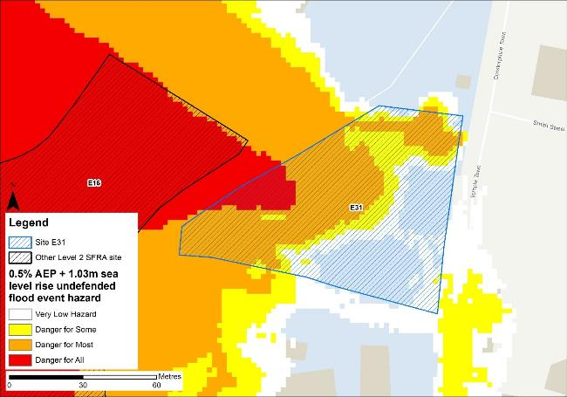
Figure 11-9: Flood hazard7 for the 0.5% AEP undefended flood event +1.03m higher central sea level rise allowance

Flood risk management
The site does not benefit from any formal engineered flood defences.

Working with Natural Processes
The EA's Working with Natural Processes (WwNP) dataset has been interrogated, however there are not any applicable areas that could benefit this site.

Residual risk
Although a site may be afforded some protection from defences, there is always a residual risk of flooding from asset failure i.e. breaching / overtopping of flood defences, blockages of culverts or bridge openings.
The 2015 Tidal Tyne model and EA spatial flood defences datasets indicate that there are no formal defences, structures or culverts that could present a residual risk to the Port of Tyne sites.

Flood risk from reservoirs
The EA's Reservoir Flood Maps (RFM) (2021) show where water may go in the unlikely event of a reservoir or dam failure. Figure 11-10 shows the RFM in a 'dry-day' scenario. A dry-day scenario assumes that the water level in the reservoir is the same as the spillway level or the underside of the roof for a service reservoir and the watercourses upstream and downstream of the reservoir are at a normal level.
This site is potentially at risk from one reservoir, located outside of the South Tyneside authority area in Northumberland.
The EA's SFRA guidance states that where a proposed development site is at flood risk from a reservoir, then an assessment into whether the reservoir design or maintenance schedule needs improving should be carried out. Expert advice may be required from an all-reservoirs panel engineer. At the FRA stage, the reservoir owner, should be contacted to ascertain the flood risk in more detail and whether the proposed development could affect the reservoir’s risk designation, it’s design category or how it is operated. The council, as category 1 responders, can access more detailed information about reservoir risk and reservoir owners using the Resilience Direct system.
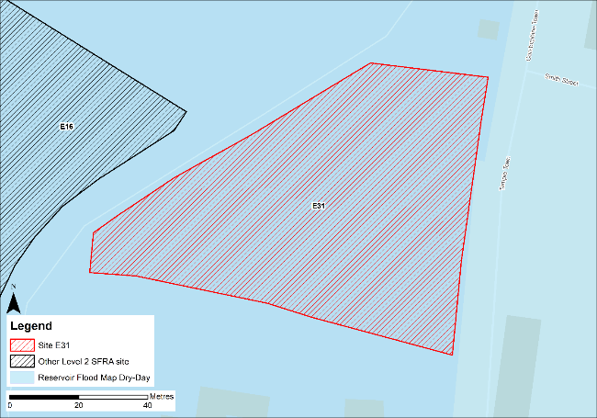
Figure 11-10: Flood risk from reservoirs

Historic flood incidents
The EA's Historic Flood Map (HFM) and Recorded Flood Outlines (RFO) datasets have been considered. Historic risk to the site is shown in Figure 11-11 which shows that the western half of the site has been subject to flooding in the past. The RFO datasets references that the historic event occurred in December 1978 due to flooding from the River Tyne.
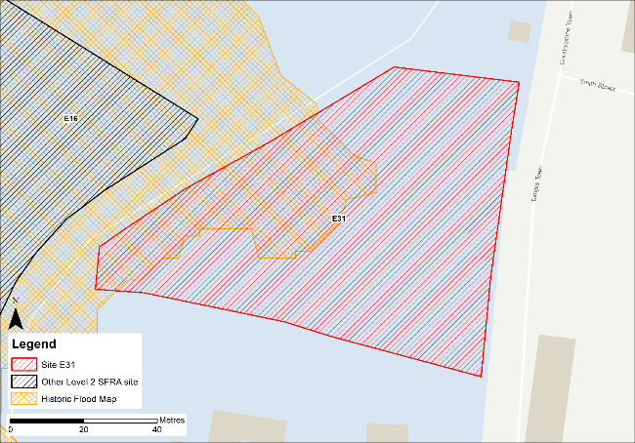
Figure 11-11: Recorded historic flood events onsite and around the site

Flood warning and access and escape routes
The EA operates a Flood Warning Service for properties located within a Flood Warning Area (FWA) for when a flood event is expected to occur. Site E31 is located within FWA 121FWT544 - Tyne estuary at North Shields, South Shields and Howdon Pans, as shown on Figure 11-12.
Flood alerts may be issued before a flood warning for properties located within a Flood Alert Area (FAA) to provide advance notice of the possibility of flooding. A flood alert may be issued when there is less confidence that flooding will occur in a FWA. The site is also located within a FAA, namely 121WAT913 - Tyne estuary from Wylam to the North Sea coast, including Watergate Car Park at Newcastle Quayside.
Safe access and escape routes would likely be difficult to achieve in a climate change event given the significant flooding to the roads surrounding the site. However, rerunning the model with the latest LIDAR data may alter the risk at this site and to the surrounding areas.
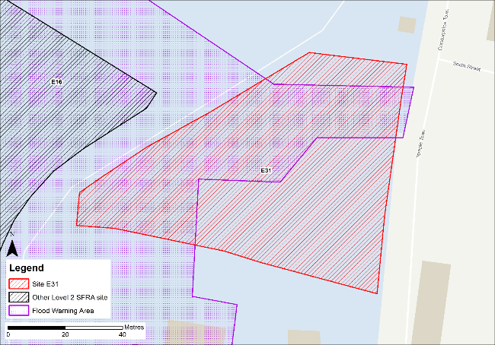
Figure 11-12: EA Flood Warning Areas

Observations, mitigation options and site suitability - tidal
- The DTM used in the model to represent the Tyne Estuary floodplain is from 2008 and does not include the infilled Tyne dock located on this site. Therefore, the modelled extent of flooding to this site is not representative of current conditions with the functional floodplain extent being overestimated, as shown by elevation and water level profiles.
- The model should be updated with the most up to date LIDAR and rerun to provide a fully robust modelled representation of risk for the site and the Port of Tyne.
- Any area of functional floodplain should be left free of development that can be left as open space that can flood when required.
- Modelled risk from climate change significantly increases the risk to the site and surrounding areas, with almost the entirety of the site becoming inundated during the 3.3% AEP + 1.43m sea level rise climate change event.
- Mitigation by way of land raising should be possible at this site with finished floor levels set 600mm above the 0.5% AEP plus climate change flood level. Investigations should ensure flood risk is not worsened elsewhere and given the risk is tidal, compensatory storage is unlikely to be required, though the EA must be consulted.
- The FRA must show that development will be safe for its lifetime taking account of the vulnerability of its users, including for appropriate evacuation procedures and flood response infrastructure are in place to manage the residual risk associated with the extreme flood event.
- EA flood warnings should continue to be in place to ensure early evacuation of site users in advance of a flood event.
- Safe access and escape routes should be achievable via the east of the site in an extreme event, based on current modelling. There must be an emergency plan in place to ensure site users can be safely evacuated.

Flood risk from surface water

Existing risk
Based on the EA's national scale Risk of Flooding from Surface Water (RoFSW) map, the site is predominantly at very low risk of surface water flooding. Only 1% of the site is within the low risk surface water extent, with an additional 2% within the medium risk surface water extent, as shown in Table 11-3. The area at risk is confined to an area within the north of the site. Greatest flood depths range between 0.3 and 0.6 m (Figure 11-13) with areas of significant hazard (Figure 11-14). Safe access and escape routes may be possible via the unnamed road to the north west of the site or via Temple Town to the east of the site.
Table 11-3: Existing surface water flood risk based on the RoFSW map
Very low risk (%) | Low risk (%) | Medium risk (%) | High risk (%)
97 | 1 | 2 | 0

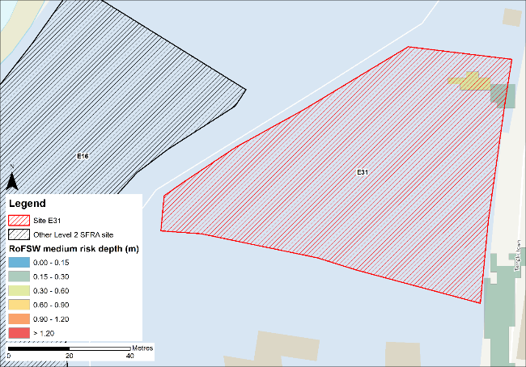
Figure 11-13: Medium risk event surface water flood depths (Risk of Flooding from Surface Water map)
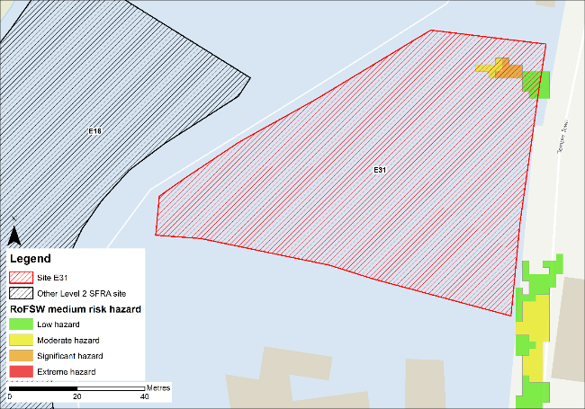
Figure 11-14: Medium risk event surface water flood hazard8 (Risk of Flooding from Surface Water map)

Impacts from climate change
The impact of climate change on surface water flood risk has been modelled. This allows for direct comparison with the RoFSW map. With consideration of the EA’s SFRA guidance, the latest climate change allowances have been modelled as shown in Table 11-4.
Table 11-4: Modelled climate change allowances for rainfall for the Tyne management catchment
Return period | Central allowance 2070s | Upper end allowance 2070s
3.3% | 30% | 40%
1% | 35% | 45%

Figure 11-15 shows the modelled surface water flood depths for the medium risk event +45% climate change. Risk is modelled to be greater than the medium risk event in present day conditions with ponding within the site increasing along the eastern, southern and western site boundaries and a flow path forming which cuts across the northern site boundary.
Maximum depths are between 0.6 and 0.9m with areas of significant hazard within the flow path at the northern corner of the site (Figure 11-16). There is also ponding along Temple Town and Corstorphine Town, east of the site, during the medium risk +45% climate change event, which means safe access and escape routes may be challenging to achieve.
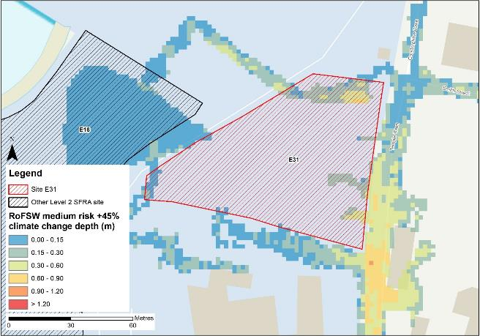
Figure 11-15: Medium risk event surface water flood depths plus 45% climate change (based on Risk of Flooding from Surface Water map)
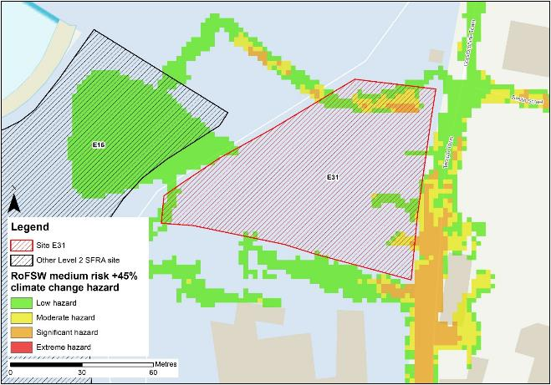
Figure 11-16: Medium risk event surface water flood hazard plus 45% climate change (based on Risk of Flooding from Surface Water map)

Risk of runoff from site post development
Runoff rates should not exceed current rates and if possible, betterment of existing rates should be aimed for. For the purposes of this assessment, the required volumes of attenuation have been calculated below based on the estimated impermeable area (ha) and limiting greenfield runoff rate of Qbar (l/s).

Table 11-5: Surface water flood risk from proposed development
Design flood event  (incl climate change) | Critical storm duration Hrs | Inflow volume m3 | Outflow volume m3 | Attenuation required  m3 | Time to empty (assuming no infiltration) Hrs | Total storage required: Area (Ha) and % of site area
30yr Rainfall+30% | 6 | 309 | 76 | 234 | 18.5 | 0.02 Ha 2.7%
30yr Rainfall+40% | 6.5 | 340 | 82 | 258 | 20.4 | 0.02 Ha 2.9%
100yr Rainfall+35% | 7.5 | 415 | 95 | 320 (87 exceedance storage) | 25.4 | 0.02 Ha 3.7%
100yr Rainfall+45% | 7.5 | 456 | 104 | 352 (94 exceedance storage) | 27.8 | 0.02 Ha 4.0%
Surface water flood risk impacts from development site, mitigation & SuDS options | As part of this Level 2 SFRA we have included calculations to provide an estimated land take if a pond with an assumed depth of 1.5m was included as part of the development.  Attenuation volumes are presented for the critical storm duration for the 3.33% AEP event with exceedance flows quantified up to the 1% event. To prevent development worsening flood risk elsewhere, surface water runoff must be managed on site.
Note: Proposed development limiting runoff rate: (l/sec). Qbar (FEH Statistical) – 2.14 (assume 5l/s minimum discharge), Q30 – 3.74, Q100 – 4.44.

Observations, mitigation options and site suitability - surface water
- Current risk to the site is predominantly low, with 97% of the site being at very low risk of surface water flooding with 1% of the site is at low risk and 2% of the site is at medium of surface water flooding. During the medium risk event, the north-eastern corner of the site is affected.
- The modelled medium risk climate change outputs indicate a greater level of risk to present day, with a flow path forming along the northern boundary of the site as well as along southern boundary and on Temple Town, to the east of the site. Safe access and escape may be achievable from the north of the site via Temple Town.
- For the 1% AEP event plus 45% climate change, approximately 4% of the total area of the site would be required for flood storage based on a 1.5m deep pond to ensure runoff volumes do not exceed existing rates.
- Assessment of the current drainage system in place should be carried out to ascertain any current capacity issues and whether the current system could accommodate the proposed development or whether further capacity will be required
- The Groundwater Flood Map (Figure 11-17) indicates that ground conditions may be suitable for infiltration SuDS. This should be further explored through appropriate ground survey as part of the FRA and drainage strategy.
- A full drainage strategy would be required to ensure there is no increase in surface water flood risk elsewhere as a result of new development. This will require surface water modelling based on layout plans and detailed design and full consultation with the LLFA.
- The RoFSW map is not suitable for identifying whether an individual property will flood and is therefore indicative. The RoFSW map is not appropriate to act as the sole evidence for any specific planning or regulatory decision or assessment of risk in relation to flooding at any scale without further supporting studies or evidence.

Flood risk from groundwater
Flood risk from groundwater sources is assessed in this SFRA using JBA's 5m Groundwater Flood Map. This dataset is recommended for use by the EA in the SFRA Good Practice Guide9. Figure 11-17 shows the map for Site E31 and the surrounding areas and Table 11-6 explains the risk classifications.
The entirety of the site is within an area where there is a negligible risk from groundwater flooding due to the nature of the local geological deposits. Groundwater conditions may therefore be suited to infiltration SuDS.
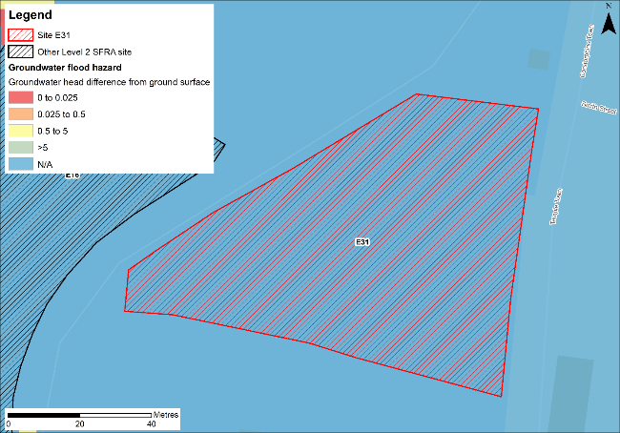
Figure 11-17: JBA 5m Groundwater Flood Map

Table 11-6: Groundwater Flood Hazard Classification
Groundwater head difference (m)* | Class label
0 to 0.025 | Groundwater levels are either at very near (within 0.025m of) the ground surface in the 100-year return period flood event.  Within this zone there is a risk of groundwater flooding to both surface and subsurface assets. Groundwater may emerge at significant rates and has the capacity to flow overland and/or pond within any topographic low spots.
0.025 to 0.5 | Groundwater levels are between 0.025m and 0.5m below the ground surface in the 100-year return period flood event.  Within this zone there is a risk of groundwater flooding to surface and subsurface assets. There is the possibility of groundwater emerging at the surface locally.
0.5 to 5 | Groundwater levels are between 0.5m and 5m below the ground surface in the 100-year return period flood event  There is a risk of flooding to subsurface assets, but surface manifestation of groundwater is unlikely.
>5 | Groundwater levels are at least 5m below the ground surface in the 100-year return period flood event.  Flooding from groundwater is not likely.
N/A | No risk.  This zone is deemed as having a negligible risk from groundwater flooding due to the nature of the local geological deposits.

Overall site assessment

Can part b) of the exception test be passed?
To pass part b) of the exception test10, it must be proven that the development can be safe for its lifetime, which is 100 years for residential development, taking account of the vulnerability of its users, without increasing risk elsewhere, and, where possible, will reduce flood risk overall.
- The site is not required to pass the exception test as it is proposed for less vulnerable uses.

Recommendation summary
Based on the evidence presented in this Level 2 SFRA:
- It should be possible to develop this site for less vulnerable uses. However, mitigation by way of land raising would be required.
- Finished floor levels should place the development 600mm above the 0.5% AEP plus climate change flood level without increasing risk elsewhere.
- Updating and rerunning the model with the latest LIDAR data before finalising finished floor levels and planning development is recommended.

FRA requirements and further work
- Any site-specific FRA for this site should update the existing model to include the latest DTM for the site and surrounding area.
- Mitigation by way of land raising should be assessed and finished floor levels set 600mm above the 0.5% AEP plus climate change flood level. Investigations should ensure flood risk is not worsened elsewhere.
- Emergency plans and evacuation procedures should be included as part of any FRA for this site.
- Any FRA should be carried out in line with the NPPF; FRCC-PPG; EA guidance; South Tyneside Local Plan and LLFA policies; and national and local SuDS policy and guidelines.
- Throughout the FRA process, consultation should be carried out with the following, where applicable, the LPA; LLFA; emergency planning officers; EA; NWL; the highways authorities; and the emergency services.

Site E32
- Location: East of wood pellet silos
- Existing site use: brownfield
- Existing site use vulnerability: less vulnerable
- Proposed site use: employment
- Proposed site use vulnerability: less vulnerable
- Site area: 1.9 hectares
- Proposed development impermeable area: 1.6 hectares (assumed 85% of total site area)
- Watercourse: River Tyne
- Summary of requirements from scoping stage:
  - Level 1 SFRA recommendation was for withdrawal from allocation or more detailed assessment through Level 2 SFRA
  - Assessment of modelled tidal flood depths and hazards
  - Assessment of surface water flood depths and hazards
  - Modelling of latest EA climate change allowances for sea level rise and peak rainfall intensities
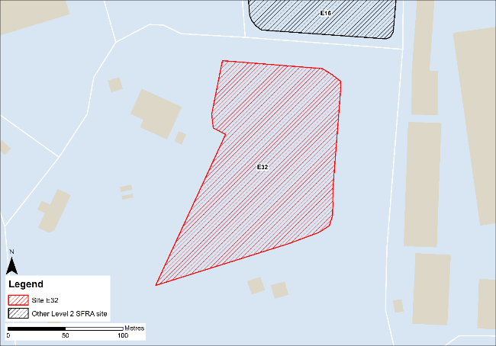
Figure 12-1: Existing site location boundary

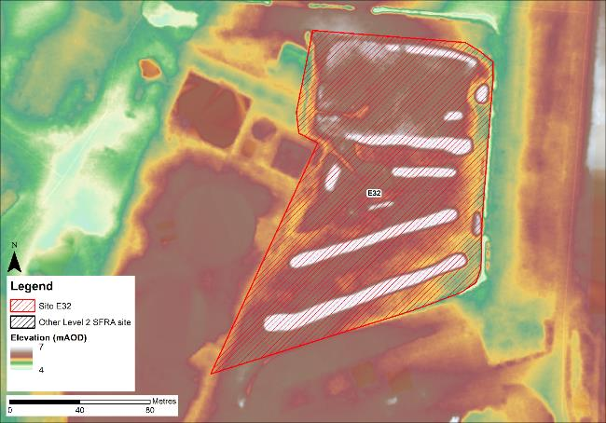
Figure 12-2: Topography

Flood risk from rivers and sea

Existing risk - Flood Map for Planning and functional floodplain
Based on the EA's Flood Map for Planning and Flood Zone 3b (functional floodplain) as updated in this Level 2 SFRA, the percentage areas of the site within each flood zone are stated in Table 12-1 and can be viewed on Figure 12-3. The Flood Map for Planning does not consider flood defence infrastructure or the impacts of climate change.
However, as discussed, the extent of flooding to this site may not be fully representative of current conditions given the model LIDAR DTM is from 2008.
Table 12-1: Existing flood risk from rivers and sea
Flood Zone 1 (%) | Flood Zone 2 (%) | Flood Zone 3a (%) | Flood Zone 3b (%)
0 | 0 | 0 | 100

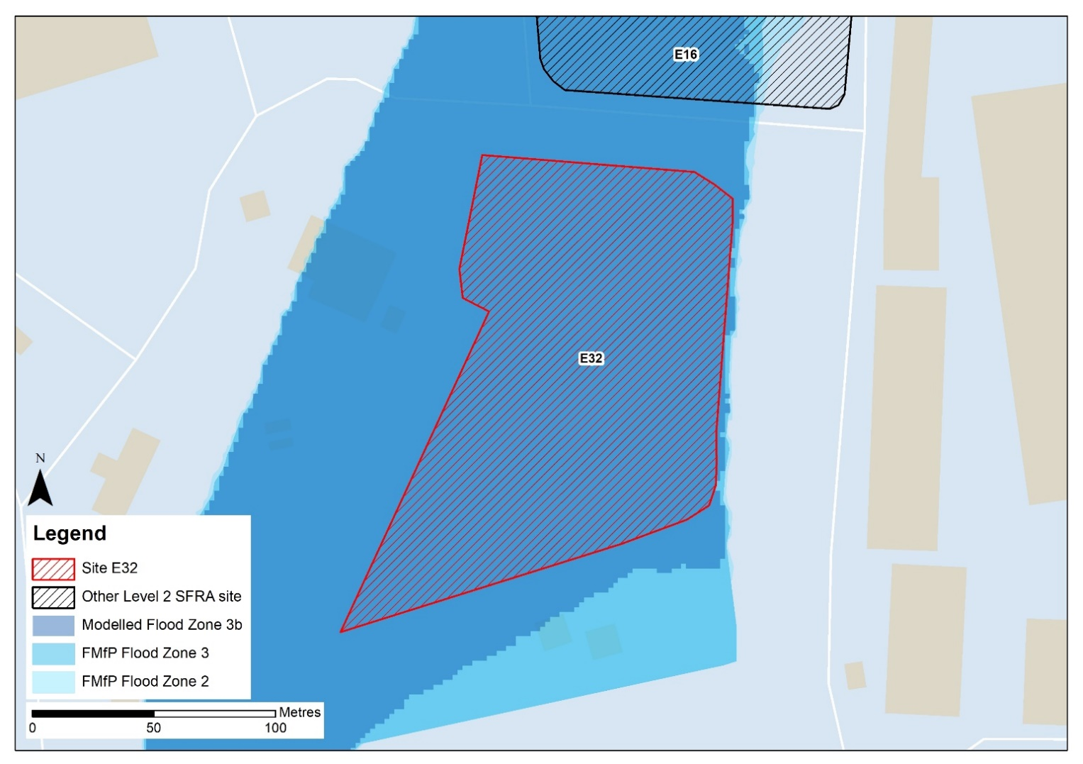
Profile line
Figure 12-3: Existing risk from rivers and sea to the site

Tyne Tidal HEC-RAS model outputs
The entire site is modelled to be at risk from the 3.3% AEP undefended event to maximum depths of >3m and therefore wholly placed within the functional floodplain. There should be no development within the functional floodplain.
However, as the DTM used to map the modelled outputs does not reflect the infilled Tyne Dock, the extents, depths and hazards of flooding to this site are not fully representative of current conditions. Any site-specific FRA for this site should update the existing model to include the latest DTM for the site and surrounding area.
In order to gauge what differences in risk to the site may emerge from updating the existing model to include the latest 2021 DTM, modelled flood levels have been compared to the 2008 DTM (as used in the 2015 model) and the 2021 DTM using a profiling GIS tool. The green line shown on Figure 12-1 is the profile line location which produced profile chart below.
The profile chart shows the elevations for the 2008 DTM, as used in the 2015 model (purple line), the 2021 LIDAR (blue line), and the modelled water level for the 3.3% AEP event i.e. the functional floodplain (red line).
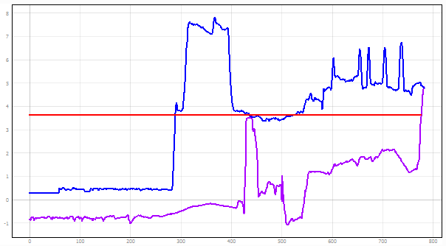
Isolated high ground
Functional floodplain level within the Tyne Estuary
2021 LIDAR bank level at the dock
Elevation at the site based on 2008 LIDAR
Elevation at the site based on 2021 LIDAR
There is a difference in elevation of approximately 4m along the bank of the Tyne Estuary at the site, which is ~600mm above the modelled flood level for the functional floodplain. In comparison to the 2021 LIDAR, the site is situated approximately 1.3m above the modelled flood levels for the functional floodplain. The site would no longer be within the functional floodplain and would therefore be considered suitable for less vulnerable development, assuming appropriate mitigation can be applied. Updating the model with the 2021 LIDAR DTM would be required to confirm this.
Appropriate mitigation would likely involve land raising and finished floor levels set at 600mm above the design event flood level, as recommended in EA standing advice on flood risk assessments. The design event should be the 0.5% AEP plus an allowance for climate change. Given the risk is tidal, compensatory storage is unlikely to be required, though the EA must be consulted on this. However, for increased certainty on water levels and subsequent finished floor levels, the model should be re-run with the 2021 LIDAR.

Impacts from climate change
Based on the EA's SFRA guidance, the latest sea level rise allowances have been modelled as shown in Table 12-2.
Table 12-2: Modelled sea level rise allowances for the Northumbria River Basin District
Return period | Higher Central (m) | Upper End (m)
3.3% (functional floodplain) | 1.03 | 1.43
0.5% | 1.03 | 1.43
0.1% | 1.03 | 1.43
Based on cumulative sea level rise from 2000 to 2125

Figure 12-4 shows the modelled flood depths for the 0.5% AEP undefended event + 1.03m of sea level rise allowance for climate change (the future functional floodplain). Risk is modelled to be significant across the entirety of the site, with maximum depths of > 3m and areas of hazard classified as 'Danger for all' (Figure 12-5).
The profile chart below indicates the future functional floodplain modelled water level in comparison to both the 2008 and 2021 LIDAR DTM levels. The future functional floodplain water level is approximately 1m higher than the 2021 LIDAR bank levels. Therefore, the site is likely to remain at risk within the future functional floodplain modelled extent were the model to be updated to include the 2021 LIDAR DTM.
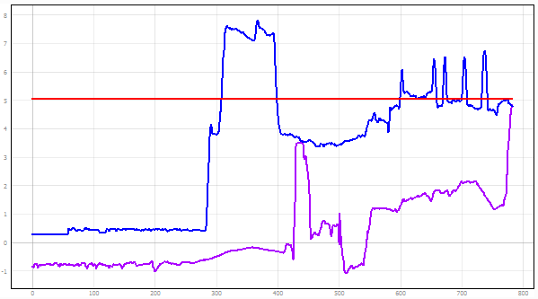
Isolated high ground
Future functional floodplain level within the Tyne Estuary
2008 LIDAR DTM bank level at the dock
2021 LIDAR DTM bank level at the dock

Elevation at the site based on 2021 LIDAR

NOTE: There are isolated areas of raised ground within the boundary of site E16, approximately 4m above the bank level of the River Tyne and visible within the 2021 LIDAR. This raised ground is not continuous and would therefore not prevent flooding to the site in the 3.3% AEP plus climate change event.
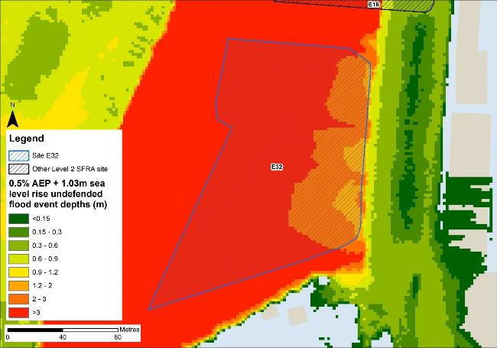
Figure 12-4: Flood depths for the 0.5% AEP undefended flood event +1.03m higher central sea level rise allowance
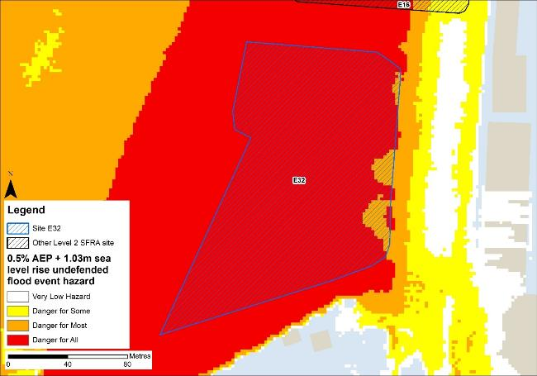
Figure 12-5: Flood hazard7 for the 0.5% AEP undefended flood event +1.03m higher central sea level rise allowance

Flood risk management
The site does not benefit from any formal engineered flood defences.

Working with Natural Processes
The EA's Working with Natural Processes (WwNP) dataset has been interrogated, however there are not any applicable areas that could benefit this site.

Residual risk
Although a site may be afforded some protection from defences, there is always a residual risk of flooding from asset failure i.e. breaching / overtopping of flood defences, blockages of culverts or bridge openings.
The 2015 Tidal Tyne model and EA spatial flood defences datasets indicate that there are no formal defences, structures or culverts that could present a residual risk to the Port of Tyne sites.

Flood risk from reservoirs
The EA's Reservoir Flood Maps (RFM) (2021) show where water may go in the unlikely event of a reservoir or dam failure. Figure 12-6 shows the RFM in a 'dry-day' scenario. A dry-day scenario assumes that the water level in the reservoir is the same as the spillway level or the underside of the roof for a service reservoir and the watercourses upstream and downstream of the reservoir are at a normal level.
This site is potentially at risk from one reservoir, located outside of the South Tyneside authority area in Northumberland.
The EA's SFRA guidance states that where a proposed development site is at flood risk from a reservoir, then an assessment into whether the reservoir design or maintenance schedule needs improving should be carried out. Expert advice may be required from an all-reservoirs panel engineer. At the FRA stage, the reservoir owner, should be contacted to ascertain the flood risk in more detail and whether the proposed development could affect the reservoir’s risk designation, it’s design category or how it is operated. The council, as category 1 responders, can access more detailed information about reservoir risk and reservoir owners using the Resilience Direct system.
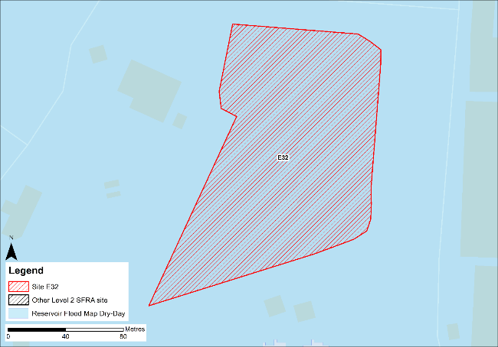
Figure 12-6: Flood risk from reservoirs

Historic flood incidents
The EA's Historic Flood Map (HFM) and Recorded Flood Outlines (RFO) datasets have been considered. Historic risk to the site is shown in Figure 12-7 which shows that the entirety of the site has been subject to flooding in the past, however this flood event is not present within the RFO dataset.
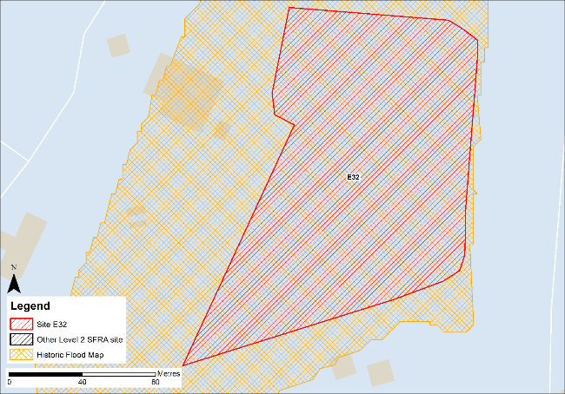
Figure 12-7: Recorded historic flood events onsite and around the site

Flood warning and access and escape routes
The EA operates a Flood Warning Service for properties located within a Flood Warning Area (FWA) for when a flood event is expected to occur. Site E32 is not located within any FWA.
Flood alerts may be issued before a flood warning for properties located within a Flood Alert Area (FAA) to provide advance notice of the possibility of flooding. A flood alert may be issued when there is less confidence that flooding will occur in a FWA. The site is located within a FAA, namely 121WAT913 - Tyne estuary from Wylam to the North Sea coast, including Watergate Car Park at Newcastle Quayside.
Safe access and escape routes would be challenging to achieve for this site. However, rerunning the model with the latest LIDAR data may alter the risk at this site and to the surrounding areas.

Observations, mitigation options and site suitability - tidal
- The DTM used in the model to represent the Tyne Estuary floodplain is from 2008 and does not include the infilled Tyne dock located on this site. Therefore, the modelled extent of flooding to this site is not representative of current conditions with the functional floodplain extent being overestimated, as shown by elevation and water level profiles.
- The model should be updated with the most up to date LIDAR and rerun to provide a fully robust modelled representation of risk for the site and the Port of Tyne.
- Any area of functional floodplain should be left free of development that can be left as open space that can flood when required.
- Modelled risk from climate change increases the risk to the site and surrounding areas, with the entire site modelled to be within the future functional floodplain.
- Mitigation by way of land raising should be possible at this site with finished floor levels set 600mm above the 0.5% AEP plus climate change flood level. Investigations should ensure flood risk is not worsened elsewhere and given the risk is tidal, compensatory storage is unlikely to be required, though the EA must be consulted.
- The FRA must show that development will be safe for its lifetime taking account of the vulnerability of its users, including for appropriate evacuation procedures and flood response infrastructure are in place to manage the residual risk associated with the extreme flood event.
- EA flood warnings should be put in place at this site to ensure early evacuation of site users in advance of a flood event.
- Safe access and escape routes will be challenging to achieve in an extreme event, based on current modelling. There must be an emergency plan in place to ensure site users can be safely evacuated.
- Were development of this site to proceed, given the proximity of this site to neighbouring sites E16, E17, E19, E31, it would be prudent to formulate a strategy to develop these sites in tandem and for consultation between each developer to take place to ensure a joined-up approach for sustainable development is in place.

Flood risk from surface water

Existing risk
Based on the EA's national scale Risk of Flooding from Surface Water (RoFSW) map, the site is predominantly at very low risk of surface water flooding. Only 15% of the site is within the low risk surface water extent, as shown in Table 12-3. The area at risk is confined to an area along the eastern boundary of the site. Greatest flood depths range between 0.3 and 0.6 m (Figure 12-8) with areas of significant hazard (Figure 12-9). Safe access and escape routes may be possible via the unnamed road to the north west of the site or via Temple Town to the east of the site.
Table 12-3: Existing surface water flood risk based on the RoFSW map
Very low risk (%) | Low risk (%) | Medium risk (%) | High risk (%)
85 | 15 | 0 | 0
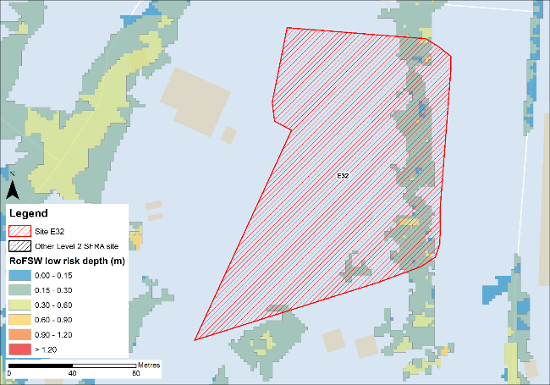
Figure 12-8: Low risk event surface water flood depths (Risk of Flooding from Surface Water map)
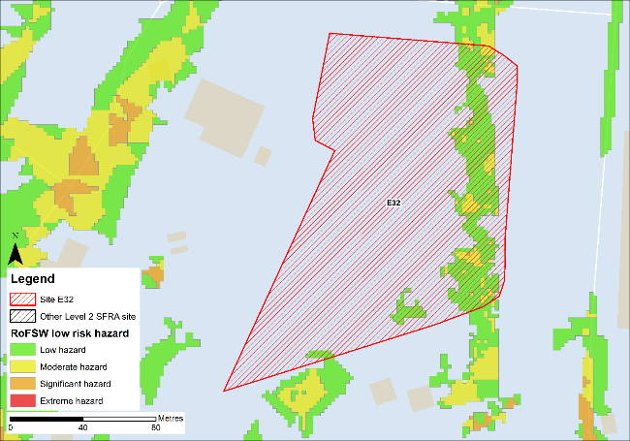
Figure 12-9: Low risk event surface water flood hazard8 (Risk of Flooding from Surface Water map)

Impacts from climate change
The impact of climate change on surface water flood risk has been modelled. This allows for direct comparison with the RoFSW map. With consideration of the EA’s SFRA guidance, the latest climate change allowances have been modelled as shown in Table 12-4.
Table 12-4: Modelled climate change allowances for rainfall for the Tyne management catchment
Return period | Central allowance 2070s | Upper end allowance 2070s
3.3% | 30% | 40%
1% | 35% | 45%

Figure 12-10 shows the modelled surface water flood depths for the medium risk event +45% climate change. Risk is modelled to be similar to the low risk event in present day conditions with risk confined to an area along the eastern boundary of the site.
Maximum depths are between 0.3 and 0.6m with areas of significant hazard (Figure 12-11). Safe access and escape routes may be possible via the unnamed road to the north west of the site or via Temple Town to the east of the site.
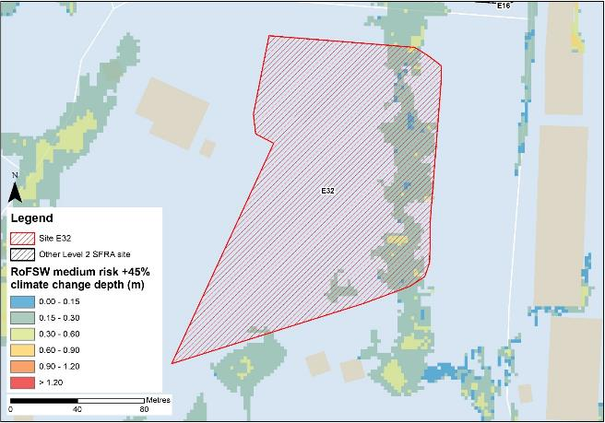
Figure 12-10: Medium risk event surface water flood depths plus 45% climate change (based on Risk of Flooding from Surface Water map)
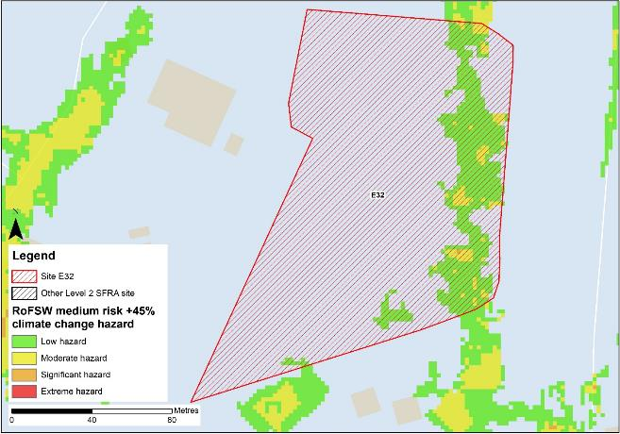
Figure 12-11: Medium risk event surface water flood hazard plus 45% climate change (based on Risk of Flooding from Surface Water map)

Risk of runoff from site post development
Runoff rates should not exceed current rates and if possible, betterment of existing rates should be aimed for. For the purposes of this assessment, the required volumes of attenuation have been calculated below based on the estimated impermeable area (ha) and limiting greenfield runoff rate of Qbar (l/s).

Table 12-5: Surface water flood risk from proposed development
Design flood event  (incl climate change) | Critical storm duration Hrs | Inflow volume m3 | Outflow volume m3 | Attenuation required  m3 | Time to empty (assuming no infiltration) Hrs | Total storage required: Area (Ha) and % of site area
30yr Rainfall+30% | 12 | 1191 | 211 | 979 | 55.4 | 0.07 Ha  3.4%
30yr Rainfall+40% | 12 | 1282 | 211 | 1071 | 60.6 | 0.07 Ha  3.7%
100yr Rainfall+35% | 12* | 1910 | 528 | 1381 (402 exceedance storage) | 78.2 | 0.09 Ha  4.8%
100yr Rainfall+45% | 12* | 2161 | 634 | 1527 (456 exceedance storage) | 86.4 | 0.1 Ha  5.3%
Surface water flood risk impacts from development site, mitigation & SuDS options | As part of this Level 2 SFRA we have included calculations to provide an estimated land take if a pond with an assumed depth of 1.5m was included as part of the development.  Attenuation volumes are presented for the critical storm duration for the 3.33% AEP event with exceedance flows quantified up to the 1% event. To prevent development worsening flood risk elsewhere, surface water runoff must be managed on site.
*Critical storm duration limited to 12 hours
Note: Proposed development limiting runoff rate: (l/sec). Qbar (FEH Statistical) – 6.99, Q30 – 12.23, Q100 – 14.54.

Observations, mitigation options and site suitability - surface water
- Current risk to the site is predominantly low, with 85% of the site being at very low risk of surface water flooding. There is a surface water flow path through the east of the site in the low risk event.
- The modelled medium risk climate change outputs indicate a greater level of risk to present day, with a flow path forming along the eastern boundary to a similar extent as the low risk present day event. Safe access and escape routes may be possible via the unnamed road to the north west of the site or via Temple Town to the east of the site.
- For the 1% AEP event plus 45% climate change, approximately 5.3% of the total area of the site would be required for flood storage based on a 1.5m deep pond to ensure runoff volumes do not exceed existing rates.
- Assessment of the current drainage system in place should be carried out to ascertain any current capacity issues and whether the current system could accommodate the proposed development or whether further capacity will be required
- The Groundwater Flood Map (Figure 12-12) indicates that ground conditions may be suitable for infiltration SuDS. This should be further explored through appropriate ground survey as part of the FRA and drainage strategy.
- A full drainage strategy would be required to ensure there is no increase in surface water flood risk elsewhere as a result of new development. This will require surface water modelling based on layout plans and detailed design and full consultation with the LLFA.
- The RoFSW map is not suitable for identifying whether an individual property will flood and is therefore indicative. The RoFSW map is not appropriate to act as the sole evidence for any specific planning or regulatory decision or assessment of risk in relation to flooding at any scale without further supporting studies or evidence.

Flood risk from groundwater
Flood risk from groundwater sources is assessed in this SFRA using JBA's 5m Groundwater Flood Map. This dataset is recommended for use by the EA in the SFRA Good Practice Guide9. Figure 12-12 shows the map for Site E32 and the surrounding areas and Table 12-6 explains the risk classifications.
The entirety of the site is within an area where there is a negligible risk from groundwater flooding due to the nature of the local geological deposits. Groundwater conditions may therefore be suited to infiltration SuDS.
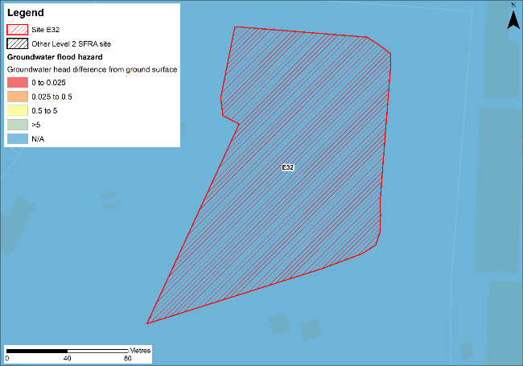
Figure 12-12: JBA 5m Groundwater Flood Map

Table 12-6: Groundwater Flood Hazard Classification
Groundwater head difference (m)* | Class label
0 to 0.025 | Groundwater levels are either at very near (within 0.025m of) the ground surface in the 100-year return period flood event.  Within this zone there is a risk of groundwater flooding to both surface and subsurface assets. Groundwater may emerge at significant rates and has the capacity to flow overland and/or pond within any topographic low spots.
0.025 to 0.5 | Groundwater levels are between 0.025m and 0.5m below the ground surface in the 100-year return period flood event.  Within this zone there is a risk of groundwater flooding to surface and subsurface assets. There is the possibility of groundwater emerging at the surface locally.
0.5 to 5 | Groundwater levels are between 0.5m and 5m below the ground surface in the 100-year return period flood event  There is a risk of flooding to subsurface assets, but surface manifestation of groundwater is unlikely.
>5 | Groundwater levels are at least 5m below the ground surface in the 100-year return period flood event.  Flooding from groundwater is not likely.
N/A | No risk.  This zone is deemed as having a negligible risk from groundwater flooding due to the nature of the local geological deposits.

Overall site assessment

Can part b) of the exception test be passed?
To pass part b) of the exception test10, it must be proven that the development can be safe for its lifetime, which is 100 years for residential development, taking account of the vulnerability of its users, without increasing risk elsewhere, and, where possible, will reduce flood risk overall.
- The site is not required to pass the exception test as it is proposed for less vulnerable uses.

Recommendation summary
Based on the evidence presented in this Level 2 SFRA:
- It should be possible to develop this site for less vulnerable uses. However, mitigation by way of land raising would be required.
- Finished floor levels should place the development 600mm above the 0.5% AEP plus climate change flood level without increasing risk elsewhere.
- Updating and rerunning the model with the latest LIDAR data before finalising finished floor levels and planning development is recommended.

FRA requirements and further work
- The site-specific FRA should update the existing model to include the latest DTM for the site and surrounding area.
- Mitigation by way of land raising should be assessed and finished floor levels set 600mm above the 0.5% AEP plus climate change flood level. Investigations should ensure flood risk is not worsened elsewhere.
- Safe access and escape routes should be assessed with appropriate emergency plans and evacuation procedures in place as part of the FRA.
- Any FRA should be carried out in line with the NPPF; FRCC-PPG; EA guidance; South Tyneside Local Plan and LLFA policies; and national and local SuDS policy and guidelines.
- Throughout the FRA process, consultation should be carried out with the following, where applicable, the LPA; LLFA; emergency planning officers; EA; NWL; the highways authorities; and the emergency services.

Site E33
- Location: Tyne Renewables Quay
- Existing site use: brownfield
- Existing site use vulnerability: less vulnerable
- Proposed site use: employment
- Proposed site use vulnerability: less vulnerable
- Site area: 10 hectares
- Proposed development impermeable area: 8.5 hectares (assumed 85% of total site area)
- Watercourse: River Tyne
- Summary of requirements from scoping stage:
  - Level 1 SFRA recommendation was for withdrawal from allocation or more detailed assessment through Level 2 SFRA
  - Assessment of modelled tidal flood depths and hazards
  - Assessment of surface water flood depths and hazards
  - Modelling of latest EA climate change allowances for sea level rise and peak rainfall intensities
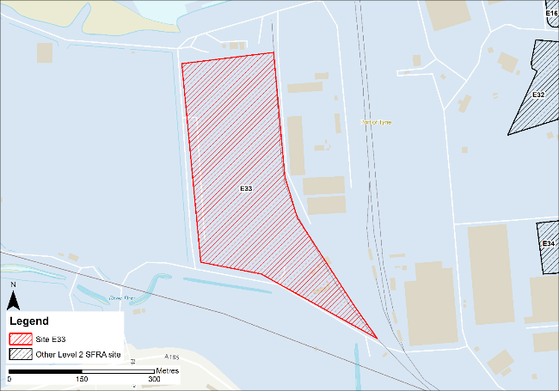
Figure 13-1: Existing site location boundary

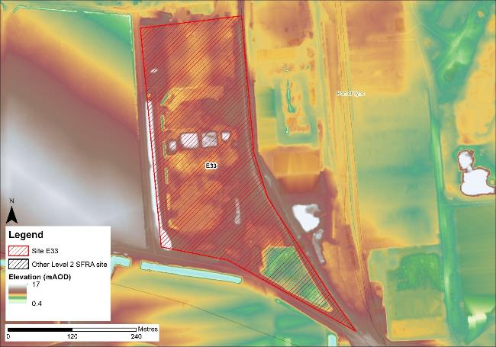
Figure 13-2: Topography

Flood risk from rivers and sea

Existing risk - Flood Map for Planning and functional floodplain
Based on the EA's Flood Map for Planning and Flood Zone 3b (functional floodplain) as updated in this Level 2 SFRA, the percentage areas of the site within each flood zone are stated in Table 13-1 and can be viewed on Figure 13-3. The Flood Map for Planning does not consider flood defence infrastructure or the impacts of climate change.
The south eastern corner of the site is within Flood Zone 3a, with a small area within Flood Zone 2. However, as discussed, the extent of flooding to this site may not be fully representative of current conditions given the model LIDAR DTM is from 2008.
Table 13-1: Existing flood risk from rivers and sea
Flood Zone 1 (%) | Flood Zone 2 (%) | Flood Zone 3a (%) | Flood Zone 3b (%)
86 | 1 | 13 | 0

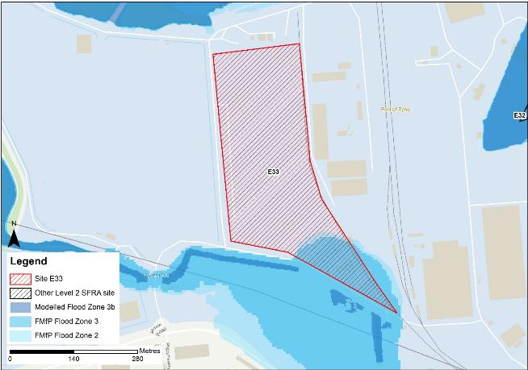
Figure 13-3: Existing risk from rivers to the site

Tyne Tidal HEC-RAS model outputs
The site is not modelled to be at risk during the extreme 0.1% AEP event. However, the DTM used to map the modelled outputs does not robustly reflect current ground conditions at the Port of Tyne. Therefore, the modelled extents, depths and hazards of flooding to this site may not be fully representative of current conditions. Any site-specific FRA for this site should update the existing model to include the latest DTM for the site and surrounding area.

Impacts from climate change
Based on the EA's SFRA guidance, the latest sea level rise allowances have been modelled as shown in Table 13-2.
Table 13-2: Modelled sea level rise allowances for the Northumbria River Basin District
Return period | Higher Central (m) | Upper End (m)
3.3% (functional floodplain) | 1.03 | 1.43
0.5% | 1.03 | 1.43
0.1% | 1.03 | 1.43
Based on cumulative sea level rise from 2000 to 2125

The site is not modelled to be at risk in the 0.5% AEP undefended event + 1.03m. Figure 13-4 shows the modelled flood depths for the 0.1% AEP undefended event + 1.43m of sea level rise allowance for climate change. Risk is modelled to be greater than present day conditions with flooding modelled to cover the north and south of the site. Maximum depths are between 0.3 and 0.6m with areas of hazard classified as 'Danger for most' (Figure 13-5). Safe access and escape routes would likely be difficult to achieve.
However, rerunning the model with the latest LIDAR data may alter the risk at this site and to the surrounding areas.
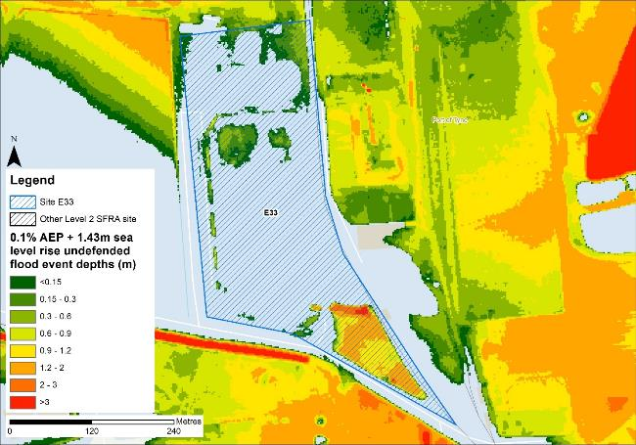
Figure 13-4: Flood depths for 0.1% AEP undefended flood event + 1.43m upper end sea level rise allowance depths (m)
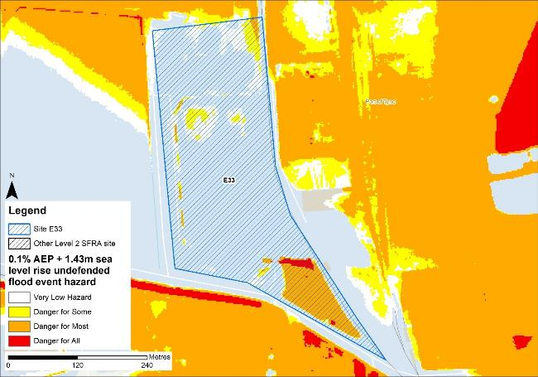
Figure 13-5: Flood hazard7 for 0.1% AEP undefended flood event +1.43m upper end sea level rise allowance

Flood risk management
The site does not benefit from any formal engineered flood defences.

Working with Natural Processes
The EA's Working with Natural Processes (WwNP) dataset has been interrogated, however there are not any applicable areas that could benefit this site.

Residual risk
Although a site may be afforded some protection from defences, there is always a residual risk of flooding from asset failure i.e. breaching / overtopping of flood defences, blockages of culverts or bridge openings.
The 2015 Tidal Tyne model and EA spatial flood defences datasets indicate that there are no formal defences, structures or culverts that could present a residual risk to the Port of Tyne sites.

Flood risk from reservoirs
The EA's Reservoir Flood Maps (RFM) (2021) show where water may go in the unlikely event of a reservoir or dam failure. Figure 13-6 shows the RFM in a 'dry-day' scenario. A dry-day scenario assumes that the water level in the reservoir is the same as the spillway level or the underside of the roof for a service reservoir and the watercourses upstream and downstream of the reservoir are at a normal level.
This site is potentially at risk from one reservoir, located outside of the South Tyneside authority area in Northumberland.
The EA's SFRA guidance states that where a proposed development site is at flood risk from a reservoir, then an assessment into whether the reservoir design or maintenance schedule needs improving should be carried out. Expert advice may be required from an all-reservoirs panel engineer. At the FRA stage, the reservoir owner, should be contacted to ascertain the flood risk in more detail and whether the proposed development could affect the reservoir’s risk designation, it’s design category or how it is operated. The council, as category 1 responders, can access more detailed information about reservoir risk and reservoir owners using the Resilience Direct system.
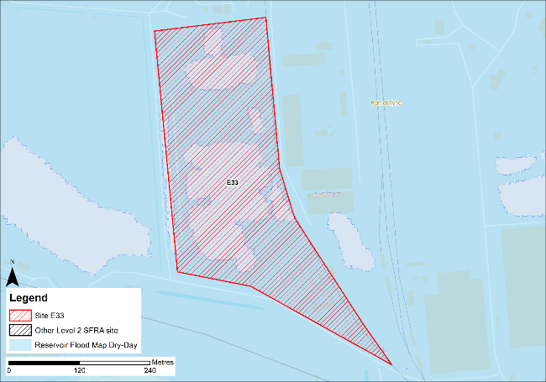
Figure 13-6: Flood risk from reservoirs

Historic flood incidents
The EA's Historic Flood Map (HFM) and Recorded Flood Outlines (RFO) datasets have been considered, and it was found that there were no recorded historic flooding incidents within the vicinity of the site.

Flood warning and access and escape routes
The EA operates a Flood Warning Service for properties located within a Flood Warning Area (FWA) for when a flood event is expected to occur. Site E33 is not located within any FWA.
Flood alerts may be issued before a flood warning for properties located within a Flood Alert Area (FAA) to provide advance notice of the possibility of flooding. A flood alert may be issued when there is less confidence that flooding will occur in a FWA. The site is located within a FAA, namely 121WAF912 - Rivers Derwent, Team, Don and estuarine tributaries.
Safe access and escape routes can be achieved based on tidal risk to the site via the unnamed road to the south of the site. However, rerunning the model with the latest LIDAR data may alter the risk at this site and to the surrounding areas.

Observations, mitigation options and site suitability - tidal
- The DTM used in the model to represent the Tyne Estuary floodplain is from 2008 and does not robustly represent current ground conditions. Therefore, the modelled extent of flooding to this site may not be fully representative of current conditions.
- The model should be updated with the most up to date LIDAR and rerun to provide a fully robust modelled representation of risk for the site and the Port of Tyne.
- Based on the modelling, the site is not modelled to be at risk in the extreme the 0.1% AEP undefended event for the present day nor the 0.5% AEP undefended event + 1.03m for climate change.
- However, risk from climate change is modelled to affect the site in the 0.1% AEP + 1.43m sea level rise climate change event, most significantly in the south of the site.
- The FRA must show that development will be safe for its lifetime taking account of the vulnerability of its users, including for appropriate evacuation procedures and flood response infrastructure are in place to manage the residual risk associated with the extreme flood event.

Flood risk from surface water

Existing risk
Based on the EA's national scale Risk of Flooding from Surface Water (RoFSW) map, the site is predominantly at very low risk of surface water flooding. Only 1% of the site is within the medium risk surface water extent, as shown in Table 13-3. The areas at risk are spread across the site. Greatest flood depths are >1.2m towards the south-eastern corner of the site (Figure 13-7). This area has a significant flood hazard (Figure 13-8). Safe access and escape routes may be possible via the unnamed roads to the east, south and west of the site.
Table 13-3: Existing surface water flood risk based on the RoFSW map
Very low risk (%) | Low risk (%) | Medium risk (%) | High risk (%)
92 | 7 | 1 | 0

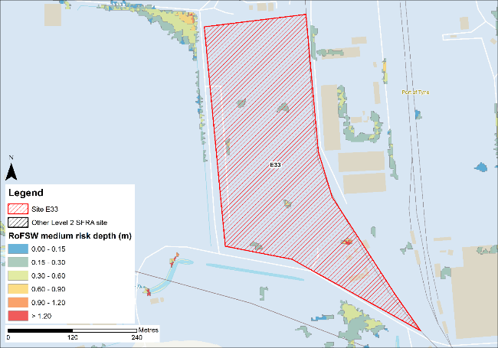
Figure 13-7: Medium risk event surface water flood depths (Risk of Flooding from Surface Water map)
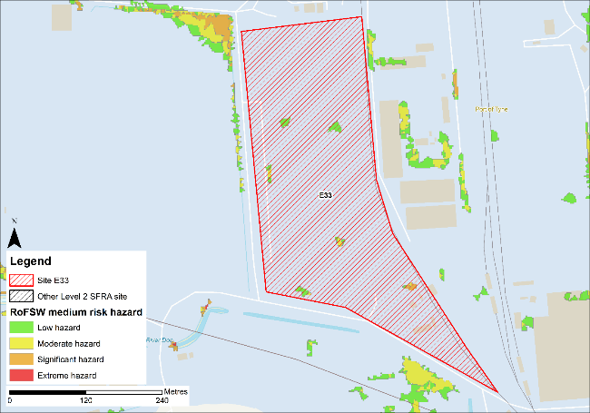
Figure 13-8: Medium risk event surface water flood hazard8 (Risk of Flooding from Surface Water map)

Impacts from climate change
The impact of climate change on surface water flood risk has been modelled. This allows for direct comparison with the RoFSW map. With consideration of the EA’s SFRA guidance, the latest climate change allowances have been modelled as shown in Table 13-4.
Table 13-4: Modelled climate change allowances for rainfall for the Tyne management catchment
Return period | Central allowance 2070s | Upper end allowance 2070s
3.3% | 30% | 40%
1% | 35% | 45%

Figure 13-9 shows the modelled surface water flood depths for the medium risk event +45% climate change. Risk is modelled to be greater than the medium risk event in present day conditions with ponding increasing across the site and alongside the road within the western site of the site.
Maximum depths are >1.2m with areas of extreme hazard near the south-eastern boundary of the site (Figure 13-10). There is also ponding along the unnamed road north-east of the site, during the medium risk +45% climate change event. However hazard along this road is predominantly classed as 'low', so safe access and escape is likely to be possible, though should be directed to the west.
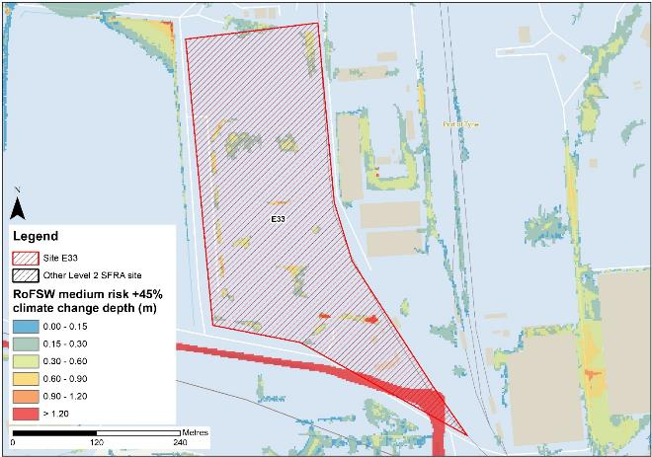
Figure 13-9: Medium risk event surface water flood depths plus 45% climate change (based on Risk of Flooding from Surface Water map)
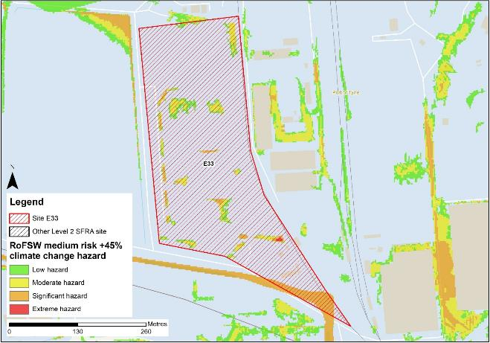
Figure 13-10: Medium risk event surface water flood hazard plus 45% climate change (based on Risk of Flooding from Surface Water map)

Risk of runoff from site post development
Runoff rates should not exceed current rates and if possible, betterment of existing rates should be aimed for. For the purposes of this assessment, the required volumes of attenuation have been calculated below based on the estimated impermeable area (ha) and limiting greenfield runoff rate of Qbar (l/s).

Table 13-5: Surface water flood risk from proposed development
Design flood event  (incl climate change) | Critical storm duration Hrs | Inflow volume m3 | Outflow volume m3 | Attenuation required  m3 | Time to empty (assuming no infiltration) Hrs | Total storage required: Area (Ha) and % of site area
30yr Rainfall+30% | 12 | 6255 | 1117 | 5138 | 55.0 | 0.34 Ha  3.4%
30yr Rainfall+40% | 12 | 6737 | 1117 | 5619 | 60.2 | 0.37 Ha  3.7%
100yr Rainfall+35% | 12* | 10062 | 2793 | 7268 (2130 exceedance storage) | 77.8 | 0.48 Ha  4.8%
100yr Rainfall+45% | 12* | 11394 | 3352 | 8042 (2423 exceedance storage) | 86.1 | 0.54 Ha  5.4%
Surface water flood risk impacts from development site, mitigation & SuDS options | As part of this Level 2 SFRA we have included calculations to provide an estimated land take if a pond with an assumed depth of 1.5m was included as part of the development.  Attenuation volumes are presented for the critical storm duration for the 3.33% AEP event with exceedance flows quantified up to the 1% event. To prevent development worsening flood risk elsewhere, surface water runoff must be managed on site.
*Critical storm duration limited to 12 hours
Note: Proposed development limiting runoff rate: (l/sec). Qbar (FEH Statistical) – 36.95, Q30 – 64.66, Q100 – 76.86.

Observations, mitigation options and site suitability - surface water
- Current risk to the site is predominantly very low, with only 1% of the site at risk in the medium risk event and a further 7% of the site at risk in the low risk event. Risk is scattered across the site and is confined to topographic low spots.
- The modelled medium risk climate change outputs indicate a greater level of risk to present day, with additional surface water flow paths present through the site. The unnamed road through the south to the site is inundated during this event, however hazard along this road is predominantly classed as 'low', so safe access and escape is likely to be possible. Access and escape should be directed to the west.
- For the 1% AEP event plus 45% climate change, approximately 5.4% of the total area of the site would be required for flood storage based on a 1.5m deep pond to ensure runoff volumes do not exceed existing rates.
- Assessment of the current drainage system in place should be carried out to ascertain any current capacity issues and whether the current system could accommodate the proposed development or whether further capacity will be required
- The Groundwater Flood Map (Figure 13-8) indicates that ground conditions may be suitable for infiltration SuDS. This should be further explored through appropriate ground survey as part of the FRA and drainage strategy.
- A full drainage strategy would be required to ensure there is no increase in surface water flood risk elsewhere as a result of new development. This will require surface water modelling based on layout plans and detailed design and full consultation with the LLFA.
- The RoFSW map is not suitable for identifying whether an individual property will flood and is therefore indicative. The RoFSW map is not appropriate to act as the sole evidence for any specific planning or regulatory decision or assessment of risk in relation to flooding at any scale without further supporting studies or evidence.

Flood risk from groundwater
Flood risk from groundwater sources is assessed in this SFRA using JBA's 5m Groundwater Flood Map. This dataset is recommended for use by the EA in the SFRA Good Practice Guide9. Figure 13-11 shows the map for Site E33 and the surrounding areas and Table 13-6 explains the risk classifications.
The majority of the site is within an area where there is a negligible risk from groundwater flooding due to the nature of the local geological deposits. Groundwater conditions may therefore be suited to infiltration SuDS. There is a very small area at the south-eastern corner of the site where there is a risk of flooding to subsurface assets, but surface manifestation of groundwater is unlikely.
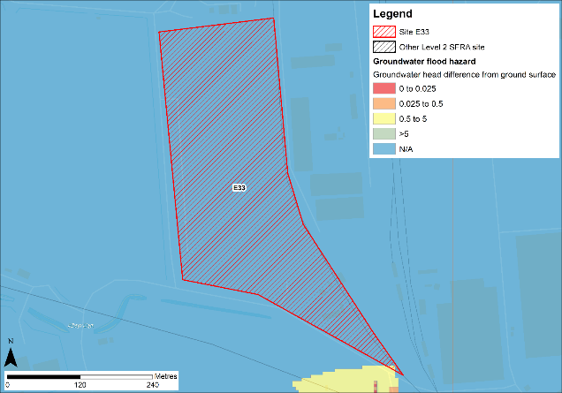
Figure 13-11: JBA 5m Groundwater Flood Map

Table 13-6: Groundwater Flood Hazard Classification
Groundwater head difference (m)* | Class label
0 to 0.025 | Groundwater levels are either at very near (within 0.025m of) the ground surface in the 100-year return period flood event.  Within this zone there is a risk of groundwater flooding to both surface and subsurface assets. Groundwater may emerge at significant rates and has the capacity to flow overland and/or pond within any topographic low spots.
0.025 to 0.5 | Groundwater levels are between 0.025m and 0.5m below the ground surface in the 100-year return period flood event.  Within this zone there is a risk of groundwater flooding to surface and subsurface assets. There is the possibility of groundwater emerging at the surface locally.
0.5 to 5 | Groundwater levels are between 0.5m and 5m below the ground surface in the 100-year return period flood event  There is a risk of flooding to subsurface assets, but surface manifestation of groundwater is unlikely.
>5 | Groundwater levels are at least 5m below the ground surface in the 100-year return period flood event.  Flooding from groundwater is not likely.
N/A | No risk.  This zone is deemed as having a negligible risk from groundwater flooding due to the nature of the local geological deposits.

Overall site assessment

Can part b) of the exception test be passed?
To pass part b) of the exception test10, it must be proven that the development can be safe for its lifetime, which is 100 years for residential development, taking account of the vulnerability of its users, without increasing risk elsewhere, and, where possible, will reduce flood risk overall.
- The site is not required to pass the exception test as it is proposed for less vulnerable uses.

Recommendation summary
Based on the evidence presented in this Level 2 SFRA:
- It should be appropriate to develop this site for less vulnerable uses, given the low risk to the site during the 0.5% AEP plus climate change event.
- Appropriate evacuation and emergency planning arrangements should be in place to ensure site users can be safely evacuated in advance of the extreme event with an allowance for climate change.
- The model should be updated with the latest LIDAR data before planning development.

FRA requirements and further work
- Any site-specific FRA for this site should update the existing model to include the latest DTM for the site and surrounding area.
- Any FRA must further consider surface water flood risk through an appropriate drainage strategy.
- Safe access and escape routes should be assessed with appropriate emergency plans and evacuation procedures in place as part of the FRA.
- Any FRA should be carried out in line with the NPPF; FRCC-PPG; EA guidance; South Tyneside Local Plan and LLFA policies; and national and local SuDS policy and guidelines.
- Throughout the FRA process, consultation should be carried out with the following, where applicable, the LPA; LLFA; emergency planning officers; EA; NWL; the highways authorities; and the emergency services.

Site E34
- Location: North of Warehouse 21
- Existing site use: brownfield
- Existing site use vulnerability: less vulnerable
- Proposed site use: employment
- Proposed site use vulnerability: less vulnerable
- Site area: 1.8 hectares
- Proposed development impermeable area: 1.5 hectares (assumed 85% of total site area)
- Watercourse: River Tyne
- Summary of requirements from scoping stage:
  - Level 1 SFRA recommendation was for withdrawal from allocation or more detailed assessment through Level 2 SFRA
  - Assessment of modelled tidal flood depths and hazards
  - Assessment of surface water flood depths and hazards
  - Modelling of latest EA climate change allowances for sea level rise and peak rainfall intensities
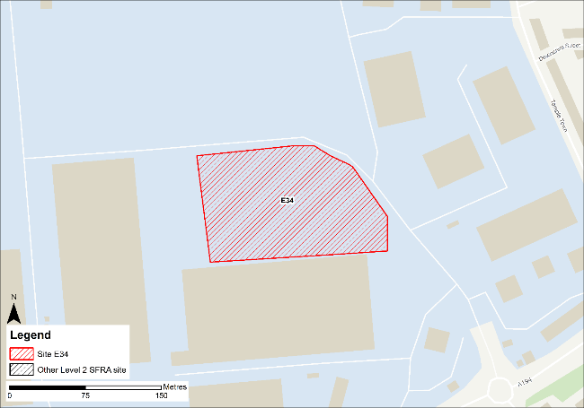
Figure 14-1: Existing site location boundary

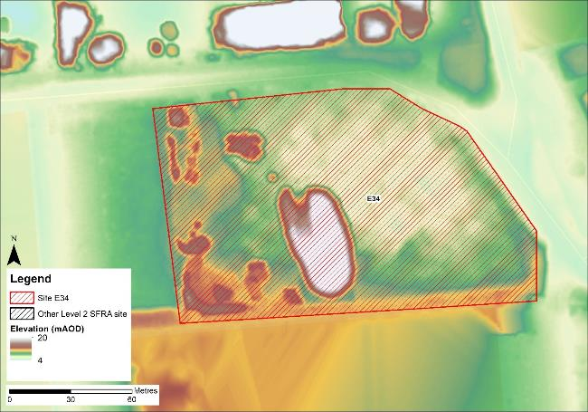
Figure 14-2: Topography

Flood risk from rivers and sea

Existing risk - Flood Map for Planning and functional floodplain
Based on the EA's Flood Map for Planning and Flood Zone 3b (functional floodplain) as updated in this Level 2 SFRA, the percentage areas of the site within each flood zone are stated in Table 14-1. The Flood Map for Planning does not consider flood defence infrastructure or the impacts of climate change (Section 14.1.3).
The entire site is within Flood Zone 1. However, as discussed, the extent of flooding to this site may not be fully representative of current conditions given the model LIDAR DTM is from 2008.
Table 14-1: Existing flood risk from rivers and sea
Flood Zone 1 (%) | Flood Zone 2 (%) | Flood Zone 3a (%) | Flood Zone 3b (%)
100 | 0 | 0 | 0

Tyne Tidal HEC-RAS model outputs
The site is not modelled to be at risk during the extreme 0.1% AEP event. However, the DTM used to map the modelled outputs does not robustly reflect current ground conditions at the Port of Tyne. Therefore, the modelled extents, depths and hazards of flooding to this site may not be fully representative of current conditions. Any site-specific FRA for this site should update the existing model to include the latest DTM for the site and surrounding area.

Impacts from climate change
Based on the EA's SFRA guidance, the latest sea level rise allowances have been modelled as shown in Table 14-2.
Table 14-2: Modelled sea level rise allowances for the Northumbria River Basin District
Return period | Higher Central (m) | Upper End (m)
3.3% (functional floodplain) | 1.03 | 1.43
0.5% | 1.03 | 1.43
0.1% | 1.03 | 1.43
Based on cumulative sea level rise from 2000 to 2125

Figure 14-3 shows the modelled flood depths for the 3.3% AEP undefended event + 1.43m of sea level rise allowance for climate change. Risk is modelled to be significantly greater than present day conditions with flooding modelled to impact the south eastern corner of the site plus some areas in the west. Maximum depths are between 1.2 and 2m with areas of hazard classified as 'Danger for most' (Figure 14-4). Safe access and escape routes would likely be difficult to achieve.
Figure 14-5 shows the modelled flood depths for the 0.5% AEP undefended event + 1.03m of sea level rise allowance for climate change. Risk is modelled to be significant across the entirety of the site, with maximum depths of between 1.2 and 2m with areas of hazard classified as 'Danger for most' (Figure 14-6). However, rerunning the model with the latest LIDAR data may alter the risk at this site and to the surrounding areas.
However, rerunning the model with the latest LIDAR data may alter the risk at this site and to the surrounding areas.
Land raising would be required at the site with finished floor levels set at 600mm above the design event flood level, once re-run using the latest LIDAR data, as recommended in EA standing advice on flood risk assessments. The design event should be the 0.5% AEP plus an allowance for climate change. Given the risk is tidal, compensatory storage is unlikely to be required, though risk must not be increased elsewhere. However, the EA must be consulted on any mitigation measures at this site.
The site-specific FRA should update the existing model with the latest LIDAR to robustly set the finished floor levels required to reduce the probability of tidal flooding to the development.

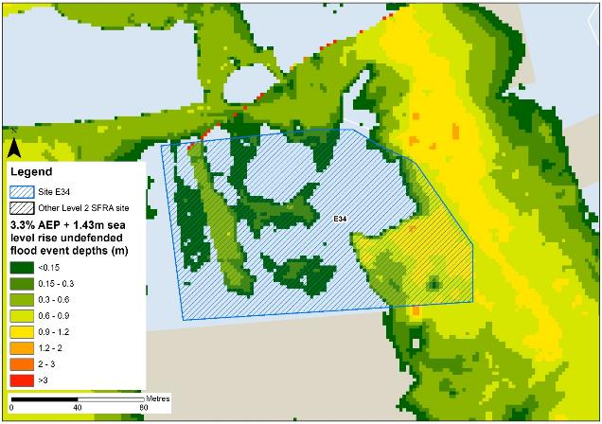
Figure 14-3: Flood depths for 3.3% AEP undefended flood event +1.43m upper end sea level rise allowance
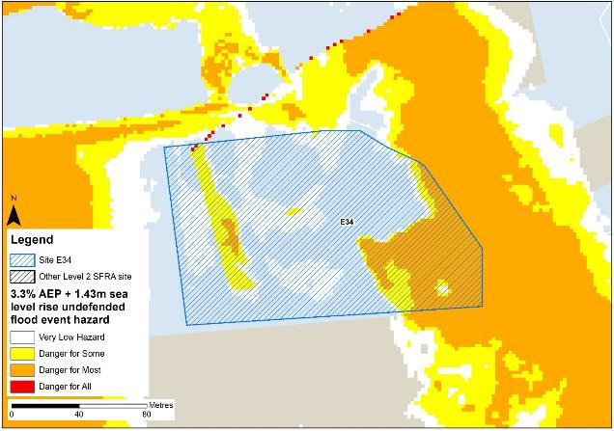
Figure 14-4: Flood hazard7 for 3.3% AEP undefended flood event +1.43m upper end sea level rise allowance
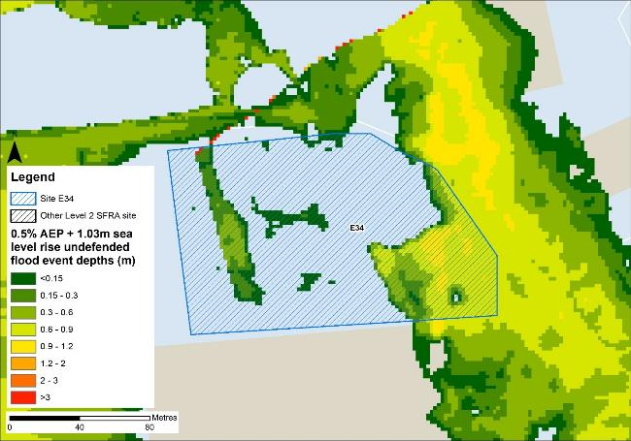
Figure 14-5: Flood depths for 0.5% AEP undefended flood event +1.03m higher central sea level rise allowance
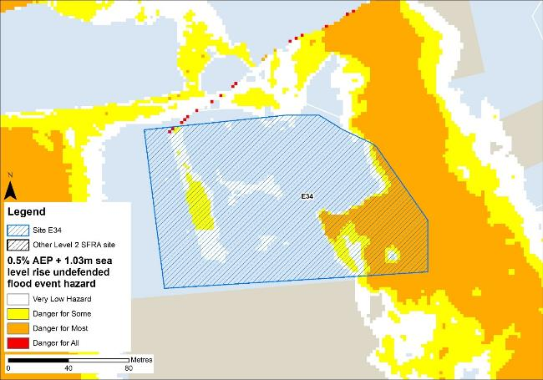
Figure 14-6: Flood hazard7 for 0.5% AEP undefended flood event +1.03m higher central sea level rise allowance

Flood risk management
The site does not benefit from any formal engineered flood defences.

Working with Natural Processes
The EA's Working with Natural Processes (WwNP) dataset has been interrogated, however there are not any applicable areas that could benefit this site.

Residual risk
Although a site may be afforded some protection from defences, there is always a residual risk of flooding from asset failure i.e. breaching / overtopping of flood defences, blockages of culverts or bridge openings.
The 2015 Tidal Tyne model and EA spatial flood defences datasets indicate that there are no formal defences, structures or culverts that could present a residual risk to the Port of Tyne sites.

Flood risk from reservoirs
The EA's Reservoir Flood Maps (RFM) (2021) show where water may go in the unlikely event of a reservoir or dam failure. Figure 14-7 shows the RFM in a 'dry-day' scenario. A dry-day scenario assumes that the water level in the reservoir is the same as the spillway level or the underside of the roof for a service reservoir and the watercourses upstream and downstream of the reservoir are at a normal level.
This site is potentially at risk from one reservoir, located outside of the South Tyneside authority area in Northumberland.
The EA's SFRA guidance states that where a proposed development site is at flood risk from a reservoir, then an assessment into whether the reservoir design or maintenance schedule needs improving should be carried out. Expert advice may be required from an all-reservoirs panel engineer. At the FRA stage, the reservoir owner, should be contacted to ascertain the flood risk in more detail and whether the proposed development could affect the reservoir’s risk designation, it’s design category or how it is operated. The council, as category 1 responders, can access more detailed information about reservoir risk and reservoir owners using the Resilience Direct system.
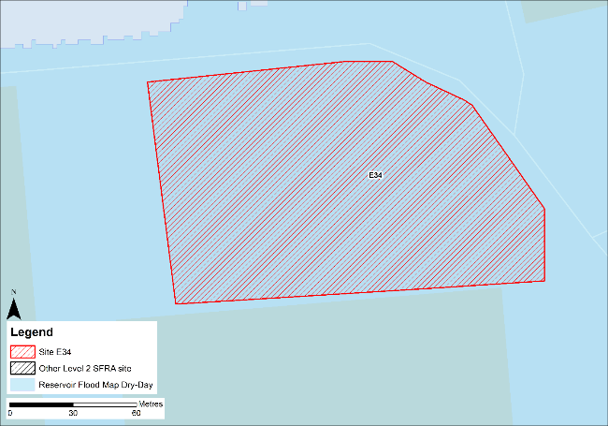
Figure 14-7: Flood risk from reservoirs

Historic flood incidents
The EA's Historic Flood Map (HFM) and Recorded Flood Outlines (RFO) datasets have been considered, and it was found that there were no recorded historic flooding incidents within the vicinity of the site.

Flood warning and access and escape routes
The EA operates a Flood Warning Service for properties located within a Flood Warning Area (FWA) for when a flood event is expected to occur. Site E34 is not located within any FWA.
Flood alerts may be issued before a flood warning for properties located within a Flood Alert Area (FAA) to provide advance notice of the possibility of flooding. A flood alert may be issued when there is less confidence that flooding will occur in a FWA. Site E34 is not located within any FWA.
Safe access and escape routes can be achieved based on present day tidal risk to the site via the unnamed road to the north. Safe access and escape may be challenging to achieve when accounting for climate change. However, rerunning the model with the latest LIDAR data may alter the risk at this site and to the surrounding areas.

Observations, mitigation options and site suitability - tidal
- The DTM used in the model to represent the Tyne Estuary floodplain is from 2008 and does not robustly represent current ground conditions. Therefore, the modelled extent of flooding to this site may not be fully representative of current conditions.
- The model should be updated with the most up to date LIDAR and rerun to provide a fully robust modelled representation of risk for the site and the Port of Tyne.
- Based on the modelling, the site is not modelled to be at risk in the extreme the 0.1% AEP undefended event.
- However, risk from climate change is modelled to affect the site in the 3.3% AEP + 1.43m sea level rise climate change event.
- Mitigation by way of land raising should be possible at this site with finished floor levels set 600mm above the 0.5% AEP plus climate change flood level. Investigations should ensure flood risk is not worsened elsewhere and given the risk is tidal, compensatory storage is unlikely to be required, though the EA must be consulted.
- The FRA must show that development will be safe for its lifetime taking account of the vulnerability of its users, including for appropriate evacuation procedures and flood response infrastructure are in place to manage the residual risk associated with the extreme flood event.

Flood risk from surface water

Existing risk
Based on the EA's national scale Risk of Flooding from Surface Water (RoFSW) map, the site is predominantly at very low risk of surface water flooding. Only 1% of the site is within the medium risk surface water extent, as shown in Table 14-3. The areas at risk are at the north-western and south-western corners of the site. Greatest flood depths are between 0.15 and 0.30m (Figure 14-8) these areas have a low to moderate flood hazard (Figure 14-9). There is a flow path along the road to the east of the site to depths of between 0.30 to 0.60m. Safe access and escape routes may be possible via the unnamed road to the north of the site, travelling west.
Table 14-3: Existing surface water flood risk based on the RoFSW map
Very low risk (%) | Low risk (%) | Medium risk (%) | High risk (%)
97 | 2 | 1 | 0

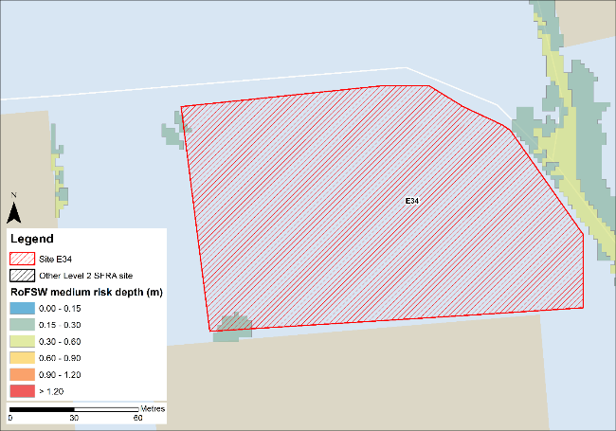
Figure 14-8: Medium risk event surface water flood depths (Risk of Flooding from Surface Water map)
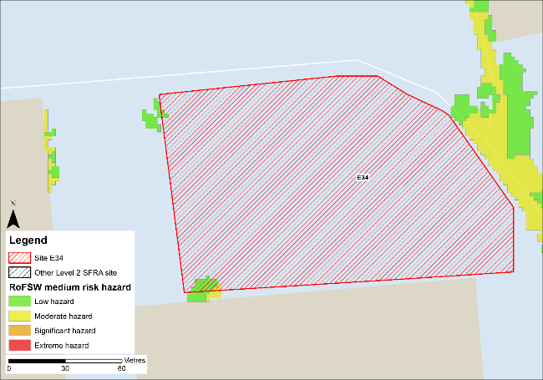
Figure 14-9: Medium risk event surface water flood hazard8 (Risk of Flooding from Surface Water map)

Impacts from climate change
The impact of climate change on surface water flood risk has been modelled. This allows for direct comparison with the RoFSW map. With consideration of the EA’s SFRA guidance, the latest climate change allowances have been modelled as shown in Table 14-4.
Table 14-4: Modelled climate change allowances for rainfall for the Tyne management catchment
Return period | Central allowance 2070s | Upper end allowance 2070s
3.3% | 30% | 40%
1% | 35% | 45%

Figure 14-10 shows the modelled surface water flood depths for the medium risk event +45% climate change. Risk is modelled to be greater than the medium risk event in present day conditions with ponding increasing across the site.
Maximum depths are between 0.6 and 0.9m with areas of extreme hazard at the western boundary of the site (Figure 14-11). There is also ponding along the unnamed roads east and north of the site during the medium risk +45% climate change event. However, on the road to the north of the site, hazard is predominantly classified as low. Therefore, safe access and escape should be directed to the unnamed road north of the site.
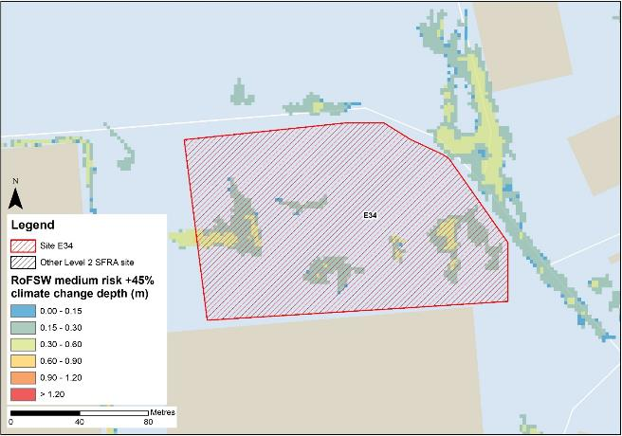
Figure 14-10: Medium risk event surface water flood depths plus 45% climate change (based on Risk of Flooding from Surface Water map)
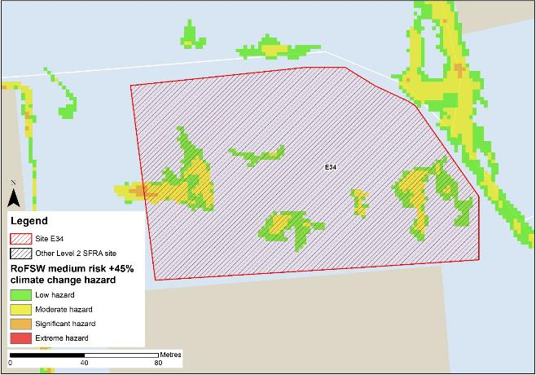
Figure 14-11: Medium risk event surface water flood hazard plus 45% climate change (based on Risk of Flooding from Surface Water map)

Risk of runoff from site post development
Runoff rates should not exceed current rates and if possible, betterment of existing rates should be aimed for. For the purposes of this assessment, the required volumes of attenuation have been calculated below based on the estimated impermeable area (ha) and limiting greenfield runoff rate of Qbar (l/s).

Table 14-5: Surface water flood risk from proposed development
Design flood event  (incl climate change) | Critical storm duration Hrs | Inflow volume m3 | Outflow volume m3 | Attenuation required  m3 | Time to empty (assuming no infiltration) Hrs | Total storage required: Area (Ha) and % of site area
30yr Rainfall+30% | 12 | 1097 | 195 | 902 | 55.4 | 0.06 Ha  3.4%
30yr Rainfall+40% | 12 | 1181 | 195 | 986 | 60.6 | 0.07 Ha  3.7%
100yr Rainfall+35% | 12* | 1760 | 487 | 1273 (371 exceedance storage) | 78.2 | 0.08 Ha  4.8%
100yr Rainfall+45% | 12* | 1992 | 584 | 1408 (421 exceedance storage) | 86.5 | 0.09 Ha  5.3%
Surface water flood risk impacts from development site, mitigation & SuDS options | As part of this Level 2 SFRA we have included calculations to provide an estimated land take if a pond with an assumed depth of 1.5m was included as part of the development.  Attenuation volumes are presented for the critical storm duration for the 3.33% AEP event with exceedance flows quantified up to the 1% event. To prevent development worsening flood risk elsewhere, surface water runoff must be managed on site.
*Critical storm duration limited to 12 hours
Note: Proposed development limiting runoff rate: (l/sec). Qbar (FEH Statistical) – 6.44, Q30 – 11.27, Q100 – 13.39.

Observations, mitigation options and site suitability - surface water
- Current risk to the site is predominantly very low, with only 1% of the site at risk in the medium risk event and a further 2% of the site at risk in the low risk event. Risk is confined to the western boundary of the site.
- The modelled medium risk climate change outputs indicate a greater level of risk to present day, with additional areas of surface water ponding across the site.
- The unnamed road to the east of the site is inundated during the climate change event, with hazard along this road predominantly classed as 'moderate', therefore safe access and egress may be challenging. Access and escape should be directed to the north.
- For the 1% AEP event plus 45% climate change, approximately 5.3% of the total area of the site would be required for flood storage based on a 1.5m deep pond to ensure runoff volumes do not exceed existing rates.
- Assessment of the current drainage system in place should be carried out to ascertain any current capacity issues and whether the current system could accommodate the proposed development or whether further capacity will be required
- The Groundwater Flood Map (Figure 14-9) indicates that ground conditions may be suitable for infiltration SuDS. This should be further explored through appropriate ground survey as part of the FRA and drainage strategy.
- A full drainage strategy would be required to ensure there is no increase in surface water flood risk elsewhere as a result of new development. This will require surface water modelling based on layout plans and detailed design and full consultation with the LLFA.
- The RoFSW map is not suitable for identifying whether an individual property will flood and is therefore indicative. The RoFSW map is not appropriate to act as the sole evidence for any specific planning or regulatory decision or assessment of risk in relation to flooding at any scale without further supporting studies or evidence.

Flood risk from groundwater
Flood risk from groundwater sources is assessed in this SFRA using JBA's 5m Groundwater Flood Map. This dataset is recommended for use by the EA in the SFRA Good Practice Guide9. Figure 14-12 shows the map for Site E34 and the surrounding areas and Table 14-6 explains the risk classifications.
The entirety of the site is within an area where there is a negligible risk from groundwater flooding due to the nature of the local geological deposits. Groundwater conditions may therefore be suited to infiltration SuDS.
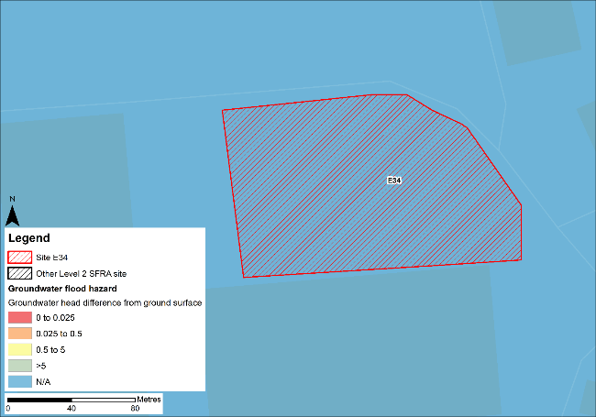
Figure 14-12: JBA 5m Groundwater Flood Map

Table 14-6: Groundwater Flood Hazard Classification
Groundwater head difference (m)* | Class label
0 to 0.025 | Groundwater levels are either at very near (within 0.025m of) the ground surface in the 100-year return period flood event.  Within this zone there is a risk of groundwater flooding to both surface and subsurface assets. Groundwater may emerge at significant rates and has the capacity to flow overland and/or pond within any topographic low spots.
0.025 to 0.5 | Groundwater levels are between 0.025m and 0.5m below the ground surface in the 100-year return period flood event.  Within this zone there is a risk of groundwater flooding to surface and subsurface assets. There is the possibility of groundwater emerging at the surface locally.
0.5 to 5 | Groundwater levels are between 0.5m and 5m below the ground surface in the 100-year return period flood event  There is a risk of flooding to subsurface assets, but surface manifestation of groundwater is unlikely.
>5 | Groundwater levels are at least 5m below the ground surface in the 100-year return period flood event.  Flooding from groundwater is not likely.
N/A | No risk.  This zone is deemed as having a negligible risk from groundwater flooding due to the nature of the local geological deposits.

Overall site assessment

Can part b) of the exception test be passed?
To pass part b) of the exception test10, it must be proven that the development can be safe for its lifetime, which is 100 years for residential development, taking account of the vulnerability of its users, without increasing risk elsewhere, and, where possible, will reduce flood risk overall.
- The site is not required to pass the exception test as it is proposed for less vulnerable uses.

Recommendation summary
Based on the evidence presented in this Level 2 SFRA:
- It should be possible to develop this site for less vulnerable uses. However, mitigation by way of land raising would be required.
- Finished floor levels should place the development 600mm above the 0.5% AEP plus climate change flood level without increasing risk elsewhere.
- Updating and rerunning the model with the latest LIDAR data before finalising finished floor levels and planning development is recommended.

FRA requirements and further work
- The site-specific FRA should update the existing model to include the latest DTM for the site and surrounding area.
- Mitigation by way of land raising should be assessed and finished floor levels set 600mm above the 0.5% AEP plus climate change flood level. Investigations should ensure flood risk is not worsened elsewhere.
- Safe access and escape routes should be assessed with appropriate emergency plans and evacuation procedures in place as part of the FRA.
- Any FRA should be carried out in line with the NPPF; FRCC-PPG; EA guidance; South Tyneside Local Plan and LLFA policies; and national and local SuDS policy and guidelines.
- Throughout the FRA process, consultation should be carried out with the following, where applicable, the LPA; LLFA; emergency planning officers; EA; NWL; the highways authorities; and the emergency services.

Site E35
- Location: Former M H Southern
- Existing site use: brownfield, industrial
- Existing site use vulnerability: less vulnerable
- Proposed site use: employment
- Proposed site use vulnerability: less vulnerable
- Site area: 2.8 hectares
- Proposed development impermeable area: 2.4 hectares (assumed 85% of total site area)
- Watercourse: River Tyne
- Summary of requirements from scoping stage:
  - Level 1 SFRA recommendation was for withdrawal from allocation or more detailed assessment through Level 2 SFRA
  - Assessment of modelled tidal flood depths and hazards
  - Assessment of surface water flood depths and hazards
  - Modelling of latest EA climate change allowances for sea level rise and peak rainfall intensities
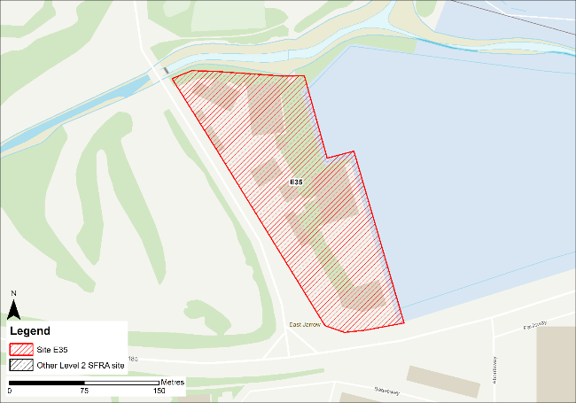
Figure 15-1: Existing site location boundary

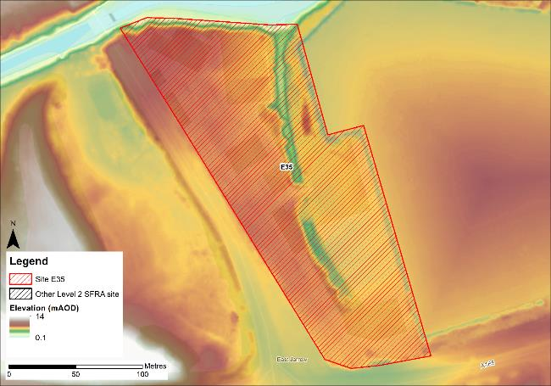
Figure 15-2: Topography

Flood risk from rivers and sea

Existing risk - Flood Map for Planning and functional floodplain
Based on the EA's Flood Map for Planning and Flood Zone 3b (functional floodplain) as updated in this Level 2 SFRA, the percentage areas of the site within each flood zone are stated in Table 15-1. The Flood Map for Planning does not consider flood defence infrastructure or the impacts of climate change (Section 15.1.3).
Approximately 3% of the site is located within Flood Zone 3b, along the small drainage ditch through the centre of the site. However, as discussed, the extent of flooding to this site may not be fully representative of current conditions given the model LIDAR DTM is from 2008.
Table 15-1: Existing tidal flood risk
Flood Zone 1 (%) | Flood Zone 2 (%) | Flood Zone 3a (%) | Flood Zone 3b (%)
96 | 1 | 0 | 3

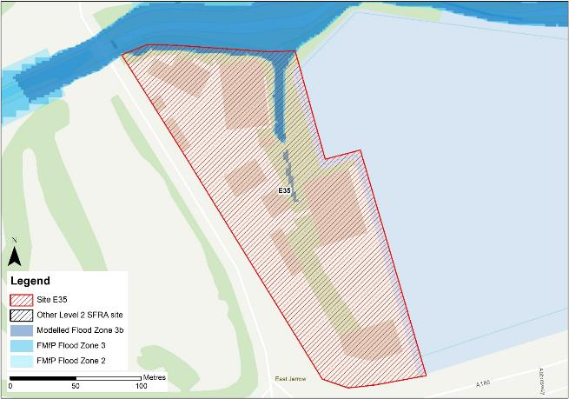
Figure 15-3: Existing risk from rivers to the site

Tyne Tidal HEC-RAS model outputs
Figure 15-4 shows the modelled flood depths for the 0.5% AEP undefended event. Flooding in this event is located along the small drainage ditch / tributary of the River Don within the northern half of the site. Maximum flood depths are between 0.9 and 1.2m with areas of hazard categorised as 'Danger for most' (Figure 15-5). Safe access and escape should be possible via Church Bank to the west of the site or via the A185 to the south of the site.
However, the DTM used to map the modelled outputs does not robustly reflect current ground conditions at the Port of Tyne. Therefore, the modelled extents, depths and hazards of flooding to this site may not be fully representative of current conditions. Any site-specific FRA for this site should update the existing model to include the latest DTM for the site and surrounding area.
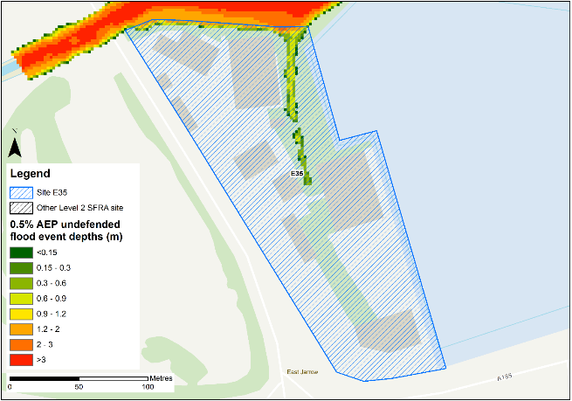
Figure 15-4: Flood depths for 0.5% AEP undefended flood event
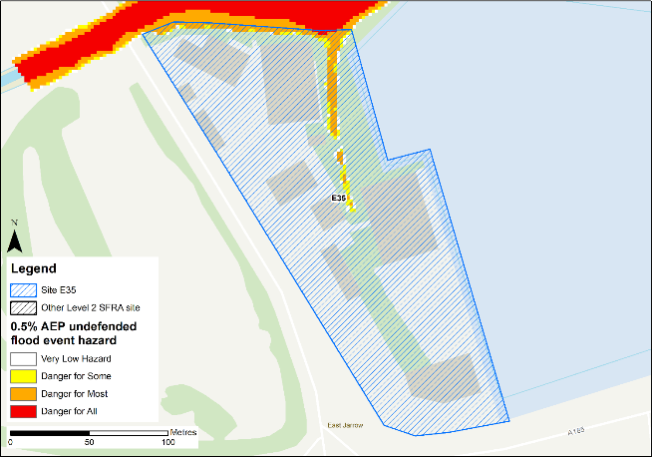
Figure 15-5: Flood hazard7 for 0.5% AEP undefended flood event

Impacts from climate change
Based on the EA's SFRA guidance, the latest sea level rise allowances have been modelled as shown in Table 15-2.
Table 15-2: Modelled sea level rise allowances for the Northumbria River Basin District
Return period | Higher Central (m) | Upper End (m)
3.3% (functional floodplain) | 1.03 | 1.43
0.5% | 1.03 | 1.43
0.1% | 1.03 | 1.43
Based on cumulative sea level rise from 2000 to 2125

Figure 15-6 shows the modelled flood depths for the 3.3% AEP undefended event + 1.43m of sea level rise allowance for climate change. Risk is modelled to be marginally greater than present day conditions with flooding from the drainage ditch modelled to encroach further onto the site in addition to flooding along the eastern boundary of the site. Maximum depths are between 2 and 3m with areas of hazard classified as 'Danger for all' (Figure 15-7) within the ditch. Safe access and escape routes should be achievable via Church Bank to the west of the site or via the A185 to the south of the site. Flood extent, depth and hazard are shown to be similar in the 0.5% AEP undefended event + 1.03m sea level allowance.
However, rerunning the model with the latest LIDAR data may alter the risk at this site and to the surrounding areas.
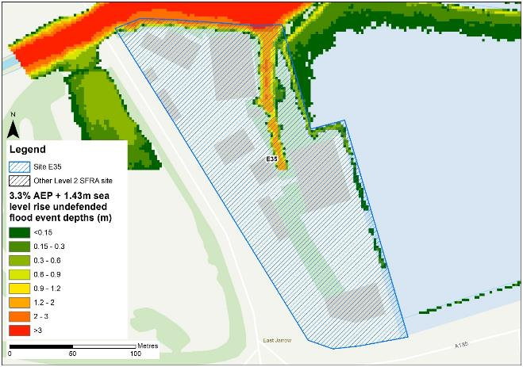
Figure 15-6: Flood depths for the 3.3% AEP undefended flood event +1.43m upper end sea level rise allowance
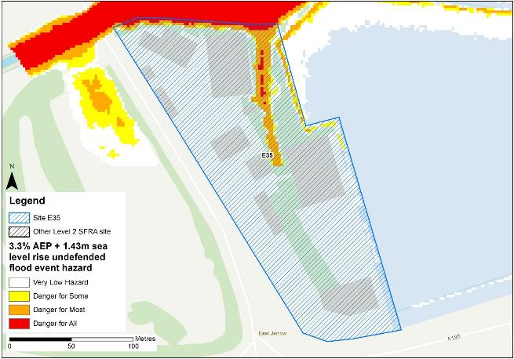
Figure 15-7: Flood hazard for the 3.3% AEP undefended flood event +1.43m upper end sea level rise allowance

Flood risk management
The site does not benefit from any formal engineered flood defences.

Working with Natural Processes
The EA's Working with Natural Processes (WwNP) dataset has been interrogated to identify opportunities for Natural Flood Management (NFM) to reduce flood risk to the site and surrounding areas. There is potential upstream of the site for floodplain reconnection and tree planting within riparian areas. These areas are shown in Figure 15-8.
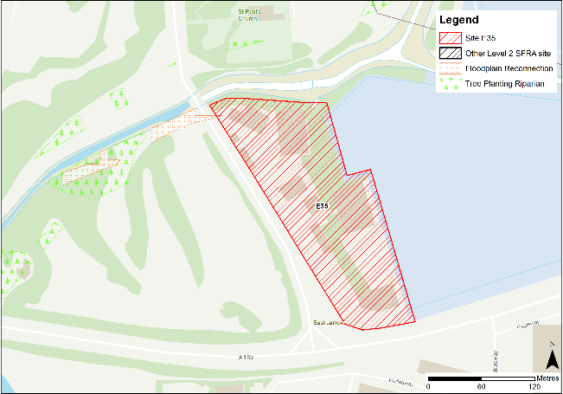
Figure 15-8: Natural Flood Management (NFM) opportunities

Residual risk
Although a site may be afforded some protection from defences, there is always a residual risk of flooding from asset failure i.e. breaching / overtopping of flood defences, blockages of culverts or bridge openings.
The 2015 Tidal Tyne model and EA spatial flood defences datasets indicate that there are no formal defences, structures or culverts that could present a residual risk to the Port of Tyne sites.

Flood risk from reservoirs
The EA's Reservoir Flood Maps (RFM) (2021) show where water may go in the unlikely event of a reservoir or dam failure. Figure 15-9 shows the RFM in a 'dry-day' scenario. A dry-day scenario assumes that the water level in the reservoir is the same as the spillway level or the underside of the roof for a service reservoir and the watercourses upstream and downstream of the reservoir are at a normal level.
This site is potentially at risk from one reservoir, located outside of the South Tyneside authority area in Northumberland.
The EA's SFRA guidance states that where a proposed development site is at flood risk from a reservoir, then an assessment into whether the reservoir design or maintenance schedule needs improving should be carried out. Expert advice may be required from an all-reservoirs panel engineer. At the FRA stage, the reservoir owner, should be contacted to ascertain the flood risk in more detail and whether the proposed development could affect the reservoir’s risk designation, it’s design category or how it is operated. The council, as category 1 responders, can access more detailed information about reservoir risk and reservoir owners using the Resilience Direct system.
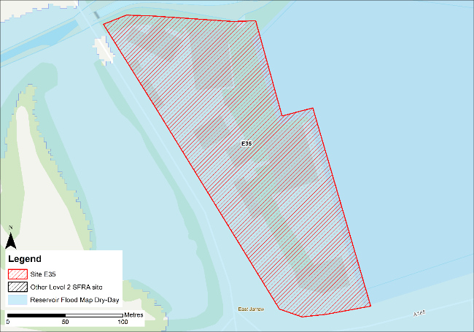
Figure 15-9: Flood risk from reservoirs

Historic flood incidents
The EA's Historic Flood Map (HFM) and Recorded Flood Outlines (RFO) datasets have been considered. Historic risk to the site is shown in Figure 15-10 which shows that the northern boundary, and part of the eastern half of the site has been subject to flooding in the past. The RFO datasets references that the historic event occurred in December 1978 due to flooding from the River Tyne.

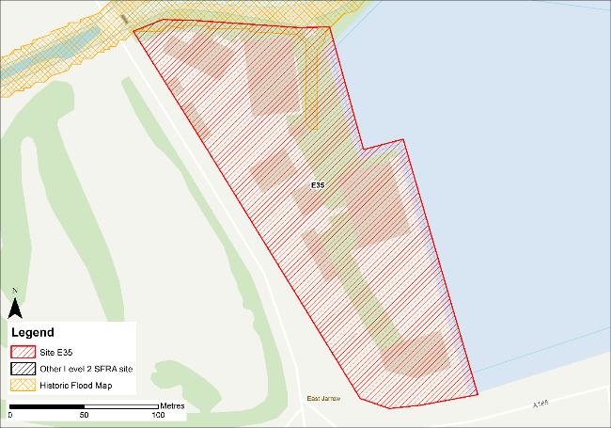
Figure 15-10: Recorded historic flood events onsite and around the site

Flood warning and access and escape routes
The EA operates a Flood Warning Service for properties located within a Flood Warning Area (FWA) for when a flood event is expected to occur. Site E35 is not located within any FWA.
Flood alerts may be issued before a flood warning for properties located within a Flood Alert Area (FAA) to provide advance notice of the possibility of flooding. A flood alert may be issued when there is less confidence that flooding will occur in a FWA. The site is located within a FAA, namely 121WAF912 - Rivers Derwent, Team, Don and estuarine tributaries.
Safe access and escape routes can be achieved based on tidal risk to the site via Church Bank to the west of the site or via the A185 to the south of the site. However, rerunning the model with the latest LIDAR data may alter the risk at this site and to the surrounding areas.

Observations, mitigation options and site suitability - tidal
- The DTM used in the model to represent the Tyne Estuary floodplain is from 2008 and does not robustly represent current ground conditions. Therefore, the modelled extent of flooding to this site may not be fully representative of current conditions.
- The model should be updated with the most up to date LIDAR and rerun to provide a fully robust modelled representation of risk for the site and the Port of Tyne.
- The site is modelled to be within the functional floodplain (according to the Tidal Tyne model) along the small drainage ditch / tributary of the river Don within the northern half of the site. Development is not permitted within the functional floodplain nor over drainage ditches. This flow path exists in the 2021 LIDAR DTM therefore should not be obstructed and potentially used as green / blue infrastructure.
- Modelled risk from climate change increases the risk to the site and surrounding areas, flooding encroaching further into the site from the drainage ditch in addition to along the eastern site boundary during the 3.3% AEP + 1.43m sea level rise climate change event.
- There is no significant additional risk to the site during the 3.3% AEP undefended event + 1.43m sea level allowance for climate change (as well as the 0.5% AEP undefended event + 1.03m sea level allowance) that would impact the ability to develop the site.
- The FRA must show that development will be safe for its lifetime taking account of the vulnerability of its users, including for appropriate evacuation procedures and flood response infrastructure are in place to manage the residual risk associated with the extreme flood event.

Flood risk from surface water

Existing risk
Based on the EA's national scale Risk of Flooding from Surface Water (RoFSW) map, the site is predominantly at very low risk of surface water flooding. Only 2% of the site is within the high risk surface water extent, as shown in Table 15-3. The areas at risk are spread across the site. Greatest flood depths are between 0.60 and 0.90m within the green area at the centre of the site (Figure 15-11) this area has a significant flood hazard (Figure 15-12). Safe access and escape routes may be possible via the Church Bank to the west of the site.
Table 15-3: Existing surface water flood risk based on the RoFSW map
Very low risk (%) | Low risk (%) | Medium risk (%) | High risk (%)
91 | 5 | 2 | 2
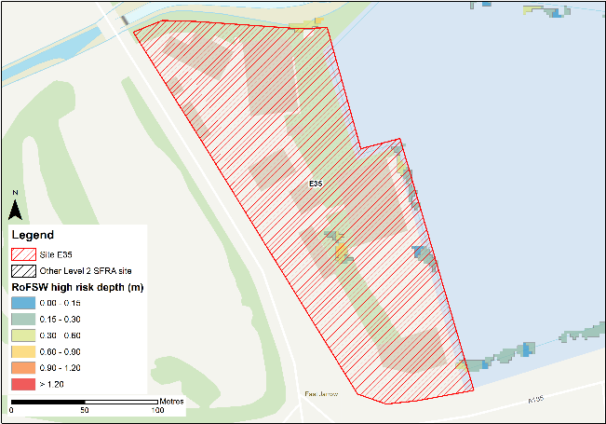
Figure 15-11: High risk event surface water flood depths (Risk of Flooding from Surface Water map)
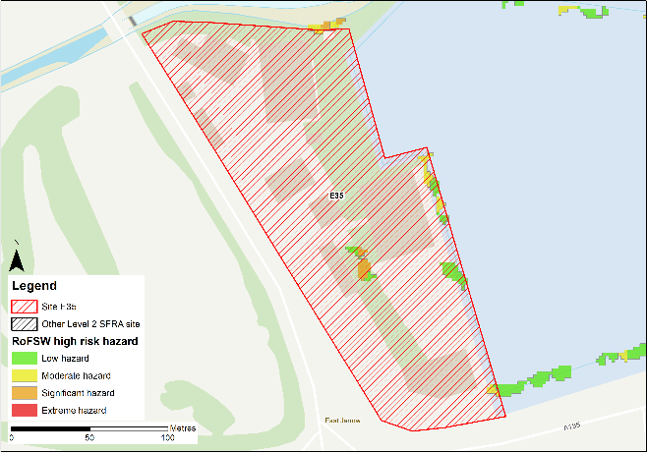
Figure 15-12: High risk event surface water flood hazard8 (Risk of Flooding from Surface Water map)

Impacts from climate change
Table 15-4: Modelled climate change allowances for rainfall for the Tyne management catchment
Return period | Central allowance 2070s | Upper end allowance 2070s
3.3% | 30% | 40%
1% | 35% | 45%
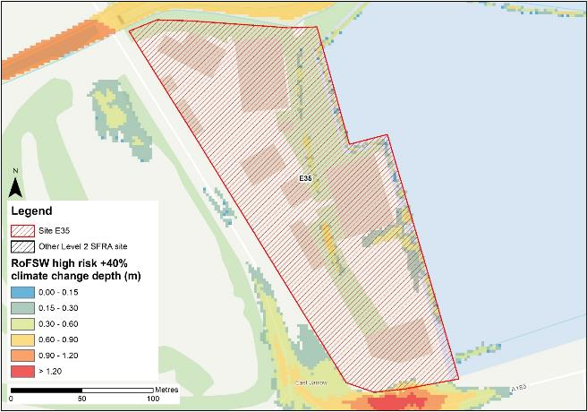
Figure 15-13: High risk event surface water flood depths plus 40% climate change (based on Risk of Flooding from Surface Water map)
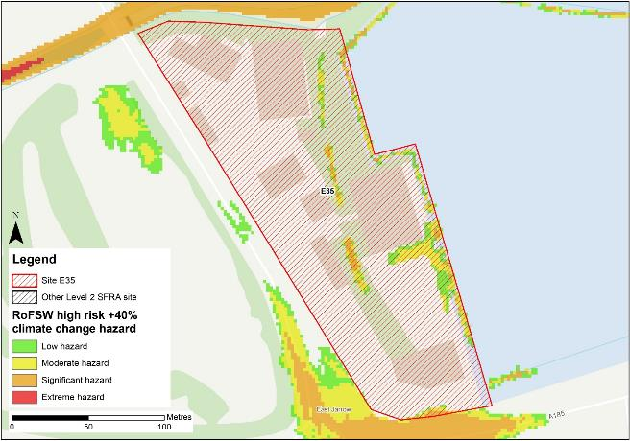
Figure 15-14: High risk event surface water flood hazard plus 40% climate change (based on Risk of Flooding from Surface Water map)
Figure 15-13 shows the modelled surface water flood depths for the high risk event +40% climate change. Risk is modelled to be greater than the high risk event in present day conditions with ponding within the site increasing along the eastern and southern site boundaries as well as along the drainage ditch within the northern half of the site.
Maximum depths are between 0.6 and 0.9m with areas of significant hazard (Figure 15-14). There is ponding along the A185, south of the site, and along the Church Bank west of the site during the high risk +40% climate change event with significant hazard. Safe access and escape routes may achievable travelling north via Church Bank to the west of the site.

Risk of runoff from site post development
Runoff rates should not exceed current rates and if possible, betterment of existing rates should be aimed for. For the purposes of this assessment, the required volumes of attenuation have been calculated below based on the estimated impermeable area (assumed 85% of total area) and limiting greenfield runoff rate of Qbar (l/s).

Table 15-5: Surface water flood risk from proposed development
Design flood event  (incl climate change) | Critical storm duration Hrs | Inflow volume m3 | Outflow volume m3 | Attenuation required  m3 | Time to empty (assuming no infiltration) Hrs | Total storage required: Area (Ha) and % of site area
30yr Rainfall+30% | 12 | 1789 | 323 | 1463 | 54.3 | 0.10 Ha 3.4%
30yr Rainfall+40% | 12 | 1923 | 323 | 1600 | 59.4 | 0.11 Ha 3.7%
100yr Rainfall+35% | 12* | 2882 | 807 | 2075 (612 exceedance storage) | 77.0 | 0.14 Ha 4.9%
100yr Rainfall+45% | 12* | 3266 | 968 | 2298 (697 exceedance storage) | 85.2 | 0.15 Ha 5.4%
Surface water flood risk impacts from development site, mitigation & SuDS options | As part of this Level 2 SFRA we have included calculations to provide an estimated land take if a pond with an assumed depth of 1.5m was included as part of the development.  Attenuation volumes are presented for the critical storm duration for the 3.33% AEP event with exceedance flows quantified up to the 1% event. To prevent development worsening flood risk elsewhere, surface water runoff must be managed on site.
*Critical storm duration limited to 12 hours
Note: Proposed development limiting runoff rate: (l/sec). Qbar (FEH Statistical) – 10.67, Q30 – 18.67, Q100 – 22.19.

Observations, mitigation options and site suitability - surface water
- Current risk to the site is predominantly very low, however 5% of the site at risk in the low risk event, 2% at risk in the medium risk event and a further 2% of the site at risk in the high risk event. Risk is spread across the site during the high risk event.
- The modelled high risk climate change outputs indicate a greater level of risk to present day, with additional areas of surface water ponding across the site.
- The A185 and the southern end of Church Bank are inundated during the climate change event, with hazard along the road predominantly classed as 'moderate', therefore safe access escape should be directed to the northern end of Church Bank.
- For the 1% AEP event plus 45% climate change, approximately 5.4% of the total area of the site would be required for flood storage based on a 1.5m deep pond to ensure runoff volumes do not exceed existing rates.
- Assessment of the current drainage system in place should be carried out to ascertain any current capacity issues and whether the current system could accommodate the proposed development or whether further capacity will be required
- The Groundwater Flood Map (Figure 15-15) indicates that ground conditions may be suitable for infiltration SuDS. This should be further explored through appropriate ground survey as part of the FRA and drainage strategy.
- A full drainage strategy would be required to ensure there is no increase in surface water flood risk elsewhere as a result of new development. This will require surface water modelling based on layout plans and detailed design and full consultation with the LLFA.
- The RoFSW map is not suitable for identifying whether an individual property will flood and is therefore indicative. The RoFSW map is not appropriate to act as the sole evidence for any specific planning or regulatory decision or assessment of risk in relation to flooding at any scale without further supporting studies or evidence.

Flood risk from groundwater
Flood risk from groundwater sources is assessed in this SFRA using JBA's 5m Groundwater Flood Map. This dataset is recommended for use by the EA in the SFRA Good Practice Guide9. Figure 15-15 shows the map for Site E35 and the surrounding areas and Table 15-6 explains the risk classifications.
The entirety of the site is within an area where there is a negligible risk from groundwater flooding due to the nature of the local geological deposits. Groundwater conditions may therefore be suited to infiltration SuDS.

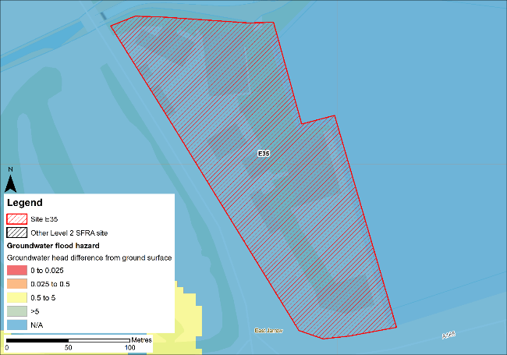
Figure 15-15: JBA 5m Groundwater Flood Map

Table 15-6: Groundwater Flood Hazard Classification
Groundwater head difference (m)* | Class label
0 to 0.025 | Groundwater levels are either at very near (within 0.025m of) the ground surface in the 100-year return period flood event.  Within this zone there is a risk of groundwater flooding to both surface and subsurface assets. Groundwater may emerge at significant rates and has the capacity to flow overland and/or pond within any topographic low spots.
0.025 to 0.5 | Groundwater levels are between 0.025m and 0.5m below the ground surface in the 100-year return period flood event.  Within this zone there is a risk of groundwater flooding to surface and subsurface assets. There is the possibility of groundwater emerging at the surface locally.
0.5 to 5 | Groundwater levels are between 0.5m and 5m below the ground surface in the 100-year return period flood event  There is a risk of flooding to subsurface assets, but surface manifestation of groundwater is unlikely.
>5 | Groundwater levels are at least 5m below the ground surface in the 100-year return period flood event.  Flooding from groundwater is not likely.
N/A | No risk.  This zone is deemed as having a negligible risk from groundwater flooding due to the nature of the local geological deposits.

Overall site assessment

Can part b) of the exception test be passed?
To pass part b) of the exception test10, it must be proven that the development can be safe for its lifetime, which is 100 years for residential development, taking account of the vulnerability of its users, without increasing risk elsewhere, and, where possible, will reduce flood risk overall.
- The site is not required to pass the exception test as it is proposed for less vulnerable uses.

Recommendation summary
Based on the evidence presented in this Level 2 SFRA:
- It should be appropriate to develop this site for less vulnerable uses, given the low risk to the site during the 0.5% AEP undefended event + 1.03m sea level allowance for climate change.
- The drainage ditch must be left free of obstruction and be included in site design.
- Updating and rerunning the model with the latest LIDAR data before finalising site plans is recommended.

FRA requirements and further work
- Any site-specific FRA for this site should update the existing model to include the latest DTM for the site and surrounding area.
- Any FRA must further consider long term surface water flood risk through a drainage strategy.
- Any FRA should be carried out in line with the NPPF; FRCC-PPG; EA guidance; South Tyneside Local Plan and LLFA policies; and national and local SuDS policy and guidelines.
- Throughout the FRA process, consultation should be carried out with the following, where applicable, the LPA; LLFA; emergency planning officers; EA; NWL; the highways authorities; and the emergency services.

Licensing
To cover all figures in this report:
- Contains Environment Agency information © Environment Agency and/or database right [2024]
- Contains Ordnance Survey data © Crown copyright and database right [2024] License number 100019570

Offices at
Bristol
Coleshill
Doncaster
Dublin
Edinburgh
Exeter
Glasgow
Haywards Heath
Isle of Man
Leeds
Limerick
Newcastle upon Tyne
Newport
Peterborough
Portsmouth
Saltaire
Skipton
Tadcaster
Thirsk
Wallingford
Warrington

Registered Office
1 Broughton Park
Old Lane North
Broughton
SKIPTON
North Yorkshire
BD23 3FD
United Kingdom

+44(0)1756 799919
info@jbaconsulting.com
www.jbaconsulting.com
Follow us:

Jeremy Benn Associates Limited
Registered in England 3246693

JBA Group Ltd is certified to:
ISO 9001:2015
ISO 14001:2015
ISO 27001:2013
ISO 45001:2018

National Planning Policy Framework | UK Government | 2021
Flood Risk and Coastal Change Planning Practice Guidance | UK Government | 2022
How to Prepare a Strategic Flood Risk Assessment | Environment Agency | 2024
Strategic Flood Risk Assessment Good Practice Guide | Association of Directors of Environment, Economy, Planning & Transport | 2021
Flood Risk Assessments: Climate Change Allowances | Environment Agency | 2022
South Tyneside Surface Water Management Plan (southtyneside.gov.uk)
Fluvial hazard ratings based on Table 4 of the SUPPLEMENTARY NOTE ON FLOOD HAZARD RATINGS AND THRESHOLDS FOR DEVELOPMENT PLANNING AND CONTROL PURPOSE – Clarification of the Table 13.1 of FD2320/TR2 and Figure 3.2 of FD2321/TR1. May 2008.
Based on Section 7.5 Hazard rating. What is the Risk of Flooding from Surface Water map? Report version 2.0. April 2019. Environment Agency
Strategic flood risk assessment good practice guide. ADEPT. December 2021.
Para 164 National Planning Policy Framework 2021

