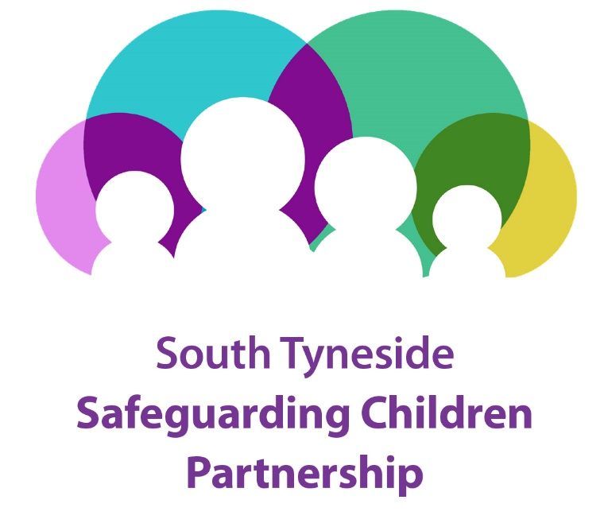

**2023-2024 Annual Report**

**CONTENTS**

|  |  |  |
| --- | --- | --- |
| **SECTION** | **TITLE** | **PAGE NO** |
| **1.** | **Foreword** | **Page 3** |
| **2.** | **Context** | **Page 4** |
| **3.** | **Purpose and Structure** | **Page 5** |
| **4.** | **Membership** | **Page 8** |
| **5.** | **CFSC Ofsted Inspection** | **Page 10** |
| **6.** | **Learning from Child Safeguarding Practice Reviews** | **Page 11** |
| **7.** | **The Strategic Delivery Plan** | **Page 13** |
| **8.** | **Multi-Agency Data and Information** | **Page 18** |
| **9.** | **The Voice of Children and Young People** | **Page 18** |
| **10.** | **Subgroup Highlights** | **Page 19** |
| **11.** | **Partner Contributions to Safeguarding** | **Page 27** |
| **12.** | **Looking Ahead to 2024-25** | **Page 31** |

**Appendices**

|  |  |  |
| --- | --- | --- |
| **A** | **Attendance at Meetings** | **Page 32** |
| **B** | **Partner Contributions to Safeguarding** | **Page 32** |
| **C** | **Contributions and Summary of 2023-2024 Budget** | **Page 32** |
| **D** | **Glossary of Abbreviations** | **Page 32** |
| **E** | **Contacts** | **Page 33** |

**1.** **FOREWORD**

1.1 This annual report has been challenging to write due to the significant change to governance and accountability for Safeguarding that has been implemented in South Tyneside.

1.2 Up until September 2023, there was a joint approach between Children’s and Adults safeguarding at a local level. However, with the update to the statutory guidance - Working Together to Safeguard Children 2023, the introduction of the National Framework for Children’s Social Care and the outcome of the Ofsted inspection of Children’s Social Care locally, it was felt that there was a need to separate these two areas to ensure there was a clear focus on Children’s Safeguarding.

1.3 As such, this annual report recognises the significant change to the governance arrangements mid-year and from September 2023 there has been a new Children’s Safeguarding Partnership in place.



Stuart Easingwood

Chair of the Safeguarding Children Partnership / Director of Childrens Services

**2. CONTEXT**

2.1 Prior to September 2023 there was a collaborative safeguarding partnership with children and adults. In September 2023 partners agreed to have a separate Safeguarding Children Partnership. The rationale for a separate arrangement was because from a national and local perspective it was becoming more evident that there was a need to have a more aligned approach to the children’s safeguarding agenda with a particular focus on the following;

* The update to the statutory guidance, Working Together to Safeguard Children 2023. The guidance includes substantial updates intended to strengthen multi-agency working across the whole system of help, support and protection for children and their families.
* The introduction of the National Framework for Children’s Social Care which describes the outcomes that local authorities should achieve for children, young people and families in children’s social care.
* The outcome of the Ofsted inspection of Children and Families Social Care

2.2 At the time of the Children and Adults Partnership there was a focus on three strategic priorities:

|  |  |  |
| --- | --- | --- |
| **Effective Safeguarding** | **Prevention and Early Intervention** | **Focus on Practice** |

2.3 The Children and Adults Safeguarding Partnership made some good progress as outlined in the [STSCAP: 2022 / 2023 Annual report - South Tyneside Council](https://southtyneside.gov.uk/article/20842/STSCAP-2022-2023-Annual-report)

2.4 The recruitment of the Partnership Independent Chair was made in November 2023.

2.5 In December 2023 the revised version of Working Together 2023 was published. Within the document it was clear that future arrangements for Safeguarding Childrens Partnerships no longer required an Independent Chair but would benefit from an Independent Scrutineer. The aim of independent scrutiny is to drive continuous improvement and provide assurance that arrangements are working effectively for children, families and practitioners and contribute to the wider system of accountability.

2.6 The Independent Chair undertook the role of Independent Scrutineer in January 2024.

2.7 The partnership undertook the DfE Partnership Health check during March/April 2024. The sessions helped inform the Partnership of the Enablers and Barriers for effective partnership working and have been considered within the partnership priorities for 2024-25.

2.8 The partnership has an agreed multi- agency implementation plan for Working Together 2023.Work is in progress to develop the new arrangements in order for them to be agreed and signed off in December 2024 with implementation from 1st January 2025.

**3. THE SAFEGUARDING CHILDRENS PARTNERSHIP – PURPOSE & STRUCTURE**

**Purpose of the Partnership**

3.1 The Childrens Act 2004 requires every local authority , Intergrated Care Board and Police constabulary to be covered by multi-agency safeguarding arrangements, MASAs.The purpose of which is to ensure that at a local level, organsiations and agencies are clear about how they will work together to safeguard childen and promotoe their welfare.

3.2 The statutory safeguarding partners are known as ‘Lead Safeguarding Partners’, LSP’s are the following:

|  |  |  |
| --- | --- | --- |
| **Local Authority Chief Executives** | **Chief Constables of Police** | **Chief Executives of ICBs** |

3.3 Each of the LSPs has appointed a Delegated Safeguarding Partner, DSP for its organsiation. The role of the DSP is to be able to speak with authority, take decisions on behalf of the LSP and hold their sectors to account.

3.4 In South Tyneside the multi-agency safeguarding arrangements are reflected in the Safeguarding Children Partnership.

3.5 The expectation of the partnership is to:

* Post December 2023 and required by December 2024

**Structure of the Partnership**

3.6 From 01/04/2023 – 05/09/2023 the joint Children and Adults Partnership was chaired by one of the Statutory partners from the local authority. An Independent Chair subsequently Chaired the Partnership until Working Together December 2023 highlighted the need to remove the role of an Independent Chair.

* The Partnership is now chaired by one of the Delegated Safeguarding Partners, DSP - the Director of Children’s Services.
* The day-to-day work of the Partnership is undertaken by the subgroups and the Safeguarding Business Unit.
* The Business Unit supports the operational running of the SCP arrangements and manages the Partnership on behalf of the multi-agency partners.

3.7 The current structure of the SCP is illustrated below:

3.8 As highlighted on the structure chart the Partnership reports by exception to the recently established South Tyneside Safeguarding Executive Board (ST-SEB). The Board was established to provide leadership, governance and ensure local accountability for Safeguarding services in South Tyneside. It is chaired by the Chief Executive of South Tyneside Council who is one of the Lead Safeguarding Partner’s, LSP. The core Membership includes the ICB and Northumbria Police with additional attendees from the following:

* Director of Adult Social Care
* Independent Chair of South Tyneside SAB
* Chair of South Tyneside SCP
* Independent Scrutineer – SCP
* Place Director – ICB
* Business Manager – SCP/SAB

3.9 The remit of ST-SEB is to provide strategic leadership and scrutiny; to scrutinise the work of safeguarding services; to identify successes and areas for improvement, and in doing so learn from experience; to monitor trends; to examine comparisons and take appropriate action.

**4. SOUTH TYNESIDE SAFEGUARDING CHILDREN PARTNERSHIP MEMBERSHIP**

|  |  |
| --- | --- |
| **Agency** | **Designation** |
| Tyne and Wear Fire and Rescue Service | Safeguarding Manager |
| South Tyneside Council, Learning and Early Help | Head of Learning and Early Help |
| Secondary Education | Head Teacher, Boldon School |
| South Tyneside Council, Children and Families Social Care | Head of Children and Families Social Care |
| Elected Members | Lead Member Children and Families Social Care and Education and Skills |
| South Tyneside College | Safeguarding Manager |
| Cumbria, Northumberland, Tyne and Wear NHS Trust | Group Nurse Director |
| South Tyneside Council, Community Safety Partnership | Senior Community Safety Officer |
| Primary Education | Head Teacher, Hedworth Lane Primary School |
| CAFCASS | Service Manager |
| South Tyneside Council, Family Help and Adolescent Services | Service Manager |
| National Probation Service | Head of South Tyneside and Gateshead |
| Independent | Independent Scrutineer |
| Northumbria Police | Detective Chief Inspector Safeguarding |
| South Tyneside Council, Public Health | Director of Public Health |
| NHS North East and North Cumbria Integrated Care Board | Designated Nurse Safeguarding Children |
| NHS North East and North Cumbria Integrated Care Board | Designated Doctor |
| South Tyneside and Sunderland NHS Foundation Trust | Assistant Director Safeguarding |

**Attendance**

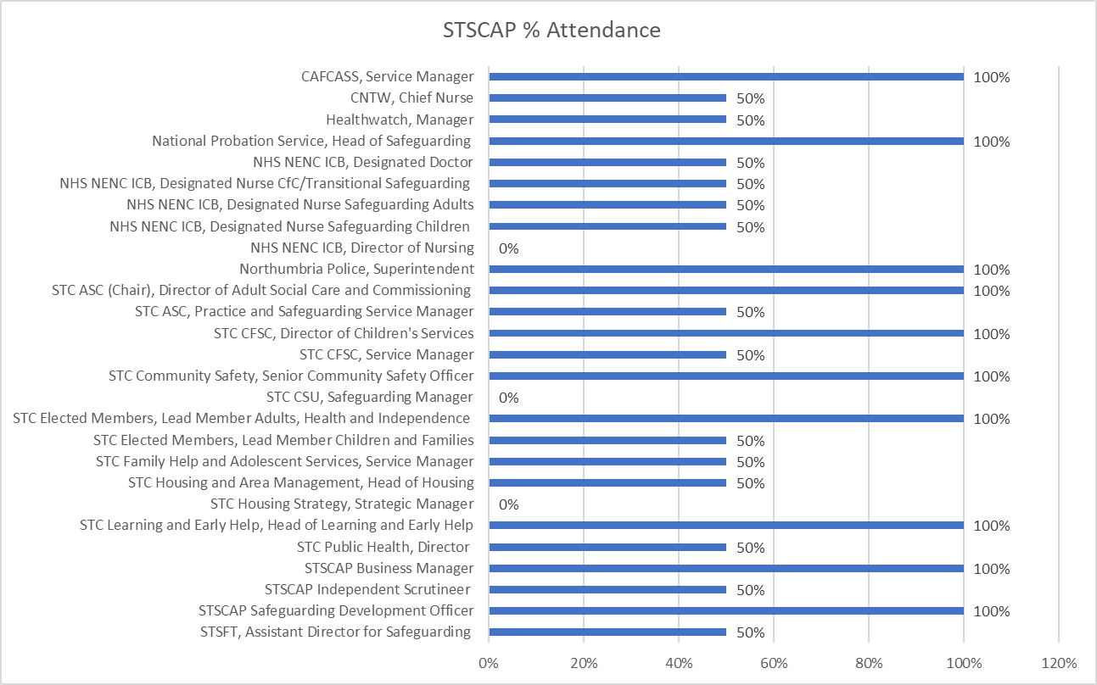

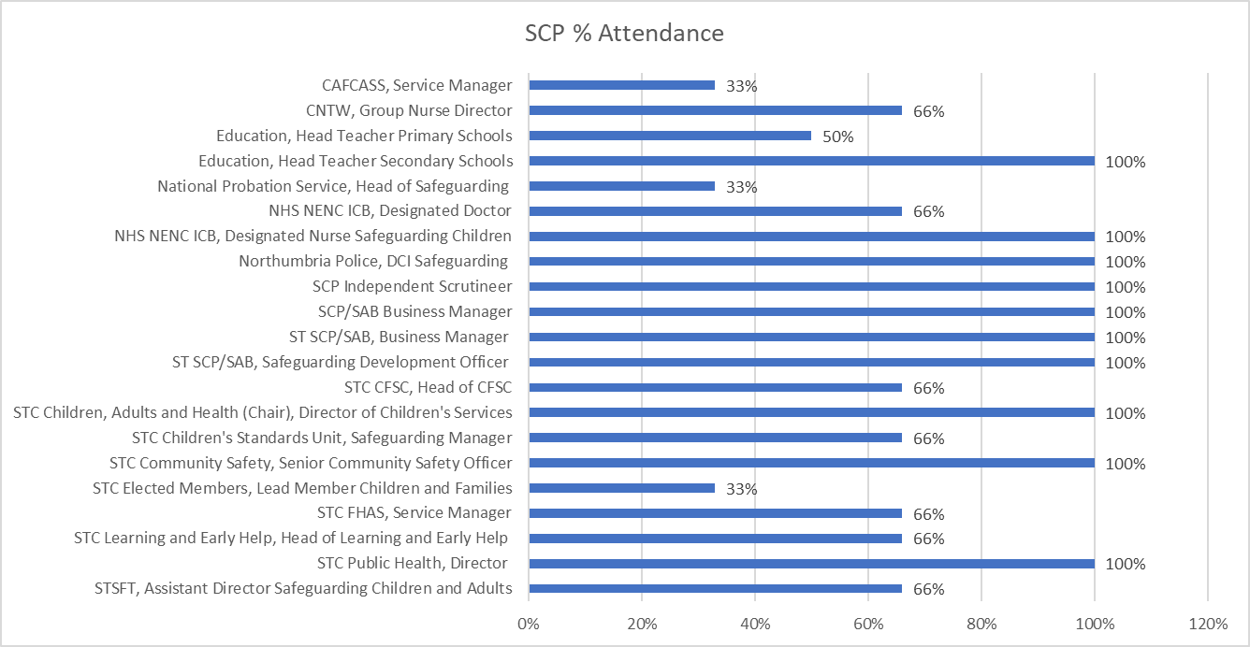

**5. CHILDREN AND FAMILIES SOCIAL CARE OFSTED INSPECTION**

5.1 The Ofsted report was published on the 10/05/2023 <https://reports.ofsted.gov.uk/provider/44/80557>.

5.2 Throughout 2023-24 there continued to be a significant amount of commitment to progress with the multi-agency Improvement Plan and notable improvements have been evidenced.

5.3 A new Director of Childrens Services and Head of Service were appointed in October 2023.

5.4 Via the joint and separate partnership arrangements relevant assurances have been sought, including updates following each of the Ofsted monitoring visits as well as the progress made against the improvement plan. Copies of the monitoring visits to date are below.

 

**6. LEARNING FROM CHILD SAFEGUARDING PRACTICE REVIEWS**

6.1 In accordance with the Childrens Act 2004 where a local authority in England knows or suspects that a child has been abused or neglected, the local authority must notify the Child Safeguarding Practice Review Panel if:

(a) the child dies or is seriously harmed in the local authority’s area, or

(b) while normally resident in the local authority’s area, the child dies or is seriously harmed outside England

6.2 During 2023 -24 there were two cases referred in for consideration for a statutory review. Neither met the criteria but learning was identified and acted upon via individual action plans that were monitored and evaluated by the Practice Evaluation and Learning sub group.

**What did we learn?**

**What did we do as a result?**

|  |
| --- |
| In partnership with education colleagues, a working group was established to improve the current school ‘In Year Transfer Additional Information Form’. This is to ensure that safeguarding concerns are highlighted to any new school. |
| Sought assurance and evidence from partners that their current cross border / area policies and procedures had been updated. |
| Gained the appropriate assurance from partners that their current multi-agency information sharing agreements were up to date, relevant and had impact. |
| Multi-agency learning shared regarding the effectiveness of services’ risk assessment and case management processes, particularly with regard to the management of sex offenders to ensure that services can act promptly and appropriately in future. |
| Included awareness raising session within PEL sub group of the criteria and rationale for a CSPR referral. In addition, a range of sessions for all multi-agency partners around the CSPR process were offered. |

6.3 In addition a CSPR that started in early March 2023 was concluded in 2024:

**What did we learn?**

**What did we do as a result?**

|  |
| --- |
| Immediately raised the awareness of the key safer sleep messages across the Partnership. |
| Participated in the regional ‘Eyes on the Baby’ campaign. |
| Produced a 7-minute briefing about Safer Sleep for multi-agency professionals. |
| Incorporated the learning within the appropriate areas of the multi-agency safeguarding training programme. |

**7. THE STRATEGIC DELIVERY PLAN**

7.1 The Strategic Delivery Plan 2021-24, which was in partnership with the Safeguarding Adults Board agreed three strategic priorities.

**Effective Safeguarding**

**Prevention and Early Intervention**

**Focus on Practice**

| **Priority 1: Continue to effectively safeguard and prevent abuse and neglect of children and young people** | | |
| --- | --- | --- |
| **What we said we would do** | **What we did** | **Outcome** |
| **The Partnership will be aware of the key local safeguarding areas of concern and implement the appropriate action** | * Awareness raising and preventative work around safeguarding. * A robust multi-agency safeguarding training offer 2023-24. * The annual MSET Roadshow focused on two key themes that were prevalent at the time – Safeguarding and Exploitation in Sport and Missing Children. | * Increase in the uptake of face-to-face training of 63% in 2023-24 (1910 compared to 1166 in 2022-23) * Safeguarding Children - multi-agency responsibility remains a popular course with 248 attendees in 2023 -24. * E-Learning increased by **43%in 2023-24.** * There were 2783 completions in 2023-24 of E-Learning compared to 1,956 in the previous year. * Level 2 & 3 Safeguarding Children with **344** applications for L2 and **257** for L3 in 2023-24. * The MSET Roadshow featured ‘Exploitation in Sport’. This was supported by Baroness Tanni Grey-Thompson and gymnast Mhairi Maclennen as guest speakers. Missing Children was included to raise the awareness of the link with missing and exploitation. * 142 delegates attended across the four sessions and 91 returned evaluations, which is a return rate of 64%. * 87% or attendees rated the roadshow as excellent or very good. * 100% stated their understanding of the subjects covered wasexcellent or good after attending the roadshow |
| **Put in place multi-agency performance monitoring/quality assurance and scrutiny arrangements** | * Evidence of greater scrutiny and challenge around the multi-agency performance data and audit cycle * Developed a robust multi-agency quality assurance and performance framework. * Reintroduce the Partnership Risk Register | * In 23/24 there has been a significant increase in the number of fixed terms exclusions.1299 in 23/24 compared to 846 in the previous year * A multi-agency performance framework, supported by Power BI, that continues to evolve. * There is now a completed and evidenced 2023-24 multi and single agency audit cycle. The findings of which are shared with the Workforce Development Subgroup and Learning Development Advisor * The Partnership Risk Register is a standard agenda item at the SCP |

| **Priority 2: Prevention and Early Intervention** | | |
| --- | --- | --- |
| **What we said we would do** | **What we did** | **Outcome** |
| **Review the current neglect strategy given the number of referrals.**  **Respond immediately to any local, regional or national learning.**  **Support schools and colleges with safeguarding issues that matter to them.** | * Working with a multi-agency group developed an up-to-date neglect strategy and tool kit for MA professionals, with the agreement that its use and impact would be reviewed in the 2024-25 multi-agency audit cycle. * Featured safeguarding articles in the resident’s quarterly newsletter. * Shared information and raised awareness across local communities/groups.   Keeping Babies Safe - In response to the tragic death of Jacob Crouch, a briefing session about Keeping Babies Safe was offered. The session aimed to support practitioners who care for, or support families with babies, to deliver a clear and consistent message regarding baby safety and highlighted the important learning to keep babies safe.  Safer sleep week – a session was held during Safer Sleep Week with the aim of training practitioners on safer sleeping practices, providing them with the knowledge and skills to educate parents and caregivers on how to create a safe sleeping environment.  The Business Unit continues to facilitate the Designated Safeguarding Leads Forum by ensuring safeguarding updates and guest speakers are relevant to their needs. The Forum meets bi-monthly due to its popularity and pace of safeguarding issues. | 28 attendees at multi-agency consultation events  The Neglect Strategy and Toolkit was launched in March 2024.  A multi-agency audit was included within the audit cycle for 2024-25 to determine effectiveness and impact.  Keeping babies safe was delivered to a diverse group of practitioners, aiming to equip them with the skills to convey a clear and consistent message about baby safety, with a particular emphasis on promoting safer sleep practices to parents and carers.  There were 102 attendees, and all rated their understanding after training as ‘good’ or ‘excellent’ and the session was rated 4*/5*. Feedback included:  *“I am now more aware of help and support offered by children's centres for a greater age range of children so could share this with families”.*  *“I can now provide parents with more knowledge on how to keep babies safe”.*  *“I will try to reach out to engage men in conversations about safeguarding babies”.*  *“I will ask questions as per presentation on how families are coping with new baby etc”.*  There were 24 attendees, and all rated their understanding after training as ‘good’ or ‘excellent’ and rated the session 5*. Feedback included:  *“I will have information around safer sleep at hand, to give to parents along with advice and guidance, allowing me more opportunities to reach more parents at what may be unexpected occasion/ out of routine”.*  *“I now feel confident to offer advice backed by research”.*  *“I am more comfortable discussing the facts around Safe sleeping and what to avoid”.*  Seven meetings were held across the year with an average attendance of 29 schools attending.  Attendees are asked to provide an update on any safeguarding concerns in their school at every meeting. The meeting is provided with an update from ICT in Schools and the Community Safety Partnership (Safer Schools) on a regular basis.  Other areas covered across 2023-24 include:  Counter Terrorism Local Profile / Knife/Weapon Crime / The importance of using appropriate language / Cross Boarder Transfers / Vaping Guidance / Missing Children and the links to school / Police wellbeing checks / School exclusions due to substance use / sexually coerced extortion online / NSPCC Speak Out Stay Safe programme / KCSIE 2023 / how Ofsted inspects safeguarding / Safer Schools / Hate Crime / Working Together 2023 / Fearless (Crimestoppers) / mobile phones in schools / Return to School Conversation process / Missing from Education (not sighted) guidance  The Forum was updated on the regional Northumbria Knife and Weapon Crime Protocol. This protocol originated from a South Tyneside document that was produced at the request of several schools. Prior to agreeing to accept the revised regional version the forum was consulted, and agreement reached to adopt the revised regional version from March 2024. |

| **Priority 3: Focus on Practice** | | |
| --- | --- | --- |
| **What we said we would do** | **What we did** | **Outcome** |
| **Participated in Child Safety Week 2023.** | * South Tyneside actively promoted the learning from regional and national CSPR’S via social media and partner information sharing platforms. Examples included Water Safety / Dog Safety and Trampoline Safety. |  |
| **Ensure multi-agency online safeguarding policies and procedures for children are up to date and relevant to front line practice.** | * Ensured compliance across safeguarding policies and procedures with the input from the relevant multi-agency partners. * Promoted online links to safeguarding policies and procedures throughout all multi-agency training. * Briefing sessions offered to support familiarity with the online safeguarding children’s policies and procedures website. | On line safeguarding policies and procedures for children - due to a move of platform, access figures for the original platform are unavailable.  Take up of briefing sessions has been minimal this year but queries have been addressed on a more informal basis and through promotion of the multi-agency safeguarding training programme and sessions.  Key updates through the year have included:   * P&P update tracker introduced and reviewed by the subgroup. * Child Protection Information leaflet for Young People – co-produced with young people. * Regional Cross Boundary Protocol agreed. * Female Genital Mutilation Guidance updated. * LADO Principles revised. |
| **Develop an incremental and thematic approach to** **Transitional Safeguarding.** | * Facilitated events whereby both Children and Families Social Care and Adult Social raised awareness of their respective roles in relation to transitional safeguarding. * Organised a multi-agency event whereby partners explained their input, offer and commitment to Transitional Safeguarding * Incorporated the voice and lived experience of care leavers as to what works / does not work within transitional safeguarding for young people. * Considered several transitional safeguarding models | This remains work in progress for 2024-25 in terms of where transitional safeguarding should be best placed. This is in response to the current revision to the Missing, Slavery, Exploitation and Trafficked process and the introduction of the Partnership Reduction Exploitation Missing, PREM model.  The care leavers idea of issuing them with a card will be implemented. The card is something young people thought would be helpful to have to show multi-agency professionals in times of frustration or distress to seek their understanding and patience. |

7.2 An additional priority was added to reflect implementation of the new safeguarding arrangements and re-establishment of the Safeguarding Childrens Partnership.

| **ADDITIONAL PRIORITY: Ensure the governance and structure of the SCP are compliant with Working Together 2023** | | |
| --- | --- | --- |
| **What we said we would do** | **What we did** | **Outcome** |
| **Cross reference the local arrangements with the requirements identified in Working Together 2023.** | * Re-established the SCP in September 2023. * Replaced the role of the Independent Chair with an Independent Scrutineer. * Identified the strategic leadership and accountability requirements. * Agreed a multi- agency implementation plan for Working Together 2023. * Participated in the DfE Partnership Health Check March – April 2024. | * The Partnership Chair seeks assurance on a range of issues as outlined in SCP minutes. * SCP meets bi-monthly; newly formed Safeguarding ExecutiveAssurance Board meets quarterly. * Have identified key individuals from the three statutory partners as Lead Safeguarding Partners and Delegated Safeguarding Partners. * Work in progress with the implementation plan. * Identified Barriers and Enablers that will help inform the priorities for 2024 -2025. * Governance & MOU agreed and in place. |

**8. MULTI-AGENCY DATA AND INFORMATION – THE HIGHLIGHTS**

8.1 The past twelve months have offered little respite from the significant and sustained pressures placed upon the broad range of services across the SCP. Most partners continued to be faced with ongoing recruitment and retention challenges alongside high demand, placing extreme pressure on services. This has been reflected in the notable increase in referrals.

**Safeguarding Activity 2023-2024**

8.2 There are key areas identified from the 2023-24 Multi-agency Performance Report that warrant additional assurance in 2024-25.

8.3 Many of the areas will be reported on via the developing Multi-agency Safeguarding Score Card and assurance from other appropriate sources. These include:

* The increasing number of referrals and the subsequent pressure on all partner agencies.
* The reduction in contacts from schools and health.
* Linking with the adult PME sub group to consider joint working around Mental Health concerns around parents/carers which are the most frequently identified issue noted at the end of an assessment.
* Assurance around the impact of the neglect guidance and toolkit given the significance of neglect as reason for a Child Protection Plan.
* Assurance related to children becoming subject to a Child Protection Plan for the second or subsequent time.
* A greater understanding of the out of borough provision in terms of numbers / quality of provision.
* Assurance of the impact of actions to increase the number of dental check-ups to date for cared for children.
* Assurance of the impact of the key performance indicators, KPI’s associated with the new Partnership Reduction Exploitation and Missing model, PREM, that replaces the Missing Slavery Exploitation and Missing Framework, MSET, in relation to the reduction in sexual offences against children.
* The rational and impact of actions to reduce the increased numbers of fixed term school exclusions needs further assurance.
* The Local Authority Designated Officer, LADO, data needs to be broadened in order that there is a better understanding of the types / themes of allegations made and the outcomes.
* The full performance report for 2023-24 can be found below.



**9. THE VOICE OF CHILDREN AND YOUNG PEOPLE**

9.1 STSCP have worked with group of care experienced young people to produce a new Child Protection Leaflet for children and young people which has been implemented across Children and Families Social Care.

9.2 STSCP are working towards the development of a new Transitional Safeguarding Protocol. To assist with this young people who had been involved with MSET were invited to take part in an event to raise awareness with multi-agency partners around their transition experience. This input was invaluable for partners and will be part of the considerations when developing the protocol. The voice of care leavers has suggested issuing them with a card to have to show multi-agency professionals in times of frustration or distress to seek their understanding and patience. This will be progressed in 2024-25.

9.3 As a partnership we will work closely with our Member of Youth Parliament, MYP, to ensure the Partnership is cited and aware of the issues that are important to children and young people. The MYP highlighted the following priorities for 2024-26 from a recent ballot.

* Health and Well-being
* Culture Media and Sport
* Crime and Safety

9.4 The MYP will be invited to attend the Partnership to provide an update on the priorities.

**10. PARTNERSHIP GOVERNANCE**

**South Tyneside Safeguarding Executive Board (ST-SEB)**

10.1 The Board was set up in January 2024. Its purpose is to provide leadership, governance and ensure local accountability for Safeguarding services in South Tyneside. It is chaired by the Chief Executive of South Tyneside Council. The core Membership includes the ICB and Northumbria Police with additional attendees. The Board has met twice to consider a strategic approach to the following;

* The governance and accountability arrangements for safeguarding in South Tyneside, across children and adults, and the actions that need to be taken.
* The required funding and resourcing required to meet the statutory duties and effective co-ordination and management of the Childrens Partnership and Safeguarding Adults Board.
* Consideration of local and national safeguarding directives applicable to children and adult safeguarding.

**Executive Board** (please note this group met twice in 2023/24 as a joint Board (May and July)

10.2 At the time the Executive Board undertook the overall safeguarding responsibilities which included the statutory and strategic functions, and oversight of the Safeguarding Children and Adults Partnership. The membership consisted of the three key statutory partners: The Local Authority; NHS North East and North Cumbria Integrated Care Board; Northumbria Police.

10.3 With the increasing development of the Partnership the Executive increased the meeting schedule to bi-monthly to ensure an increased focus and consistency was maintained. For 2023 -24 the Executive Board met twice as the decision was taken to revert to a separate Safeguarding Children Partnership and Safeguarding Adults Board in September 2023. Highlights from the Executive Board related to safeguarding children included:

* Received regular assurance and updates on progress with the Ofsted Improvement Plan.
* Agreed the multi-agency Escalation and Challenge Protocol.
* Continue with the conversation around future budgets and contributions.
* Considered the impact and requirement of the Partnership related to national initiatives such as the outcome of the national consultation of the Children’s Social Care National Framework and revision to Working Together 2023.

**Practice Partnership** (please note the Partnership met once in 2023/24, (June 2023), as the decision was taken to revert to a separate Safeguarding Children Partnership in September 2023)

10.4 The aim of the Practice Partnership was to strengthen the focus on practice ensuring a direct link with practitioners to influence and fully understand frontline practice from both a practitioner, child and adult perspective. Members of the Partnership were expected to consider solutions and disseminate learning from shared good practice across the partnership and community and identify, agree, and support with the development and dissemination of the learning. All partners were expected to raise safeguarding issues that their organisation was experiencing as well as share examples of good practice. As part of the development of the Partnership members views were sought in terms of the structure and proportionality of the agenda across adults and children to ensure fairness and transparency. Key highlights related to safeguarding children included:

* The introduction by the police of Right Care, Right Person, RCRP, initiative and the implications on the multi-agency safeguarding response and understanding of risk thresholds.
* Restructure and impact of the Family Hubs and Adolescent Service.
* Homelessness and the number of cases involving children.
* PREVENT Duty and the expectation from all partners.

**Safeguarding Children Partnership** (with the reintroduction of the SCP in September 2023 the Board met on three occasions during 2023/24)

10.5 Highlights from the SCP included:

* Revised governance arrangements for the SCP.
* Recruitment of an Independent Scrutineer.
* SCP Annual report sign off for 2022 -23.
* The Independent Scrutineers report sign off for 2022-23.
* Update on the first Ofsted monitoring visit.
* Agreed and signed off the Annual Child Death Overview Panel Report.
* Considered Working Together 2023, the updates and requirements.
* Continued the conversation around the SCP Budget.
* Re-introduction of the Partnership Risk Register.

**JOINT SCP/SAB SUBGROUPS**

**Practice Evaluation and Learning Subgroup (PEL).** Joint subgroup with adults although this report will focus on child related information only.

10.6 The aim of the subgroup is to:

* Make recommendations to the SCP Chair to undertake a Child Safeguarding Practice Review, CSPR
* Initiate and monitor Child Safeguarding Practice Reviews as per the statutory guidance.
* Oversee and ensure action plans and learning from CSPR’s are embedded and evaluated for impact on multi-agency practice.

10.7 In addition, the subgroup has the authority to determine and recommend to the SCP Chair to undertake learning reviews should any cases not meet the statutory criteria but clearly highlight learning for multi-agency partners.

10.8 To support PEL members, awareness raising sessions were built into subgroup meetings. These highlighted the purpose, criteria and required compliance with the statutory processes.

**Child Safeguarding Practice Reviews (CSPR)**

10.9 During 2023 -24 there were two cases referred for consideration for a statutory review. Neither met the criteria but learning was identified and acted upon via individual action plans that were monitored and evaluated by the Practice Evaluation and Learning sub group.

10.11 In addition, a CSPR that had started in early March 2023 was concluded in 2024.The report is currently being ratified by the PEL sub group prior to sign off by the SCP.

10.12 The main learning point from this CSPR was round Safer Sleep. Immediate learning was acted upon:

* Participated in the regional ‘Eyes on the Baby’ campaign.
* Produced a 7-minute briefing about Safer Sleep for multi-agency professionals.

**Workforce Development and Training (WD&T) Subgroup**

10.13 The aim of the subgroup is to develop a multi-agency safeguarding training programme across adults and children as well as to implement a robust quality assurance process across all the training.

10.14 The annual training report highlighted a significant increase in request and attendance on multi-agency safeguarding training courses with 99% of attendees rating their understanding after training as ‘Good’ or ‘Excellent’.

|  |  |  |  |
| --- | --- | --- | --- |
| **Requests** | **Attendance** | **Additional Training** | **Quality** |
| 63% increase in face-to-face training | 7% increase in face-to-face attendance | 41% increase in additional training requests | 37% increase in 4*/5*ratings |
| 12% increase in virtual training | 21% increase in virtual attendance |  | 9% increase in evaluations completed |
| 37% increase in overall requests | 9% decrease in briefing session attendance |  |  |

10.15 A robust quality assurance process was established to evaluate internal multi-agency adult and children safeguarding training courses to ensure that all courses align with current safeguarding trends and effectively reflect emerging themes to provide participants with timely knowledge and skills. Moving forward all courses will be reviewed against a set of quality standards at the beginning of the training year or when changes to learning outcome are made to align training with national or regional safeguarding trends and themes. Quarterly focus groups are scheduled to assess the efficacy of training implemented, in addition to post-course evaluation.

10.16 The 2023/24 training programme was reviewed and updated for 2024/25 so that the programme remained current and relevant in addressing emerging safeguarding themes and challenges. The training evaluation process for the 2024/25 training programme involved an analysis of both quantitative and qualitative data.

10.17 Participants numbers for each course were reviewed to identify trends and popularity. Qualitative data allowed an understanding of the specific needs and preferences of delegates. By combining both elements, our proposal for the 2024/25 training year is informed by a well-rounded understanding and insight shared by our audience.

10.18 The decision to increase Safeguarding Children: A Multi-Agency Responsibility from six sessions to eight sessions was made to ensure that all practitioners could attend courses that cover emerging themes, and trends in safeguarding, providing participants with the most up to date knowledge and skills.

**Strategic Exploitation Group**

10.19 This group ensures that both the Childrens Safeguarding Partnership and Safeguarding Adults Board have a strategic oversight and assurance that appropriate actions have been taken in response to the exploitation of children, young people and adults at risk in South Tyneside. The group seeks assurance from the operational progress of the South Tyneside Missing, Slavery, Exploited and Trafficked (MSET) subgroup. Through a ‘live’ multiagency action plan the group can contribute and measure the impact of partners actions against the key elements of the plan. These include:

* Prevention - by creating an increased awareness and understanding of exploitation of vulnerable groups and the indicators and actions to be taken. This was a key focus of the sessions offered to the local ‘Welcoming Spaces’.
* South Tyneside Licensing Service mandate exploitation awareness sessions as part of the application process for taxi drivers.
* Raising the profile of PREVENT as a standard agenda item.
* Multi-Agency working around Transitional Safeguarding continues to make significant progress. There have been three multiagency events held with a focus on the expectations of both adult and children service areas and their roles within transitional safeguarding, the legal parameters and a focus on the role of multiagency partners in transitional safeguarding. Work continues to progress and develop a South Tyneside Transitional Safeguarding model.
* Work is in progress to revise the current MSET process and is likely to be completed by the summer of 2024.

**Pre-Missing, Slavery, Exploited and Trafficked (Pre-MSET)**

10.20 The pre-MSET was set up to ensure that robust and appropriate screening is undertaken on cases put forward for consideration at MSET. Pre-MSET was established to offer the appropriate support, advice, and guidance to any child or adult who remain vulnerable and at risk of exploitation.

10.21 In 2023-24 110 children and young people were considered. The main concerns identified were around missing, physical/mental health and concerning associates. There were concerns/risks around exploitation but no evidence.

**Missing, Slavery, Exploited and Trafficked (MSET)**

10.22 MSET is responsible for ensuring the effectiveness of multiagency working to safeguard and promote the welfare of those children, young people and adults who have been identified as medium/high risk on the Exploitation Framework for Screening, Assessment, Safeguarding and Disruption, and Review. In addition, the group provides advice, learning, and signposting to additional support to those frontline workers responsible for medium/high risk young people / adults. A representative from Adults Social Care supports the MSET process with advice and intervention, where appropriate with young people aged 17+.

10.22 During 2023 -2024 there have been a total of 5 full MSET meetings. Of these five meetings 10 children and young people were discussed. Key areas of concern identified:

* Missing episodes increasing vulnerability to exploitation.
* Exploitative online activity including the sharing of explicit images and unsafe relationships.
* Alcohol and substance misuse.

**SAFEGUARDING CHILDREN PARTNERSHIP SUBGROUPS**

**Policies and Procedures (P&P) Subgroup**

10.23 The aim of the Policy and Procedures subgroup is to develop and maintain up to date multiagency policies and procedures for safeguarding and promoting the welfare of children in South Tyneside. Key policies and procedures progressed and agreed in 2023-24 included:

* North East Knife and Weapon Crime Protocol.
* Neglect guidance and toolkit.
* Conference dissent process.

10.24 A link to the online safeguarding policies and procedures is included at all multiagency training sessions. The online multi-agency policies and procedures have now been embedded in all the face-to-face training sessions to ensure that multi-agency practitioners are fully aware of the resource.

**Performance Management and Evaluation (PME) Subgroup**

10.25 The group receives, monitors, and analyses multiagency performance data on a quarterly basis which inform the Practice Evaluation and Learning sub group, PEL, the multi-agency safeguarding training offer as well as highlight strategic issues and provide the SCP with additional information for further consideration. To date key pieces of work have included:

* The development and implementation of a 2023 -24 Quality Assurance Framework.
* The development and implementation of the single and multi—agency audit cycle 2023-24. The findings of which inform the work of the sub group as well the future priorities of the Partnership.
* Throughout 2023-24 the sub group has continued to develop and contribute to a multiagency safeguarding score card. This remains work in progress to ensure the score card aligns with the SCP priorities for 2024-25.
* There has been a delay of the NCNE ICB-wide Safeguarding Dashboard to provide consistency to reporting due to the ICB restructure. This remains a risk that the subgroup continues to monitor.

**OTHER GROUPS**

10.26 In addition to the Partnership subgroups the Safeguarding Business Unit organise and facilitate the Designated Safeguarding Leads (DSL) Forum for schools and post-sixteen providers and the Multi-Agency Cost of Living Group.

**Designated Safeguarding Leads (DSL) Forum**

10.27 The Designated Safeguarding Leads (DSL) network facilitates and promotes a culture of safeguarding as everybody’s business. It provides a networking opportunity for DSLs in education settings, including post 16 provision to keep abreast of the latest safeguarding updates and guidance nationally and locally. A key agenda item is for schools and providers to highlight safeguarding issues that they are facing. The Forum is the key educational link into the Safeguarding Childrens Partnership. The DSL Forum currently meets six times a year. To date the following key areas have been included within the forum:

* Dissemination of learning from a range of referral forms that highlighted the use of appropriate language to avoid ‘victim blaming’.
* Working Together 2023 updates.
* ICT Updates – including E-Safety around sexually coerced extortion on line / Tik Tok trends and the latest Apps.
* Prevent Duty and how to make a referral.
* Consultation around the Northumbria Weapon and Knife Crime Protocol.
* Keeping Children Safe in Education 2023.

10.28 An example of the impact of the DSL Forum was highlighted in the support schools gave to the Police in addressing an anti-social issue within the town centre that involved several young people. The schools supported the police by disseminating the appropriate communication to parents and carers. The outcome was a de-escalation in the situation.

**Multi-Agency Cost of Living Group**

10.29 This group was set up to gain assurance from multi-agency partners and community groups that safeguarding remained a focus during the ‘cost of living crises’. Safeguarding awareness sessions around exploitation, indicators and actions were offered to all involved with the ‘Welcoming Spaces’ Although the update of these sessions was minimal, it was agreed that Safeguarding was a key agenda item at all meetings.

10.30 In November 2023 this group was stood down and merged with the local authority Poverty Group to avoid duplication. The Partnership is represented on this group and safeguarding remains a standard agenda item.

**11. PARTNER CONTRIBUTIONS REGARDING THEIR ACHIEVEMENTS AND SAFEGUARDING PRIORITIES FOR 2023-24**

**South Tyneside Council, Children and Families Social Care**

11.1 **Timescales for assessment**.

* Assessment checkpoints ensure managers review assessment progress and timeliness.
* On average assessments are completed within 35 working days.
* Assessments are detailed and include information gathered from partner agencies.
* Strategy Meetings are timely, and most are well attended by the relevant agencies. Multi-agency information sharing is effective and leads to an understanding of risks and vulnerabilities for the child.

11.2 **Operational Multi-agency Safeguarding Hub, MASH, group and monthly MASH audits.**

* Ensures clear roles and lines of accountability.
* Provides a better understanding of the quality and impact of practice for children and their families. Promotes a culture of shared learning across the partnership to improve the quality of contacts and threshold decisions to ensure children and families receive the right service, at the right time.

11.3 **Well established Children in Care Council and Care Leavers Forum**

* Ensures the voices of children and young people inform practice development.

11.4 **Improved key multi-agency safeguarding documents e.g. threshold document and Multi-Agency Referral Form (MARF)**

* Partners have a better understanding of thresholds resulting in better quality contacts and threshold decisions.
* Significant increase in the number of Early Help contacts received following implementation of MARF and co-location of Early Help in the MASH. More families are receiving timelier targeted Early Help interventions and support.

11.5 **Investment in the workforce**

* Increased management and social work capacity across the service.
* Increased multi-agency partners in the MASH.
* Reduction in caseloads, better management grip, timelier decision making and social workers spending more time with children and their families.
* Supporting earlier, better quality information sharing, analysis and decision making to safeguard children more effectively.

**South Tyneside Council, Family Help and Adolescent Services**

11.6 Highlights:

* Youth Services are delivering the Youth Connect programme for young people electively home educated and who are not currently attending education, employment or training.
* Joint working between Youth Service, Youth Justice, Family Hubs and Community Safety partners to tackle youth ASB and disorder.
* Families are better informed of safeguarding issues arising from the hotspot areas, wider support offers are in place and partner solutions to pool resources are explored. There has been a recent reduction in the numbers of young people frequenting hotspot areas.

11.7 Holiday Activity and Food (HAF) programme ensure safeguarding due diligence is undertaken for all programme providers:

* Assurance of appropriate safeguarding responses and safe care that children, young people and families require when accessing activities as part of the HAF programme.

11.8 Children, young people, adults, families/carers inform safeguarding outcomes.

* The voice of children, young people and families is recorded and acted upon when considering strategies and safeguarding outcomes.

11.9 Early Help support is timely, effective and reflects the ‘Think Family’ approach and referral pathways are clear and accessible:

* Evidence based practice which is of a high quality with internal and external governance and scrutiny.

**NHS North East and North Cumbria Integrated Care Board**

11.10 **A successful pilot of GP information sharing by the Health Navigator in the MASH, recurrent funding has been agreed and this is now standard practice.**

* Timely sharing of primary care information for cases of children thought to be at risk of significant harm.
* Data sharing agreement signed by the ICB, STSFT and social care to enable timely information sharing of primary care medical records.

11.11 **Staying close programme has been implemented and a health and wellbeing counsellor has been appointed.**

* Care experienced young people have access and unlimited sessions with an experienced and qualified counsellor who also affords health promotion, reducing health inequalities and better health outcomes.

**Northumbria Police**

11.13 **Introduction of the Prevention Department which includes the addition of a missing person investigation team.**

* Early indications show a reduction in average time missing, a reduction in average missing episodes and evidence of rapport building between the investigation team and those vulnerable repeat missing children.
* The addition of the dedicated Inspector for Missing, Slavery, Exploitation and Trafficked has allowed a real focus on working with partners to improve and adapt the process to better meet the demands and needs of the region, this includes a review and refresh of the process that will be implemented in October 2024

11.14 **Geographical re-location**

* At a strategic level Northumbria police has returned to a six-area command locality model as opposed to three.
* For South Tyneside this means that it is a standalone area command.
* The responsibility for Statutory partnership requirements will be facilitated by Area Command, with the Executive group representative now being the Area Command Chief Superintendent with responsibility for South Tyneside.
* This has supported the delivery of the refreshed Working Together with there being an individual Delegated Safeguarding Partner for the local authority area.

11.15 **Core safeguarding practice is effective in keeping children, young people and adults safe.**

* Vulnerability matters training became mandatory in 2023, ensuring that all staff and new staff receive suitable guidance and training in safeguarding.
* Compliance is tracked through our protecting vulnerable people governance board and currently stands at 88% of all staff force wide have completed.

**South Tyneside and Sunderland NHS Foundation Trust**

11.16 **Improving Safeguarding**

* Maintained core business in relation to staff advice, support, supervision and training in relation to safeguarding. This includes a single point of contact and visibility upon wards and departments.
* Data collection in respect of teenage pregnancies has been updated in order to identify whether the rise in numbers is an ongoing trend, requiring safeguarding referral.
* Safeguarding link forums and “Hot Topic” sessions are held regularly. A bi-monthly safeguarding newsletter is disseminated across STSFT and held on the Intranet.
* The key aim of the newsletter and link forums is to share any safeguarding learning, training courses and 7-minute briefings Child Safeguarding Practice Reviews and /or other learning.

11.17 **Information Sharing**

* The safeguarding team have advocated for the need of the sharing of police child concern notifications (CCN’s) related to domestic abuse to the school nursing service if the child is actively working with the service.
* This initiative has allowed for the consideration of additional support for school age children in South Tyneside as well as improve information sharing systems and additional consideration for staff safety.

11.18 **Supported a new initiative of ‘MASH Assessment’.**

* STSFT health staff are providing health information from the acute Trust and GP services (with consent).
* This initiative supports South Tyneside Local Authority improvement plan to ensure the Local Authority are making well informed decisions with parental consent at the front door to ensure children and families receive the correct level of support and intervention.
* The two-way information sharing process also allows for improved information sharing and recording for those actively working with families which additionally improves outcomes for children and families.

11.19 **Safeguarding referral pathways are understood and used appropriately.**

* The Trust use a system called Datix to generate all safeguarding children and adult referrals.
* Datix allows the safeguarding team to have oversight of all referrals.
* The safeguarding team are then able to quality assure the referrals and provide feedback to staff where necessary on the threshold applied. This has resulted in an improvement in the quality of safeguarding referrals resulting in children and families receiving the appropriate level of support they require.
* Child protection medical requests are now centralised within the safeguarding children’s team. This has resulted in a streamlined and standardised child medical referral process, enabling improved data collection, record keeping and audit trail.

**Tyne Coast College**

11.20 The college has several safeguarding initiatives which include the following;

* Hot topics (introduction in to the curriculum of hot topics where we present common, local national concerns/trends etc
* Mandatory safeguarding training for all staff every quarter on a concern/trend
* Additional qualifications, level 4 for front line Safeguarding Officers and level 5 for Safeguarding Leads
* Staff development day, presenting quarterly statistics related to safeguarding and concerns, trends coming through
* Informing parents via text of any concerns/trends of a safeguarding nature

11.21 General vigilance and awareness amongst staff has increased, although referrals have maintained the trajectory, the standard of referrals has improved, which demonstrates better knowledge from staff of what a safeguarding concern is.

**Full partner highlights can be found at** **Appendix B**

**12. LOOKING AHEAD TO 2024-25**

12.1 This annual report references the progress made of the collaborative working model from 1st April to 1st September 2023.

12.2 In addition it also includes the detail of work of the SCP from September 2023 to March 2024. The SCP has agreed the following four priorities for 2024-25.

|  |
| --- |
| Communication and Information Sharing |
| Healthy Relationships |
| Contextual Safeguarding |
| Relational/ Restorative Practice Approach |

Work continues with the development of the new multi-agency safeguarding arrangements as outlined on Working Together 2023.

These arrangements will be agreed and signed off in December 2024 with publication and implementation from 1st January 2025.

**APPENDIX A – REPRESENTATION AT PARTNERSHIP / SCP MEETINGS 2023-2024**



**APPENDIX B – PARTNER CONTRIBUTIONS TO SAFEGUARDING**



**APPENDIX C – CONTRIBUTIONS AND SUMMARY OF 2023-2024 BUDGET**



**APPENDIX D – GLOSSARY OF ABBREVIATIONS**



**APPENDIX E – CONTACTS**

|  |  |  |  |
| --- | --- | --- | --- |
| **Name** | **Organisation** | **Telephone Number** | **Email Address** |
| **Business Unit** | SCP/SAB | 07483 406 311 | [STSCAP@southtyneside.gov.uk](mailto:STSCAP@southtyneside.gov.uk) |
| **Jackie Nolan** | SCP/SAB Business Manager | 0191 424 6513  07881 510 758 | [jacqueline.nolan@southtyneside.gov.uk](mailto:jacqueline.nolan@southtyneside.gov.uk) |
| **Leah Collinson** | SCP/SAB Safeguarding Development Officer | 0191 424 4086 | [leah.collinson@southtyneside.gov.uk](mailto:leah.collinson@southtyneside.gov.uk) |
| **Julie Sloanes** | SCP/SAB Learning and Development Advisor | 0191 424 6519 | [julie.sloanes@southtyneside.gov.uk](mailto:julie.sloanes@southtyneside.gov.uk) |
| **Lynn Hodson** | SCP/SAB Business Support Officer | 0191 424 6512 | [lynn.hodson@southtyneside.gov.uk](mailto:lynn.hodson@southtyneside.gov.uk) |

**If you would like to have copies of the embedded documents please contact** [**STSCAP@southtyneside.gov.uk**](mailto:STSCAP@southtyneside.gov.uk)

**If you, or someone you know, would like this document in another format/language please contact the communications team on 0191 424 7385**