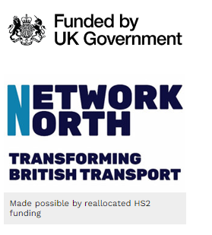
Network North Roads Resurfacing Fund - SmartSurvey Reporting Requirements
 |  | Note: Please add as many rows as you feel is necessary to highlight the scope and scale of the works being undertaken from Budget 2023 and Network North funding
 |  | Local Authority Name: South Tyneside
 |  | Areas / roads where work is planned | Type of works being undertaken on asset group | Indicative cost | Surface area resurfaced (if applicable) m2 | Benefits from it (eg: improved journey times etc) | Quarterly Update
 |  | River Drive, South Shields | Carriageway resurfacing | £365,000 | 6000 | Improving connections to jobs | Complete Q1
 |  |  |  |  |  | Part of strong communities
 |  | Perth Ave; South Shields | Carriageway resurfacing | £140,000 | 1500 | Improving connections to jobs | To be programmed
 |  |  |  |  |  | Part of strong communities
 |  | Hedworth Lane, Jarrow | Carriageway resurfacing | £120,000 | 1200 | Improving connections to jobs | Programmed for October 2024
 |  |  |  |  |  | Part of strong communities
 |  | The plan should include summaries of the additional resurfacing and other work either completed in 2023/24 or scheduled in 2024/25 using the additional funding in Budget 2023 and the further funding confirmed in this letter. This should set out the total volumes of additional work already completed and due to be completed by March 2025; particular roads, communities, or locations that have already benefited from it, or that are due to benefit from it; and the further additional work that will be completed during 2024/25 – again setting out both expected total volumes of additional work and where it is planned

