Assessment Reference  ???? | Site/Location  ???? |  |  | Work Activity  ????
Assessor(s)  ????  ???? | Date of Assessment  ???? | Date of Previous  ???? | Date of Review  ???? | Level of Risk Before Controls  (See risk matrix) |  |  |  | Level of risk After Controls  (See risk matrix)
Hazard Area/activity | Persons at Risk | Significant Risks to Health and Safety |  | Probability | Severity | Risk Rating | Controls and Precautions | Probability | Severity | Residual Risk
??? | ??? | ??? |  | ?? | ?? | ?? | ??? | ?? | ?? | ??
???? | ??? | ??? |  | ?? | ?? | ?? | ??? | ?? | ?? | ??
???? | ??? | ??? |  | ?? | ?? | ?? | ??? | ?? | ?? | ??
??? | ??? | ??? |  | ?? | ?? | ?? | ??? | ?? | ?? | ??
??? | ??? | ??? |  | ?? | ?? | ?? | ??? | ?? | ?? | ??
??? | ??? | ??? |  | ?? | ?? | ?? | ??? | ?? | ?? | ??
??? | ??? | ??? |  | ?? | ?? | ?? | ??? | ?? | ?? | ??
??? | ??? | ??? |  | ?? | ?? | ?? | ??? | ?? | ?? | ??
Signature of Assessor(s)

Risk Matrix
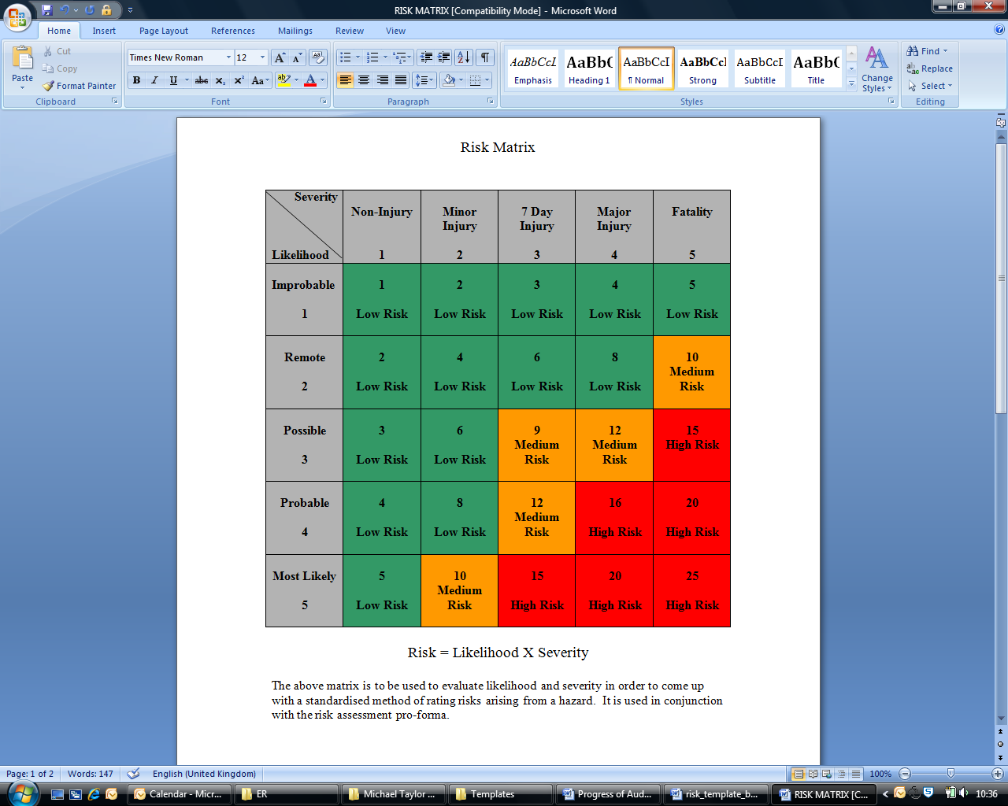

Last updated/reviewed: August 2023
Date of next review: August 2024

