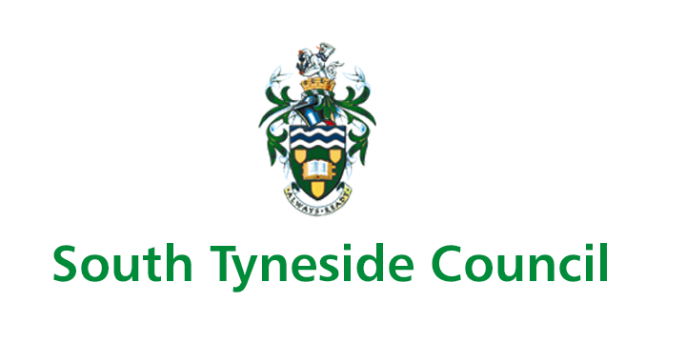

Corporate Health & Safety Manual

3.22 SLIPS AND TRIPS

Guidance and Procedures

Summary

- Managers must have an appropriate risk assessment carried out for the risks of slips, trips and resulting falls in their departments and the assessment is recorded.
- The risk assessment includes all necessary control measures to eliminate or minimise the risks of slips, trips and resulting falls in their departments; and relevant staff are made aware
- Ensure that where risk assessment dictates, personal protective equipment is supplied and worn.
- All workplace health and safety inspection checklists include a section on slips, trips and falls hazards.
- Employees must ensure they appropriately clear up any spillages and use appropriate signage to warn people of hazards.
- Ensure that working areas are kept clear of clutter or items that may be hazardous or increase the risk of tripping.
- Position equipment to avoid cables crossing areas, such as corridors, or pedestrian routes.
- Ensure that they do not carry drinks around work areas if they are likely to create a hazard.
- Ensure they wear suitable footwear for the task they are carrying out.
- Report and slips trips or resulting falls they may have to their direct line manager.

- Legal Requirements

The Health and Safety at Work Etc. Act 1974 places a General Duty on every employer to ensure the health safety and welfare of their employees.
The Management of Health and Safety at Work Regulations 1999 extended that duty to assess the risks of slips trips and resultant falls to employees.
The Workplace (Health, Safety and Welfare) Regulations 1992 require floors to be suitable, in good condition and free from obstructions.

- Important Definitions

Slip – A slip is a slide accidently causing the individual to lose their balance, this is either corrected or causes an individual to fall.

Trip – A trip is to stumble accidently often over an obstacle causing an individual to lose their balance, this is either corrected or causes an individual to fall.

Fall – A fall is an event which results in an individual or a body part of the individual coming to rest inadvertently on the ground or other surface lower than the individual, whether or not an injury is sustained.

- Procedures

The prime focus on reducing the risk of slips, trips and resulting falls is to ensure that a suitable and sufficient risk assessment is carried out for all work areas. Line managers must therefore ensure that an assessment is carried out for their particular working area.

The following Guidance will assist Managers within South Tyneside Council to identify and subsequently eliminate or manage these risks.

Implementation

Contamination and Obstacles

Prevent contamination and you reduce or even eliminate the slip risk as most floors only become slippery once they become contaminated.

- Prevent contamination from water, oil, grease, etc. Pay particular attention to wet areas such as kitchens, entrance lobbies, water dispensers, filling points etc.

- If contamination occurs ensure that you have a cleaning procedure and the correct equipment to clear it up.

- In office areas sufficient space should be allowed to ensure office furniture does not encroach on to walkways, and that power cables are correctly routed away from them, all personal equipment such as handbags shoes should be stowed in personal lockers.

Flooring

The floor in a workplace must be suitable for the type of work activity undertaken, therefore it will be different in an entrance lobby, an office, a workshop and a kitchen. The following must be considered to ensure floor surfaces are of the correct type:

- Where a floor cannot be kept dry, people should be able to walk on it without fear of slipping despite any contamination that may be on it.

- Flooring types should have different levels of “roughness”, this gives the flooring its non-slip properties.

- The floor must be able to be cleaned correctly to ensure that it does not become slippery or that it keeps its slip resistance properties (if a non-slip floor).

- The floor must be fitted correctly to ensure that there are no hazards and any non-slip coatings are correctly applied.

- The floor must be maintained in good order to ensure that there are no trip hazards e.g. holes, uneven surfaces, badly fitted carpets at door thresholds or curled up carpet edges.

- Ramps, raised platforms and other changes of level should be avoided, if they can’t they must be highlighted.

Environment

Environmental issues such as lighting (natural or otherwise), loud or unfamiliar noises, the weather, humidity, condensation etc. can affect the risk of slips and trips, therefore the following factors should be considered when carrying out risk assessments:

- Too much light on a shiny floor can cause glare and stop people from seeing hazards on floors and stairs.

- Too little light will also prevent people from seeing hazards on the floor and stairs.

- Unfamiliar and loud noises may be distracting.

- If rainwater gets onto a smooth surface inside of a building, it may create a slip hazard.

- Cold weather can cause frost and ice to form, which may create slippery surfaces.

- Condensation can make a smooth floor slippery.

Stairs

Stairs can potentially create a higher risk of slips trips and resulting falls. To help to control this risk stairs should:

- Have high visibility, non-slip stair nosing on the step edges, be fitted with a suitable handrail and the steps should be of equal height and width.

- Have adequate lighting.

- Be kept clear and unobstructed and maintained in good condition, free of defective coverings or raised nosing etc.

People

How people act and behave in their work environments can have an effect on slips and trips, the following should be considered when carrying out a risk assessment

- Encourage a positive attitude toward health and safety, this can reduce the risk of slip and trip accidents e.g. dealing with a spillage, instead of waiting for someone else to deal with it, or at the very least warning others of it whilst it is cleared.

- Distractions which prevent staff from seeing or thinking about where you are going, can also increase the risk of an accident e.g. rushing about, carrying large objects or becoming distracted whilst walking e.g. using a mobile phone.

Footwear

In areas of Council properties where the public have access to and control of footwear cannot be achieved, it is important to ensure that smooth floors are kept clean and dry.

- In working areas which are clean and dry the wearing of flat shoes or a low sensible heel, with the sole and heel made in a softer material providing some grip, can help reduce risks from slips and trips

- Where floors can’t be kept dry or clean e.g. food preparation, the right footwear will be particularly important, so a slip resistant shoe may be required.

- In areas where a risk assessment has identified the need for slip resistant or special footwear, the footwear will be considered to be personal protective equipment and will be subject to the requirements of the Personal Protective Equipment Regulations

Cleaning Activities

Cleaning affects every workplace, nowhere is exempt. It is not just a subject for cleaning staff; everyone in the organisation has a job to do e.g. keeping your workspace clear; and dealing with your own spillages. The process of cleaning can create slip and trip hazards, especially for those entering the area being cleaned, for example, smooth floors left damp by a mop are likely to be extremely slippery and trailing wires from a vacuum or buffing machine can present a trip hazard, therefore the following precautions should be considered:

- Prohibition pedestrian access to smooth floors whilst they are wet by using barriers or cleaning in sections:

- Using signs and cones to warn of the wet floor hazard.

- Carrying out cleaning activities outside of office hours.

- Providing effective training and supervision to cleaning staff to ensure cleaning is undertaken to the correct standard.

- Informing cleaning staff of their duties and why the cleaning needs to be undertaken in a particular way or at a particular time. Lack of understanding can lead to inappropriate shortcuts.

Accident Reporting

All incidents of slips and trips which have resulted in an injury must be reported to the health and safety team, in the first instance by telephone flowed by an Incident Report Form IRF(see Appendix Ji).

Where an incident regarding a slip or trip does not result in injury the incident must still be reported to the health and safety team on a Near Miss form (see Appendix Jiii)

Responsibilities of Managers

Mangers have a responsibility under this guidance and procedure to ensure that:
- An appropriate risk assessment is carried out for the risks of slips, trips and resulting falls in their departments and the assessment is recorded.
- The risk assessment includes all necessary control measures to eliminate or minimise the risks of slips, trips and resulting falls in their departments.
- Ensure that where risk assessment dictates, personal protective equipment is supplied and worn.
- All relevant staff are made aware of the risk assessment:
- All workplace health and safety inspection checklists include a section on slips, trips and falls hazards.

Responsibilities of Employees

Employees must be vigilant and ensure any slip and trip hazards that they are aware of are reported to their line manager as a minimum requirement.
- Ensure they appropriately clear up any spillages and use appropriate signage to warn people of hazards.
- Ensure that working areas are kept clear of clutter or items that may be hazardous or increase the risk of tripping.
- Position equipment to avoid cables crossing areas, such as corridors, or
pedestrian routes.
- Ensure that they do not carry drinks around work areas if they are likely to create a hazard.
- Ensure they wear suitable footwear for the task they are carrying out.
- Report and slips trips or resulting falls they may have to their direct line manager.

Associated Guidance

Managers should be mindful of the Councils Risk Assessment arrangements as contained in the Corporate Health & Safety Policy (3.1 Risk Assessment).

Slip and Trip Potential Models

The diagrams below are the HSE slip and trip potential models, the grey bubbles highlight the main factors which play a part in contributing to a slip or trip incident.

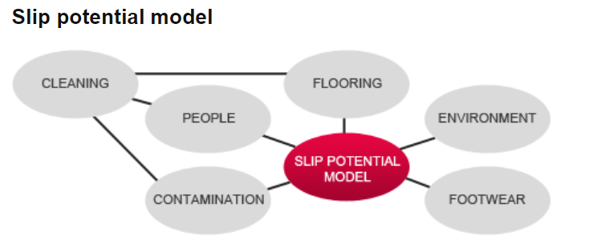

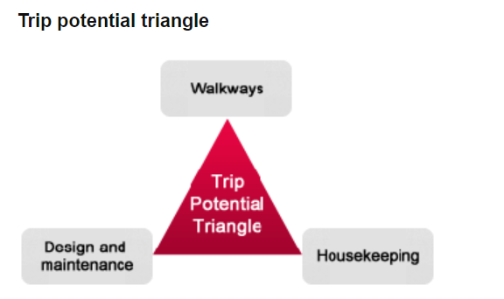

In most cases one or more of the contributing factors above play a part in an accident occurring, cleaning operations can exacerbate and existing potential.

Typical Slip Hazards | Typical Trip Hazards
- Spills and splashes or liquids and solids.  - Incorrect footwear for the working environment.  - Change from a wet to dry surface  (Footwear still wet).  - Unsuitable floor surface/covering  - Dusty floors.  - Sloping surfaces.  - Adverse weather (rain, sleet and snow, ice); | - Loose floorboards/tiles.  - Uneven outdoor surfaces.  - Holes/cracks.  - Changes in surface level.  - Changes in surface roughness.  - Cable across walking areas.  - Bumps, ridges and protruding nails etc.  - Electrical and telephone socket outlets.  - Handbags.  - Chairs protruding on to walkways.
Typical Fall Hazards | Typical Factors which increase risk
- Staff not trained in moving and handling.  - Overreaching.  - Climbing on furniture.  - Rushing down steps/stairs, faulty or unsuitable equipment.  - Not holding the banister when ascending/descending stairs.  - Ladders.  - Faulty equipment; | - Untrained staff.  - Risk assessments not carried.  - Work areas not inspected regularly.  - Poor or unsuitable lighting.  - Rushing around.  - Distractions (using mobile phones.  - Effects of alcohol, Drugs and.  - Fatigue.  - Medication.  - Wet floors (after cleaning)

- Links to Guidance

Health & Safety Executive - Slips and trips - https://www.hse.gov.uk/slips/index.htm

The Health and Safety at Work Etc. Act 1974 http://www.legislation.gov.uk/ukpga/1974/37

The Management of Health and Safety at Work Regulations 1999 http://www.legislation.gov.uk/uksi/1999/3242/made

The Workplace (Health, Safety and Welfare) Regulations 1992 http://www.legislation.gov.uk/uksi/1992/3004/contents/made

3.1 Risk Assessment Guidance and Procedures http://intranet.stc.local/documents/documentLibrary_DocumentSummary.asp?pk_document=6513

3.24 Personal Protective Equipment Guidance and Procedures http://intranet.stc.local/documents/documentLibrary_DocumentSummary.asp?pk_document=34341

Reporting Forms:

IRF - http://intranet.stc.local/documents/documentLibrary_DocumentSummary.asp?pk_document=35507&class=1859

AR2/AR3 - http://intranet.stc.local/documents/documentLibrary_DocumentSummary.asp?pk_document=35508&class=1859

Near Miss
http://intranet.stc.local/documents/documentLibrary_DocumentSummary.asp?pk_document=35509&class=1859

- Review
These guidance and procedures will be reviewed on an annual basis.

Document approved by: H&S Policy Review Group

Last updated/reviewed: November 2023
Date issued: November 2023
Date of next review: November 2024

