

Corporate Health & Safety Manual

3.4 DISPLAY SCREEN EQUIPMENT (DSE)

Guidance and Procedures

Summary

- Managers must identify employees who are DSE 'Users' within their teams.
- Ensure Users complete the DSE Self-Assessment of their workstations, this should be done alongside the enrolment process for new starters.
- Ensure DSE Assessments are reviewed every 2 years or when there are changes to the circumstances to which the assessment relates.
- Ensure hybrid working risk assessments are completed where appropriate and reviewed every 2 years or when there are changes to the circumstance to which the assessment relates.
- Managers must ensure that workstations meet the minimum requirements laid down in the Schedule to the regulations.
- Employees to receive suitable training and information.
- Eyesight tests are available and corrective lenses are offered where appropriate.

- Legal Requirements

The Health and Safety at Work Etc. Act 1974 http://www.legislation.gov.uk/ukpga/1974/37 places a general duty on every employer to ensure the health safety and welfare of their employees.

The Health and Safety (Display Screen Equipment (DSE) Regulations 1992 http://www.legislation.gov.uk/uksi/1992/2792/ as amended by the Health and Safety (Miscellaneous Amendments) Regulations 2002, extend that duty to assess DSE users and the equipment they use to ensure they are safe to use.

The DSE Regulations apply to workers who use DSE daily, for continuous periods of an hour or more. The regulations don't apply to workers who use DSE infrequently or only use it for a short time.

- Important Definitions

Display Screen Equipment-this is any alphanumeric or graphic display screen, regardless of the display process involved;

Use- for or in connection with work and includes Laptops, Touch Screen, smartphones, Ipad’s and other similar devices when in prolonged use;

User- employee who habitually uses display screen equipment for continuous or near continuous periods of an hour or more; and on a more or less daily basis.

Workstation a workstation is an assembly comprising of:

- display screen equipment (whether provided with software determining the interface between the equipment and its operator or user).
- a keyboard or any other input device including mouse;
- any optional accessories to the display screen equipment;
- a laptop computer;
- any disk drive, telephone, modem, printer, document holder, work chair, work desk, work surface or other item peripheral to the display screen equipment;
- the immediate work environment around the display screen equipment.

Portable Display Screen Equipment these include Laptops, Computers, smartphones ipads and other similar devices.

Hot Desking – the shared use of workstations or docking stations between a number of persons.

Docking Station – a hot desking station fitted with sufficient additional equipment to set up a Laptop Computer as a workstation.

- Procedures

A high proportion of DSE workers report aches, pains or eye discomfort. These aches and pains are sometimes called upper limb disorders (ULDs), which can include a range of medical conditions such as Repetitive Strain Injury (RSI). Most of these conditions do not indicate any serious ill health, but it makes sense to avoid them as far as possible.

South Tyneside Council recognises these risks and its duty under the above legislation and has provided this policy guidance to enable managers to reduce the risks to users and to comply with the regulations.

Risks of Working with DSE

- Postural Problems

Working in a fixed position for long periods of time may give rise to musculoskeletal disorders such as back pain or upper limb disorders (sometimes known as repetitive strain injury or RSI). The problem is exacerbated if this fixed position is incorrect, or the user has existing medical issues.

- Visual Problems

Visual problems will occur if the screen is too far away from the user or the text is too small for the user to read comfortably, this problem can be made worse by Incorrect brightness and contrast.

- Fatigue

The users required concentration and attention to detail for word processing can cause mental stress and headaches and can exacerbate visual problems.
Some users may experience ‘screen fatigue’ common symptoms include blurred vision, double vision, dry eye, general eye discomfort, headaches and other related symptoms.

- Incorrect Vision

The use of incorrect prescription spectacles or contact lenses or the need for them can also exacerbate both visual problems and fatigue.

New and Expectant Mothers

DSE assessments need to be kept under review in respect of new and expectant mothers. Managers must ensure that adjustments are made to ensure the health and safety of new and expectant mothers where necessary. Further information can be found in the New and Expectant Mothers section in the Corporate Health and Safety Manual See Policy Guidance 3.10.

Aim

It is the aim of South Tyneside Council to ensure that the risks involved in working with Display Screen Equipment as highlighted above are reduced and kept to a minimum therefore Corporate Strategic Groups will ensure that:

- DSE ‘Users’ are identified within their Groups;
- ‘Users’ Workstations are assessed;
- DSE Assessments are reviewed every 2 years or when there are changes to the circumstances to which the assessment relates;
- That workstations meet the minimum requirements laid down in the Schedule to the regulations;
- Users receive suitable training and information;
- Hybrid working risk assessments are completed;
- Screen users are entitled to a VDU Eyecare Voucher.

Responsibilities of Managers

Line Managers have the delegated responsibility for ensuring that the risk to staff under their control have been reduced to the lowest level and will ensure that:

- A list of users has been developed and maintained.
- DSE users have had suitable e-learning training in the risks involved in using a workstation, their right to eye tests and corrective lenses, and how to adjust their workstation;
- They have countersigned the risk assessment for all staff under their control;
- Any remedial actions arising from the risk assessment have been resolved;
- Managers to remind staff that there is an eyesight test policy in place.

Staff User Responsibility

Users have a responsibility for:

- Carrying out a DSE Self-Assessment of their workstation using the combined assessment and checklist at Appendix E of the Corporate Health and Safety Policy and review it regularly;
- Complete the Hybrid Working Risk Assessment where appropriate;
- Ensuring that their line manager has received a copy of their DSE Self-Assessment;
- Endeavouring to wear prescriptive DSE lenses and report any wear and damage to their line manager;
- Report any health concerns to their line manager.

Implementation

To help minimise the risk of such discomfort it is essential that all user’s workstations are designed to ensure a good posture and provide the user with adequate support.

To facilitate this, the first action a line manager should do is identify which of their staff are users, a user is an employee who: uses DSE for continuous or near-continuous spells of an hour or more at a time;

The line manager should develop and keep a record of who their DSE users are. The list should include the type of user whether mobile or static, dates that workstation assessment were completed, dates when employees received eye examinations and any occupational health referrals.

The manager must request each user within their team to complete the DSE self-assessment checklist. On completion of the assessment the user must submit the assessment to their Line Manager. If they are a hybrid worker the online hybrid working risk assessment must be completed too. Click here to access online form

The line manager must then analyse the assessment or instigate a further assessment via a 3rd party supplier and identify any required actions recorded on it. The flow chart at the end of this document illustrates the procedure to be used.

User Self-Assessment

On request from your line manager, you as a user must complete Workstation Self-Assessment to ensure that your Workstation is adequate for you.

There are several area’s which must be assessed and adjusted to your requirements these are included in the DSE risk assessment pro forma at Appendix E (Appendix E takes you to the DSE workplace assessment not a risk assessment) The assessment includes a checklist with suggested ‘things to consider’ (see summary in table below) to ensure your work station is set up correctly. On completion of the Self-Assessment, you must ensure that you give a completed copy to your line manager.

Issue | Things to consider
Postural Problems | Repositioning of equipment, or adjustment of chair
Postural Problems | Provision of new chair or workstation to comply with current standards
Postural Problems | Provision of footrest or document holder
Visual Problems | Repositioning of screen
Visual Problems | Cleaning of screen
Visual Problems | Adjusting brightness and contrast
Visual Problems | Increasing text size
Visual Problems | Provision of window blinds or modification of lighting
Visual Problems | Ensure that you have had an eye test
Fatigue and Stress | Variation of the task to include other duties
Fatigue and Stress | Matching staffing to work volumes
Fatigue and Stress | Involvement of users in work planning
Fatigue and Stress | Introduction of planned breaks, 5–10-minute break after 50-60 minutes.

Hybrid Working

This procedure and the responsibilities are applicable to DSE Workstations set up in employees homes and must be read in conjunction with Human Resources Policy on Hybrid Working

Eye and Eyesight Tests

To date there is no evidence to suggest that working with DSE can damage the eyes or eyesight or indeed aggravate any existing problem or defect. However, the Council will meet its responsibilities under Regulation 5 of the Regulations, by making provision of eyesight tests for all DSE users and having in place a scheme to assist in the cost of visual aids where required. Further information can be found in the Human Resources Manual the Eye Sight Test Policy.

An eye test should be carried out for new employees who are going to be users, when an analysis deems an existing employee to be a user, and biannually or at a period recommended by an optician during an eye test under this guidance.

Laptop Computers

Where possible laptop computers should only be used on their own for short periods, any substantial work to be carried out on a laptop should be done so when it is linked to a docking station, with additional adjustable screen, adjustable keyboard and mouse and separate screen where required. Failure to do so can result in awkward postures that can cause discomfort if frequently repeated.

The screen should be positioned directly in front of the user, the keyboard and mouse in easy reach and the mouse positioned as close as possible, i.e., next to the keyboard.

Training

Users of laptop computers and those that share workstations may be at increased risk as a result of using multiple workstations. Therefore, the Council will provide you with adequate e-learning training in how to recognize and control risk factors. This includes sitting comfortably, angling the screen so it can be seen clearly with minimal reflections, and taking frequent breaks if work is prolonged.

Health and Safety Support

All Corporate Strategic Groups have a designated Health and Safety Advisor who is available to advise in the development of Workstation Assessments and signposting for further support and guidance.

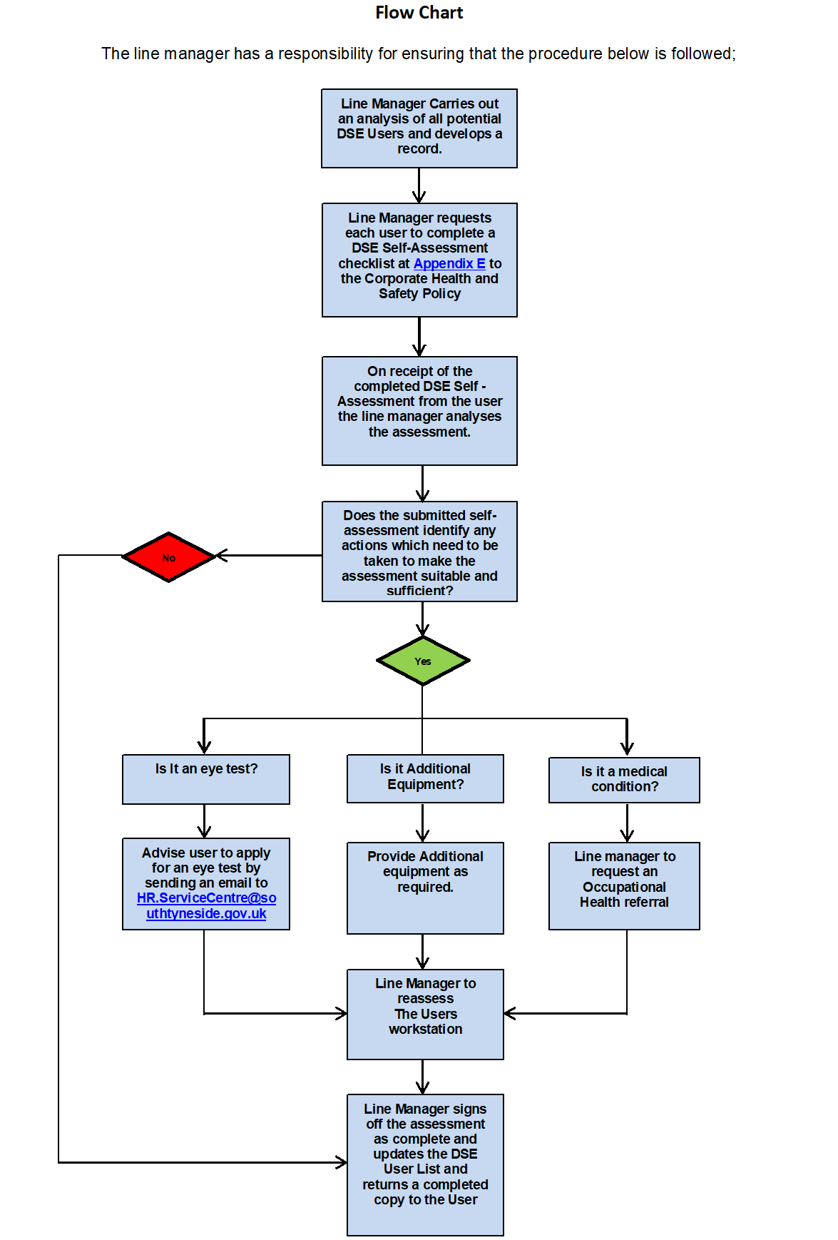

- Links to Guidance

Working Safely with DSE - https://www.hse.gov.uk/msd/dse/

Working with Display Screen Equipment, A Brief Guide - https://www.hse.gov.uk/pubns/indg36.PDF

The Health & Safety (Display Screen Equipment) Regulations 1992 - https://www.legislation.gov.uk/uksi/1992/2792/contents

Display Screen Equipment Risk Assessment and Checklist, Appendix E -
https://intranet.southtyneside.gov.uk/article/20676/Display-screen-equipment-risk-assessment-and-checklist

Online Hybrid assessments and further details-
Working safely at home (sharepoint.com)

HR Policy
Hybrid - Remote Working Policy (stc.local)

- Review
These guidance and procedures will be reviewed on an annual basis.

Document approved by: H&S Policy Review Group

Last updated/reviewed: June 2024
Date issued: June 2024
Date of next review: June 2025

