**Strategic Plan 2024 – 2027**

|  |  |  |
| --- | --- | --- |
| **Version** | **Date** | **Review Date** |
| Draft | January 2024 |  |
| Version 1 | April 2024 |  |

**Contents**

|  |  |  |
| --- | --- | --- |
| **1.** | **Introduction** | **3** |
| **2.** | **About South Tyneside** | **4** |
| **3.** | **The Role of the SAB** | **6** |
| **4.** | **Our Vision** | **7** |
| **5.** | **Our Values** | **8** |
| **6.** | **Strategic Aims** | **9** |
| **7.** | **The Board’s Planning Cycle** | **10** |
| **8.** | **Governance Arrangements** | **11** |
| **9.** | **STSAB On a Page** | **12** |
| **10.** | **Business Plan – Goals** | **13** |

# 1. Introduction

1.1 I am pleased to present our Strategic Plan for the South Tyneside Safeguarding Adults Board (SAB) for 2024 – 2027. This strategic plan is a statement of the SAB’s vision and strategic aims over the next three years and details how we will work as a partnership to keep people safe from abuse and neglect.

1.2 The Care Act 2014 sets out the statutory responsibilities of SABs to work together to safeguard adults to reduce/negate the risk of abuse and neglect. As chair of the SAB I am keen to ensure that people who live and work locally in South Tyneside are clear about our vision and the important role the SAB has to play in supporting an effective partnership response to abuse and neglect. **Safeguarding is everyone’s business**. By helping people to understand what abuse and neglect is, how to report concerns and what steps agencies will take to respond to these concerns we aim to build resilience and empower our communities.

1.3 Our strategic aims/priorities for the next three years will be delivered through our annual business plan, which will be reviewed and revised regularly to ensure we are achieving what we said we would do and that safeguarding needs are being addressed across South Tyneside.

**Steve Chapman**

**Independent Chair**

**South Tyneside Safeguarding Adults Board**

# 2. About South Tyneside

2.1 South Tyneside covers an area of 64 sq.km and includes the towns of South Shields, Hebburn and Jarrow, and the villages of Boldon, Cleadon and Whitburn.

|  |  |
| --- | --- |
| **76.4 81.2**  **years men women**  **is the average life expectancy for a resident of South Tyneside**  This compares poorly to 79.4 average for a man and 83.1 for a woman nationally – which represents a life expectancy gap of 3 years for men and 1.9 years for women. | **Health and Disability in Older Age**  **Of South Tyneside’s over 65s:**  **18% 54%**  **Have impaired have some hearing**  **Mobility loss**  **9% Have a moderate or**  **severe visual**  **impairment** |
| **57.3 58.9**  **years men women**  **is the average number of years after birth a person can expect live healthily, prior to having any activity-limiting health conditions**  This compares to 63.2 years for a man and 63.5 years for a woman nationally and 59.1 years for a woman regionally. |
| **Dementia**  **18% Of South Tyneside**  **residents aged 65**  **or over are estimated**  **to have dementia**  **estimated dementia**  **diagnosis rate is**  **69.1%**  Similar to the national rate of 63% and regional rate of 69.6% |
| Life expectancy varies considerably by ward  **For men, it ranges from 71.4 years in Primrose to 82.7 years for men in Cleadon and East Boldon** – 1.3 year difference  **For women, it ranges from 78.3 years in Hebburn North to 88 years in Horsley Hill** – a 9.7 year difference |

|  |  |
| --- | --- |
| **Frailty and Falls**    **685 emergency**  **Hospital admissions**  **due to falls in people**  **aged 65 and over in**  **South Tyneside in 2021/22, a rate of 2,236 per 100,000**  Compared to the national rate of 2,100 per 100,000  Emergency hospital admissions due to falls were notably higher in the age group 65-79, with a rate of  1132 admissions per 100,000  Compared to 993 per 100,000 nationally | **57.3% of people aged 65 and over were still at home 91 days after discharge from hospital into reablement services**  Much lower than the 79.1% nationally. |
| **67.3%**  **Of Adult Social Care**  **Service users aged**  **65+ are satisfied with their**  **care and support services**  Higher than the national rate of 63.9%  **67.8% of Adult Social Care service users aged 65+ feel that they have control over their daily lives**  A slightly lower proportion than those nationally (74%).  **Preventable and Premature Mortality**  **454.6 per 100,000 is the under 75 mortality rate from all causes**  Significantly worse than the England rate of 363.4.    **The under 75 mortality rate from causes considered preventable is at**  **251.7 per 100,000f per 100,000**  Worse than the England rate of 183.2 per 100,000 |
| **195 hip fractures in over 65s, a rate of 640 hip fractures per 100,000 people aged 65 or over**  Slightly higher than national average of 551  **Hip fractures occurred in numbers higher than the national average in those aged 65-79, with a rate of 265 admissions per 100,000**  Compared to 236 per 100,000 nationally. |
| **People who draw upon**  **Adult Social Care Support**  **261**    **People admitted to**  **Residential care per**  **100,000 65+, a rate**  **of 847**  Higher than both the England 539 rate and the North East 739 rate. |

**3. The Role of the SAB**

3.1 Safeguarding Adults means protecting an adult’s right to live in safety, free from abuse and neglect. It is about working together to support people to make decisions about the risks they face in their own lives and protecting those who lack the mental capacity to make these decisions.

3.2 What do we do?

* As a SAB we work together to safeguard any adult that is at risk of harm or abuse, as defined in legislation and guidance
* The risk of abuse can increase through age, disability, ill health, an individual’s personal characteristics, additional vulnerabilities or life circumstances. We want to prevent and reduce these whilst supporting individuals to take and maintain control over their lives
* The SAB leads this work across multi-agency organisations and is focussed on ensuring that it is effectively co-ordinated to safeguard and promote the welfare and protection of those adults who may be at risk of abuse and harm.

3.3 Statutory Framework: The work of SABs is directed by legislation – the Care Act 2014. The Act sets out the core purpose of the SAB as ensuring that local safeguarding arrangements are effective and taking account of the views of the local community. The SAB also seeks assurance that safeguarding practice is person-centered and outcome focused – Making Safeguarding Personal.

3.4 The SAB has three core duties. They **must:**

* develop and publish a strategic plan setting out how they will meet their objectives and how their member and partner agencies will contribute
* publish an annual report detailing how effective their work has been
* commission safeguarding adults reviews (SARs) for any cases which meet the criteria for these

3.5 Who are we?

The SAB is a statutory body which Local Authorities are responsible for establishing. The Care Act 2014 specifies that there ***must*** be three core statutory members; the Local Authority, NHS North East and North Cumbria Integrated Care Board (ICB) and Northumbria Police. The Care Act allows for further members to be specified in future.

For the SAB to fulfil its responsibilities and duties effectively, additional partners are included. These are:

|  |  |
| --- | --- |
| * Cumbria, Northumberland, Tyne and Wear NHS Trust * National Probation Service * South Tyneside and Sunderland NHS Foundation Trust * South Tyneside Community Safety Partnership | * South Tyneside Council, Public Health * South Tyneside Homes * Tyne and Wear Fire and Rescue Service * Voluntary Sector |

# 4. Our Vision

*“Our vision is for all partners to work together effectively to* *enable and empower people in South Tyneside to be free and safe from abuse and neglect”*

4.1 This strategy aligns with the South Tyneside 20 year vision – “***A*** place where people live healthy, happy, and fulfilled lives". The strategy outlines how the Safeguarding Adults Board will help people to be able to live as safely and independently as possible, making their own decisions, taking control of their lives, and where the local communities:

4.2 To achieve this vision we will:

4.3 The key role for the SAB is to hold all agencies/members to account if this vision is not being realised.

**5.**  **Our Values**

5.1 Six Safeguarding Principles:

**Empowerment** – People being supported and encouraged to make their own decisions and informed consent. “I am asked what I want as the outcomes from the safeguarding process and these directly inform what happens.”



**Prevention** – It is better to act before harm occurs. “I receive clear and simple information about what abuse is, how to recognise the signs and what I can do to seek help.”



**Proportionality** – The least intrusive response appropriate to the risk presented. “I am sure that the professionals will work in my interest, as I see them, and they will only get involved as much as needed.”



**Protection** – Support and representation for those in greatest need. “I get help and support to report abuse and neglect. I get help so that I am able to take part in the safeguarding process to the extent to which I want.”

**Partnership** – Local solutions through services working with their communities. Communities have a part to play in preventing, detecting, and reporting neglect and abuse. “I know that staff treat any personal and sensitive information in confidence, only sharing what is helpful and necessary. I am confident that professionals will work together and with me to get the best result for me.”

**Accountability** – Accountability and transparency in delivering safeguarding. “I understand the role of everyone involved in my life and so do they.”

These principles influence the delivery of our vision.

5.2 **Making Safeguarding Personal**: In addition to these principles it's also important that safeguarding partners take an approach to safeguarding that focuses on the person, not the process. It means that safeguarding should be person-led and outcome-focused, engaging the person in a conversation about how best to respond to their safeguarding situation in a way that enhances involvement, choice, and control, as well as improving quality of life, wellbeing, and safety.

**6. Strategic Aims**

6.1 Our strategic aims are what we want to achieve. These were agreed by SAB members at a development session:

“I receive clear and simple information about what abuse is , how to recognise the signs and what I can do to seek help.”

“We will provide continued assurance that effective safeguarding arrangements are in place across the partnership”

6.2 Delivering Effective Safeguarding – What will we do?

1. Use the SAB data/information to understand safeguarding trends, themes, risks and appropriate response.
2. In partnership, develop innovative strategies/practice that reduces the risks of abuse/neglect.
3. Link with local, regional and national forums to identify innovative practice, emerging issues and the most effective response.

6.3 Making Safeguarding Personal

**“We will ensure MSP is a golden thread that constantly runs through our strategic and operational safeguarding work”**

**I am asked what I want as the outcome of the safeguarding process and these directly informs what happens.**

What will we do?

1. Use an appropriate term for ‘safeguarding’ that people will recognise and understand.
2. We will support and empower adults to make choices and have control about how they want to live their lives.
3. Ensure the appropriate audit and scrutiny is in place, to give the Board assurance that MSP is embedded across the SAB.

6.4 Learning and Delivering

**“We will provide clear and effective leadership at both a strategic and operational level, ensuring a strong partnership built on collaboration, early intervention and problem solving”**

**“We will ensure the voice of people with lived experience and the communities of South Tyneside are always heard. We will involve people as partners, as we improve safeguarding across South Tyneside”**

What will we do?

1. Use the voice of people with lived experience to ensure continuous improvement in service delivery.
2. Ensure the learning from Safeguarding Adult Reviews (SAR's) and local reviews, translate into effective development/training for organisations/staff.
3. Ensure we have a Multi-agency Safeguarding Training programme that reflects local and national learning and highlights effective safeguarding prevention and intervention methods.

**7. The Board’s Planning Cycle**

7.1 Whilst this strategic plan lays out our medium-term vision and the steps needed to deliver the vision, it is equally important that we produce and publish our business plan. This provides the additional detail as to how the three aims of the SAB will be realised as well as enable us to measure our progress.

7.2 In addition an annual report will be produced. This will detail how effective the work of the SAB has been.

7.3 The SAB Planning Cycle:

7.4 As we make progress and roll the plan forward annually, we will engage and consult with our local Healthwatch and the local community. This may include advocacy groups, disability groups and relevant voluntary organisations.

7.5 We will also continue to engage with other local strategic partnerships - Children’s Safeguarding Partnership, Community Safety Partnership, Health and Wellbeing Board and the Domestic Abuse Board.

**8. Governance Arrangements**

8.1 The details of the Governance of the SAB and expectation of the members are set out in the Governance and Memorandum of Understanding document below:



8.2 In line with requirements within the Care Act 2014 and Working Together 2023, the Independent Chairs for the Safeguarding Adults Board and the Safeguarding Children Partnership (SCP) report into the Safeguarding Assurance Executive Board. Here assurance is given to the Lead Safeguarding Partners on the SAB Governance Structure, Strategy and progress of the Business Plan.

8.3 It is the role of the Independent Chair to effectively engage with partners and ensure that the SAB not only maintains its strategic focus but also demonstrates its effectiveness and impact . In addition the Independent Chair plays a crucial role in holding partners to account when seeking the assurance of effective safeguarding practice.

8.4 The current structure of the Board:

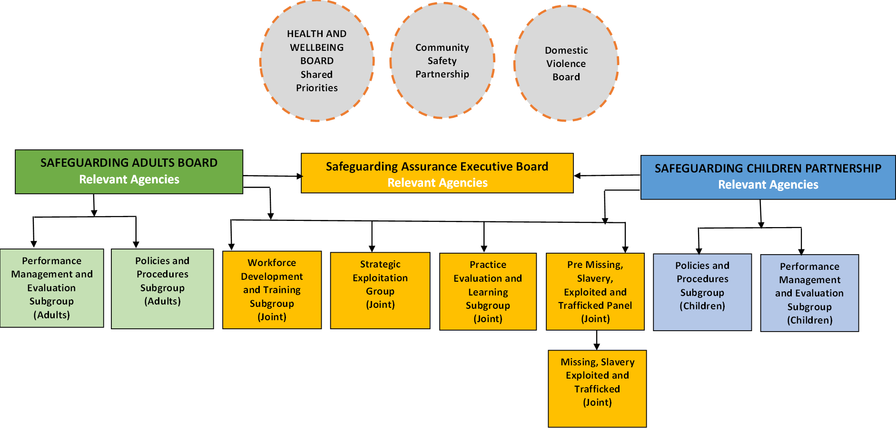

**9. South Tyneside Safeguarding Adults Board (STSAB) Plan on a Page**

|  |  |  |  |  |  |  |  |  |  |  |  |  |  |  |  |
| --- | --- | --- | --- | --- | --- | --- | --- | --- | --- | --- | --- | --- | --- | --- | --- |
| **Our Vision**  Why are we here? | | *“Our vision is for all partners to work together effectively to* *enable and empower people in South Tyneside to be free and safe from abuse and neglect”* | | | | | | | | | | | | | |
| **Our Values**  6 Safeguarding Principles | **Empowerment** | | | | **Prevention** | | **Proportionality** | | | **Protection** | | **Partnership** | | **Accountability** | |
| **Purpose**  What do we want to achieve? | | | Delivering Effective Safeguarding | | | | | Making Safeguarding Personal | | | | | Learning and Delivering | | |
| **Approach**  What are the key principles for delivery? | | | | Leadership | | Assurance | | | Innovative | | Learning | | | | Listening |

**South Tyneside Safeguarding Adult Board (STSAB)**

**Priority Objectives 2024-25**

The SAB haveagreed a number of shared priority objectives over the next year: