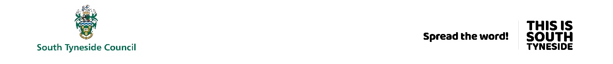**Duty List (36)**

|  |  |  |  |  |
| --- | --- | --- | --- | --- |
| Bin Collection |  | | | |
| Goats Water |  | | | |
| Levers Water |  | | | |
| Low Water |  | | | |
| Tarn Hows |  | | | |
| Boo Tarn |  | | | |
| Blind Tarn |  | | | |
| Hallways |  | | | |
| Staircase |  | | | |
| Lounge |  | | | |
| Cloakroom |  | | | |
| Dining Room |  |  | |  |
| Girls Showers |  | |  | |
| Boys Showers |  | |  | |
| Drying Room | L | G | | Y |
| Locker Area |  | |  | |
| Main Entrance |  | |  | |
| Litter Pick |  | | | |
| Barn |  | |  | |
| Top Barn |  | |  | |
| Classroom |  | |  | |
| Rucksack Room |  | |  | |
| Drinks Room |  | |  | |

**Room Inspection**

|  |  |  |  |  |  |
| --- | --- | --- | --- | --- | --- |
|  | Tue | Wed | Thurs | Fri | Total |
| Goats Water |  |  |  |  |  |
| Levers Water |  |  |  |  |  |
| Low Water |  |  |  |  |  |
| Tarn Hows |  |  |  |  |  |
| Boo Tarn |  |  |  |  |  |
| Blind Tarn |  |  |  |  |  |