

Drainage Strategy 2018 - 2029

Date: October 2018 Version: 1.3

Date: October 2023 Version: 1.4

Contents

Importance of Highway Drainage 3

Objectives of the Strategy 4

Council Objectives 4

Drainage Objectives 4

Drainage Inventory and Condition 5

Service Delivery 6

Data and Systems 8

Forward Planning 9

The future 9

Funding 9

Action Plan (2018-2029) 10

# Importance of Highway Drainage

In recent decades, the importance of highway drainage has become more apparent, with an increased frequency in severe flooding events and impact on other highway infrastructure assets. Highway drainage is a key contributor to supporting network resilience, allowing people, goods and services to move freely around the network.

The Highways Act 1980 empowers highway authorities to construct and maintain drainage systems to remove surface water from the highway. More recently, the Flood and Water Management Act 2010 gives local authorities a role for the management of local flood risk.

One of the major challenges for the council in managing highway drainage and local flood risk has been defining the asset. Historically the location and condition of highway drainage assets has been poorly recorded, if at all. This has resulted in a lack of investment and reduces the council’s ability to target maintenance effectively.

South Tyneside has recently invested in new technologies, data collection and information systems that will support the effective management of the drainage asset. In this strategy we set out the approach to utilise data and systems to align with current best practice in Asset Management for highway drainage, including ‘Well-Managed Highways: A Code of Practice’ and HMEP ‘Guidance on the Management of Highway Drainage assets.

# Objectives of the Strategy

## **Council Objectives**

The South Tyneside County Council Highway Asset Management Policy establishes the Council’s commitment to establish Highway Asset Management at the core to its service. This approach aligns with the overarching Highway Asset Management Strategy.

## **Drainage Objectives**

To help deliver the Council priorities and implement the relevant recommendations from the Highways Maintenance Efficiency Programme (HMEP) - Guidance on the Management of Highway Drainage Assets (2012) and the Code of Practice ‘Well Managed Highways’ (2016), the objectives for highway drainage in South Tyneside are as follows:

* Follow a Risk Based approach.
* Collect data that supports an informed approach to asset management.
* Improve network resilience.
* Promote stakeholder engagement and communication.

These objectives guide the approach to highway drainage asset management in South Tyneside and will focus the delivery of the actions identified within this strategy.

# Drainage Inventory and Condition

The current inventory of highway drainage assets across South Tyneside includes approximately **25,472 gullies** and **6.5 km’s of open ditches.** In addition to details about the location and specification of these assets, there is now information collected regarding gully condition and silt depths recorded during cyclic cleaning operations, conducted since 2014. Recording of silt levels in highway gullies during cyclic maintenance visits provides useful statistics to help focus, support and inform a new risk based cyclical maintenance approach. What we do not currently know is the location, condition and performance of the majority of the highway drains that remove surface water drainage to watercourses or water company sewers.

Figure 1 below shows an extract of the gully silt depths recorded during the gully cleaning operations:

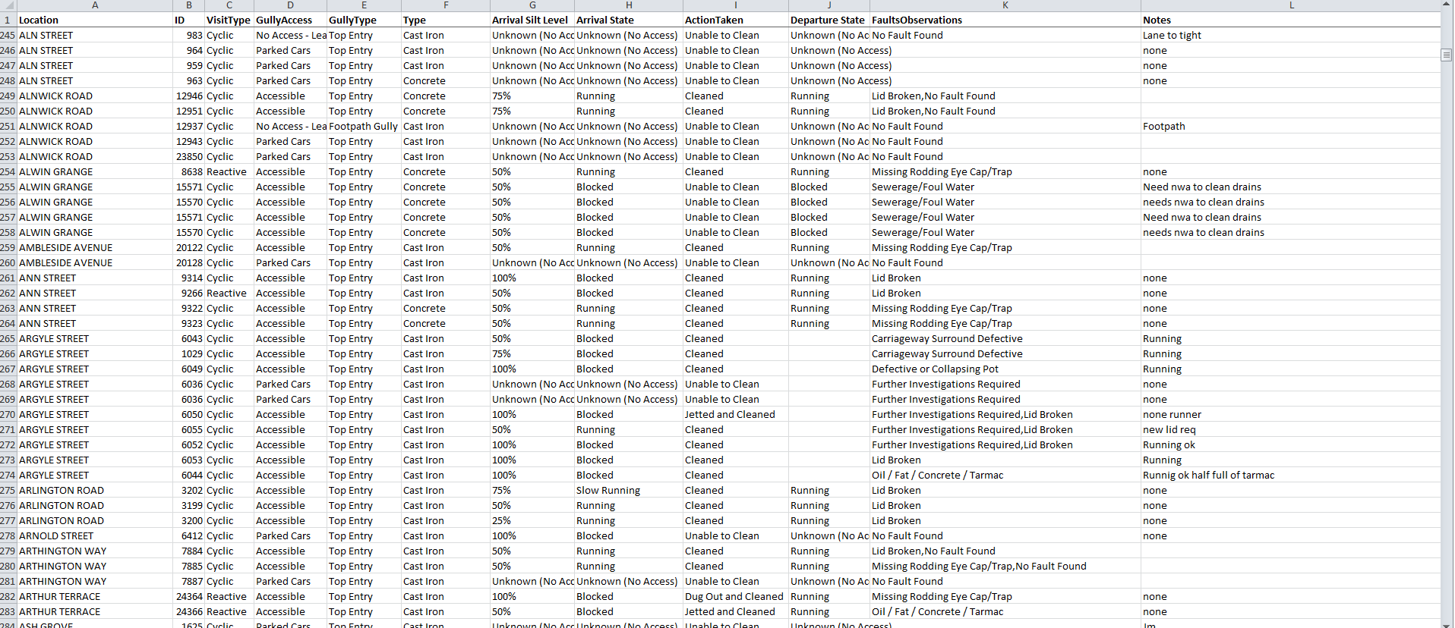

Figure 1 - Gully silt depths as of April 2016.

Targeted surveys will be undertaken to identify and record the highway drainage asset in areas of greatest risk first. These targeted surveys shall initially be prioritised around our Resilient Network to build an inventory of highway drainage assets. Ultimately the goal is to capture and record all highway drainage assets including gullies, kerb drains, ditches and all highway drains. The extent of third-party drainage assets will also ultimately need to be captured.

Resilient Network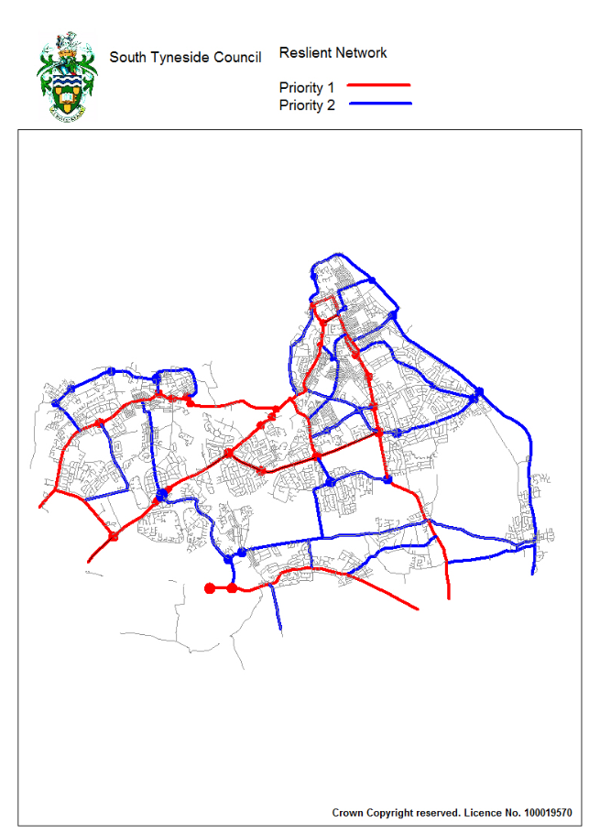

# *Figure 2 – Resilient Network with priority Routes 1 and 2.*

# Service Delivery

Historically, the approach in South Tyneside to repairing and improving our highway drainage assets has been predominantly reactive, rather than proactive.

We are now shifting our focus to proactively maintain our drainage asset and deliver a drainage service that follows a risk-based approach, in accordance with the Code of Practice, that ensures the controlled removal of water from the carriageway to allow customers to use it safely and promotes network resilience.

To achieve an efficient and effective drainage service we will deliver the following:

* Maintain the drainage asset to a condition in which it remains functional for draining the highway.
* Designing, constructing and managing drainage assets to meet both current and future needs in a changing environment while making effective use of limited budgets.
* Prioritise our maintenance activities based on risk and areas of the network in most need of maintenance.

**Future Delivery**

The principles of Asset Management are now at the core the Highway service delivery, with a focus upon outcome delivery and performance. The drainage strategy needs to acknowledge the initial limited understanding of asset extent and condition, whilst meeting the requirements HMEP Drainage guidance and new risk-based Code of Practice.

The two elements of efficiency and effectiveness need to be balanced appropriately to ensure the effective use of the finite resources available to the Council.

Following an increase in resources for gully maintenance in November 2023, linked to the delivery of the Winter Service, a new schedule for gully maintenance will ensure all gullies will be emptied at least once a year.

The intention in parallel with the above works is to begin a process of gradually mapping resilient network highway drainage and assessing its maintenance requirements with a view to seeking appropriate resources to properly manage associated risks.

Once the resilient network is mapped the process can be extended to other classified roads and known flooding hotspots.

Table 1 - Proposed Gully cleaning frequency

## 

All gullies on the classified road network will be cleaned at least twice a year. All gullies on the unclassified road network will be cleaned annually.

## **Data and Systems**

It is recognised that effective Asset Management planning and decision making relies on having the appropriate data available to those who need it and for that data to be appropriate, reliable and accurate.

We have worked with external software providers to build a Data Management System, Alloy, to store and analyse our current highway inventory and condition information which includes gullies. We will continue to develop this system further which will focus maintenance activities along with the other network hierarchy priorities. The development of this system will ensure that we address the causes of failing drainage assets rather than just the symptoms.

# Forward Planning

Although South Tyneside Council has seen a significant NWA investment, which has been used to target known problem areas in the borough, there is still a significant backlog of defective drainage assets across the network. Addressing this backlog will put pressure on limited revenue budgets and therefore we will target capital investment to resolve the cause of the drainage issues rather than just the symptoms.

Current Council investment in drainage maintenance is static, conducted on a reactive basis, and does not address the backlog of maintenance. By investing in capital drainage schemes, savings will be realised through reducing the maintenance cost to other highway infrastructure, especially carriageways and footways that often suffer from accelerated deterioration caused by failing drainage systems.

In 2023, we invested in a new data system, Alloy, which helps us plan and issue the new gully schedule supported by the extra resource. This will provide a full inventory, condition, and silt depth records of all gully assets on the network. This will provide the basis for future gully cleaning and maintenance priorities.

## **The future**

Our Asset Management Policy is committed to asset management best practice. To align with this, we will continue to build upon our drainage inventory register, prioritising the resilient network and in areas at risk of local flooding. We will continue to update current inventory and condition collection programmes. This will improve the performance of the asset and set the foundations in place for future programmes to prioritise maintenance effectively and efficiently.

## **Funding**

We will be improving our knowledge of drainage infrastructure across the borough to develop capital schemes where deemed appropriate. These schemes will demonstrate evidence-based decisions on drainage improvements, enabling us to bid for capital funding, such as the DfT Challenge Fund, meet the requirements for the DfT Incentive Fund and recommendations in the new Code of Practice. We will consider bids based on new information as it becomes available.

# Action Plan (2018-2029)

To achieve the Council’s Priorities and the objectives for highway drainage asset management in South Tyneside, a plan has been developed which will be delivered between 2017 and 2020.

Table 2 - Action Plan

|  |  |  |  |
| --- | --- | --- | --- |
| **Drainage Objectives** | **Action** | **Target Year** | **HMEP – Guidance**  **recommendation** |
| Follow a Risk Based approach.  Collect data that supports an informed approach to asset management.  Improve network resilience. | Collect missing asset data on the Resilient Network. | **2023-2028** | Recommendation 3  Recommendation 4 |
| Collect missing asset data on main and secondary distributors. | **2028-onwards** | Recommendation 3  Recommendation 4 |
| Collect missing asset data based on local roads | **Ongoing** | Recommendation 3  Recommendation 4 |
| Collect missing asset data on new developments and add them to the system | **Ongoing** | Recommendation 3  Recommendation 4 |
| Collect missing data in regard to camera surveys and add them onto the system | **Ongoing** | Recommendation 3  Recommendation 4 |
| Define areas at risk of known flooding and prepare high level estimates and risk rate them based on the resilient network and hierarchy. | **Ongoing** | Recommendation 3  Recommendation 4 |
| Undertake targeted inventory & condition collection in areas at risk of known flooding based on above action. | **Ongoing** | Recommendation 3  Recommendation 4 |
| Targeted cyclical gully cleansing programme. | **Ongoing** | Recommendation 1  Recommendation 6  Recommendation 9  Recommendation 11 |
| Develop process to address drainage defects | **Ongoing** | Recommendation 1  Recommendation 6  Recommendation 11 |
| Develop Kerb drainage cleansing programme. | **2024** |  |
| Develop prioritised programme of capital schemes. | **Ongoing** | Recommendation 1  Recommendation 6 |
| Improve network resilience.  Promote stakeholder engagement and communication. | Engage with internal teams and external organisations especially in relation to flood risk management | **Ongoing** | Recommendation 2  Recommendation 7  Recommendation 8  Recommendation 10 |
| Develop existing data on drainage maintained by others. | **Ongoing** |  |
| Develop existing Data Management System to include all known drainage asset inventory and mapped areas at risk of flooding to focus maintenance activities. | **Ongoing** | Recommendation 5 |