Maths Activity – Rounding and Estimating
The Department for Education and the government have established Key Themes as specific topics that aim to enrich your learning by improving your wider skills and understanding above and beyond the course you are taking. South Tyneside Works and your training provider want you to gain the most from your programme of learning and these activities will help to embed those Key Themes. The Key Themes are:
M-  Maths | E-  English | ILT- Information Learning Technology | EDI- Equality, Diversity Inclusion | S-  Safeguarding | P- Prevent | C-  Climate | HS- Health and Safety | BV-  British Values
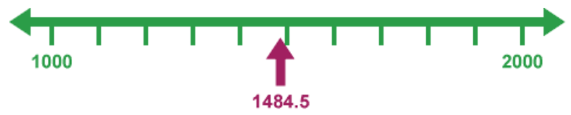
Rounding to the nearest 1,000
What is 1,484.5 to the nearest 1, 000?
It is between 1,000 and 2,000, but is closer to 1,000, so round down.
1,484.5 rounded to the nearest thousand is 1,000

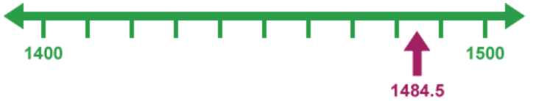
Rounding to the nearest 100
What is 1,484.5 to the nearest 100?
1,484.5 is between 1,400 and 1,500, but it is closer 1,500, so round up.
1,484.5 rounded to the nearest hundred is 1,500

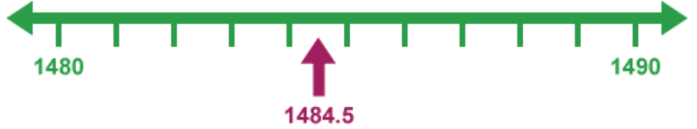
Rounding to the nearest 10
1,484.5 lies between 1,480 and 1.490, but it is closer to 1,480, so round down.
1,484.5 rounded to the nearest ten is 1,480.

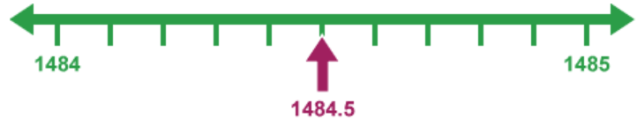
Rounding to the nearest whole number
1,484.5 lies between 1,484 and 1,485 and it is exactly halfway between them. In this situation round up.
1,484.5 rounded to the nearest whole number is 1,485

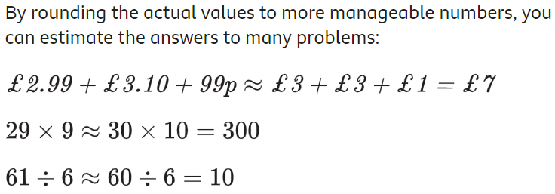
Making Estimates
Rounding prices
Imagine that you are buying a T-shirt for £9.99, a pair of socks for £1.49 and a belt for £8.99. The cashier charges you £23.47. You feel that this is too much – but how do you know?


One way of finding out whether you have been over-charged is to estimate what the total amount should be Round the different prices into easier numbers - £9.99 is approximately £10, £1.49 is approximately £1.50 and £8.99 is approximately £9 – and you can do the calculation quickly in your head.
£9.99 + £1.49 + £8.99 = £10 + £1.50 + £9 = £20.50.
This is almost £3 less than the cashier asked for, so obviously you have been over-charged.

Useful Links
Find out more information on rounding and estimating here
Find out more information on significant figures here
You can choose to do any or all the suggested activities below and your tutor will support you with any help you may need:
Activity: take this BBC Bitesize quiz, how many did you get right? Click here to enter text.
Question: if you round the number 1,222 to the nearest 10 what would the answer be? Click here to enter text.

Health and Wellbeing – World Sleep Day March 17th
The Department for Education and the government have established Key Themes as specific topics that aim to enrich your learning by improving your wider skills and understanding above and beyond the course you are taking. South Tyneside Works and your training provider want you to gain the most from your programme of learning and these activities will help to embed those Key Themes. The Key Themes are:
M-  Maths | E-  English | ILT- Information Learning Technology | EDI- Equality, Diversity Inclusion | S-  Safeguarding | P- Prevent | C-  Climate | HS- Health and Safety | BV-  British Values
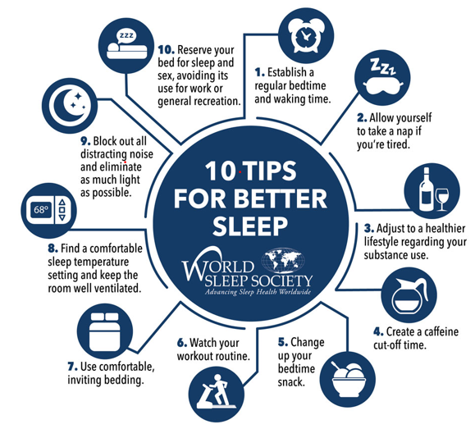
World Sleep Day 2023 takes place on March 17th. We all know that a lack of sleep can leave us feeling grumpy and not at our best but did you know that sleep deprivation can also damage our physical and mental health? 1 in 3 of us suffer from poor sleep and this puts us at risk of serious medical conditions including obesity, coronary heart disease and diabetes and can even shorten your life expectancy.

An occasional night without good quality sleep won’t harm your health, but after several sleepless nights the mental effects become more serious. Your brain will fog, making it difficult to concentrate, learn and make decisions. Find out more about why lack of sleep is bad for your health.

How much sleep do we need?

The average person needs around 8 hours of good-quality sleep each night to function properly. This varies from person to person so it’s important to find out how much sleep is right for you and to try to get that amount consistently. As a general rule, if you wake up tired and spend the day longing for a chance to have a nap, it’s likely that you’re not getting enough sleep. A variety of factors can cause poor sleep, including health conditions such as sleep apnoea. Find out about other reasons, see 10 medical reasons for feeling tired.

What are the benefits of good quality sleep?
A good night’s sleep can:
- Boost immunity
- Keep you slim
- Boost mental wellbeing
- Help to prevent diabetes
- Wards off heart disease
- Improve fertility

How to improve your sleep hygiene
Sleep hygiene means the habits that help you have a good night’s sleep. There is lots of advice available to help you improve your sleeping habits and get a good night’s sleep on a regular basis. See below for more:
- NHS Sleep Advice
- World Sleep Day
- Every Mind Matters – How to Sleep Better
True or False: sleeping at regular times each day can improve your quality of sleep Click here to enter text.
Research Online: what ways can insomnia be beaten? Click here to enter text.
Safeguarding - Stop Child Exploitation Awareness Day – 18th March 2023
The Department for Education and the government have established Key Themes as specific topics that aim to enrich your learning by improving your wider skills and understanding above and beyond the course you are taking. South Tyneside Works and your training provider want you to gain the most from your programme of learning and these activities will help to embed those Key Themes. The Key Themes are:
M-  Maths | E-  English | ILT- Information Learning Technology | EDI- Equality, Diversity Inclusion | S-  Safeguarding | P- Prevent | C-  Climate | HS- Health and Safety | BV-  British Values

Child Sexual Exploitation (CSE) is a form of sexual abuse that involves the manipulation and/or coercion of young people under the age of 18 into sexual activity. The National Child Exploitation Day aims to highlight the issues surrounding Child Exploitation; encouraging everyone to think, spot and speak out against abuse and adopt a zero tolerance to adults developing inappropriate relationships with children or children exploiting and abusing their peers.

NWG (formerly the National Working Group for Sexually Exploited Children and Young People) is a charitable organisation formed as a UK network of over 14,500 practitioners who disseminate information down through their services, to professionals working on the issue of child exploitation (CE) and trafficking within the UK. NWG are committed to the fight against CSE and CE and supporting victims and their families who are subjected to child exploitation. But they cannot succeed without the support of people like you.

Child Abuse in the UK – The Facts
- Over 90% of sexually abused children are abused by someone they know
- Over 50,000 children in the UK have been identified as needing protection from abuse
- It’s not just adults that abuse children; 65.9% of the contact sexual abuse reported by children and young people was perpetrated by other children and young people
- Neglect effects up to 1 in 10 children in the UK
- It is a myth that those abused as children will become abusers as adults

Together, we can work to inform, educate and prevent child abuse within the UK.

There are various ways you can show your support. Write a personal pledge on your hands to show support for the Helping Hands campaign. Post your photo on social media with the hashtag #HelpingHands and #CEADay22 to help NWG raise awareness of CSE and wider exploitation. You can help to give victims a voice.
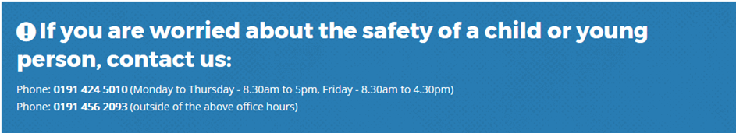
You can choose to do any or all the suggested activities below and your tutor will support you with any help you may need:
Question: What different forms of abuse could young people suffer? Click here to enter text.
Research Online: What role can technology play in child sexual exploitation? Click here to enter text.
Question: The Crime Survey for England and Wales estimated that one in five adults aged 18-74 years experienced at least one form of child abuse before the age of 16 years (8.5 million people). What is 1 in 5 as a percentage? Click here to enter text.
Climate Change in South Tyneside
The Department for Education and the government have established Key Themes as specific topics that aim to enrich your learning by improving your wider skills and understanding above and beyond the course you are taking. South Tyneside Works and your training provider want you to gain the most from your programme of learning and these activities will help to embed those Key Themes. The Key Themes are:
M-  Maths | E-  English | ILT- Information Learning Technology | EDI- Equality, Diversity Inclusion | S-  Safeguarding | P- Prevent | C-  Climate | HS- Health and Safety | BV-  British Values
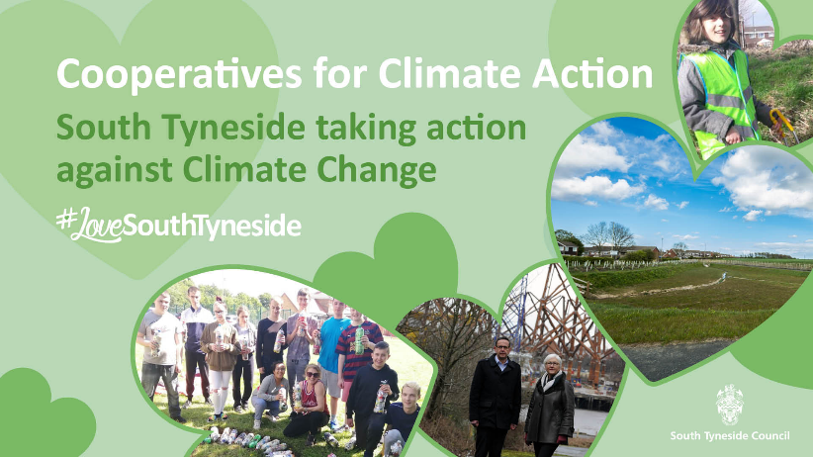
Climate change will affect South Tyneside in ways you may already understand – like flooding, droughts and heatwaves – but also in ways you may not have anticipated such as food insecurity, mass migration, local extinctions, further pandemics and resulting global financial crises. But the good news is, while combatting climate change will be a significant challenge, it’s not too late to change course.

The Covid-19 pandemic has been tough. It has presented us with some extremely testing and difficult times. But it has also brought many of us closer to nature, benefitting from fewer cars on the road, more birdsong and a greater awareness of our local wildlife. In pursuit of different places to exercise, many of us will have discovered new and exciting areas nearby, leading to an increase in community spirit and a new-found appreciation for our local green spaces.

In some circumstances, it has given us opportunities to reflect on how we live our lives and how we might be able to change for the better in the future. Instead of returning ‘back to normal’, we now have the opportunity to build back better.

South Tyneside Council is leading the way in creating a Sustainable South Tyneside. In 2019, we declared a ‘Climate Emergency’. Since then, we have adopted our 5-year Climate Change Strategy and Action Plan, which includes a commitment to become carbon neutral by 2030 www.southtyneside.gov.uk/climatechange to see why reducing carbon emissions are so important.

What Can You Do? 1st-7th March is Food Waste Action Week

Food waste is a big environmental problem.
- Food is responsible for 30% of the world’s greenhouse gas emissions.
- Food production is the number 1 cause of biodiversity loss. And yet;
- 1/3 of food produced is wasted.
- 70% of the food that is wasted in the UK is wasted by people in their own homes.
Check out the WRAP website where you can find recipes and ideas on meal planning to help you stop wasting food in your home. You can also check out @lfhw_uk on Instagram.
You can choose to do any or all the suggested activities below and your tutor will support you with any help you may need:
Research Online: What can we do personally to reduce our carbon emissions and reduce our carbon footprint? Click here to enter text.
Question: In what ways has COVID-19 changed your lifestyle and does this reduce your carbon footprint? Click here to enter text.

