South Tyneside Council Modern Slavery Statement

**Introduction:**

South Tyneside Council is committed to understanding and mitigating risks of slavery and human trafficking in our corporate activities and supply chains. This statement, which covers the financial year 1 April 2018 to 31 March 2019, sets out actions taken by the Council to ensure there is no slavery within our services, businesses or supply chains.

**Organisational Structure and Supply Chains:**

This statement covers the activities of South Tyneside Council. This statement covers direct employees of the Council and services delivered on behalf of the Council by third party organisations, including our South Tyneside Homes arms-length management organisation, and in the supply chain.

More information about the Council structure and governance is available in the [Council Constitution2.13MB](https://www.southtyneside.gov.uk/media/3226/Council-Constitution/pdf/CONSTITUTION_May_2018.pdf).

**Countries of operation and supply and high risk activities:**

South Tyneside Council only operates within the United Kingdom. While the risk of slavery and human trafficking is considered low, the Council remains vigilant and will take all steps available to manage the risks presented.

**Responsibility:**  
Each Head of Service is responsible for ensuring risks of Modern Slavery are understood and mitigated in their service areas and for maximising each service’s capacity to prevent and disrupt slavery and support and protect victims.

Any concerns regarding modern slavery or human trafficking in the organisation or supply chains should be raised with the Corporate Director of Business and Resources.

**Relevant policies and initiatives:**

* **Employee Code of Conduct:** The Council's Employee code of conduct is included in the Council's Constitution and was reviewed in May 2017.  It makes it clear to employees the actions and behaviours expected of them when representing the Council.  The Council strives to maintain the highest standards of employee conduct and ethical behaviour and breaches are investigated.
* **Speak out – Whistleblowing Policy:**South Tyneside Council is committed to the highest possible standards of openness, probity and accountability. Integrity is one of our core values; this means we will do the right thing whatever the circumstances. The Council encourage its employees, contractors and partners who may have concerns about any aspect of the Council's work to come forward and voice those concerns.
* **Equality and Diversity Policies:**The Council has two Equality and Diversity Policies, one for employees and one for residents in the South Tyneside Borough.  Both outline the Council's commitment to integrating equality of opportunity and respect for diversity into all aspects of its activity.  The overall aim is to: eliminate unlawful discrimination; promote equality of opportunity; promote equality of access; and promote good relations between diverse communities in the Council's employment policies and practices, in service delivery and in engagement with partners and communities in the Borough.
* **Recruitment Policies:** The Council's recruitment processes are transparent and reviewed regularly.  This includes robust procedures in place for the vetting of new employees and ensures they are able to confirm their identities and qualifications, and they are paid directly into an appropriate, personal bank account.
* **Training:** The Council has a programme of multi-agency training available for all relevant employees and members, including Safeguarding Awareness Training.  Training enables officers in community-facing and regulatory roles to look out for, identify and report incidents of abuse and neglect, including modern slavery and trafficking, to the relevant agencies. In the last year, a new e-learning module on Modern Slavery, Trafficking and Exploitation has been developed and made available to all staff.
* **Responsible Procurement:** Responsible procurement is an integral duty in South Tyneside Council's procurement process. The South Tyneside Council Procurement Strategy 2016-2021 sets out procurement policies, including a commitment to ensure ethical, honest and fair procurement.
* **Living Wage:** In 2015, following an Independent Wage Commission, South Tyneside Council became the first Council in the North East to commit to paying all employees the National Living Wage.
* **Supplier Due Diligence:** Our Supplier Selection Questionnaire, which forms part of all appropriate procurements, includes confirmation that suppliers meet Modern Slavery Act 2015 requirements:

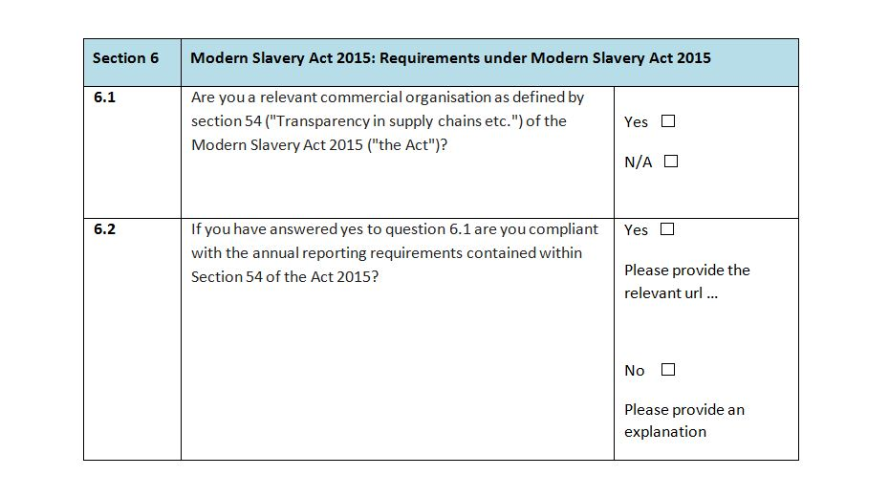

The Selection Questionnaire also includes a section detailing human trafficking crimes which constitute grounds for mandatory exclusion, and requires prospective suppliers to make a declaration about any trafficking offences which they have been involved in. The Procurement Team have engaged with partners to further strengthen risk assessments and due diligence practices.

The Council, in its role as a Modern Slavery Act first responder, has a number of plans and procedures in place to ensure effective support for and signposting of potential modern slavery victims. The Council’s Modern Slavery, Exploitation and Trafficking Response Plan sets out the responsibilities and procedures governing a range of services who may play a role should a modern slavery incident or emergency be identified locally. The South Tyneside Local Safeguarding Children Board and South Tyneside Safeguarding Adults Board Policies and Procedures also set out procedures in place for staff working with potential victims.

Looking forward, the Council is committed to exploring and implementing further ways to strengthen practices governing supply lines, and will work with local partners to support victims and identify and disrupt perpetrators. A wider Modern Slavery Strategy is also under development, and will include planned actions across service areas, as well as key performance indicators.

**Responsibility:**

Heads of services will be responsible for conducting risk assessments.

Any concerns regarding modern slavery or human trafficking should be raised with the Corporate Director of Business and Resources.

### ****Practical Guidance on Slavery and Trafficking:****

***Recognising modern day slavery and trafficking:***

* The true extent of modern slavery is unknown, but there are estimated to be between 10-13,000 victims of slavery and trafficking currently in the UK and millions worldwide.
* Victims are forced against their will to work for little or no pay for the benefit of others. They are often abused or threatened and stripped of their rights.
* There is no typical victim of slavery. Victims can be men, women or children of all ages and nationalities. Many victims are foreign nationals who are brought into the UK specifically so that they can be exploited for the benefit of others, however, a high number of victims are UK nationals, including children.
* Modern slavery crimes take place in many different sectors and workplaces, including factories, fields, retail or service units, and within private homes.
* Crimes of modern slavery have taken place all over the country, including within South Tyneside.

***Key indicators of trafficking include:***

* Is the person in possession of their own passport, identification or travel documents or are these documents in possession of someone else?
* Does the person act if they were instructed or coached by someone else? Do they allow others to speak for them when spoken to directly?
* Was the person recruited for one purpose and forced to engage in some other job? Have transport costs been paid for by facilitators, whom they must pay back through working or providing services?
* Does the person receive little or no payment for their work? Is someone else in control of their earnings?
* Does the victim have freedom of movement? Are they dropped off and collected from work?
* Is the person withdrawn or do they appear frightened?
* Has the person or their family been threatened with harm if they attempt to escape?
* Is the person under the impression they are bonded by debt, or in a situation of dependence?
* Has the person been physically or emotionally harmed or deprived of food, water, sleep, medical care or other life necessities?
* Can the person freely contact friends or family? Do they have limited social interaction or contact with people outside their immediate environment?

***What to do if you encounter or suspect modern day slavery or trafficking?***

In the first instance the point of contact for all modern slavery crimes should be the local police force. If you have information about a potential modern slavery crime that requires an immediate response (such as where victims are at risk) dial 999.

If you hold information that could lead to the identification, discovery and recovery of victims in the UK, you can contact the Modern Slavery Helpline on 0800 0121 700. Alternatively you can make calls anonymously to Crimestoppers on 0800 555 111.

If you have concerns or suspect that an adult is at risk of harm or abuse, you can call South Tyneside's Let’s Talk single point of contact for Adult Safeguarding:

* 0191 424 6000 (Monday to Friday, 8.30am until 5pm)
* 0191 456 2093 (outside of the above office hours)

If you have concerns or suspect that a child is at risk of harm or abuse, is being trafficked or enslaved, you can call South Tyneside's single point of contact for Children's Safeguarding at:

* 0191 424 5010 (Monday to Friday, 8.30am until 5pm)
* 0191 456 2093 (outside of the above office hours)