English Activity – Understanding Different Types of Text
The Department for Education and the government have established Key Themes as specific topics that aim to enrich your learning by improving your wider skills and understanding above and beyond the course you are taking. Skills South Tyneside and your training provider want you to gain the most from your programme of learning and these activities will help to embed those Key Themes. The Key Themes are:
M-  Maths | E-  English | ILT- Information Learning Technology | EDI- Equality, Diversity Inclusion | S-  Safeguarding | P- Prevent | C-  Climate | HS- Health and Safety | BV-  British Values
Texts can come in any form and be any kind of writing. Letters, adverts, user-guides, emails, postcards, notes and magazine articles are all different types of text.

When reading something, it helps to know what type of text it is. It also helps to know why it’s been written. For example:
- An advert is written to persuade you to buy something
- A user-guide is instructive and is written to tell you how to use something (such as a video recorder or washing machine)
- A formal (business) letter might be written to inform you about school dates
- A personal letter might be written by a friend describing a holiday

Persuasive Texts
A persuasive text tries to encourage you to do something. It may:
- Use capital letters, exclamation marks, questions, and repeated words to catch your attention
- Use adjectives to make something sound attractive
- Only give one side or an argument
- Take the form of an advert

For example, the following text is written to persuade the reader to take a holiday:
Enjoy an Enchanting Holiday in the Maldives

Scattered across the Indian Ocean lie islands with the finest white sand beaches and clearest crystal blue waters. These are the MALDIVES! Over 1,000 coral islands and temperatures here are always glorious.

What can our holiday offer you?

Luxurious accommodation with your own 5* suite
Free water sports for the duration of your holiday
Drinks and entertainment included at no extra charge
Chauffeur-driven limousine to and from the airport
Combine this with another seven-night holiday in our opulent apartments at the Kelai Country Club

Prices start from just £899 per person!



You can choose to do any or all the suggested activities below and your tutor will support you with any help you may need:
Activity: It’s important to understand the difference between what is fact and what is the writer’s opinion. Try and work out what is fact and what is opinion in the text in the blue box above. Click here to enter text.
Question: Which words are adjectives in the text in the blue box? Click here to enter text.
Question: What do you think are the persuasive words in the text in the blue box above? Click here to enter text.
Climate – World Rainforest Day – June 22nd 2022
The Department for Education and the government have established Key Themes as specific topics that aim to enrich your learning by improving your wider skills and understanding above and beyond the course you are taking. Skills South Tyneside and your training provider want you to gain the most from your programme of learning and these activities will help to embed those Key Themes. The Key Themes are:
M-  Maths | E-  English | ILT- Information Learning Technology | EDI- Equality, Diversity Inclusion | S-  Safeguarding | P- Prevent | C-  Climate | HS- Health and Safety | BV-  British Values
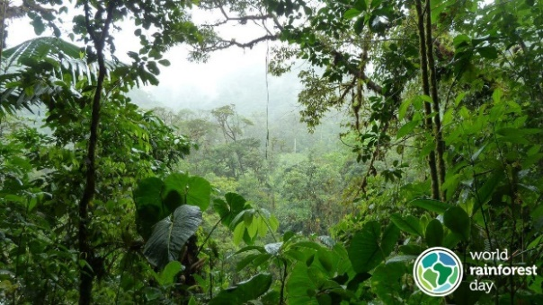

The first World Rainforest Day was launched on June 22nd 2017 by the Rainforest Partnership as a collaborative effort to raise awareness and encourage action to protect the world’s rainforests. Rainforests are vital for the survival of life on Earth. Not only do they provide us with the freshwater we drink, but they absorb carbon dioxide, stabilise climate patterns, and provide a home to half the world’s plants and animal species. And yet, over the last 40 years, deforestation has stripped an area equivalent to the size of Europe, or 1 billion hectares, from tropical rainforests.

Essential to our survival, rainforests are responsible for more than 25% of all Western medicine and house more than 50% of the world’s plant and animal species. Only covering 2% of the planet’s surface area, rainforests are dense and concentrated, however, they directly provide for indigenous populations who live off the land and work to protect this previous resource.

The United Nations has officially recognised the vital role that indigenous people play in fighting deforestation and preserving biodiversity. Unfortunately, world governments have failed to protect indigenous lands from logging, mining, ranching, oil exploration, and other harmful activities.

World Rainforest Day is an opportunity to celebrate this precious resource each year and take action to preserve it. Together we will create a positive impact on rainforests for years to come.

So, what can you do? Click on the links to find out more…


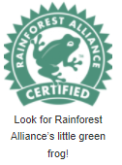

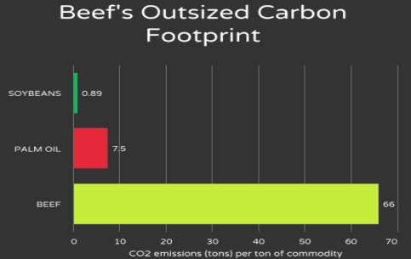
Eat More Plants - An area roughly the size of Slovenia of rainforest is destroyed every year to convert forest to farmland. From 2000 to 2005, beef production accounted for 65 to 70 percent of all deforestation in the Amazon, and that number is estimated to be even higher today.
Shop for rainforest-friendly products – Look for rainforest alliance certified products
Travel sustainability – Reduce your carbon footprint.
Hold leaders and corporations accountable – Vote for leaders who commit to protecting tropical rainforests.
Spread the word - Spread the word about World Rainforest Day on social media to inspire others to take action on June 22nd.
There’s also a huge range of resources and further information available here
You can choose to do any or all the suggested activities below and your tutor will support you with any help you may need:
Question: what did you learn from this article? Click here to enter text.
Question: if 70% of 10,000 trees in the amazon are removed how many remain? Click here to enter text.

British Values – UK Armed Forces Day – 25th June 2022
The Department for Education and the government have established Key Themes as specific topics that aim to enrich your learning by improving your wider skills and understanding above and beyond the course you are taking. Skills South Tyneside and your training provider want you to gain the most from your programme of learning and these activities will help to embed those Key Themes. The Key Themes are:
M-  Maths | E-  English | ILT- Information Learning Technology | EDI- Equality, Diversity Inclusion | S-  Safeguarding | P- Prevent | C-  Climate | HS- Health and Safety | BV-  British Values

What is UK Armed Forces Day?
Armed Forces Day is a chance to show your support for the men and women who make up the Armed Forces community: from currently serving troops to Service families, veterans and cadets. Showing support for the Armed Forces provides a much-valued morale boost for the troops and their families. There are many ways for people, communities, and organisations across the country to show their support and get involved.
British Values & UK Armed Forces Values
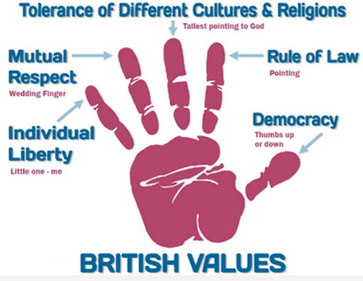
The British Values are designed to improve the the spiritual, moral, social and cultural development of learners to ensure that they leave learning prepared for life in moder Britain. The British Values and The UK Armed Forces are very similar.

The British Values are Democracy, The Rule of Law, Individual Liberty and Mutual Respect and Tolerance of Those With Different Faiths or Beliefs. British Values point more importance towards ensuring every single person in the UK regardless of culture/religion, is mutually respected and has freedom to do as they wish as law abiding citizens. The Army although sharing the value of respect, focuses more upon the integrity of a soldier and how much discipline, loyalty and courage they show in their roles.

Find out more about upcoming UK Armed Forces day events near you HERE
Keep up to date with the UK Armed Forces Blog HERE
#SaluteOurForces is a simple way for anyone to pay tribute to the British Armed Forces community for their hard work, dedication, and efforts to and keep us safe in the UK and across the globe. Last year, celebrities, members of the public and businesses all got involved.
To join in, simply send us a photo or video of yourself or your friends and colleagues saluting!

Here are examples of how to salute like the: Navy, Army & RAF. Give it a go!

You can submit your images in several ways:


- Tweet @ArmedForcesDay using #SaluteOurForces.
- Comment on one of our Facebook posts

- or email us at armedforcesdayuk@gmail.com
You can choose to do any or all the suggested activities below and your tutor will support you with any help you may need:
Question: what did you learn from this article? Click here to enter text.
Question: how can you show mutual respect? Click here to enter text.
Research Online: what is a reservist within the UK Armed Forces? Click here to enter text.

International Women in Engineering Day – 23rd June 2022
The Department for Education and the government have established Key Themes as specific topics that aim to enrich your learning by improving your wider skills and understanding above and beyond the course you are taking. Skills South Tyneside and your training provider want you to gain the most from your programme of learning and these activities will help to embed those Key Themes. The Key Themes are:
M-  Maths | E-  English | ILT- Information Learning Technology | EDI- Equality, Diversity Inclusion | S-  Safeguarding | P- Prevent | C-  Climate | HS- Health and Safety | BV-  British Values

International Women in Engineering Day is an international awareness campaign to raise the profile of women in engineering and focus attention on the amazing career opportunities available to girls in this exciting industry. It celebrates the outstanding achievements of women engineers throughout the world.

Taking place annually on 23 June, it’s a day to get engineering‚ and girls (or women!) into the same sentence as often as possible, and to start to raise the profile of an engineering career as a great choice, with an exciting future, and amazing opportunities.

National Women in Engineering Day was launched for the first time in the UK on 23 June 2014 by the Women’s Engineering Society (WES) and since then the day has grown enormously over the subsequent years to the point where it received UNESCO patronage in 2016. In 2017, International Women in Engineering Day (INWED) was born to allow the celebration of women in engineering to become global.

Did You Know?
- 79.8% of female engineering students geta First or 2:1 compared to 74.6% of male students
- There is a 27.5% increase in women in engineering occupations (compared to 4.6% in the overall workforce) since 2016
- This is an increase of 185,199 women in engineering occupations between 2016 and 2020


The theme this year will be ‘Inventors and Innovators’
This yea we’ll be celebrating the amazing work that women engineers around the world are doing, and not just to respond to the pandemic but also to support lives and livelihoods every day. They’re profiling the best, brightest and bravest women in engineering, who recognise a problem, then dare to be part of the solution; who undertake every day ‘heroics’ as much as emergency ones.
You can sign up to the newsletter or follow the weeks activities on Twitter and Instagram @INWED1919
You can also download the selfie card template here.
You can choose to do any or all the suggested activities below and your tutor will support you with any help you may need:
Question: 14.5% of all engineers in the UK are women. Why do you think this number is so low? Click here to enter text.
Question: what did you learn from this article? Click here to enter text.

