5 Minute Lesson Plan
Schedule Number |  | Course Code:
Course Title
Tutor |  | Date

Overview |  | Objectives   |  | Assessment Methods |  | Wider Key Themes  
Key Words/Phrases   |  | Maths  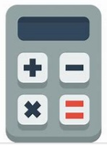 |  | English   |  |   ICT
start

end

Homework/
further learning

Evaluation

