

**The Licence holder MUST read the following pages 1-9:**

**The Licence holder MUST complete and return the forms on pages 10 and 11**

* Having paid the Licence fee to the Council is hereby licensed during the currency hereof to launch the motorised leisure craft, specified, from the Launching Ramp situate in the Southern Wave Trap, South Shields, subject to compliance with the Covenants, Conditions, Agreements, and hereinafter contained or referred to.
* Should not launch or collect passengers from Sandhaven or Littlehaven Beach.
* If at any time the Licence Holder fails to comply with any of the conditions hereof, this Licence shall be revoked forthwith, without notice, and without refund of the fee or any part thereof. The decision of the Council shall be final in this respect.
* Must not leave any trailer, craft or vehicle on the ramp, or access area, when not in use. Vehicles and trailers must be left in the Car Park.
* Access to the Launch Ramp to be kept clear at all times so as not to obstruct the line of passage for other users, or prevent access for Emergency vehicles.
* Must at all times observe and perform the Byelaws of the Port of Tyne Authority (a copy of which is available for inspection at the Council’s Cultural Services Department) (See also Appendix A)
* Must at all times carry a minimum of £5 million indemnity valid Third Party Insurance, and the Licence Holder hereby agrees to indemnify the Council against any claims, actions, demands, injuries, costs, charges, expenses and liabilities which may be renewed by the Council as a result as granting the Licence on the exercise of any right thereunder.
* Must produce the Licence to any authorised Officer of the Council, when called upon to do so.
* Any Licence Holder, who engages in behaviour causing or likely to cause a nuisance or annoyance to other sea/beach users, or who encourages or instigates others to do so, will have their Licence revoked and will be prohibited from any future use of the site for a minimum of two years at the discretion of the Council. Persistent nuisance behaviour may lead to legal action being taken, which could include the imposition of an Antisocial Behaviour Order.
* Breach of an ASBO is a criminal offence and carries a maximum of five years imprisonment, and/or a £2,000 fine. Information on offenders will be passed to neighbouring Authorities to assist in the control of nuisance or annoying behaviour.
* The craft Licence must be carried at all times and Vehicle permits must remain on display at all times.
* This Licence, shall remain in force for the period stated unless determined by one week’s written notice served at any time by the Council on the Licence Holder, at the address shown on the Licence. Upon such determination the Council shall refund an appropriate proportion of the licence fee having regard to the period the licence when expired.
* The benefit of the Licence is personal to the Licence Holder and relates only to the craft named on the Licence application. It may, with the consent of the Council, be exercised in relation to that craft by person’s acting at the request or with the authority of the Licence Holder, (who will nonetheless remain liable hereunder for their acts or omissions) but may not be transferred or assigned.
* The Licence Holder must ensure the barrier is closed after use, to prevent unauthorised use of the site. **Any Licence Holder found disregarding** this condition will be asked to return their Licence immediately.
* The Licence remains the property of South Tyneside Council at all times and must be returned when requested.
* No person under the age of 12yrs, should use a Personal Watercraft. Persons aged between 12yrs and 16yrs may use a Personal Watercraft, but only under the direct supervision of an adult.
* Motorised leisure craft includes, but is not limited to the following:- Personal Watercraft/Speed boats/Leisure craft.
* The Licence Holder must at all times comply with the Water Safety Code (See Appendix B)
* **Enforcement of the Regulations will be carried out by Officers of the Council, Police, and assisted by other Maritime Agencies.**
* **Information regarding this licence will be shared with other Local Authorities.**

### 

### APPENDIX

The attention of persons navigating boats in the Port of Tyne is drawn to the Port of Tyne Authority’s byelaws for the regulation of the Port, a copy of which may be inspected at the Council’s Community Services Department. The following byelaws are particularly relevant:-

**Vessels to be navigated with care**  
11. (1) The master shall navigate his vessel with such care and caution and at such speed and in such manner as not, directly or indirectly, to endanger the lives of or cause injury to persons or damage to property or to other vessels including, without prejudice to the foregoing provisions of this byelaw, injury or damage by or resulting from wash, swell or suction, and as not to cause any obstruction to or to interfere with the navigation, manoeuvring, working, loading or discharging of vessels, or buoys, moorings, river banks or other property.  
(2) Without prejudice to the provisions of paragraph (1) of this byelaw the master of a power driven vessel shall reduce its speed so as not to cause a hazard to any other vessel which is being docked or undocked or to any person or vessel engaged in dredging, diving or other underwater operations or in work on any buoy, mooring, quay or other riverside property.  
  
**Speed of vessels**  
12. Except with the permission of the harbour master and, without prejudice to the provisions of byelaw 11 and the Collision Regulations, the master of a vessel shall not cause or permit the vessel to proceed at a speed greater than 6 knots over the ground in the port westwards of the Herd Groyne Lighthouse at South Shields.

**Vessels to keep to starboard side of fairway or river**  
13. The master of a vessel being navigated shall cause the vessel to keep as near as is safe and practicable to the outer limit of the fairway or, in the case of a vessel not confined to navigating in the fairway in the river, to the river bank, in either case which lies on the starboard side of the vessel except when the vessel is turning in or crossing the fairway.  
  
**Vessels not to obstruct fairway**  
14. The master of a vessel, whether under power or sail, which is not confined to navigating within the fairway shall not make use of the fairway so as to cause obstruction to other vessels which can navigate only within the fairway.  
  
**Vessels entering or crossing the fairway**  
15. The master of a vessel shall cause the vessel to enter, cross or turn or manoeuvre in the fairway only when the fairway in the vicinity of the vessel is clear, and in such a manner as shall not or shall not be likely to impede or endanger any other vessel.

**Vessels to be stopped or so navigated as to allow boarding when required**  
17. The master of a vessel shall, when required by the harbour master or a police constable stop or so navigate the vessel so as to allow the harbour master or the police constable, as the case may be, to board the vessel for the purpose of ascertaining whether any relevant part of these byelaws has been or is being duly observed.  
  
**Navigation under influence of drink or drugs**  
18. A person shall not navigate any vessel whilst under the influence of drink or drugs to such an extent as to be incapable of taking proper charge of the vessel.

**Water skiing, aquaplaning and other similar activities**  
95. No person shall engage or take part in water skiing, aquaplaning, kiting or parachute towing or any similar waterborne or airborne activity except with the permission of the Authority given either specifically or generally and only in such areas as may be designated by the Authority and in accordance with such conditions as the Authority may impose.

Owners of boats are reminded that when navigating during night time they must ensure that the lights prescribed by the **International Regulations for Preventing Collisions at Sea** are exhibited on their boats. Guidance on the prescribed lights may be obtained from the Port of Tyne Authority’s Harbour Master, Port of Tyne, North Shields.

#### The maximum penalty for contravening any byelaw is £1000



**Littlehaven Beach Safety Zone:**

The Littlehaven Beach is a large and relatively shallow part of the harbour extending seaward from the shore between the Herd Groyne and the inner wall of the South Pier.

It is an area which encompasses al the regular seafront beach based leisure actives.

A Beach Safety Zone has been established to reduce the interaction between leisure vessels and beach users, and the outer limit of this Safety Zone is marker by five yellow marker buoys.

Littlehaven Beach Safety zone will be in operation between May and September.

To avoid coming in contact with beach users, leisure craft should not proceed in the are between the five yellow marker buoys and the beach, unless in the case of an emergency.

These five marker buoys also mark the approximate location of where the 6-knot speed limit applies.

This beach is not provided with a Lifeguard service.

Unpowered paddle sports such as paddle board and kayaking may occasionally take place within the beach safety zone.

The middle and north o f this beach are bathing areas encompass all the regular seafront beach based leisure actives.

A Beach Safety Zone has been established to reduce the interaction between leisure vessels and beach users in the middle and northern sections of this beach. The outer limit of this Safety Zone is marked by four yellow buoys.

The area recommended for surfing can be identified as being the area to the south of the southernmost marker buoy.

To avoid coming into contact with beach users, leisure craft should not proceed in the area between the four yellow marker buoys and the beach, unless in the case of an emergency.

Sandhaven Beach Safety zone will be in operation between June and September, following the end of the seasonal costal net fishing activity.

This beach is provided with a Lifeguard service during June, July and August. 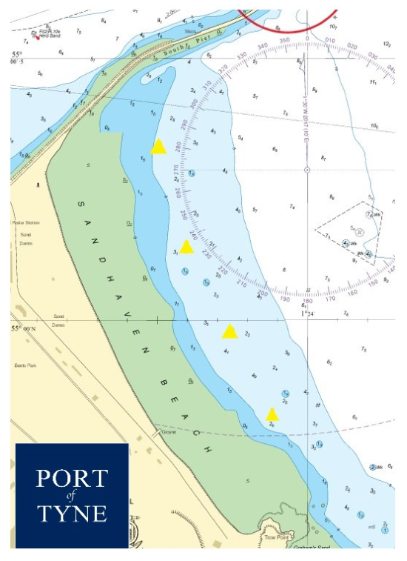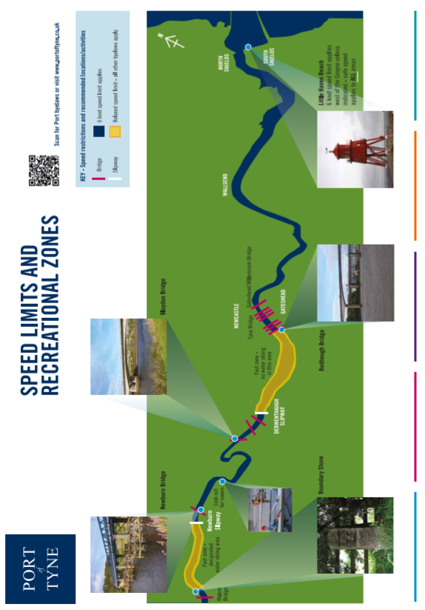

**3.8.2 Sandhaven Beach Safety Zone:**

The Sandhaven beach is relatedly large area extending south from the outer wall of the South Pier to Trow Point, South Shields.

For mor information please see The Port of Tyne website:

https://www.portoftyne.co.uk/site-map

