

2021 Air Quality Annual Status Report (ASR)

In fulfilment of Part IV of the Environment Act 1995 Local Air Quality Management

Date: June, 2021

|  |  |
| --- | --- |
| Information | South Tyneside Council Details |
| **Local Authority Officer** | Kevin Burrell |
| **Department** | Environmental Health |
| **Address** | Town Hall, Westoe Road, South Shields |
| **Telephone** | 0191 424 7836 |
| **E-mail** | [Kevin.burrell@southtyneside.gov.uk](mailto:Kevin.burrell@southtyneside.gov.uk) |
| **Report Reference Number** | STC/ASR2021 |
| **Date** | 24th June 2021 |

# Executive Summary: Air Quality in Our Area

# Air Quality in South Tyneside

Air pollution is associated with a number of adverse health impacts. It is recognised as a contributing factor in the onset of heart disease and cancer. Additionally, air pollution particularly affects the most vulnerable in society: children, the elderly, and those with existing heart and lung conditions. There is also often a strong correlation with equalities issues because areas with poor air quality are also often less affluent areas[1],[2].

The mortality burden of air pollution within the UK is equivalent to 28,000 to 36,000 deaths at typical ages[3], with a total estimated healthcare cost to the NHS and social care of £157 million in 2017[4].

South Tyneside Council adopts a collaborative, corporate-wide approach to air quality led by its Development Services Team. Within Development Services, the Environmental Health Unit is responsible for overseeing local air quality management, including air quality monitoring and reporting results to the Department of Environment, Food and Rural Affairs (Defra). Close working relationships with transport, public health and spatial planning colleagues are important to improve air quality as a consequence of transport and public health initiatives and also through routine planning applications that may impact upon air quality.

There are several principal air pollutants produced by industrial, domestic and traffic sources they include: sulphur dioxide; nitrogen oxide/ nitrogen dioxide (NO2); PM10 and PM2.5; ozone and volatile organic compounds; toxic organic micro pollutants; 1-3 butadiene; benzene; carbon monoxide; lead and heavy metals.

Historically, the main air pollutants have been high levels of smoke and sulphur dioxide emitted by combustion of sulphur containing fossil fuels i.e. coal, however currently the main air pollutant threat occurs from traffic emissions.

Nitrogen Dioxide (NO2) and Nitric Oxide (NO) are both oxides of nitrogen, and are collectively referred to as nitrogen oxides (NOx). All combustion processes produce NOx emissions, largely in the form of nitric oxides, which is then converted to nitrogen dioxide (NO2). Nitric oxide (NO) is mainly derived from road transport emissions and other combustion processes such as the electricity supply industry.

The principal source of Nitrogen Dioxide is road transport; combustion processes such as power generation and industrial processes also provide a significant contribution. The main contribution within South Tyneside is from road traffic.

South Tyneside Council ceased monitoring Sulphur Dioxide due to continued compliance during previous rounds of review and assessment.

Together, Environmental Health, Transport and Public Health colleagues are striving to reduce pollutant levels throughout the Borough even further to improve air quality and the health and wellbeing of residents. Various initiatives are discussed within this report and further information can be found in the links provided.

We shall continue to undertake continuous and non-continuous monitoring; all monitoring results can be found within Appendix A.

Air quality is everyone’s business and there are various ways that residents and businesses can improve local air quality.

## Actions to Improve Air Quality

Whilst air quality has improved significantly in recent decades and will continue to improve due to national policy decisions, there are some areas where local action is needed to improve air quality further.

The 2019 Clean Air Strategy[5] sets out the case for action, with goals even more ambitious than EU requirements to reduce exposure to harmful pollutants. The Road to Zero[6] sets out the approach to reduce exhaust emissions from road transport through a number of mechanisms; this is extremely important given that the majority of Air Quality Management Areas (AQMAs) are designated due to elevated concentrations heavily influenced by transport emissions.

The Council has completed a number of significant strategic transport improvements to improve air quality, reduce congestion and promote public transport in recent years:

* Significant improvements along the A185, A194 and A19;
* Air Quality Grant Funding to improve junctions and active travel corridors
* Transforming Cities Investment Tranche 1 delivering: -
  + A19 Cycle Scheme - £1m
  + Follingsby Lane Carriageway Improvements - £1m
  + A185 Strategic Transport Corridor - £0.9m

The delivery of these strategic transport priorities has been resultant from positive relationships with external funding providers such as the Department for Transport, Highways England, Department for the Environment, Farming, Rural Affairs and regionally through the North East Local Enterprise Partnership. Added to this, is that South Tyneside Council has a strong reputation for delivery.

With regards to forthcoming schemes over the next 5 years to support air quality and increase the uptake in active travel and public transport, the Council is set to embark on the following schemes: -

* A194 Strategic Transport Corridor - £1m
* South Shields to Newcastle Bus Corridor - £2.5m
* Healthier / Safer Metro Stations - £2m
* Intelligent Transport Corridors (traffic signal upgrades) - £1m
* Emergency Active Travel Funding - £0.6m
* Delivery of Active Travel scheme identified in the Local Cycling and Walking Investment Plan;
* Active Travel Capability Funding - £0.3m (awaiting approval)
* Highway and Accessibility Improvements to facilitate the International Advanced Manufacturing Park (close to Nissan, Sunderland)
* Electric Vehicle Charging Points roll-out - £0.25m
* A19 Southbound Lane Gain / Lane Drop - £3.5m (dependent on External Funding Bids
* White Mare Pool Interim Improvements (dependent on external funding bids)

In addition to the above, South Tyneside is working closely with Highways England who are delivered specific junction improvements along the A19 corridor as part of the National Road Investment Study (RIS) process.

The A19 corridor is s key regional economic corridor and a fundamental transport link into the Borough. Highways England will construct improvements at the A19 / A184 Testo’s junction and at the A19 / A1290 Downhill Lane junction. Both schemes are seen to improve road safety, reduce congestion and improve air quality, with the schemes being constructed from 2019 and completed in 2023. Testo’s Flyover as shown below below, with Downhill Lane expected to be completed in 2022.

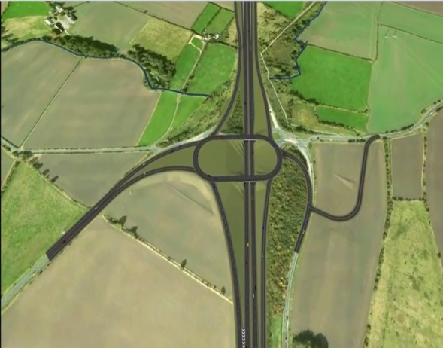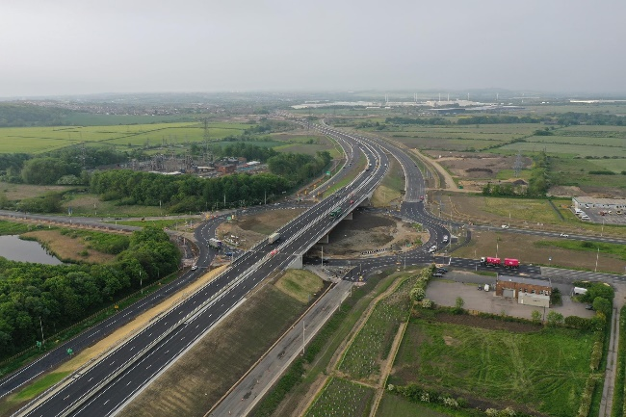

Active Travel and Physical Activity

We know transportation plays an important role in supporting daily activities; However, we also know active travel (cycling, walking and use of public transport) can increase physical activity levels and improve health and mental wellbeing.

Prioritisation of active travel can also reduce over reliance on motorised transport, contributing to improved air quality and a reduction in road injuries. Re-allocation of road space to support walking and cycling; restricting motor vehicle access; introducing road-user charging and traffic calming schemes; and creating safe routes to schools. Such changes have prompted substantial shifts from car transport to walking and cycling.

The Council has prepared a draft Local Cycling and Walking Implementation Plan (LCWIP) which is expected to be endorsed by the Council in July 2021. On adoption, this will provide the Council with the mechanism to attract further investment from the Emergency Active Travel Fund and other Central Government Funding opportunities. This is further expanded within the physical activity strategy for the borough, where it is bold in its commitments:

* To develop a traffic free cycle/walkway connecting South Tyneside to the IAMP and over 5000 new jobs;
* All of our children will achieve the early learning goal in physical activity;
* More children will travel to school by foot, bike, scoot, bus and metro than anywhere else in the region;
* We will ensure that physical activity forms part of quality GP and health professional conversations.

Environmental Sustainability

In July 2019 the Council declared a climate emergency pledging to take all necessary steps to become “carbon neutral by 2030”.

Following the declaration the Council developed the ‘Sustainable South Tyneside’ Strategy and produced a 5-year action plan, which set out the foundation providing a platform of collective actions and a shared vision, which supports an ambition of a cleaner, greener, low carbon and resilient future.

We have already taken actions to reduce Council emissions through a number of measures, including:

* A significant building rationalisation programme
* Building modernisation and retrofit improvements
* Purchase of new Refuse Collection Vehicles (RCV) meeting Euro 6 standards
* Route optimisation for RCVs
* Expansion of Electric Charging infrastructure
* Purchase of 3 new EV vans

The strategy contains 11 key themes that focus on key areas to support the target of carbon neutrality by 2030. The themes cover:

* Reducing Emissions from Council Buildings
* Streetlighting
* Transportation and Staff Travel
* Environment and Biodiversity
* Schools
* South Tyneside Homes (Operations)
* Procurement
* Policy
* Adaptation
* Cultural Change and Awareness
* Championing a Carbon Neutral Future

The Council continues to drive forward its aspiration of a greener Borough, by introducing three new electric vans to its fleet. The new vans along with future additions will feature a distinctive Sustainable South Tyneside branding on them so they stand out, helping to raise awareness, promoting the importance of a sustainable and brighter future for all.

Electric vehicles (EVs) are becoming an increasingly prominent fixture across transport systems, to support this transition the Council continues to expand its network of 38 electric vehicle charge points across the Borough with a further 19 due to be installed within coming months, further enhancing the EV charging infrastructure across South Tyneside

Tree planting is also an integral part of the Councils approach using nature-based solutions to sequester and store carbon emissions from the atmosphere.

A recent tree canopy assessment has been undertaken across South Tyneside, highlighting that the average canopy coverage across the borough is 16%, already exceeding UK standards for Coastal Towns, which is 15%.

## Conclusions and Priorities

There is a clear trend in the 2020 monitoring data.

Decreases in the annual mean concentration have been seen at all monitoring sites, both continuous monitoring at our three automatic monitoring stations, and at our non-continuous monitoring stations, 43 diffusion tubes located across the borough.

In March 2020, as a result of the Coronavirus pandemic, the most significant set of restrictions on British life in living memory were set in place as the Prime Minister ordered people to stay in their homes.

Lockdown restrictions led to less traffic and changing travel patterns and many people experienced better air quality.

However, the temporary improvement in air quality does not mask the need for progression on driving down air pollution. Longer term changes to how people live, work and travel as a result of the pandemic will bring opportunities, but also challenges.

The noticeable improvement many people experienced due to improved air quality following the initial lockdown illustrates the fundamental benefits of action being pro-active in reducing and pollutants and improve air quality for all of us.

South Tyneside Council is currently meeting local air quality objectives for NO2 and PM10.

No exceedances of the national objective levels have been recorded across the borough and we have not declared any new air quality management areas (AQMA’s) or had to amend/extend our current AQMA’s at Lindisfarne roundabout/Leam Lane and Boldon Lane. Non continuous (diffusion tube) data collected in 2020 has not demonstrated any exceedances of the national annual average for nitrogen dioxidethe data collected from continuous monitoring stations has not identified any exceedance of the national objective levels for NO2 or PM10 over the last five years.

Defra’s Local Air Quality Management technical guidance (TG16) states that an air quality management area can be revoked following a detailed assessment or if there is a robust evidence base including monitoring over a sufficient period i.e. several years to reflect national trends in emissions; Other factors such as works carried out as part of the action plan associated with the AQMA that may have had an effect on pollutant levels can also be taken into account. Revocation of the AQMA’s are subject to internal review and approval via a formal corporate process which will begin after completion of the detailed assessments.

## Local Engagement and How to get Involved

A significant proportion of air pollution is a result of road traffic sources, the two main pollutants of concern being NO2 and PM10. Making changes to your daily life including walking short journeys, using public transport and car sharing when you can will ultimately reduce levels of NO2 and PM10.

South Tyneside Council works with public health and the sustainability teams to encourage the uptake of sustainable modes of transport. South Tyneside has continued to encourage residents to cycle, walk, and use alternative methods of transport.

Other measures that residents can undertake to improve air quality include:

* Purchasing low emission electric/ and or hybrid vehicles;
* Working with schools on the importance of air quality and active travel;
* Upgrading boilers to newest and most efficient gas condensing boilers with lowest NOx (and carbon) emissions.

Table of Contents

Executive Summary: Air Quality in Our Area i

Air Quality in South Tyneside i

Actions to Improve Air Quality ii

Conclusions and Priorities vii

Local Engagement and How to get Involved viii

1 Local Air Quality Management 1

2 Actions to Improve Air Quality 2

2.1 Air Quality Management Areas 2

2.2 Progress and impact of measures to address Air Quality in South Tyneside 6

2.3 PM2.5 – Local Authority Approach to Reducing Emissions and/or Concentrations 13

3 Air Quality Monitoring Data and Comparison with Air Quality Objectives and National Compliance 17

Summary of Monitoring Undertaken 17

3.1.1 Automatic Monitoring Sites 17

3.1.2 Non-Automatic Monitoring Sites 17

3.2 Individual Pollutants 18

3.2.1 Nitrogen Dioxide (NO2) 18

.2.2 Particulate Matter (PM10) 20

3.1.3 Particulate Matter (PM2.5) 21

Appendix A: Monitoring Results 22

Appendix B: Full Monthly Diffusion Tube Results for 2020 45

Appendix C: Supporting Technical Information / Air Quality Monitoring Data QA/QC 47

New or Changed Sources Identified Within South Tyneside Council During 2020. 47

Additional Air Quality Works Undertaken by South Tyneside Council During 2020. 47

QA/QC of Diffusion Tube Monitoring 47

Diffusion Tube Annualisation 48

Diffusion Tube Bias Adjustment Factors 49

NO2 Fall-off with Distance from the Road 50

QA/QC of Automatic Monitoring 51

PM10 and PM2.5 Monitoring Adjustment 51

Automatic Monitoring Annualisation 51

NO2 Fall-off with Distance from the Road 51

Appendix D: Map(s) of Monitoring Locations and AQMAs 55

Appendix E: Summary of Air Quality Objectives in England 60

Appendix F: Impact of COVID-19 upon LAQM 61

Impacts of COVID-19 on Air Quality within South Tyneside 62

Non continuous monitoring stations 62

Continuous monitoring stations. 62

Lindisfarne Roundabout/ Leam Lane AQMA traffic levels 63

Boldon Lane AQMA Traffic levels 63

Opportunities Presented by COVID-19 upon LAQM within South Tyneside 64

Challenges and Constraints Imposed by COVID-19 upon LAQM within South Tyneside 64

Glossary of Terms 66

References 67

Figures

Figure 1.1 – Trends in Annual Mean NO2 Concentrations – Lindisfarne AQMA 30

Figure 1.2 – Trends in Annual Mean NO2 Concentrations – Boldon Lane AQMA 31

Figure 1.3 – Trends in Annual Mean NO2 Concentrations – Whitburn Cleadon &Boldons 32

Figure 1.4 – Trends in Annual Mean NO2 Concentrations – Fellgate (for A19) 33

Figure 1.5 – Trends in Annual Mean NO2 Concentrations – Hebburn and Jarrow 34

Figure 1.6 – Trends in Annual Mean NO2 Concentrations – Tyne Dock 35

Figure 1.7 – Trends in Annual Mean NO2 Concentrations – Westoe 36

Figure 1.8 – Trends in Annual Mean NO2 Concentrations – South Shields 37

Figure A.2 – Trends in Annual Mean PM10 Concentrations 40

Figure A.3 – Trends in Annual Mean PM2.5 Concentrations 43

Figure D.1 – Map of Non-Automatic Monitoring Site 52

Tables

Table 2.1 – Declared Air Quality Management Areas 5

Table 2.2 – Progress on Measures to Improve Air Quality 7

Table A.1 – Details of Automatic Monitoring Sites 18

Table A.2 – Details of Non-Automatic Monitoring Sites 19

Table A.3 – Annual Mean NO2 Monitoring Results: Automatic Monitoring (µg/m3) 22

Table A.4 – Annual Mean NO2 Monitoring Results: Non-Automatic Monitoring (µg/m3) 23

Table A.5 – 1-Hour Mean NO2 Monitoring Results, Number of 1-Hour Means > 200µg/m3 35

Table A.6 – Annual Mean PM10 Monitoring Results (µg/m3) 36

Table A.7 – 24-Hour Mean PM10 Monitoring Results, Number of PM10 24-Hour Means > 50µg/m3 38

Table A.8 – Annual Mean PM2.5 Monitoring Results (µg/m3) 39

Table B.1 – NO2 2020 Diffusion Tube Results (µg/m3) 41

Table C.1 – Bias Adjustment Factor 50

Table C.2 – Annualisation Summary (concentrations presented in µg/m3) 53

Table C.3 – Local Bias Adjustment Calculation 54

Table E.1 – Air Quality Objectives in England 57

Table F 1 - Impact Matrix 64

# Local Air Quality Management

This report provides an overview of air quality in South Tyneside Council during 2020. It fulfils the requirements of Local Air Quality Management (LAQM) as set out in Part IV of the Environment Act (1995) and the relevant Policy and Technical Guidance documents.

The LAQM process places an obligation on all local authorities to regularly review and assess air quality in their areas, and to determine whether or not the air quality objectives are likely to be achieved. Where an exceedance is considered likely the local authority must declare an Air Quality Management Area (AQMA) and prepare an Air Quality Action Plan (AQAP) setting out the measures it intends to put in place in pursuit of the objectives. This Annual Status Report (ASR) is an annual requirement showing the strategies employed by South Tyneside Council to improve air quality and any progress that has been made.

The statutory air quality objectives applicable to LAQM in England are presented in Table E.1.

# Actions to Improve Air Quality

# 2.1 Air Quality Management Areas

Air Quality Management Areas (AQMAs) are declared when there is an exceedance or likely exceedance of an air quality objective. After declaration, the authority must prepare an Air Quality Action Plan (AQAP) within 12-18 months setting out measures it intends to put in place in pursuit of compliance with the objectives.

A summary of AQMAs declared by South Tyneside Council can be found in Table 2.1.

Further information related to declared or revoked AQMAs, including maps of AQMA boundaries are available online at <https://uk-air.defra.gov.uk/aqma/local-authorities?la_id=251> Alternatively see [Appendix D](#_Appendix_E:_Map(s)) which provides for a map of air quality monitoring locations in relation to the AQMA(s).

There has been continued compliance with national air quality objective levels for nitrogen dioxide at Lindisfarne Roundabout/ Leam Lane and at the Boldon Lane/Stanhope Road AQMA’s. Continued compliance has been demonstrated in the last five years of continuous and non-continuous monitoring data. Appendix D: Maps of Monitoring locations and AQMA’S, provides a map of air quality monitoring locations.

**Boldon Lane AQMA**

Figure A1

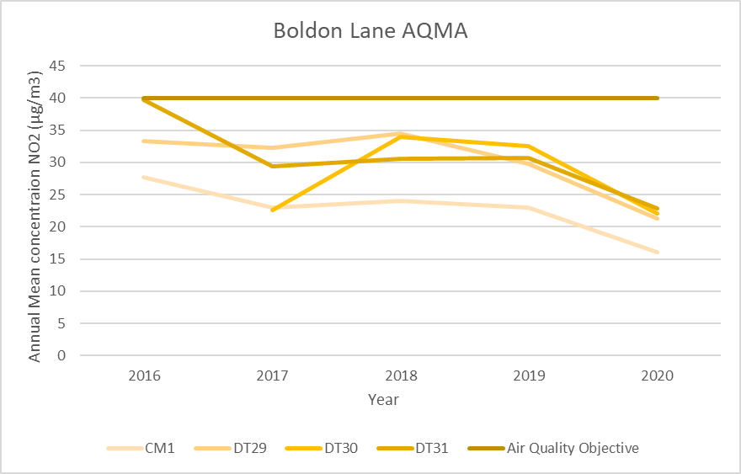

The figure above shows the results of continuous monitoring and non-continuous monitoring data within the Boldon Lane. It can be seen that NO2 levels have significantly decreased by 6µg/m³ at CM1 from 2019 with a concentration of 16 µg/m³. All three non continuous monitoring diffusion tubes have shown significant decreases in concentrations in 2020.

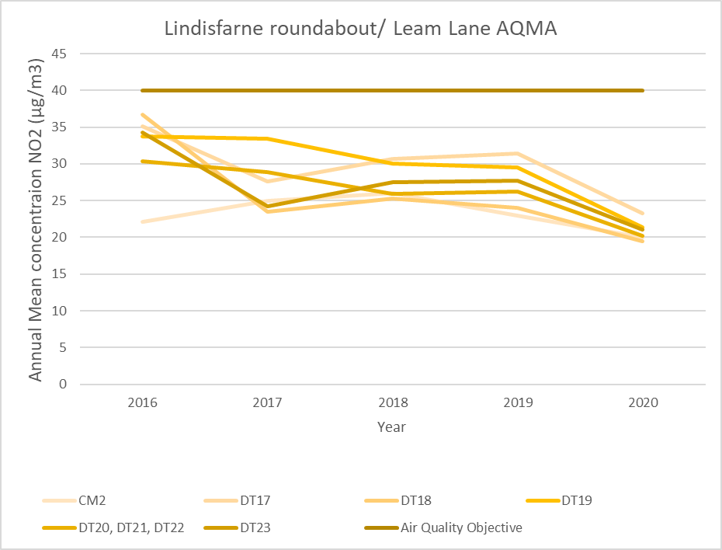

Figure A.1.2 – Lindisfarne Roundabout/Leam Lane AQMA shows all levels remain well below the national annual average objective level for NO2. There was an decrease of 3 µg/m³ to annual mean NO2 levels at Edinburgh Road continuous monitoring data in 2020 from 2019 concentrations. Diffusion tube data has been gathered over the past five years, concentrations have remained below the target concentration of 40 µg/m³. There is a clear reduction in NO2 concentrations at all diffusion tube locations.The highest concentration recorded was 23.2 µg/m³ from DT17 the concentration is down 8 µg/m³ from last year.

Table 2.1 – Declared Air Quality Management Areas

| AQMA Name | Date of Declaration | Pollutants and Air Quality Objectives | One Line Description | Is air quality in the AQMA influenced by roads controlled by Highways England? | Level of Exceedance: Declaration | Level of Exceedance: Current Year | | Name and Date of AQAP Publication | Web Link to AQAP |
| --- | --- | --- | --- | --- | --- | --- | --- | --- | --- |
| Lindisfarne Roundabout/ Leam Lane | 1st March 2006 | NO2 Annual Mean | A number of properties around Lindisfarne roundabout, extending along Leam Lane and the A19 | No | 43 µg/m3 | | 20 µg/m3 | Under review as part of the Climate Change Strategy. Refer to broad measures in table 2.2 | <https://uk-air.defra.gov.uk/aqma/local-authorities?la_id=251> |
| Boldon Lane/ Stanhope Road | 1st March 2006 | NO2 Annual Mean | Commercial properties with residential properties extending along Boldon Lane and Stanhope Road | No | 41 µg/m3 | | 16 µg/m3 | Under review as part of the Climate Change Strategy. Refer to broad measures in table 2.2 | <https://uk-air.defra.gov.uk/aqma/local-authorities?la_id=251> |

**South Tyneside Council confirm the information on UK-Air regarding their AQMA(s) is up to date.**

**South Tyneside Council confirm that all current AQAPs have been submitted to Defra.**

## 2.2 Progress and impact of measures to address Air Quality in South Tyneside

Defra’s positive appraisal of last year’s ASR concluded –

“The report is well structured, detailed, and provides the information specified in the Guidance. The following comments are designed to help inform future reports.

* Robust and accurate QA/QC procedures were applied. Calculations for bias adjustment, annualisation and distance-correction factors were outlined in detail.
* The Council has included discussion and review of its AQMAs and monitoring strategy, informed due to the extensive monitoring network and also the additional tubes in place to provide data. This demonstrates the Councils proactive and dedicated approach to improving air quality across the area.
* Comments from last year’s ASR have been mentioned and addressed. This is welcomed, and we encourage this to continue in future ASRs.
* There are several minor formatting issues seen throughout the report with results not presented to the correct number of decimal places, text from the template in red is required to be removed also and the bias adjustment factor reported is from the previous year despite using the correct factor for the calculation for 2019. Please take care when writing the ASR. – **DEFRA’s advise has been considered and has been applied to improve the quality of this report.**
* The Public Health Outcomes Frameworks was mentioned. The Council have referred specifically to indicator D01, which is the fraction of mortality attributable to particulate air pollution, and this is encouraged.
* Council have provided a clear map of the diffusion tube monitoring network; trends are displays and discussed in the report, this is welcomed.
* Council are considering the revocation of AQMAs if continued compliance with the Air Quality Objectives is seen in future years with this supported by the monitoring data through the detailed assessments being carried out presently.
* Overall the report is detailed, concise and satisfies the criteria of relevant standards. The Council should continue their good and thorough work.

South Tyneside Council has taken forward a number of direct measures during the current reporting year of 2020 in pursuit of improving local air quality. Details of all measures completed, in progress or planned are set out in Table 2.2. 23 measures are included within Table 2.2, with the type of measure and the progress South Tyneside Council have made during the reporting year of 2020 presented. Where there have been, or continue to be, barriers restricting the implementation of the measure, these are also presented within Table 2.2.

More detail on these measures can be found in their respective action plans i.e. the integrated Transport Plan and Physical Activity Strategy ([Physical Active Strategy](https://www.southtyneside.gov.uk/media/40947/South-Tyneside-Physical-Activity-Strategy/pdf/South_Tyneside_Physical_Activity_Strategy_2019.pdf?m=636961083198130000)).

Key completed measures include:

* Lindisfarne Corridor (A19, A194, A1300) Improvements - £8.1m
* The Arches (A185 / A194) junction improvements) - £9m
* South Shields Public Transport Interchange - £18m
* A19 Northbound Lane Gain / Lane Drop - £3.5m
* A19 Cycle Scheme - £1m
* Follingsby Lane Carriageway Improvements - £1m
* A185 Strategic Transport Corridor - £0.9m

The Council is set to embark on the construction of the following schemes in the coming years:

* **A194 Strategic Transport Corridor - £1m**

Following a successful external funding bid to the National Productivity Investment fund, the Council will deliver targeted improvements to reduce congestion, improve air quality and lead to economic growth. The designs are being finalised and will be constructed from September 2021.

* **South Shields to Newcastle Bus Corridor - £2.5m**

The Council has been provisionally awarded Transforming Cities fund as part of a successful regional funding ask. This will enable South Tyneside to bring forward improvements for public transport and other motorists at critical junctions, thus reducing congestion and improving air quality.

This will be delivered over a 3-year delivery programme from 2020-2023.

* **Healthier / Safer Metro Stations - £3m**

As with the above, South Tyneside will invest in both the Chichester and Tyne Dock metro stations in terms of sustainable transport links and improved security. The funding will come from the Transforming Cities Fund, with the schemes promoting sustainable transport options in an area close to the Boldon Lane Air Quality Management Area. This will be delivered over a 3-year delivery programme from 2020-2023.

* **Intelligent Transport Corridors - £1.5m**

Again, as part of the successful Transforming Cities Fund bid, the Council will work with the Regional Traffic Signals team to deliver intelligent transport corridors using new technology and undertaking traffic signal upgrades.

These upgrades will see improved traffic flows which will assist in reducing pollutants from stationary vehicles at the junctions. This will be delivered over a 3-year delivery programme from 2020-2023.

* **Active Travel Funding - £0.6m**

As part of a 20/21 successful bid for Active Travel Funding, South Tyneside is to bring forward sustainable transport initiatives on schemes highlighted in our consultation work undertaken as part of the draft Local Cycling and Walking Investment Plan. Works will be constructed over 21/22.

* **IAMP Highway and Accessibility Improvements**

The International Advanced Manufacturing Park (IAMP) being constructed in land adjacent to the Nissan Manufacturing Plant in Sunderland requires a significant amount of highway infrastructure to enable the development to come forward.

Measures include the construction of 2 road bridges, the dualling of the A1290 carriageway along with the internal road network to facilitate the development.

The required highway infrastructure within South Tyneside will come forward as part of a separate planning application from late Summer 2021.

The funding has been secured through the North East Local Growth Fund and will be implemented over the course of 2022-2025.

* **Ultra-Low Emission Charging Points roll-out - £0.25m**

South Tyneside has been successful in bidding for on-street charging point funding through Central Government. This will allow the local authority to further expand the EV charging point network over the course of the 2020/21 period.

South Tyneside Council anticipates that the measures stated above and in Table 2.2 will help to continue to achieve compliance in Lindisfarne/Leam Lane and Boldon Lane AQMA’s

Table 2.2 – Progress on Measures to Improve Air Quality

| Measure No. | Measure | Category | Classification | Year Measure Introduced | Estimated / Actual Completion Year | Organisations Involved | Funding Source | Defra AQ Grant Funding | Funding Status | Estimated Cost of Measure | Measure Status | Reduction in Pollutant / Emission from Measure | Key Performance Indicator | Progress to Date | Comments / Barriers to Implementation |
| --- | --- | --- | --- | --- | --- | --- | --- | --- | --- | --- | --- | --- | --- | --- | --- |
| 1 | North East Freight Quality Partnership | Freight and Delivery Management | Delivery and  Service plans | North East Combined Authority  (NECA) | Ongoing | North East Combined Authority  (NECA) | n/a | n/a | n/a | n/a |  | No direct improvement | Measures to assist freight movements including freight consolidation centres | Ongoing | <http://www.northeastfreightpartnership.info/> |
| 2 | North East Freight Maps | Freight and Delivery Management | Route  Management Plans/ Strategic routing strategy for HGV's | NECA | Ongoing | NECA | n/a | n/a | n/a | n/a |  | No direct improvement | Limiting freight movements to the strategic routes around the region | Ongoing | <http://www.northeastfreightpartnership.info/> |
| 3 | Set up a multi-disciplinary air quality steering group to drive forward STC clean air agenda | Policy Guidance and Development Control | Regional Groups co-ordinating programmes to develop area wide strategies to reduce emissions and improve air quality | STC | Ongoing | STC | n/a | n/a | n/a | n/a |  | No direct improvement | Ensure that all external funding opportunities are considered | Ongoing | Quarterly meeting undertaken |
| 4 | Set Up a Regional Air Quality Group | Policy Guidance and Development Control | Regional Groups co-ordinating programmes to develop area wide strategies to reduce emissions and improve air quality | NECA | Ongoing | NECA | n/a | n/a | n/a | n/a |  | No direct improvement | Ensure that air quality is considered in a trans boundary manner, maximise funding opportunities for combined authority bids | Ongoing | Regular meetings |
| 5 | Local Air Quality Strategy | Policy Guidance and Development Control | Air Quality Planning and Policy Guidance | STC | Oct 2021 | STC | n/a | n/a | n/a | n/a |  | No Direct Improvement |  | Oct 2021 |  |
| 6 | Ensure Air Quality is considered at pre application stage to allow effective use of planning conditions | Policy Guidance and Development Control | Air Quality Planning and Policy Guidance | STC | Ongoing | STC | n/a | n/a | n/a | n/a |  | No Direct Improvement | Ensure all planning applications comply with requirements to ensure air quality is not adversely affected by development | Ongoing |  |
| 7 | Completion of the Local Delivery Plan and Infrastructure delivery plan | Policy Guidance and Development Control | Air Quality Planning and Policy Guidance | STC | 2022 | STC | n/a | n/a | n/a | n/a | Yearly Service Delivery plans | No Direct Improvement | All new development will adhere to the prescribed guidance in the LDP and IDP to ensure that developments are compliant | 2022 |  |
| 8 | Ensure new developments have adequate travel plans that are continuously reviewed and updated | Policy Guidance and Development Control | Air Quality Planning and Policy Guidance | STC | Ongoing | STC | n/a | n/a | n/a | n/a | Ongoing | No Direct Improvement | Increase the number of travel plans within the borough | Ongoing |  |
| 9 | North East Air Quality Strategy | Policy Guidance and Development | Air Quality  Strategy | NECA | 2018 | NECA | n/a | n/a | n/a | n/a | Ongoing | No direct improvement | Reduced CO2 emissions | 2018 | North East  Combined Authority Leading on this |
| 10 | North East Combined Authority Sustainable Transport Group | Policy Guidance and Development | Regional Groups  to develop Area  wide Strategies to  reduce emissions | NECA | 2018 | NECA | n/a | n/a | n/a | n/a | Ongoing | No direct improvement | Air Quality Improvements | 2018 | Regular Meetings undertaken |
| 11 | STC promoting electric vehicles through an employer car lease scheme | Promoting Low Emission Transport | Company Vehicle Procurement -Prioritising uptake of low emission vehicles | STC | Ongoing | STC | n/a | n/a | n/a | n/a | Final Draft for Approval | No direct improvement | Reduced emissions | Ongoing |  |
| 12 | Investment in Electric Charging Infrastructure | Promoting Low Emission Transport | Priority parking for LEV's | STC | Ongoing | STC | OLEV | n/a |  |  | Ongoing | No direct improvement | Reduced emissions, Improved air quality | Ongoing | 15 additional charging points will be implemented in 2021 (May onwards). |
| 13 | Council Fleet to investigate options for electric fleet including Taxi’s | Promoting Low Emission Transport | Prioritising uptake  of low emission vehicles | STC | Ongoing, with STH fleet taking ownership of EV vans | STC | OLEV | n/a | n/a | n/a | Draft of LDP and IDP paused for a review of the Spatial Strategy | No direct improvement | Reduced emissions, improved air quality | Ongoing, with STH fleet taking ownership of EV vans |  |
| 14 | Council have installed EV Charging Points | Promoting Low Emission Transport | Prioritising uptake  of low emission vehicles, | STC | Ongoing | STC | OLEV | n/a | Yearly bids | £100k per annum | Ongoing | No direct improvement | Reduced emissions, improved air quality | Ongoing |  |
| 15 | Travel Planning through Planning Process | Promoting Travel Alternatives | Intensive active travel campaign & infrastructure | NECA & STC | Ongoing | NECA & STC | n/a | n/a | n/a | n/a | complete | Limited improvements | Reduced emissions, Improved air quality, | Ongoing |  |
| 16 | New South Shields Public Transport Interchange | Transport Planning and Infrastructure | Public transport improvements-interchanges stations and services | NEXUS / STC | Opened in August 2019 | NEXUS / STC | Local Growth Funding | n/a | n/a | £20m | Ongoing | No direct improvement | Reduced emissions, Improved air quality, | Opened in August 2019 |  |
| 17 | A19 Testos and Downhill lane junction improvements | Transport Planning and Infrastructure | Public transport improvements-interchanges stations and services | Highways  England | Testo’s open to traffic June 2021, Downhill Lane expected in 2022 | Highways  England | Highways England RIS | n/a | n/a | £125m | Ongoing | Improved Air Quality | Providing a safe and serviceable road network | Testo’s open to traffic June 2021, Downhill Lane expected in 2022 | <http://www.highways.gov.uk/roads/road-projects/a19-testos-junction-improvements/> |
| 18 | STC Active Travel Work stream | Vehicle Fleet Efficiency | Driver training and ECO driving aids | NECA | Ongoing | NECA | n/a | n/a | n/a | n/a | Ongoing | Limited improvements | Reduced emissions, Improved air quality, | Ongoing |  |
| 19 | Travel Information through the UTMC centre | Traffic planning and management | UTC, Congestion management, traffic reduction | NECA / STC | Ongoing | NECA / STC | n/a | n/a | n/a | n/a | Ongoing | Yes | Reduced emissions, Improved air quality, | Ongoing |  |
| 20 | Junction Improvements within the borough | Traffic Planning and Management | UTC, Congestion management, traffic reduction | STC | Ongoing | STC | Local Growth Funding | n/a | n/a | n/a | Ongoing | Yes | Reduced emissions, Improved air quality, | Ongoing |  |
| 21 | Intelligent Transport Solutions at Key Junctions | Traffic Planning and Management | UTC, Congestion management, traffic reduction | STC | Ongoing | STC | n/a | n/a | n/a | n/a | Ongoing | Yes | Reduced emissions, Improved air quality, | Ongoing |  |
| 22 | Successful Clean Bus Fund Bid | Promoting Travel Alternatives | Public transport improvements-interchanges stations and services | STC | Delivered | STC | Clean Bus Funding | n/a | n/a | n/a | Construction started in 2018 | Yes | Reduced emissions, Improved air quality, | Delivered |  |
| 23 | Delivery of the Council’s Strategic Transport Priorities | Traffic Planning and Management | Congestion management, traffic reduction | STC | Ongoing | STC | Various Central Government | n/a | n/a | various | Construction from 2019 | Yes | Reduced emissions, Improved air quality | Ongoing |  |

## 2.3 PM2.5 – Local Authority Approach to Reducing Emissions and/or Concentrations

As detailed in Policy Guidance LAQM-PG16 (Chapter 7), local authorities are expected to work towards reducing emissions and/or concentrations of PM2.5 (particulate matter with an aerodynamic diameter of 2.5µm or less).

There is now an extensive body of evidence that long-term exposure to everyday air pollutants over several years contributes to the development of cardiovascular disease (CVD), lung cancer, and respiratory disease. PM is inhaled into the lungs and ultrafine PM0.1 is thought to pass into the blood causing many adverse outcomes including systemic inflammation. Air pollution is strongly associated with all-cause mortality statistics.

In 2019 PHOF indicator D01, *Fraction of mortality attributable to particulate air pollution,* attributed 5.1% of mortality in England to particle air pollution, locally the figure was 3.6%.[7]

More recently, the impact of the global COVID-19 pandemic has clearly had an effect on behaviour due to periods of lock-down and limited movement (reduced car/transport use), employment and job losses, and more reliance on more active or greener forms of transport due to changes in lifestyle and circumstances.

The longer-term impact of the pandemic on air quality and overall emissions will become more apparent in the near future and local approaches to improving air quality will adapt and develop in response to this. There will be a key role for local authorities, and industry as a whole, to consider how positive impacts can be maintained through more agile and flexible working and travel arrangements as part of our COVID recovery plans.

**Impacts on Health Outcomes**

The Office of National Statistics consistently reports that residents of South Tyneside have a significantly lower life expectancy than the England average.

Life Expectancy – 2017-19

|  |  |  |
| --- | --- | --- |
|  | Male | Female |
| South Tyneside | 77.0 years | 81.8 years |
| National Average | 79.8 years | 83.4 years |

There is evidence to suggest that long term exposure to poor air quality increases the risk of premature mortality from cardiovascular and respiratory diseases. The premature mortality rates for cardiovascular, respiratory diseases and cancer are given below. It is important to note that other lifestyle factors such as smoking, etc. do influence these figures.

* Premature (under 75 years) mortality rates from all cardiovascular disease of 90.3 per 100,000 as compared to 70.4 per 100,000 for England; of this 36.7 per 100,000 were considered preventable.
* Premature (under 75 years) mortality rates from respiratory disease of 54.3 per 100,000 as compared to 34.2 per 100,000 for England; of this 38.9 per 100,000 were preventable.
* Premature (under 75 years) mortality rates from cancer of 155.5 per 100,000 as compared to 129.2 per 100,000 for England; of this 76.0 per 100,000 were preventable.

The mortality rates for respiratory disease can be broken down further into South Tyneside Ward areas as shown in the table below, benchmarked against England and South Tyneside as a whole.

**Chart 2.3. Deaths from respiratory diseases, all ages, standardised mortality ratio, by Ward 2015-2019:**

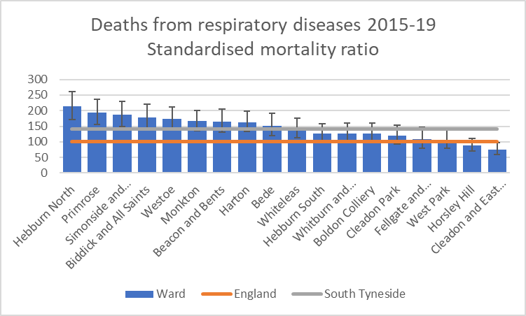

To note two of these wards (Biddick & All Saints, Bede) include air quality management areas.

Additional data shows:

* Emergency admissions for chronic obstructive pulmonary disease is significantly worse in South Tyneside at 740 per 100,000 population in comparison to England at 415 per 100,000[8].
* Hospital admissions for asthma in children (birth to 9 years) are 205.1 per 100,000 as opposed to the England rate of 160.7 per 100,000.[9]
* The hospital admission rates for young people aged 10 -18 is 238.7 per 100,000, significantly higher than the England rate of 123.4. This has seen a continual increase from 2010. We should note however the numbers associated with this rate are fairly low at 30.[10]

It is worth noting that variations that are statistically significant do not in themselves establish a causal relationship and that a wide range of factors affect mortality rates and associated hospital admissions, including rates of smoking, general health, deprivation and historic industrial exposures.

Nonetheless, diseases that can be worsened by poor air quality emphasises the importance of continued monitoring of air quality to reduce the impact of air pollution on the health of our residents.

South Tyneside Council is undertaking the measures detailed in the executive summary and detailed in table 2.2. These measures will have a positive effect in reducing NO2 and PM10 and would have similar effect upon levels of PM2.5.

From an operational point of view, South Tyneside Council Public Health are supporting South Tyneside and Sunderland NHS Foundation Trust with their work around active travel and healthy environments as part of their Employee Wellbeing Strategy, and wider businesses via the North East Better Health at Work Award. Public Health are also in the process of appointing a new practitioner to lead on healthy weight and physical activity, who will be supporting some of this wider work including re-energising the local Physical Activity Strategy, local work linked to the national Obesity Strategy, and our South Tyneside Cycling and Walking Investment Plan, all of which will support outcomes around improving air quality through increased physical activity and green exercise, and less reliance on motorised transport.

As detailed in Policy Guidance LAQM.PG16 (Chapter 7), local authorities are expected to work towards reducing emissions and/or concentrations of PM2.5 (particulate matter with an aerodynamic diameter of 2.5µm or less). There is clear evidence that PM2.5 has a significant impact on human health, including premature mortality, allergic reactions, and cardiovascular diseases.

THE AIR QUALITY (DOMESTIC SOLID FUELS STANDARDS) (ENGLAND) REGULATIONS 2020

A major source of PM2.5 particles is from burning at home, particularly with traditional house coal or wet wood.

Restrictions on the sale of coal, wet wood and manufactured solid fuels for burning in the home came into force on the 1st May, 2021

People with log burners and open fires can still use them, but will be required to buy cleaner alternative fuels – if they are not already – such as dry wood and manufactured solid fuels which produce less smoke. Both of these cleaner options are just as easy to source and more efficient to burn, making them more cost effective. Burning dry wood also produces more heat and less soot than wet wood and can reduce emissions by up to 50%.

The restrictions that mean that:

* Sales of bagged traditional house coal and wet wood in units under 2m3 are now unlawful.
* Wet wood in larger volumes must be sold with advice on how to dry it before burning.
* All manufactured solid fuels must now have a low sulphur content and only emit a small amount of smoke.
* In addition, a new certification scheme will see products certified and labelled by suppliers to ensure that they can be easily identified, and retail outlets will only able to sell fuel that is accompanied by the correct label.

# Air Quality Monitoring Data and Comparison with Air Quality Objectives and National Compliance

This section sets out the monitoring undertaken within 2020 by South Tyneside Council and how it compares with the relevant air quality objectives. In addition, monitoring results are presented for a five-year period between 2016 and 2020 to allow monitoring trends to be identified and discussed.

## Summary of Monitoring Undertaken

### Automatic Monitoring Sites

This section sets out what monitoring has taken place and how it compares with objectives.

South Tyneside Council undertook automatic (continuous) monitoring at 3 sites during 2020. Table A.1 in Appendix A shows the details of the sites. NB. Local authorities do not have to report annually on the following pollutants: 1,3 butadiene, benzene, carbon monoxide and lead, unless local circumstances indicate there is a problem. National monitoring results are available at https://uk-air.defra.gov.uk/

Maps showing the location of the monitoring sites are provided in Appendix D. Further details on how the monitors are calibrated and how the data has been adjusted are included in Appendix C.

There are no exceedances of the Annual Air Quality Object of 40µg/m3

### Non-Automatic Monitoring Sites

South Tyneside Council undertook non- automatic (i.e. passive) monitoring of NO2 at 43 sites during 2020. Table A.2 in Appendix A presents the details of the non-automatic sites.

Maps showing the location of the monitoring sites are provided in

[https://drive.google.com/open?id=1mRyjjoiCBuFuU7S8XqtGZsfKXJUso-q3&usp=sharing](https://drive.google.com/open?id=1mRyjjoiCBuFuU7S8XqtGZsfKXJUso-q3&usp=sharing" \o "South Tyneside Council Diffusion tube locations)

Further details on Quality Assurance/Quality Control (QA/QC) for the diffusion tubes, including bias adjustments and any other adjustments applied (e.g. annualisation and/or distance correction), are included in Appendix C.

## 3.2 Individual Pollutants

The air quality monitoring results presented in this section are, where relevant, adjusted for bias, annualisation (where the annual mean data capture is below 75% and greater than 33%), and distance correction. Further details on adjustments are provided in Appendix C.

### 3.2.1 Nitrogen Dioxide (NO2)

Table A.3 and Table A.4 in Appendix A compare the ratified and adjusted monitored NO2 annual mean concentrations for the past five years with the air quality objective of 40µg/m3. Note that the concentration data presented represents the concentration at the location of the monitoring site, following the application of bias adjustment and annualisation, as required (i.e. the values are exclusive of any consideration to fall-off with distance adjustment).

For diffusion tubes, the full 2020 dataset of monthly mean values is provided in Appendix B. Note that the concentration data presented in Table B.1 includes distance corrected values, only where relevant.

Table A.5 in Appendix A compares the ratified continuous monitored NO2 hourly mean concentrations for the past five years with the air quality objective of 200µg/m3, not to be exceeded more than 18 times per year.

There has been one change to the Diffusion tube monitoring network in 2020, DT39 is regularly stolen and therefore removed from the network. Previous years concentrations have been significantly below the Air Quality Objective level for the annual mean.

No diffusion tubes have been added to the network in 2020, however the network is constantly under review.

Trend graphs for diffusion tubes are provided in Appendix A and show a clear trend of decreasing concentrations in 2020. There are no exceedances of the Annual air quality objective level.

The highest concentration continues to be DT27 at the Arches roundabout, however at 26 µg/m3 it is still significantly lower than the annual objective. This diffusion tube does not represent relevant public exposure as per the relevant guidance in LAQM TG.16, however it is in its position due to the heavy traffic in this area, and to monitor improvements as a result of significant changes to the road network in this area.

The lowest concentration is found at DT3, Front Street with a concentration of 13.5 µg/m3.

The highest decrease from 2019 to 2020 is 12.4 µg/m3 at DT6, Front St, Boker Lane in Boldon. This site is located on a key commuter route between Sunderland and Newcastle, therefore traffic levels will have been heavily influenced by lockdown. Another reason for the drop in traffic at this site could be aligned to disruption associated with the Testo’s flyover construction scheme being in place from 2018, through to the opening in June 2021

The smallest decrease from 2019 to 2020 is 1.3 µg/m3 at DT38 Alice St. This indicates that the concentration at this site, on the façade of a residential property near to the A194 is not hugely influenced by road traffic levels, even though the A194 is one of the busiest roads on our network.

The average decrease across all diffusion tubes concentrations is 6.7 µg/m3

As no diffusion tubes have a concentration of over 60 μg/m³, this indicates that the hourly objective of 200 μg/m3 not to be exceeded more than 18 times a year has not been breached.

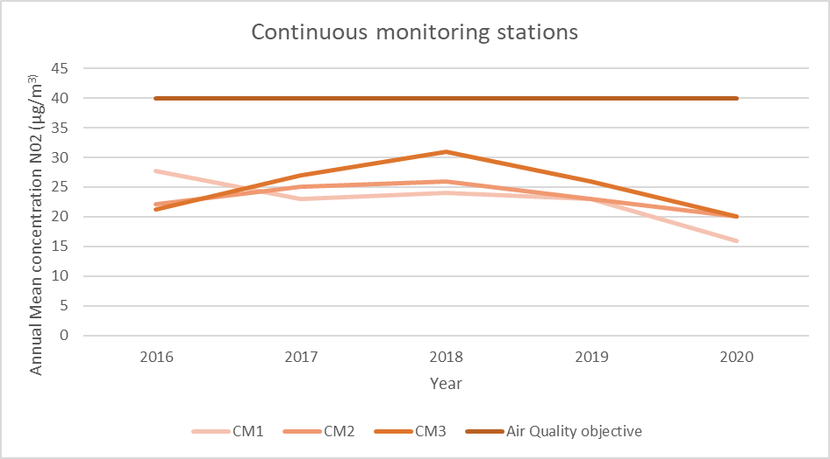

The figure above shows a steady decline in NO2 concentrations at the three continuous monitoring stations in South Tyneside.

The largest decrease is at the continuous monitoring station at Boldon Lane.

As there are no exceedances of any annual air quality objectives, South Tyneside Council has no requirement to declare any new AQMA’s.

## .2.2 Particulate Matter (PM10)

Table A.6 in Appendix A: Monitoring Results compares the ratified and adjusted monitored PM10 annual mean concentrations for the past five years with the air quality objective of 40µg/m3. There are no exceedances of the Air Quality Objective for annual mean at the two continuous monitoring sites in South Tyneside.

Table A.7 in Appendix A compares the ratified continuous monitored PM10 daily mean concentrations for the past five years with the air quality objective of 50µg/m3, not to be exceeded more than 35 times per year. There are have been four exceedances of the Air Quality Objective for the daily mean at the continuous monitoring station at Lindisfarne.

These instances occurred in November; further investigation shows that regional weather episodes were the cause of these peaks. The graph below shows a comparison of a number of automatic stations in Tyne and Wear

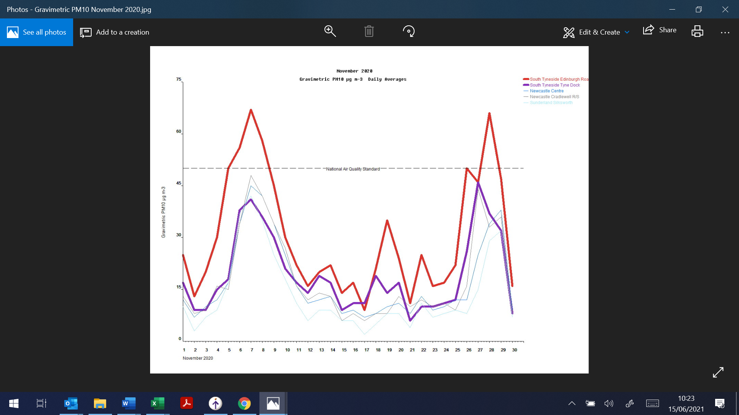

### Particulate Matter (PM2.5)

Table A.8 in Appendix A presents the ratified and adjusted monitored PM2.5 annual mean concentrations for the past five years.

Local authorities are not legally obliged to monitor PM2.5. South Tyneside started to report on PM2.5 in 2016. As detailed in Policy Guidance LAQM.PG16 (Chapter 7) PM2.5 levels can be estimated from PM10 levels by using a nationally derived correction ratio of 0.7. Table A.7 provides PM2.5 data converted using the correction ratio with PM10 data collected in 2020

The last 5 years worth of monitoring shows that the PM2.5 has remained fairly constant and below that target value. There are no exceedances of the annual objective for PM2.5

# Appendix A: Monitoring Results

Table A.1 – Details of Automatic Monitoring Sites

| Site ID | Site Name | Site Type | X OS Grid Ref (Easting) | Y OS Grid Ref (Northing) | Pollutants Monitored | In AQMA?  Which AQMA? | Monitoring Technique | Distance to Relevant Exposure (m) (1) | Distance to kerb of nearest road (m) (2) | Inlet Height (m) |
| --- | --- | --- | --- | --- | --- | --- | --- | --- | --- | --- |
| CM1 | Boldon Lane, South Shields | Roadside | 435,949 | 564,468 | NO2 | YES (Boldon Lane/ Stanhope Road ) | Chemiluminescent | 15 | 3 | 1.5 |
| CM2 | Lindisfarne Roundabout, Jarrow | Roadside | 434,068 | 563,695 | NO2; PM10 | YES (Lindisfarne Roundabout/ Leam Lane | Chemiluminescent TEOM | 27 | 1 | 2 |
| CM3 | Tyne Dock South Shields | Roadside | 435,565 | 565,040 | NO2; PM10 | No | Chemiluminescent TEOM | 12 | 14 | 2 |

**Notes:**

(1) 0m if the monitoring site is at a location of exposure (e.g. installed on the façade of a residential property).

(2) N/A if not applicable

Table A.2 – Details of Non-Automatic Monitoring Sites

| Diffusion Tube ID | Site Name | Site Type | X OS Grid Ref (Easting) | Y OS Grid Ref (Northing) | Pollutants Monitored | In AQMA? Which AQMA? | Distance to Relevant Exposure (m) (1) | Distance to kerb of nearest road (m) (2) | Tube Co-located with a Continuous Analyser? | Tube Height (m) |
| --- | --- | --- | --- | --- | --- | --- | --- | --- | --- | --- |

|  |  |  |  |  |  |  |  |  |  |  |
| --- | --- | --- | --- | --- | --- | --- | --- | --- | --- | --- |
| DT1 | Sunderland Road Jolly Sailor Whitburn | Roadside | 440,820 | 561,821 | NO2 | NO | 9.3 | 1.7 | NO | 2.3 |
| DT2 | Sunderland Road Cleadon | Roadside | 438,542 | 562,321 | NO2 | NO | 8.3 | 1.5 | NO | 2.65 |
| DT3 | Front Street Cleadon Café | Roadside | 438,539 | 562,329 | NO2 | NO | 0 | 2.5 | NO | 2.7 |
| DT4 | Station Road East Boldon | Roadside | 437,053 | 561,418 | NO2 | NO | 5 | 1.5 | NO | 2.5 |
| DT5 | Front Street / Grange Terrace | Kerbside | 436,524 | 561,275 | NO2 | NO | 4 | <1 | NO | 2.3 |
| DT6 | Front Street/ Boker Lane | Roadside | 436,021 | 561,368 | NO2 | NO | 11.5 | 1.5 | NO | 2.5 |
| DT7 | Arnold Street | Roadside | 434,623 | 561,746 | NO2 | NO | 0 | 1.5 | NO | 2.5 |
| DT8 | Holland Park Drive (A19) | Roadside | 433,883 | 562,644 | NO2 | NO | 0 | 30 | NO | 2 |
| DT9 | Southlands (A19) | Roadside | 433,739 | 562,070 | NO2 | NO | 19 | 40 | NO | 2.9 |
| DT10 | Mill Lane/ A185 Junction | Roadside | 430,469 | 563,040 | NO2 | NO | 3 | 28 | NO | 2.5 |
| DT11 | Victoria Road | Roadside | 430,538 | 563,420 | NO2 | NO | 1.6 | 20 | NO | 2 |
| DT12 | Victoria Road West /South Street | Roadside | 430,587 | 563,671 | NO2 | NO | 3 | 9 | NO | 2 |
| DT13 | Station Road Hebburn -PJ's Hairdressers | Roadside | 430,976 | 564,378 | NO2 | NO | 0 | 3.8 | NO | 2.6 |
| DT14 | Victoria Road East - Junction with Park Road | Kerbside | 432,169 | 564,962 | NO2 | NO | 12.5 | <1 | NO | 2.5 |
| DT15 | Ellison Street roundabout - Pizza Addict | Kerbside | 432,676 | 565,443 | NO2 | NO | 16.2 | 2.2 | NO | 2.5 |
| DT16 | Epinay Walk | Roadside | 433,093 | 564,998 | NO2 | NO | 8 | 28 | NO | 2 |
| DT17 | Hadrian Road | Roadside | 433,658 | 563,497 | NO2 | NO | 2 | 5 | NO | 2.5 |
| DT18 | Lindisfarne Road (55) | Roadside | 433,698 | 563,825 | NO2 | NO | 10 | 8 | NO | 2.5 |
| DT19 | Hadrian Road / Finchale Terrace Junction | Roadside | 433,780 | 563,692 | NO2 | NO | 3 | 13.5 | NO | 3 |
| DT20 | Edinburgh Road Monitoring Station | Roadside | 434,068 | 563,695 | NO2 | YES | 30 | <1 | NO | 2.9 |
| DT21 | Edinburgh Road Monitoring Station | Roadside | 434,068 | 563,695 | NO2 | YES | 30 | <1 | NO | 2.9 |
| DT22 | Edinburgh Road Monitoring Station | Roadside | 434,068 | 563,695 | NO2 | YES | 30 | <1 | NO | 2.9 |
| DT23 | John Reid Road, Junction with Stirling Ave | Roadside | 433,232 | 565,006 | NO2 | NO | 19.2 | 1.8 | NO | 2.85 |
| DT24 | Opposite 173 Hadrian Road | Roadside | 434,313 | 563,963 | NO2 | NO | 25 | 3.5 | NO | 2.35 |
| DT25 | Opposite 237 Newcastle Road | Roadside | 434,402 | 563,976 | NO2 | NO | 32 | 3.2 | NO | 2.4 |
| DT26 | Stanhope Road/ Newcastle Road | Roadside | 434,303 | 563,977 | NO2 | NO | 18 | 22 | NO | 2.5 |
| DT27 | A194 Arches Roundabout | Kerbside | 435,330 | 564,846 | NO2 | NO | 15 | <1 | NO | 2.2 |
| DT28 | Commercial Road | Roadside | 435,565 | 565,221 | NO2 | NO | 3.8 | 1.5 | NO | 2.6 |
| DT29 | Corner of Boldon Lane/ Stanhope Road | Kerbside | 435,930 | 564,600 | NO2 | YES | 6.5 | 1 | NO | 2.4 |
| DT30 | Stanhope Road | Kerbside | 435,980 | 564,641 | NO2 | YES | 1 | 4 | NO | 2.5 |
| DT31 | Boldon Lane | Roadside | 435,965 | 564,329 | NO2 | NO | 2 | 1.7 | NO | 2.3 |
| DT32 | King George Road | Roadside | 437,438 | 564,391 | NO2 | NO | 4 | 13 | NO | 2.5 |
| DT33 | Sunderland Road/ next to the Cranny | Roadside | 437,816 | 564,338 | NO2 | NO | 7 | 2 | NO | 2.3 |
| DT34 | Westoe Road | Roadside | 436,981 | 565,906 | NO2 | NO | 7 | 2 | NO | 2.35 |
| DT35 | Imeary Street/ The Glebe | Roadside | 436,729 | 566,375 | NO2 | NO | 14 | 4 | NO | 2.7 |
| DT36 | Chichester Metro | Kerbside | 436,483 | 565,887 | NO2 | NO | 18.9 | <1 | NO | 2.25 |
| DT37 | Western Approach Laygate Flats | Roadside | 436,220 | 566,620 | NO2 | NO | 11.5 | 2.5 | NO | 2.5 |
| DT38 | Alice Street (A194) | Kerbside | 436,168 | 565,875 | NO2 | NO | <1 | 27 | NO | 2.5 |
| DT40 | Anderson Street | Roadside | 436,595 | 567,298 | NO2 | NO | 10 | 2 | NO | 2.5 |
| DT41 | Campell Park Road | Kerbside | 431,432 | 564,498 | NO2 | NO | 25 | 6.5 | NO | 2.5 |
| DT42 | West Park Roundabout | Kerbside | 436,370 | 565,000 | NO2 | NO | 5 | 1.5 | NO | 2.5 |
| DT43 | Redhead Park | Kerbside | 437,165 | 565,576 | NO2 | NO | 10 | 2.5 | NO | 2.5 |
| DT44 | Imeary Street | Roadside | 436,923 | 565,966 | NO2 | NO | <1 | 2 | NO | 2.5 |

**Notes:**

(1) 0m if the monitoring site is at a location of exposure (e.g. installed on the façade of a residential property).

(2) N/A if not applicable.

Table A.3 – Annual Mean NO2 Monitoring Results: Automatic Monitoring (µg/m3)

| Site ID | X OS Grid Ref (Easting) | Y OS Grid Ref (Northing) | Site Type | Valid Data Capture for Monitoring Period (%) (1) | Valid Data Capture 2020 (%) (2) | 2016 | 2017 | 2018 | 2019 | 2020 |
| --- | --- | --- | --- | --- | --- | --- | --- | --- | --- | --- |
| CM1 | 435,949 | 564,456 | Roadside | Automatic | 97.7 | 27.7 | 23 | 24 | 23 | 16 |
| CM2 | 434,068 | 563,695 | Roadside | Automatic | 99.9 | 22.1 | 25 | 26 | 23 | 20 |
| CM3 | 435,565 | 565,040 | Roadside | Automatic | 98.9 | 21.3 | 27 | 31 | 26 | 20 |

**Annualisation has been conducted where data capture is <75% and >33% in line with LAQM.TG16.**

**Reported concentrations are those at the location of the monitoring site (annualised, as required), i.e. prior to any fall-off with distance correction.**

**Notes:**

The annual mean concentrations are presented as µg/m3.

Exceedances of the NO2 annual mean objective of 40µg/m3 are shown in **bold**.

All means have been “annualised” as per LAQM.TG16 if valid data capture for the full calendar year is less than 75%. See Appendix C for details.

Concentrations are those at the location of monitoring and not those following any fall-off with distance adjustment.

(1) Data capture for the monitoring period, in cases where monitoring was only carried out for part of the year.

(2) Data capture for the full calendar year (e.g. if monitoring was carried out for 6 months, the maximum data capture for the full calendar year is 50%).

Table A.4 – Annual Mean NO2 Monitoring Results: Non-Automatic Monitoring (µg/m3)

|  |  |  |  |  |  |  |  |  |  |  |
| --- | --- | --- | --- | --- | --- | --- | --- | --- | --- | --- |
| **Diffusion Tube ID** | **X OS Grid Ref (Easting)** | **Y OS Grid Ref (Northing)** | **Site Type** | **Valid Data Capture for Monitoring Period (%)** | **Valid Data Capture 2020 (%)** | **NO2 Annual Mean Concentration (µg/m3)** | | | | |
| **2016** | **2017** | **2018** | **2019** | **2020** |
| DT1 | 440820 | 561821 | Roadside | 72.6 | 72.6 | 30.0 | 25.9 | 24.3 | 24.9 | 20.9 |
| DT2 | 438542 | 562321 | Roadside | 83.8 | 83.8 | 37.6 | 31.7 | 28.8 | 30.6 | 23.8 |
| DT3 | 438412 | 562368 | Roadside | 65.5 | 65.5 | 29.4 | 21.5 | 20.3 | 19.7 | 13.5 |
| DT4 | 437053 | 561418 | Roadside | 72.6 | 72.6 | 28.9 | 20.5 | 19.5 | 19.8 | 14.7 |
| DT5 | 436528 | 561280 | Kerbside | 83.8 | 83.8 | 31.5 | 24.1 | 23.9 | 23.7 | 18.1 |
| DT6 | 436021 | 561368 | Roadside | 77.8 | 77.8 |  | 31.9 | 34.3 | 34.2 | 21.8 |
| DT7 | 434623 | 561746 | Roadside | 66.6 | 66.6 | 35.5 | 24.6 | 24.1 | 23.1 | 17.4 |
| DT8 | 433883 | 562644 | Roadside | 83.8 | 83.8 |  | 18.3 | 21.0 | 21.1 | 16.2 |
| DT9 | 433739 | 562070 | Roadside | 59.2 | 59.2 |  | 21.7 | 21.3 | 19.4 | 12.7 |
| DT10 | 430489 | 563058 | Roadside | 83.8 | 83.8 | 38.2 | 27.9 | 27.3 | 27.9 | 20.9 |
| DT11 | 430540 | 563425 | Roadside | 49.6 | 49.6 |  | 24.0 | 29.1 | 23.3 | 15.2 |
| DT12 | 430582 | 563663 | Roadside | 59.5 | 59.5 |  | 18.9 | 22.5 | 21.0 | 15.1 |
| DT13 | 430976 | 564378 | Roadside | 83.8 | 83.8 | 36.6 | 23.4 | 24.2 | 25.1 | 18.3 |
| DT14 | 432393 | 564994 | Kerbside | 74.2 | 74.2 | 34.9 | 30.0 | 26.2 | 26.3 | 21.8 |
| DT15 | 432682 | 565456 | Roadside | 66.6 | 72.6 | 28.9 | 22.4 | 24.8 | 23.8 | 23.7 |
| DT16 | 433088 | 565007 | Roadside | 83.8 | 83.8 | 32.6 | 24.4 | 24.6 | 26.2 | 18.2 |
| DT17 | 433658 | 563497 | Roadside | 83.8 | 83.8 | 35.1 | 27.6 | 30.6 | 31.4 | 23.2 |
| DT18 | 433698 | 563825 | Roadside | 83.8 | 83.8 | 36.7 | 23.4 | 25.3 | 24.0 | 19.4 |
| DT19 | 433780 | 563692 | Roadside | 83.8 | 83.8 | 33.8 | 33.4 | 30.1 | 29.5 | 21.4 |
| DT20, DT21, DT22 | 434068 | 563695 | kerbside | 83.8 | 83.8 | 30.4 | 28.9 | 25.9 | 26.3 | 20.2 |
| DT23 | 434326 | 563728 | kerbside | 75.1 | 75.1 | 34.2 | 24.2 | 27.5 | 27.7 | 21.1 |
| DT24 | 434297 | 563934 | Roadside | 83.8 | 83.8 | **40.6** | 32.8 | 35.3 | 32.3 | 24.6 |
| DT25 | 434376 | 563955 | kerbside | 83.8 | 83.8 | **41.9** | 28.4 | 30.7 | 29.3 | 22.4 |
| DT26 | 434298 | 563970 | Roadside | 83.8 | 83.8 | 32.2 | 28.0 | 29.0 | 28.8 | 22.6 |
| DT27 | 435321 | 564843 | Kerbside | 83.8 | 83.8 | **47.4** | 39.0 | 38.8 | 38.1 | 26.2 |
| DT28 | 435605 | 565290 | Roadside | 75.6 | 75.6 | 34.1 | 27.7 | 28.6 | 29.0 | 25.0 |
| DT29 | 435926 | 564596 | Kerbside | 61.9 | 61.9 | 33.4 | 32.2 | 34.5 | 29.8 | 21.3 |
| DT30 | 435987 | 564647 | Kerbside | 56.7 | 56.7 |  | 22.6 | 33.9 | 32.6 | 22.1 |
| DT31 | 435959 | 564470 | Kerbside | 74.2 | 74.2 | 39.8 | 29.4 | 30.6 | 30.7 | 22.8 |
| DT32 | 437540 | 564355 | Kerbside | 69.6 | 69.6 | 28.9 | 27.0 | 25.8 | 24.1 | 19.0 |
| DT33 | 437819 | 564335 | Kerbside | 23.6 | 23.6 | 32.7 | 28.3 | 28.2 | 26.9 | 19.5 |
| DT34 | 437010 | 565873 | Roadside | 83.8 | 83.8 | 37.6 | 36.6 | 32.7 | 30.4 | 23.3 |
| DT35 | 436923 | 565967 | Roadside | 83.8 | 83.8 | 27.4 | 25.9 | 26.7 | 23.9 | 19.2 |
| DT36 | 436727 | 566374 | Kerbside | 76.2 | 76.2 | 29.8 | 29.2 | 29.2 | 30.1 | 19.9 |
| DT37 | 436216 | 566216 | Roadside | 49.6 | 49.6 | **40.2** | 32.8 | 34.0 | 32.6 | 20.8 |
| DT38 | 436169 | 565876 | Roadside | 83.8 | 83.8 |  | 22.6 | 21.2 | 18.9 | 17.6 |
| DT39 | 436098 | 565902 | Roadside |  |  |  | 25.7 | 24.1 | 27.5 | **-** |
| DT40 | 436597 | 567308 | Roadside | 76.2 | 76.2 | 29.3 | 27.7 | 26.7 | 22.9 | 19.9 |
| DT41 | 431428 | 564493 | Kerbside | 83.8 | 83.8 |  |  | 27.5 | 24.8 | 19.2 |
| DT42 | 436396 | 565012 | Roadside | 83.8 | 83.8 |  |  | 34.7 | 30.8 | 23.3 |
| DT43 | 437161 | 565572 | Roadside | 83.8 | 83.8 |  |  | 28.6 | 26.9 | 20.7 |
| DT44 | 436923 | 565967 | Kerbside | 83.8 | 83.8 |  |  | 29.1 | 24.3 | 19.7 |

**Annualisation has been conducted where data capture is <75% and >33% in line with LAQM.TG16.**

**Diffusion tube data has been bias adjusted.**

**Reported concentrations are those at the location of the monitoring site (bias adjusted and annualised, as required), i.e. prior to any fall-off with distance correction.**

**Notes:**

The annual mean concentrations are presented as µg/m3.

Exceedances of the NO2 annual mean objective of 40µg/m3 are shown in **bold**.

NO2 annual means exceeding 60µg/m3, indicating a potential exceedance of the NO2 1-hour mean objective are shown in **bold and underlined**.

Means for diffusion tubes have been corrected for bias. All means have been “annualised” as per LAQM.TG16 if valid data capture for the full calendar year is less than 75%. See Appendix C for details.

Concentrations are those at the location of monitoring and not those following any fall-off with distance adjustment.

(1) Data capture for the monitoring period, in cases where monitoring was only carried out for part of the year.

(2) Data capture for the full calendar year (e.g. if monitoring was carried out for 6 months, the maximum data capture for the full calendar year is 50%).

Figure 1.1 – Trends in Annual Mean NO2 Concentrations – Lindisfarne Roundabout/Leam Lane AQMA

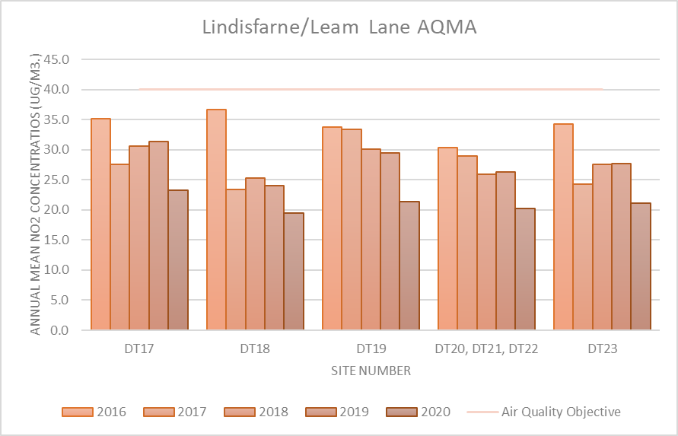

Figure 1.2 – Trends in Annual Mean NO2 Concentrations – Boldon Lane AQMA

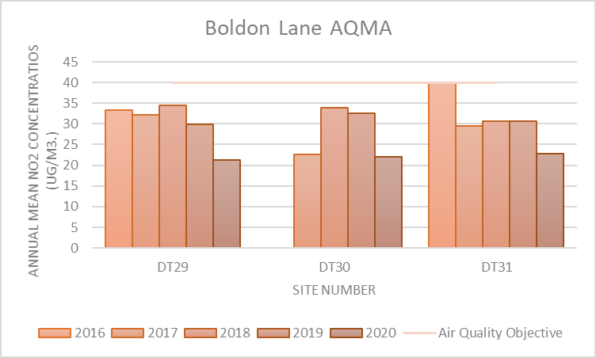

Figure 1.3 – Trends in Annual Mean NO2 Concentrations – Whitburn Cleadon and the Boldons

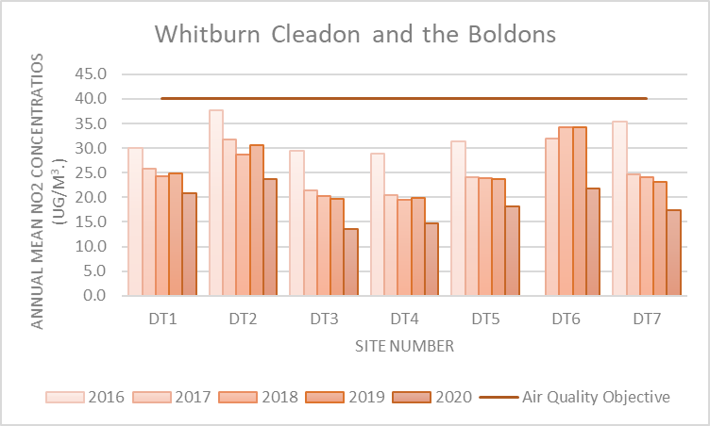

Figure 1.4 – Trends in Annual Mean NO2 Concentrations – Fellgate (for A19)

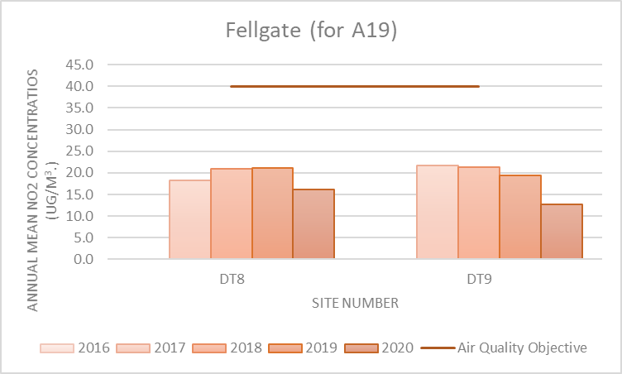

Figure 1.5 – Trends in Annual Mean NO2 Concentrations – Hebburn and Jarrow

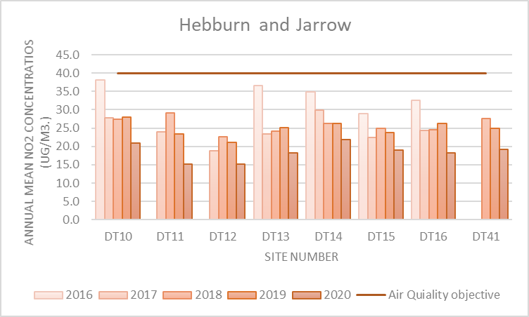

Figure 1.6 – Trends in Annual Mean NO2 Concentrations – Tyne Dock

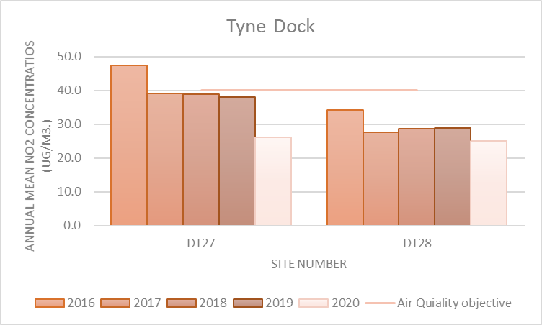

Figure 1.7 – Trends in Annual Mean NO2 Concentrations – Westoe

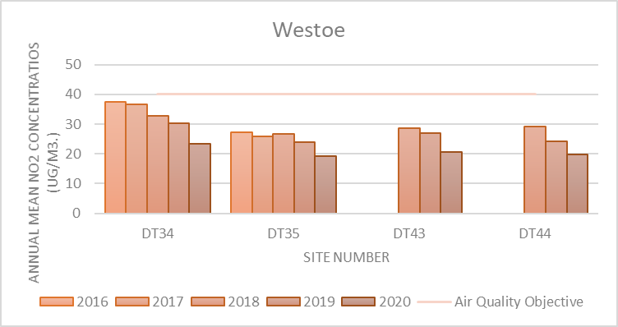

Figure 1.8 – Trends in Annual Mean NO2 Concentrations – South Shields

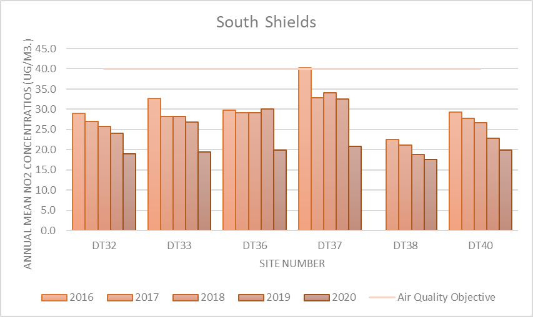

Table A.5 – 1-Hour Mean NO2 Monitoring Results, Number of 1-Hour Means > 200µg/m3

| Site ID | X OS Grid Ref (Easting) | Y OS Grid Ref (Northing) | Site Type | Valid Data Capture for Monitoring Period (%) (1) | Valid Data Capture 2020 (%) (2) | 2016 | 2017 | 2018 | 2019 | 2020 |
| --- | --- | --- | --- | --- | --- | --- | --- | --- | --- | --- |

|  |  |  |  |  |  |  |  |  |  |  |  |
| --- | --- | --- | --- | --- | --- | --- | --- | --- | --- | --- | --- |
| CM1 | 435,949 | 564,456 | Roadside | Automatic | 97.7 | 97.7 | 0 | 0 | 0 | 0 | 0 |
| CM2 | 434,068 | 563,695 | Roadside | Automatic | 99.9 | 99.9 | 0 | 0 | 0 | 0 | 0 |
| CM3 | 435,565 | 565,040 | Roadside | Automatic | 98.9 | 98.9 | 3 (268) | 0 | 0 | 0 | 0 |

**Notes:**

Results are presented as the number of 1-hour periods where concentrations greater than 200µg/m3 have been recorded.

Exceedances of the NO2 1-hour mean objective (200µg/m3 not to be exceeded more than 18 times/year) are shown in **bold**.

If the period of valid data is less than 85%, the 99.8th percentile of 1-hour means is provided in brackets.

(1) Data capture for the monitoring period, in cases where monitoring was only carried out for part of the year.

(2) Data capture for the full calendar year (e.g. if monitoring was carried out for 6 months, the maximum data capture for the full calendar year is 50%).

Table A.6 – Annual Mean PM10 Monitoring Results (µg/m3)

| Site ID | X OS Grid Ref (Easting) | Y OS Grid Ref (Northing) | Site Type | Valid Data Capture for Monitoring Period (%) (1) | Valid Data Capture 2020 (%) (2) | 2016 | 2017 | 2018 | 2019 | 2020 |
| --- | --- | --- | --- | --- | --- | --- | --- | --- | --- | --- |
| CM2 | 434,068 | 563,695 | Roadside | 99.5 | 99.5 | 14.3 | 15 | 18 | 19 | 18 |
| CM3 | 435,565 | 565,040 | Roadside | 98.5 | 98.5 | 17.3 | 18 | 19 | 19 | 14 |

**Annualisation has been conducted where data capture is <75% and >33% in line with LAQM.TG16**

**Notes:**

The annual mean concentrations are presented as µg/m3.

Exceedances of the PM10 annual mean objective of 40µg/m3 are shown in **bold**.

All means have been “annualised” as per LAQM.TG16 if valid data capture for the full calendar year is less than 75%. See Appendix C for details.

(1) Data capture for the monitoring period, in cases where monitoring was only carried out for part of the year.

(2) Data capture for the full calendar year (e.g. if monitoring was carried out for 6 months, the maximum data capture for the full calendar year is 50%).

Figure A.2 – Trends in Annual Mean PM10 Concentrations

Table A.7 – 24-Hour Mean PM10 Monitoring Results, Number of PM10 24-Hour Means > 50µg/m3

| Site ID | X OS Grid Ref (Easting) | Y OS Grid Ref (Northing) | Site Type | Valid Data Capture for Monitoring Period (%) (1) | Valid Data Capture 2020 (%) (2) | 2016 | 2017 | 2018 | 2019 | 2020 |
| --- | --- | --- | --- | --- | --- | --- | --- | --- | --- | --- |
| CM2 | 434,068 | 563,695 | Roadside | 99.6 | 99.6 | 0 | 1 | 2 (67) | 2(69) | 4(67) |
| CM3 | 435,565 | 565,040 | Roadside | 99.9 | 99.9 | 2 | 3 | 3 (64) | 4(70) | 0 |

**Notes:**

Results are presented as the number of 24-hour periods where daily mean concentrations greater than 50µg/m3 have been recorded.

Exceedances of the PM10 24-hour mean objective (50µg/m3 not to be exceeded more than 35 times/year) are shown in **bold**.

If the period of valid data is less than 85%, the 90.4th percentile of 24-hour means is provided in brackets.

(1) Data capture for the monitoring period, in cases where monitoring was only carried out for part of the year.

(2) Data capture for the full calendar year (e.g. if monitoring was carried out for 6 months, the maximum data capture for the full calendar year is 50%).

Table A.8 – Annual Mean PM2.5 Monitoring Results (µg/m3)

| Site ID | X OS Grid Ref (Easting) | Y OS Grid Ref (Northing) | Site Type | Valid Data Capture for Monitoring Period (%) (1) | Valid Data Capture 2020 (%) (2) | 2016 | 2017 | 2018 | 2019 | 2020 |
| --- | --- | --- | --- | --- | --- | --- | --- | --- | --- | --- |
| CM2 | 434,068 | 563,695 | Roadside | 99.6 | 99.6 | 10.01 | 10.5 | 12.6 | 13.3 | 12.6 |
| CM3 | 435,565 | 565,040 | Roadside | 99.9 | 99.9 | 12.11 | 12.6 | 13.3 | 13.3 | 9.8 |

**Annualisation has been conducted where data capture is <75% and >33% in line with LAQM.TG16.**

**Notes:**

The annual mean concentrations are presented as µg/m3.

All means have been “annualised” as per LAQM.TG16 if valid data capture for the full calendar year is less than 75%. See Appendix C for details.

(1) Data capture for the monitoring period, in cases where monitoring was only carried out for part of the year.

(2) Data capture for the full calendar year (e.g. if monitoring was carried out for 6 months, the maximum data capture for the full calendar year is 50%).

Figure A.3 – Trends in Annual Mean PM2.5 Concentrations

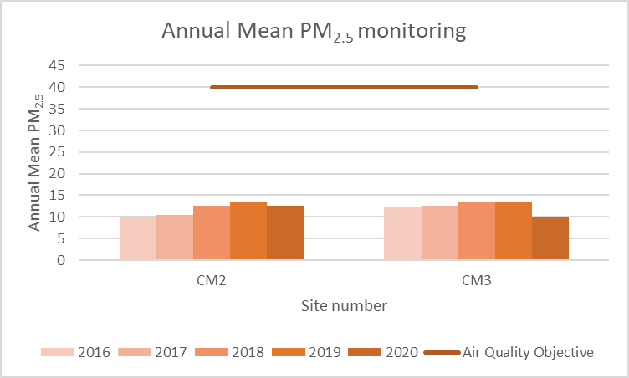

# Appendix B: Full Monthly Diffusion Tube Results for 2020

Table B.1 – NO2 2020 Diffusion Tube Results (µg/m3)

|  |  |  |  |  |  |  |  |  |  |  |  |  |  |  |  |  |  |
| --- | --- | --- | --- | --- | --- | --- | --- | --- | --- | --- | --- | --- | --- | --- | --- | --- | --- |
| **Diffusion Tube ID** | **X OS Grid Ref (Easting)** | **Y OS Grid Ref (Northing)** | **NO2 Mean Concentrations (µg/m3)** | | | | | | | | | | | | **Time Weighted Annual Mean (µg/m3)** | | |
| **Jan** | **Feb** | **Mar** | **Apr** | **May** | **Jun** | **Jul** | **Aug** | **Sep** | **Oct** | **Nov** | **Dec** |
| **Raw Data** | **Bias Adjusted (0.85) and Annualised** | **Distance Corrected to Nearest Exposure** |
| DT1 | 440820 | 561821 | 31.1 | 19.1 | **16.10** | | 19.3 | 22.0 | 19.9 | 23.9 | 26.0 |  | 33.4 | 30.6 | 24.7 | 20.9 |  |
| DT2 | 438542 | 562321 | 38.9 | 25.2 | **17.18** | | 19.8 | 21.8 | 23.1 | 23.5 | 28.6 | 32.8 | 40.0 | 29.9 | 28.1 | 23.8 |  |
| DT3 | 438412 | 562368 | 26.4 | 16.5 | **11.70** | | 11.5 | 8.9 |  |  | 16.1 | 19.7 | 25.0 | 23.5 | 18.4 | 13.5 |  |
| DT4 | 437053 | 561418 | 25.7 | 19.2 | **11.80** | | 10.0 | 14.0 | 11.3 | 13.0 | 17.0 |  | 25.3 | 23.2 | 17.4 | 14.7 |  |
| DT5 | 436528 | 561280 | 29.7 | 19.3 | **12.41** | | 12.7 | 22.8 | 16.0 | 14.7 | 21.4 | 22.3 | 29.6 | 27.8 | 21.3 | 18.1 |  |
| DT6 | 436021 | 561368 | 37.2 | 26.3 | **17.63** | | 18.3 | 14.1 | 21.7 | 23.5 | 32.8 | 29.2 |  | 29.0 | 25.7 | 21.8 |  |
| DT7 | 434623 | 561746 | 30.0 | 20.4 | **14.33** | | 12.6 |  | 16.0 | 16.9 | 22.6 | 26.3 | 33.0 |  | 21.8 | 17.4 |  |
| DT8 | 433883 | 562644 | 23.1 | 17.6 | **13.69** | | 12.2 | 14.2 | 12.4 | 16.6 | 20.8 | 22.8 | 26.6 | 26.4 | 19.1 | 16.2 |  |
| DT9 | 433739 | 562070 | 20.9 | 14.9 | **11.41** | |  |  | 8.8 |  | 17.7 | 20.4 | 21.3 | 24.8 | 18.3 | 12.7 |  |
| DT10 | 430489 | 563058 | 32.1 | 19.9 | **15.45** | | 16.4 | 20.3 | 18.1 | 23.0 | 26.2 | 27.8 | 32.3 | 31.9 | 24.6 | 20.9 |  |
| DT11 | 430540 | 563425 | 30.4 | 17.1 |  | |  |  |  |  | 20.5 | 24.3 | 28.0 | 22.2 | 23.5 | 15.2 |  |
| DT12 | 430582 | 563663 | 24.4 |  | **21.53** | | 10.7 | 14.7 | 12.1 | 16.3 | 20.2 | 22.4 |  |  | 17.3 | 15.1 |  |
| DT13 | 430976 | 564378 | 23.8 | 17.6 | **15.74** | | 14.3 | 20.4 | 15.7 | 23.5 | 27.3 | 24.3 | 22.9 | 26.9 | 21.6 | 18.3 |  |
| DT14 | 432393 | 564994 | 33.7 | 21.4 | **17.74** | | 18.4 | 20.3 |  | 23.0 | 30.7 | 28.3 | 27.4 | 29.3 | 25.7 | 21.8 |  |
| DT15 | 432682 | 565456 | 33.1 | 22.2 | **15.44** | | 13.9 | 17.2 | 22.5 | 18.4 | 23.8 |  | 84.7 | 31.5 | 22.9 | 19.1 |  |
| DT16 | 433088 | 565007 | 26.1 | 18.6 | **16.07** | | 14.8 | 18.4 | 17.7 | 17.0 | 23.2 | 23.2 | 27.9 | 28.8 | 21.4 | 18.2 |  |
| DT17 | 433658 | 563497 | 31.6 | 26.0 | **19.88** | | 20.3 | 28.1 | 15.0 | 28.5 | 29.8 | 30.4 | 35.0 | 32.8 | 27.4 | 23.2 |  |
| DT18 | 433698 | 563825 | 24.3 | 17.4 | **16.33** | | 14.7 | 23.2 | 22.3 | 22.5 | 26.2 | 23.9 | 25.5 | 29.6 | 22.9 | 19.4 |  |
| DT19 | 433780 | 563692 | 36.3 | 22.7 | **18.04** | | 15.1 | 19.8 | 15.4 | 21.4 | 27.6 | 28.6 | 39.3 | 30.7 | 25.2 | 21.4 |  |
| DT20 | 434068 | 563695 | 29.5 |  | **17.52** | | 15.4 | 16.4 | 20.1 | 22.5 | 26.2 | 27.1 | 31.6 | 29.2 | - | **-** |  |
| DT21 | 434068 | 563695 | 29.7 | 21.5 | **17.60** | | 16.4 | 18.3 | 19.1 | 22.5 |  | 27.5 | 31.9 | 27.1 | - | **-** |  |
| DT22 | 434068 | 563695 | 32.8 | 20.8 | **17.96** | | 14.3 | 18.2 | 17.4 |  | 26.1 | 28.3 | 30.7 | 28.7 | 23.8 | 20.2 |  |
| DT23 | 434326 | 563728 | 29.0 |  | **17.90** | | 17.7 | 21.9 | 17.4 | 22.1 | 28.8 | 26.4 | 30.7 | 32.1 | 24.9 | 21.1 |  |
| DT24 | 434297 | 563934 | 31.4 | 29.0 | **20.57** | | 21.3 | 21.3 | 18.0 | 23.2 | 32.7 | 35.1 | 45.1 | 37.0 | 29.1 | 24.6 |  |
| DT25 | 434376 | 563955 | 31.9 | 23.0 | **17.28** | | 17.2 | 23.3 | 24.2 | 26.7 | 29.9 | 29.5 | 35.0 | 26.5 | 26.4 | 22.4 |  |
| DT26 | 434298 | 563970 | 43.3 | 24.5 | **18.26** | | 16.2 | 19.7 | 20.0 | 24.8 | 26.9 | 26.8 | 35.1 | 32.9 | 26.7 | 22.6 |  |
| DT27 | 435321 | 564843 | 39.3 | 26.9 | **27.41** | | 27.8 | 32.1 | 18.0 | 20.9 | 35.0 | 32.9 | 42.6 | 39.0 | 30.9 | 26.2 |  |
| DT28 | 435605 | 565290 | 26.2 | 19.0 | **19.39** | |  | 44.0 | 27.3 | 30.2 | 28.3 | 27.0 | 33.5 | 32.9 | 29.5 | 25.0 |  |
| DT29 | 435926 | 564596 | 38.3 | 23.5 |  | |  |  | 18.4 | 22.3 | 31.0 | 32.3 |  | 36.7 | 28.8 | 21.3 |  |
| DT30 | 435987 | 564647 | 38.7 | 25.5 |  | |  |  | 22.0 | 25.5 | 32.7 |  | 31.4 | 36.5 | 30.0 | 22.1 |  |
| DT31 | 435959 | 564470 | 29.5 | 21.7 | **22.90** | | 23.1 | 29.4 | 21.0 | 21.9 | 33.6 | 28.8 | 39.5 |  | 26.9 | 22.8 |  |
| DT32 | 437540 | 564355 | 31.8 | 18.4 | **14.71** | |  | 26.3 | 15.8 | 26.1 | 22.7 | 26.1 |  | 31.0 | 24.7 | 19.0 |  |
| DT33 | 437819 | 564335 | 38.7 |  |  | |  |  |  |  | 22.7 |  |  | 31.3 | 31.4 | 19.5 |  |
| DT34 | 437010 | 565873 | 42.1 | 21.7 | **18.09** | | 17.2 | 17.3 | 24.7 | 16.2 | 30.5 | 32.2 | 41.2 | 35.6 | 27.6 | 23.3 |  |
| DT35 | 436923 | 565967 | 33.9 | 24.4 | **17.00** | | 13.8 | 17.4 | 16.7 | 10.5 | 24.4 | 27.1 | 30.9 | 29.4 | 22.6 | 19.2 |  |
| DT36 | 436727 | 566374 |  | 22.4 | **20.65** | | 17.4 | 20.5 | 22.1 | 10.3 | 27.9 | 27.0 | 33.9 | 31.7 | 23.4 | 19.9 |  |
| DT37 | 436216 | 566216 | 37.7 |  |  | |  |  | 23.1 | 14.9 | 33.8 | 21.9 | 41.2 |  | 27.2 | 20.8 |  |
| DT38 | 436169 | 565876 | 25.2 | 18.4 |  | | 35.2 | 11.4 | 15.4 | 7.2 | 18.6 | 26.5 | 27.4 | 22.9 | 20.8 | 17.6 |  |
| DT39 | 436098 | 565902 |  |  |  | |  |  |  |  |  |  |  |  |  | **-** |  |
| DT40 | 436597 | 567308 |  | 24.2 | **16.00** | | 13.0 | 15.4 | 17.8 | 17.6 | 23.3 | 33.9 | 38.5 | 27.7 | 23.5 | 19.9 |  |
| DT41 | 431428 | 564493 | 28.3 | 19.8 | **14.73** | | 15.1 | 17.1 | 18.1 | 20.0 | 27.3 | 25.9 | 28.1 | 28.2 | 22.6 | 19.2 |  |
| DT42 | 436396 | 565012 | 38.0 | 24.0 | **21.66** | | 19.7 | 21.8 | 18.8 | 24.8 | 30.4 | 31.5 | 33.5 | 34.3 | 27.5 | 23.3 |  |
| DT43 | 437161 | 565572 | 31.2 | 26.1 | **17.07** | | 17.7 | 17.3 | 20.0 | 22.3 | 26.1 | 26.7 | 30.5 | 27.8 | 24.4 | 20.7 |  |
| DT44 | 436923 | 565967 | 33.4 | 23.2 | **16.85** | | 14.1 | 14.7 | 17.1 | 16.2 | 23.1 | 24.2 | 34.3 | 34.7 | 23.3 | 19.7 |  |

**All erroneous data has been removed from the NO2 diffusion tube dataset presented in Table B.1**

**Annualisation has been conducted where data capture is <75% and >33% in line with LAQM.TG16**

**Local bias adjustment factor used.**

**National bias adjustment factor used.**

**Where applicable, data has been distance corrected for relevant exposure in the final column.**

**South Tyneside Council confirm that all 2020 diffusion tube data has been uploaded to the Diffusion Tube Data Entry System**.

**Notes:**

Exceedances of the NO2 annual mean objective of 40µg/m3 are shown in **bold**.

NO2 annual means exceeding 60µg/m3, indicating a potential exceedance of the NO2 1-hour mean objective are shown in **bold and underlined**.

See Appendix C for details on bias adjustment and annualisation.

# Appendix C: Supporting Technical Information / Air Quality Monitoring Data QA/QC

## New or Changed Sources Identified Within South Tyneside Council During 2020.

The International Advanced Manufacturing Park (IAMP) is one the most important development sites in the North of England, with the North East seen as an exemplar in this industry. Both Sunderland and South Tyneside Councils have allocated 150 hectares of development land to the north of Nissan UK and adjacent to the A19 trunk road. The IAMP was designated a ‘Nationally Significant Infrastructure Project’ (NSIP) by the UK Government, with a Development Consent Order expected from 2019.

In order to facilitate the first phase of development, both Councils adopted the International Advanced Manufacturing Park Area Action Plan on 30 November 2017. A planning application for IAMP ONE was approved by Sunderland City Council in May 2018 and the construction commenced during 2018, with the first site occupied in 2019.

The second phase of the IAMP scheme ‘IAMP two’ is currently going through the planning process and a development consent order application will be submitted in 2021, with a view to bringing forward the further development. An Environmental Impact Assessment scoping report has been appraised by both South Tyneside Council and Sunderland Council.

## Additional Air Quality Works Undertaken by South Tyneside Council During 2020.

South Tyneside Council has not completed any additional works within the reporting year of 2020 relating to the development of action plan measures or the declaration, amendment or revocation of an AQMA.

## QA/QC of Diffusion Tube Monitoring

Diffusion tubes are supplied and analysed by Gradko International Ltd, Winchester, Hampshire. The preparation method used is 20% TEA and acetone.

Gradko has full U.K.A.S. accreditation for compliance with ISO-IEC 17025 for laboratory management system. The accuracy and consistency of analytical methods is regularly monitored using external proficiency schemes such as

* Workplace analysis scheme for proficiency (W.A.S.P.)
* Laboratory Environmental Analysis Proficiency (L.E.A.P.)

Gradko follow the procedures set out by the DEFRA Harmonisation Practical Guidance.

Gradko participate in the AIR PT scheme for NO2 diffusion tube analysis and annual Inter-Comparison Exercise. Results are available on request. Regarding the 2020 AIR-PT results, the laboratory carried out internal blind testing in September 2020 as Air PT samples could not be provided due to Covid-19. This cannot be considered the same as proficiency testing, but is included to provide reassurance of laboratory performance during this period.

As a result of the Covid-19 pandemic, diffusion tubes were not collected in adherence with the Diffusion tube calendar in March and April. Discussions were held with the DEFRA helpdesk regarding the validity of these tubes. The helpdesk advised thus:

*“Under ‘normal’ conditions and years, it would be more preferable to remove this data as it is unknown how extended exposure periods may impact the analysed concentrations, however we appreciate that due to the unprecedented nature of 2020 that data may be quire sparse for the entire year. Therefore, it is advisable to compare this data against your other monthly data to identify whether the concentrations for this 8 week period look relevant in relation to changing traffic flows in the area. It may also be more preferable to include this data if there are many months’ worth of data missing throughout 2020 so that as much data is presented as possible”*

**As only one month’s data is missing, the decision has been taken to remove this data from the calculation for the annual mean to ensure accurate and transparent data.**

In addition, to test the impact that the data would have on the annual mean, Calculations were undertaken with the results included, and the annual mean at all locations was relatively unchanged.

The data is presented in Table B.1 for April, however it has not been included in the calculations for the annual mean.

### Diffusion Tube Annualisation

For those sites with a data capture of less than 75%, annualisation is required to calculate the annual mean. The sites requiring this calculation are:

DT3, DT7, DT9, DT11, DT12, T15, DT29, DT30, DT32, DT33, DT37.

Table C.2 below shows the calculation method that is used as per LAQM TG.16.

Four local sites which are part of the national Automatic Urban and Rural monitoring network have been identified, however data capture at Sunderland Silksworth is not sufficient to be included in the calculation methodology, three sites are appropriate according to guidance.

### Diffusion Tube Bias Adjustment Factors

The diffusion tube data presented within the 2020 ASR have been corrected for bias using an adjustment factor. Bias represents the overall tendency of the diffusion tubes to under or over-read relative to the reference chemiluminescence analyser. LAQM.TG16 provides guidance with regard to the application of a bias adjustment factor to correct diffusion tube monitoring. Triplicate co-location studies can be used to determine a local bias factor based on the comparison of diffusion tube results with data taken from NOx/NO2 continuous analysers. Alternatively, the national database of diffusion tube co-location surveys provides bias factors for the relevant laboratory and preparation method.

South Tyneside Council have applied a local bias adjustment factor of 0.85 to the 2020 monitoring data. A summary of bias adjustment factors used by South Tyneside Council over the past five years is presented in Table C.1.

For comparison, using the national bias adjustment spreadsheet calculation found on the [LAQM website](https://laqm.defra.gov.uk/bias-adjustment-factors/national-bias.html) the national bias adjustment figure is 0.81 –

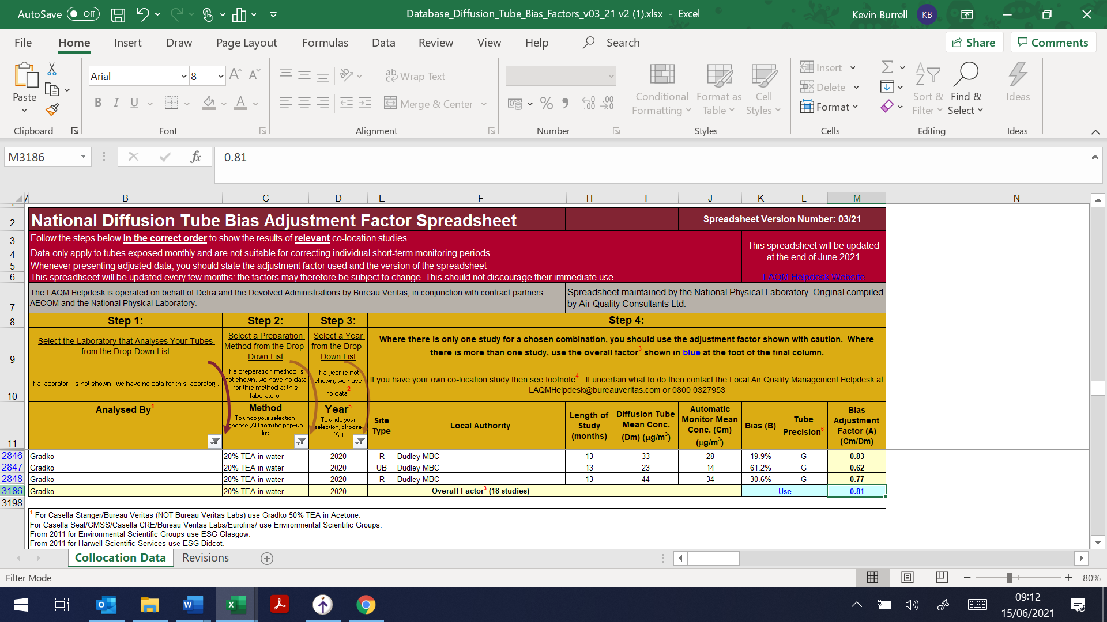

Therefore, as the overall diffusion tube precision, and the overall continuous monitor data capture has been identified as “good” using the AEA_DifTPAB_v04 processing tool provided by DEFRA –

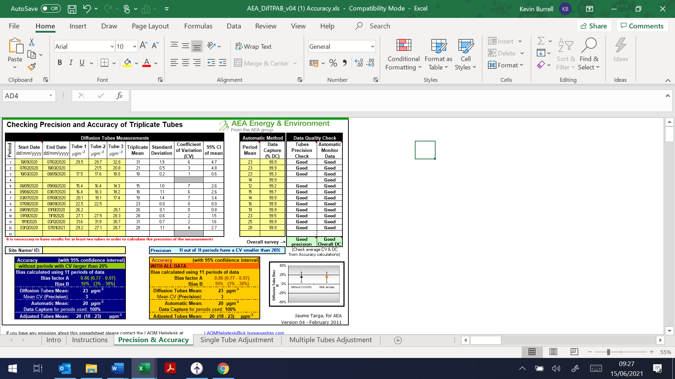

South Tyneside Council have taken the cautious “Worst case scenario” approach to use the local bias adjustment factor.

The co-location site is the Edinburgh Road continuous monitoring station, where triplicate diffusion tubes are located next to the inlet of the station

Table C.1 – Bias Adjustment Factor

|  |  |  |  |
| --- | --- | --- | --- |
| Year | Local or National | If National, Version of National Spreadsheet | Adjustment Factor |
| **2020** | Local | - | 0.85 |
| **2019** | National | 03/20 | 0.93 |
| **2018** | National | 03/19 | 0.93 |
| **2017** | National | 03/18 | 0.87 |
| **2016** | National | 03/17 | 0.92 |

### NO2 Fall-off with Distance from the Road

Wherever possible, local authorities should ensure that monitoring locations are representative of exposure. However, where this is not possible, the NO2 concentration at the nearest location relevant for exposure should be estimated using the Diffusion Tube Data Processing Tool/NO2 fall-off with distance calculator available on the LAQM Support website. Where appropriate, non-automatic annual mean NO2 concentrations corrected for distance are presented in Table B.1.

No diffusion tube NO2 monitoring locations within South Tyneside Council required distance correction during 2020

## QA/QC of Automatic Monitoring

The QA/QC procedures of South Tyneside Council are based on the AUN Site Operator’s manual along with training received from our original equipment suppliers, Casella Group.

Maintenance / Calibration of equipment:

* A qualified engineer services automatic analysers every 6 months under a contracted service agreement. The analysers are calibrated during service visits.
* Matt’s Monitors Ltd are under contract to maintain the stations, staff visit each monitoring station at least once every 4 weeks to ensure all of the equipment is working within normal parameters and to conduct zero and span checks of the equipment. The filters at each site are changed during these visits.
* If a problem is noted with any of the stations, a call-out is initiated and a service engineer will visit the site within 2 days to correct the fault.

### PM10 and PM2.5 Monitoring Adjustment

The type of PM10 monitor(s) utilised within South Tyneside Council do not required the application of a correction factor.

### Automatic Monitoring Annualisation

All automatic monitoring locations within South Tyneside Council recorded data capture of greater than 75% therefore it was not required to annualise any monitoring data. In addition, any sites with a data capture below 33% do not require annualisation.

### NO2 Fall-off with Distance from the Road

Wherever possible, local authorities should ensure that monitoring locations are representative of exposure. However, where this is not possible, the NO2 concentration at the nearest location relevant for exposure should be estimated using the NO2 fall-off with distance calculator available on the LAQM Support website. Where appropriate, non-automatic annual mean NO2 concentrations corrected for distance are presented in Table B.1.

No automatic NO2 monitoring locations within South Tyneside Council required distance correction during 2020.

Table C.2 – Annualisation Summary (concentrations presented in µg/m3)

| Site ID | Annualisation Factor Silksworth | Annualisation Factor Sunderland Wessington Way | Annualisation Factor Newcastle Centre | Annualisation Factor Newcastle Cradlewell | Average Annualisation Factor | Raw Data Annual Mean | Annualised Annual Mean |
| --- | --- | --- | --- | --- | --- | --- | --- |

|  |  |  |  |  |  |  |  |
| --- | --- | --- | --- | --- | --- | --- | --- |
| DT3 |  | 0.8099 | 0.8871 | 0.8915 | 0.8628 | 18.4 | 15.9 |
| DT7 |  | 0.9295 | 0.9561 | 0.9463 | 0.9440 | 21.8 | 20.6 |
| DT9 |  | 0.7605 | 0.8507 | 0.8538 | 0.8217 | 18.3 | 15.0 |
| DT11 |  | 0.6964 | 0.7897 | 0.7995 | 0.7619 | 23.5 | 17.9 |
| DT12 |  | 1.0356 | 1.0300 | 1.0334 | 1.0330 | 17.3 | 17.8 |
| DT15 |  | 0.9595 | 1.0019 | 0.9927 | 0.9847 | 22.9 | 22.5 |
| DT29 |  | 0.8331 | 0.8870 | 0.8986 | 0.8729 | 28.8 | 25.1 |
| DT30 |  | 0.8216 | 0.8941 | 0.8936 | 0.8698 | 30.0 | 26.1 |
| DT32 |  | 0.8781 | 0.9165 | 0.9284 | 0.9077 | 24.7 | 22.4 |
| DT33 |  | 0.6269 | 0.7765 | 0.7906 | 0.7313 | 31.4 | 23.0 |
| DT37 |  | 0.8740 | 0.9101 | 0.9229 | 0.9023 | 27.2 | 24.5 |

Table C.3 – Local Bias Adjustment Calculation

|  | Local Bias Adjustment Input 1 | Local Bias Adjustment Input 2 | Local Bias Adjustment Input 3 | Local Bias Adjustment Input 4 | Local Bias Adjustment Input 5 |
| --- | --- | --- | --- | --- | --- |
| **Periods used to calculate bias** | 10 |  |  |  |  |
| **Bias Factor A** | 0.84 (0.78 - 0.92) |  |  |  |  |
| **Bias Factor B** | -  18% (9% - 28%) |  |  |  |  |
| **Diffusion Tube Mean (µg/m3)** | 24 |  |  |  |  |
| **Mean CV (Precision)** | 3.7% |  |  |  |  |
| **Automatic Mean (µg/m3)** | 20.2 |  |  |  |  |
| **Data Capture** | 98% |  |  |  |  |
| **Adjusted Tube Mean (µg/m3)** | 20 19-22 |  |  |  |  |

**Notes:**

A single local bias adjustment factor has been used to bias adjust the 2020 diffusion tube results.

# Appendix D: Map(s) of Monitoring Locations and AQMAs

Figure D.1 – Map of Non-Automatic Monitoring Sites – Boldon Lane AQMA

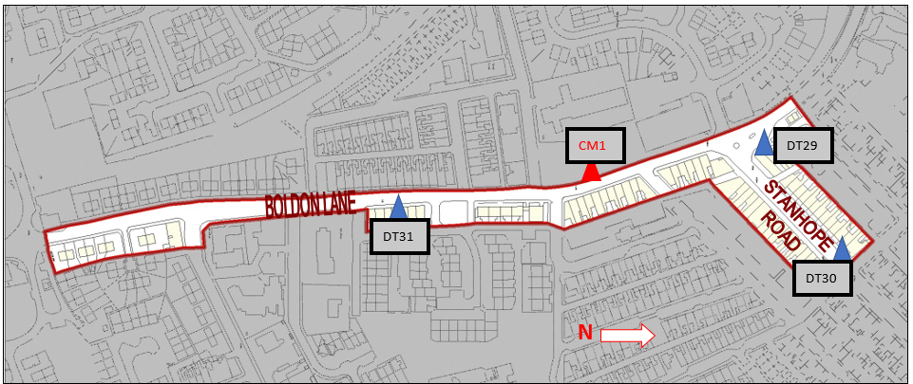

Figure D.2 – Map of Non-Automatic Monitoring Sites – Lindisfarne roundabout/Leam Lane AQMA

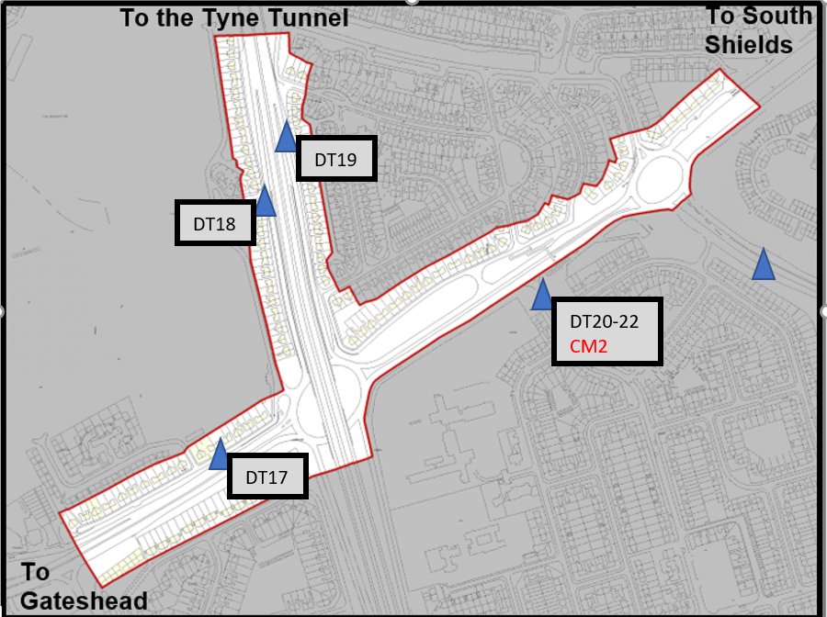

Non-Automatic monitoring sites - Hebburn

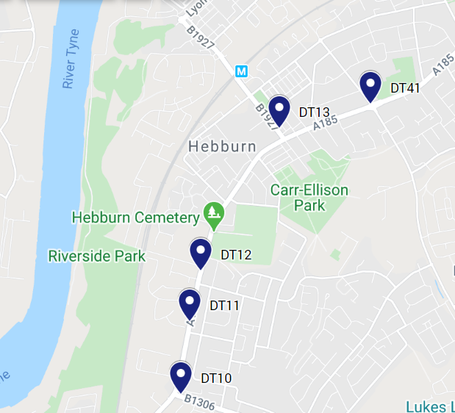

Non-Automatic monitoring sites - Jarrow

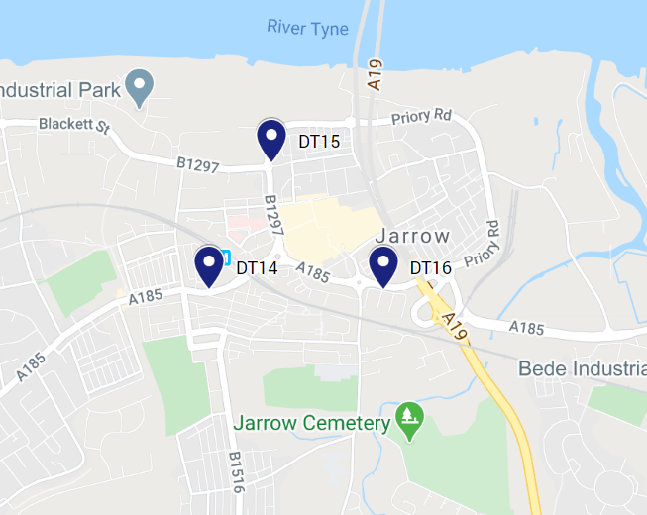

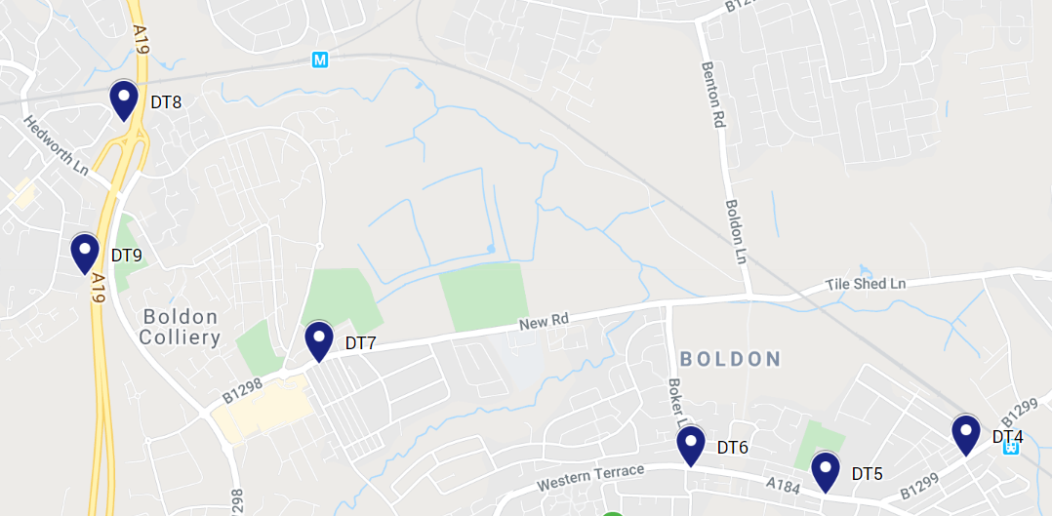 Non-Automatic monitoring sites – Boldon and A19

Non-Automatic monitoring sites Location Map – Cleadon and Whitburn

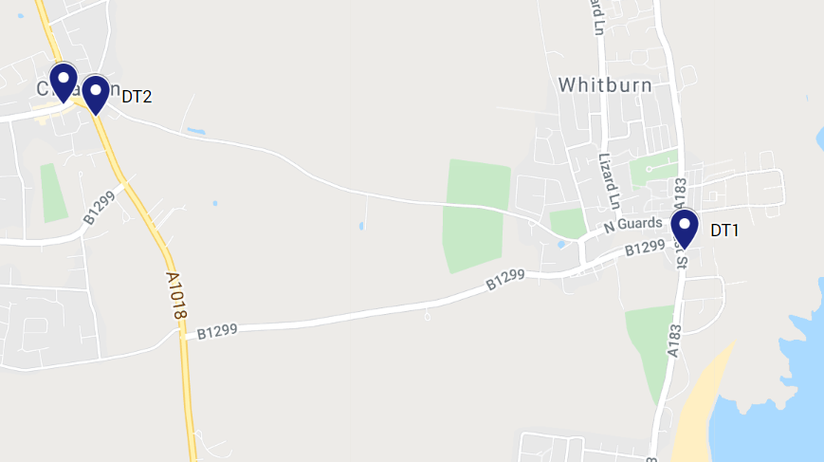

Non-Automatic monitoring sites Location Map – Tyne Dock and West Park

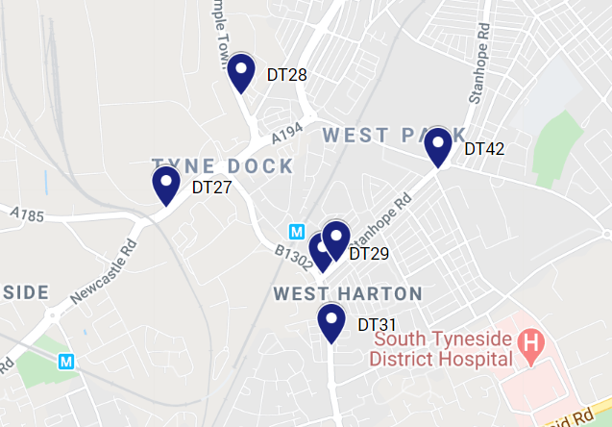

Non-Automatic monitoring sites Location Maps – Harton

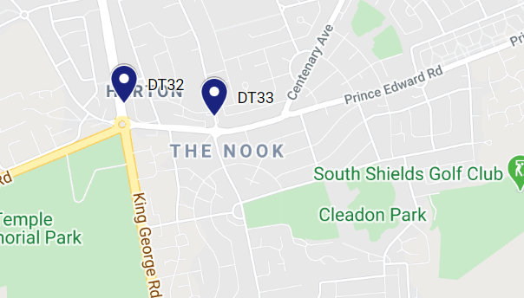

Non-Automatic monitoring sites Location Map – Lindisfarne, Jarrow

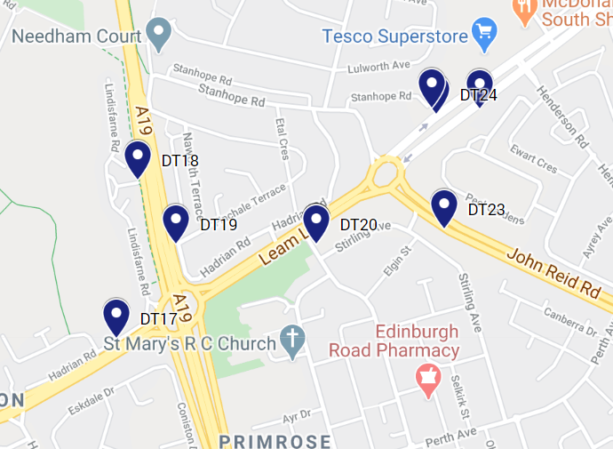

Non-Automatic monitoring sites Location Map – South Shields

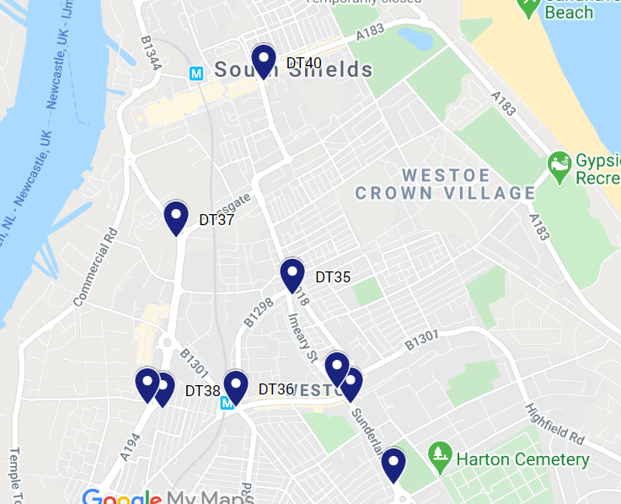

# Appendix E: Summary of Air Quality Objectives in England

Table E.1 – Air Quality Objectives in England[11]

| Pollutant | Air Quality Objective: Concentration | Air Quality Objective: Measured as |
| --- | --- | --- |
| Nitrogen Dioxide (NO2) | 200µg/m3 not to be exceeded more than 18 times a year | 1-hour mean |
| Nitrogen Dioxide (NO2) | 40µg/m3 | Annual mean |
| Particulate Matter (PM10) | 50µg/m3, not to be exceeded more than 35 times a year | 24-hour mean |
| Particulate Matter (PM10) | 40µg/m3 | Annual mean |
| Sulphur Dioxide (SO2) | 350µg/m3, not to be exceeded more than 24 times a year | 1-hour mean |
| Sulphur Dioxide (SO2) | 125µg/m3, not to be exceeded more than 3 times a year | 24-hour mean |
| Sulphur Dioxide (SO2) | 266µg/m3, not to be exceeded more than 35 times a year | 15-minute mean |

# Appendix F: Impact of COVID-19 upon LAQM

COVID-19 has had a significant impact on society. Inevitably, COVID-19 has also had an impact on the environment, with implications to air quality at local, regional and national scales.

COVID-19 has presented various challenges for Local Authorities with respect to undertaking their statutory LAQM duties in the 2021 reporting year. Recognising this, Defra provided various advice updates throughout 2020 to English authorities, particularly concerning the potential disruption to air quality monitoring programmes, implementation of Air Quality Action Plans (AQAPs) and LAQM statutory reporting requirements. Defra has also issued supplementary guidance for LAQM reporting in 2021 to assist local authorities in preparing their 2021 ASR. Where applicable, this advice has been followed.

Despite the challenges that the pandemic has given rise to, the events of 2020 have also provided Local Authorities with an opportunity to quantify the air quality impacts associated with wide-scale and extreme intervention, most notably in relation to emissions of air pollutants arising from road traffic. The vast majority (>95%) of AQMAs declared within the UK are related to road traffic emissions, where attainment of the annual mean objective for nitrogen dioxide (NO2) is considered unlikely. On 23rd March 2020, the UK Government released official guidance advising all members of public to stay at home, with work-related travel only permitted when absolutely necessary. During this initial national lockdown (and to a lesser extent other national and regional lockdowns that followed), marked reductions in vehicle traffic were observed; Department for Transport (DfT) data[12] suggests reductions in vehicle traffic of up to 70% were experienced across the UK by mid-April, relative to pre COVID-19 levels.

This reduction in travel in turn gave rise to a change of air pollutant emissions associated with road traffic, i.e. nitrous oxides (NOx), and exhaust and non-exhaust particulates (PM). The Air Quality Expert Group (AQEG)[13] has estimated that during the initial lockdown period in 2020, within urbanised areas of the UK reductions in NO2 annual mean concentrations were between 20 and 30% relative to pre-pandemic levels, which represents an absolute reduction of between 10 to 20µg/m3 if expressed relative to annual mean averages. During this period, changes in PM2.5 concentrations were less marked than those of NO2. PM2.5 concentrations are affected by both local sources and the transport of pollution from wider regions, often from well beyond the UK. Through analysis of AURN monitoring data for 2018-2020, AQEG have detailed that PM2.5 concentrations during the initial lockdown period are of the order 2 to 5µg/m3 lower relative to those that would be expected under business-as-usual conditions.

As restrictions are gradually lifted, the challenge is to understand how these air quality improvements can benefit the long-term health of the population.

## Impacts of COVID-19 on Air Quality within South Tyneside

### Non continuous monitoring stations

* There was an average 23% reduction of annual mean NO2 concentrations of diffusion tubes DT17-DT26 2020 relative to 2019 at Lindisfarne roundabout/ Leam Lane AQMA.  The average annual concentration level of (DT17-26) in 2020 is 21.86µg/m³ as compared to 28.66µg/m³ in 2019.
* There was an average 28% reduction of annual mean NO2 concentrations of diffusion tubes DT29-DT31 2020 relative to 2019 at Boldon Lane AQMA.  The average annual concentration level of (DT29-31) in 2020 is 22.06µg/m³ as compared to 31.03 µg/m³ in 2019.

### Continuous monitoring stations.

* There were large decreases in N02 concentrations at our three continuous monitoring stations due to the March 2020 lockdown. However, there is usually a large decrease between March and April at the start of spring. The effect of the lockdown can therefore be estimated by comparing the change between March and April 2020 with the expected change.
* After correcting for the expected change:
  + The percentage decreases in concentrations at Boldon Lane were similar to the average for the region and England.
  + The percentage decreases in concentrations at Edinburgh Road were greater than average for the region and England
  + The percentage decreases at Tyne Dock were much greater than the average for the region and England.

### Lindisfarne Roundabout/ Leam Lane AQMA traffic levels

Traffic has so far increased by an average of 5% over pre-Covid levels in the area of the Lindisfarne roundabout / Leam Lane AQMA:

* + Pre-Covid (February 2020)
* Average Daily Flow (Total) = 21,730
* Average Daily Flow (Eastbound) = 10,897
* Average Daily Flow (Westbound) = 10,838
  + Post-Covid (10-12 May 2021)
* Average Daily Flow (Total) = 22,780
* Average Daily Flow (Eastbound) = 11,412
* Average Daily Flow (Westbound) = 11,368

### Boldon Lane AQMA Traffic levels

Traffic has so far increased by an average of 2% over pre-Covid levels in the area of the Boldon Lane AQMA:

* + Pre-Covid (February 2020)
* Average Daily Flow (Total) = 14,241
* Average Daily Flow (Northbound) = 7,152
* Average Daily Flow (Southbound) = 7,089
  + Post-Covid (10-23 May 2021)
* Average Daily Flow (Total) = 14,540
* Average Daily Flow (Northbound) = 7,322
* Average Daily Flow (Southbound) = 7,218
* As observed, the concentration levels have reduced at both AQMA’s in 2020, it can be attributed to reduced traffic flows throughout this period due to lockdown restrictions.  As discussed in previous annual status reports levels pre pandemic have remained significantly lower that the annual limit value for NO2 40 µg/m³ for this reason we have expressed our intention of revoking both AQMA’s.  Unfortunately, due to the pandemic we have been unable to progress with this work, however we will be starting the process this year and will provide updates in next year’s ASR.

## Opportunities Presented by COVID-19 upon LAQM within South Tyneside

* Town Hall occupancy rates have reduced by 50%, with Council staff encouraged to work from home through an agile working policy. This has led to a considerable reduction in the pollutants associated with traffic when staff are travelling to work.
* Last year, applications to the Council’s Cycle to Work scheme tripled compared to the previous year. We had 100 cycle scheme applicants internally last year (3x increase since 2019)
* The Local Authority have purchased a BMW I3, since the electrical vehicle has been commissioned and utilised by staff, 710 miles and 78 hours’ worth of trips have been made across South Tyneside and the North East.
* We are about to launch a car share scheme for staff. It is hoped that the scheme will reduce miles travelled by members of staff, thus improving emissions and providing a cost saving.

## Challenges and Constraints Imposed by COVID-19 upon LAQM within South Tyneside

The Pandemic has had a minor impact on Local Air Quality monitoring.

* As discussed in the report, there was an unavoidable delay in retrieving diffusion tubes in full adherence to the diffusion tube calendar provided by DEFRA, however data capture over the full year is still considered more than satisfactory.
* As discussed in the report, the process to consideration revocation of the AQMA’s in the borough has been delayed by the pandemic. However, this will now move forward as a priority.

Table F – Impact Matrix

| Category | Impact Rating: None | Impact Rating: Small | Impact Rating: Medium | Impact Rating: High |
| --- | --- | --- | --- | --- |
| Automatic Monitoring – Data Capture (%) | More than 75% data capture | 50 to 75% data capture | 25 to 50% data capture | Less than 25% data capture |
| Automatic Monitoring – QA/QC Regime | Adherence to requirements as defined in LAQM.TG16 | Routine calibrations taken place frequently but not to normal regime. Audits undertaken alongside service and maintenance programmes | Routine calibrations taken place infrequently and service and maintenance regimes adhered to. No audit achieved | Routine calibrations not undertaken within extended period (e.g. 3 to 4 months). Interruption to service and maintenance regime and no audit achieved |
| Passive Monitoring – Data Capture (%) | More than 75% data capture | 50 to 75% data capture | 25 to 50% data capture | Less than 25% data capture |
| Passive Monitoring – Bias Adjustment Factor | Bias adjustment undertaken as normal | <25% impact on normal number of available bias adjustment colocation studies (2020 vs 2019) | 25-50% impact on normal number of available bias adjustment studies (2020 vs 2019) | >50% impact on normal number of available bias adjustment studies (2020 vs 2019) and/or applied bias adjustment factor studies not considered representative of local regime |
| Passive Monitoring – Adherence to Changeover Dates | Defra diffusion tube exposure calendar adhered to | Tubes left out for two exposure periods | Tubes left out for three exposure periods | Tubes left out for more than three exposure periods |
| Passive Monitoring – Storage of Tubes | Tubes stored in accordance with laboratory guidance and analysed promptly. | Tubes stored for longer than normal but adhering to laboratory guidance | Tubes unable to be stored according to be laboratory guidance but analysed prior to expiry date | Tubes stored for so long that they were unable to be analysed prior to expiry date. Data unable to be used |
| AQAP – Measure Implementation | Unaffected | Short delay (<6 months) in development of a new AQAP, but is on-going | Long delay (>6 months) in development of a new AQAP, but is on-going | No progression in development of a new AQAP |
| AQAP – New AQAP Development | Unaffected | Short delay (<6 months) in development of a new AQAP, but is on-going | Long delay (>6 months) in development of a new AQAP, but is on-going | No progression in development of a new AQAP |

# Glossary of Terms

| Abbreviation | Description |
| --- | --- |
| AQAP | Air Quality Action Plan - A detailed description of measures, outcomes, achievement dates and implementation methods, showing how the local authority intends to achieve air quality limit values’ |
| AQMA | Air Quality Management Area – An area where air pollutant concentrations exceed / are likely to exceed the relevant air quality objectives. AQMAs are declared for specific pollutants and objectives |
| ASR | Annual Status Report |
| Defra | Department for Environment, Food and Rural Affairs |
| DMRB | Design Manual for Roads and Bridges – Air quality screening tool produced by Highways England |
| EU | European Union |
| FDMS | Filter Dynamics Measurement System |
| LAQM | Local Air Quality Management |
| NO2 | Nitrogen Dioxide |
| NOx | Nitrogen Oxides |
| PM10 | Airborne particulate matter with an aerodynamic diameter of 10µm or less |
| PM2.5 | Airborne particulate matter with an aerodynamic diameter of 2.5µm or less |
| QA/QC | Quality Assurance and Quality Control |
| SO2 | Sulphur Dioxide |
|  |  |

# References

* Local Air Quality Management Technical Guidance LAQM.TG16. April 2021. Published by Defra in partnership with the Scottish Government, Welsh Assembly Government and Department of the Environment Northern Ireland.
* Local Air Quality Management Policy Guidance LAQM.PG16. May 2016. Published by Defra in partnership with the Scottish Government, Welsh Assembly Government and Department of the Environment Northern Ireland.
* **Geoff Broughton Air Quality Data Management (AQDM)** [Geoff.Broughton@aqdm.co.uk](mailto:Geoff.Broughton@aqdm.co.uk) Tel: 01235 559761

For continuous monitoring data and trend analysis.

1. Public Health England. Air Quality: A Briefing for Directors of Public Health, 2017
2. Defra. Air quality and social deprivation in the UK: an environmental inequalities analysis, 2006
3. Defra. Air quality appraisal: damage cost guidance, July 2020
4. Public Health England. Estimation of costs to the NHS and social care due to the health impacts of air pollution: summary report, May 2018
5. Defra. Clean Air Strategy, 2019
6. DfT. The Road to Zero: Next steps towards cleaner road transport and delivering our Industrial Strategy, July 2018
7. <https://fingertips.phe.org.uk/profile/public-health-outcomes-framework/data#page/4/gid/1000043/pat/6/par/E12000001/ati/102/are/E08000023/iid/30101/age/230/sex/4/cid/4/page-options/ovw-do-0_car-do-0>
8. [Emergency hospital admissions for COPD South Tyneside](https://fingertips.phe.org.uk/search/copd#page/3/gid/1/pat/6/par/E12000001/ati/201/are/E08000023/iid/92302/age/202/sex/4/cid/4/tbm/1/page-options/ovw-do-0_car-do-0)
9. [Admissions for asthma for children aged 0 to 9 South Tyneside](https://fingertips.phe.org.uk/search/asthma%23page/4/gid/1/pat/6/par/E12000001/ati/102/are/E08000023/iid/92481/age/288/sex/4)
10. [Admissions for asthma for young people aged 10 to 18 South Tyneside](https://fingertips.phe.org.uk/search/asthma%23page/4/gid/1/pat/6/par/E12000001/ati/102/are/E08000023/iid/92624/age/249/sex/4)
11. The units are in microgrammes of pollutant per cubic metre of air (µg/m3).
12. Prime Minister’s Office, COVID-19 briefing on the 31st of May 2020
13. Air Quality Expert Group, Estimation of changes in air pollution emissions, concentrations and exposure during the COVID-19 outbreak in the UK, June 2020