

**Activity Operating Procedures**



Review: August 2024

**Contents Page**

|  |  |
| --- | --- |
| **Topic** | **Page** |
| Introduction & Contact Information | 3 |
| Land Based Activities list | 4 |
| Water Based Activities list | 5 |
| Emergency procedures | 6 |
| Normal Working Practice | 9 |
| Staffing & Consent | 10 |
| Activity Ratio’s & Equipment | 12 |
| Technical Advisor’s | 13 |
|  |  |
| **Land Activities** | 14 |
| Rock Climbing, Bouldering & Indoor Wall Climbing | 14, |
| Orienteering | 17 |
| Hillwalking & Mountaineering | 18 |
| Mountain Biking/Cycling | 18 |
| Archery | 19 |
| Problem Solving | 19 |
| First Aid | 20 |
| Bushcraft | 20 |
|  |  |
| **Water Activities** | 21 |
| Canoeing/Kayaking/Bellboating | 22 |
| Powerboating | 23 |
| Personal Watercraft | 24 |
| Water Safety Management Programme | 25 |
| Stand Up Paddle Boarding | 26 |
| Secret Pool | 26 |
| Refuelling of tractor, Humber RIB & PWC | 26 |
| Tractor Driving | 27 |
|  |  |
| **Residential & Akenshawburn Cottages** | 28 |
| Food Safety | 29 |
| Building management for Akenshawburn. Water, Electricial, Solar,Gas, Comms | 30 |
|  |  |
| Staff Acknowledegment | 33 |
|  |  |
| Appendices |  |
| 1. Beaufort Wind Scale 2. RIB checklist & water Activity emergency action flowchart 3. Picture of Harbour and working area 4. COVID 19 information 5. Climbing Wall Emergency Action flowchart 6. Primary Survey aide memoir |  |

**Introduction.**

We are a South Tyneside Council maintained outdoor education provision which provides a range of outdoor and adventurous activities both land & water based including residential experiences to a range of client groups including young people and adults.

We are responsible for the Simonside Climbing Wall (NE34 9SD), Water Activity Centre (NE33 1LH) & Akenshawburn cottages in Kielder Forest (NE48 1HU, NY 609897). Our staff include 6 full time, 6 part time and 5 volunteers.

We hold a Adventurous Acitvity Licencing Service (AALS) licence. (L7474/R0815) and a LOtC Quality Badge no. QB104037 which covers all of our local authority provision including Duke of Edinburgh’s Award expeditions that are delivered by ourselves as an Approved Activity Provider (AAP).

The centre is a member of the Institute for Outdoor Learning (IOL), Outdoor Education Advisors Panel (OEAP) and its Head of Centre is a member of the Association of Heads of Outdoor Education Centres (AHOEC).

The following information covers our normal working practices and procedures and is to be used in conjunction with our risk assessments and our policy document entitled ‘Off Site Visits Policy’. This is available in an electronic format and can be downloaded from [www.simonsideoutdooradventure.com/resources](http://www.simonsideoutdooradventure.com/resources)

**Contact Information**

Email; [info@simonsideoutdooradventure.com](mailto:info@simonsideoutdooradventure.com)

Web; [www.simonsideoutdooradventure.com](http://www.simonsideoutdooradventure.com)

Tel; 0191 424 0118

Head of Centre; Martin Simpson

**Responsible Officers within South Tyneside Council**

Director of Children, Adults & Health - 0191 427 1717

Head of Service – Beverley Scanlon - 0191 4271717

Operations Manager – Alex D’Ambrosie - 0191 424 0118

Head of Centre - Martin Simpson 0191 424 0118

[martin.simpson@southtyneside.gov.uk](mailto:martin.simpson@southtyneside.gov.uk) [martin@simonsideoutdooradventure.com](mailto:martin@simonsideoutdooradventure.com)

**Land Based Activities**

All staff delivering activities will hold the relevant National Governing Body qualification or in some cases a site specific award that is signed off by the relevant technical advisor and will work within the remit of their award.

Our land based activities include;

* Single Pitch Rock Climbing
* Bouldering
* Indoor Rock Climbing/Mobile Climbing Wall
* Hillwalking & Mountaineering
* Orienteering
* Mountain Biking/Off-Road Cycling
* Archery
* First Aid Courses
* Bushcraft
* Duke of Edinburgh’s Award Expeditions
* Problem Solving/Team Buiding Activities
* OEAP’s Outdoor Learning Cards OEAP’s EVC and GLV Training

**Water Based Activities**

More information pertaining to the water centre’s facilities can be found at [www.simonsideoutdooradventure.com/centres](http://www.simonsideoutdooradventure.com/centres)

All staff delivering activities will hold the relevant National Governing Body qualification and will work within the remit of their award.

Our water based activities include;

* Powerboating
* Personal Watercraft
* Stand Up Paddle Boarding
* Kayaking inc. sit on tops
* Open Canoeing
* Open Water Swimming
* RLSS National Water Safety Management Programme inc open water swimming
* RLSS National Rescue Test for Swimming Teachers and Coaches

**SOA Emergency Procedures**

Despite planning and organisation including the establishment and maintenance of risk assessments and operating procedures, there may be incidents or emergencies which require an immediate response by a member of staff. These cannot be comprehensively defined but may range from overdue groups or minor injury to more serious injury or fatality. A recommended framework of procedures to be followed in the event of an incident or emergency is set out below. Staff follow Outdoor Education Advisors Panel (OEAP) Guidance and use OEAP Emergency Action Cards.

**Recommended actions:**

Immediate

* Establish nature and extent of incident and emergency.
* Ensure all other people involved are safe and accounted for.
* If possible, remove all people from water or to appropriate shelter/minibus.
* If there are injuries, prioritise treatment, administer appropriate first aid and monitor casualties.
* If medical assistance is required, stablish name(s) of the casualty/casualties and call the emergency services – **999 – Ambulance / Mountain Rescue / Coastguard / Police / Fire & Rescue** as appropriate.
* If on the River Tyne: VHF Channel 16 should be used for a Mayday call and/or Tyne VTS Channel 12.
* Contact Head of Centre: Martin Simpson (0191 424 0118 / 07715 903855) or Alex D’Ambrosie (07787 005273) and explain that emergency procedures are in effect.

Managing the incident

* Monitor casualty/casualties condition, consider environmental factors.
* Control access to mobile phones/photography equipment.
* Monitor and manage other group members and public, consider environmental factors, supervision, designating roles, emotional wellbeing and skills of group members e.g. first aid, group shelter. Arrangements may be made to return group to centre/school/organisation.
* Arrange for an SOA staff member to remain at incident scene to liaise with emergency services until incident is concluded and everyone is accounted for.
* A member of staff may need to rendezvous with emergency services if remote. Ensure incident details including location and contact numbers are duplicated for planned rendezvous.
* A member of staff must accompany the casualty/casualties to hospital.
* Contact should be made with the Director of Children, Adults & Health for incidents requiring emergency services; anything that may involve publicity, serious injury and/or fatalities.
* Control to telephones and mobile phones until contact is made with Director of Children, Adults & Health their representative, the Head Teacher(s)/Management of the school(s)/organisation(s) involved, emergency contact point or designated senior member of staff have had time to contact those directly involved.
* Upon reporting through hierarchical chain, it may be decided that other council departments/personnel may need to be included in the incident support. This group may include the following representatives; These would be ordinarily tasked/informed by the Operations Manager, Outdoor Education & Youth Service

|  |  |
| --- | --- |
| Operations Manager, Outdoor Education & Youth Service |  |
| Service Manager, Early Help |  |
| Head of Service, Learning & Early Help |  |
| Corporate Lead, Strategy & Performance | Communication |
| Head of Legal Services |  |
| Head of Transport | Highways & Transport |
| Head of Corporate Health & Safety |  |
| Head of Finance |  |
| Head of Insurance |  |

Liability and media

* **Legal liability should not be discussed or admitted.**
* For serious incidents where the media may be involved, try to identify alternative phone numbers “off site” as other lines may become jammed with calls. The leader in charge or other group members must not discuss matters with the media: Under no circumstances should the name of anyone involved in the incident be divulged to the media and all questions must be directed to The Director of Children’s Services.
* **If it is necessary to talk to the media, the Director of Children, Adults & Health will take the lead.** A designated person should then act as the ongoing point of contact with the media to whom all involved in the incident should direct questions and requests. This person will need to liaise with the emergency services, perhaps away from the centre.

Incident recording

* The leader involved should write down as soon as practicable or during the incident all relevant details whilst they are still fresh in their memory. This may include completing casualty monitoring forms. Other people involved may also be asked to do so: Record names and addresses of witnesses and any used equipment should be kept in its original condition.
* Ensure all relevant accident/incident forms are completed as soon as possible (AR1/2/3/VR) and the Health and Safety Executive or Local Authority inspector should be contacted if appropriate.
* Follow South Tyneside Council’s Corporate Health and Safety policy reporting of accidents and incidents involving the Health and Safety Team at the earliest possible time. If necessary, report to RIDDOR, EVOLVE, AALS, Ofsted or HSE.

Incident Management Contacts

|  |  |
| --- | --- |
| Simonside Outdoor Adventure Office | 0191 424 0118 |
| Martin Simpson | 07715 903855 |
| Alex D’Ambrosie | 07787 005273 |
| Andy Sallabank (Thurston OEC Office) | 015394 41218 |
| Anthony Mordue | 07375 377078 |
| Iain Arthur | 07814 412977 |
| Kirstie Macmillan | 07740 362001 |
|  |  |
| Harbour Master / VTS (River Tyne) | 0191 257 2080 / VHF Channel 12 |
| Hawkhirst Scout Centre (Kielder) | 01434 250217 / VHF on Kielder Water |
| STC Out of Hours 24h Control Room | 0191 4239926 |
| Director of Children, Adults & Health | 0191 4271717 |

Local Hospitals

|  |  |
| --- | --- |
| Climbing Wall/Water Activities:  South Tyneside District Hospital  Harton Lane  South Shields  NE34 0PL | Akenshawburn Cottages:  Hexham General Hospital  Corbridge Road  Hexham  NE46 1QJ |

Centre locations

|  |  |  |
| --- | --- | --- |
| **Simonside Climbing Wall**  St. Simon’s Street  South Shields  Tyne & Wear  NE34 9SD  **OS:** NZ 351 635  **W3W:**gravel.books.mini | **Water Activities Centre**  River Drive  South Shields  Tyne & Wear  NE33 1TL  **OS:** NZ 367 681  **W3W:** awards.feels.fumes | **Akenshawburn Cottages**  Bloodybush Road  Kielder  Northumberland  NE48 1HU  **OS:** NY 609 897  **W3W:** discount.cities.distracts |

**Normal Working Practice**

Risk assessments have been carried out by the Simonside Outdoor Adventure team and are not contained within this document. All activities have been documented and hazards identified. How tasks must be carried out, general guidance and advice of the precautions and training required by staff when carrying out their duties are contained in this document.

**Main Venues.**

We work from a variety of locations which can change for a number of reasons. These are based on what a customer wants, their ability, experience, conditions and time of year. This also takes into account staff interest and skill maintenance/retention and best outcomes for the customer. The table below highlights our main working areas and this list is not exhaustive.

|  |  |
| --- | --- |
| **Location** | **Activity/ies** |
| Water Activity Centre | Listed previously on pg. 3 |
| Kielder Water | Bell Boating/Canoeing |
| River Wear, North & South River Tyne  River Tweed | Canoeing |
| Simonside Climbing Wall | Indoor Climbing. Archery, PS, First Aid, expedition preparation |
| Local Parks | Orienteering |
| Various crags in Northumberland | Single Pitch Rock Climbing |
| Local Area/Northumberland/N. Yorkshire/Lake District | Hillwalking & Mountineering |
| Local Area/Northumberland/N. Yorkshire | Mountain Biking |
| South Tyneside | Akenshawburn Cottages |

Simonside Climbing Wall is our main working base where contact can be made with us. The centre’s opening times can be found on our web page. [www.simonsideoutdooradventure.com](http://www.simonsideoutdooradventure.com)

The accident recording forms, incident/near miss forms are located in the main reception office/staff office at Simonside Climbing Wall,Water Activities Centre & Akenshawburn Cottages. For activities that take place away from these venues then upon return, these must be filled in. Once completed these must be scanned and saved on the shred drive under folder entitled ‘incidents’.

First aid kits are located in the main reception in the Simonside Climbing Wall, Water Activities Centre and the upstairs equipment store, East cottage at Akenshawburn Cottages and in the kitchen area. For activities that take place away from these venues, then the group leader/instructor will carry a Simonside OA first aid kit with them. For DofE expeditions or for longer residntials then a first aid bag either red or blue must be taken. These are located in the map/first aid store at Simonside Climbing Wall.

All staff including volunteers will have had a full induction and been given this document and risk assessments. They will have an enhanced Disclosure and Barring Service check, Safeguarding training and an in date First Aid certificate which is a minimum of a 16 hour course.

The instructional team will hold weekly meetings on a Monday morning prior to the weeks activities taking place. This will also include equipment, first aid kit and instructor kit checks. Daily or sessional briefings will take place prior to each session and these will be led by either the Head of Centre or by the lead instructor for the session. All briefings must include staff roles, working areas and lesson plan.

The activity board at the Water Activity Centre staff office, next to the teams office at Simonside Climbing Wall and kit store, East Cottage at Akensahwburn must be completed by instructor prior to activities that place outide of climbing wall ensuring all sections are completed and a weather report is gained including sea/river/hill conditions.

If a change is made to the activity during the event as an opportunity has presented itself or conditions dictate a change is necesaary then the activity board will need to be updated and this may be done by VHF radio or mobile phone updating any changes including the new plan, venue and ETA.

**Staffing**

Our staff fall into 4 categories. These are; Full and Part time South Tyneside council employees, volunteers for South Tyneside Council under Simonside Outdoor Adventure and freelance instructors. All staff are required to have the appropriate skills and qualifications for delivering the specified activities. Copies of these will be held securely and electronically. All staff will hold an enhanced Disclosure and Barring Service check through South Tyneside Council or a portable enhanced DBS in the case of freelance instructors.

**Consent & Registration**

We require all participants irrespective of age or type of course/activity to complete a standard registration form and this to be by parent or legal guardian if they are under 18 years of age. In addition to this form, if we become aware of any conditions that may require additional information such as use of emergency medication or ongoing treatments then a separate medical form will be issued. This allows staff to understand a persons needs better, ensure that medication is taken appropriately, and evidence if required too. This will be held to the same standard of care of personal information as a consent/registration form is. Below is an explanantion of what we do with that information and why.

Statement for consent forms to fall in line with the EU General Data Protection Regulation 2016/679

Why we collect your information? Simonside Outdoor Adventure collects the information on our consent forms to ensure the safety and wellbeing of participants. By allowing us further details, we can best suit our preparation for your participation. An example of this could be an allergy to certain foods or matching your needs with staff with the appropriate skills and experience to support you best.

Who we might share it with? We will not share the information with anyone - except medical professionals in the event of a need for treatment.

What we do with the information? After your participation, the information will be securely stored at the centre during the course and afterwards will be scanned and stored on the South Tyneside Council secure servers.

How long we keep it? Information provided on this form will be kept for the time required by the Limitation Act 1990. (I.e. 7 years for adults, until a young person reaches the age of 25, or for 99 years in the case of Looked After Children.) The original paper copies will be kept for a period of three years securely at Simonside Climbing Wall then confidentially shredded.

How people can access their personal information? If you wish to access the personal information that we hold you should contact Simonside Outdoor Adventure. [info@simonsideoutdooradventure.com](mailto:info@simonsideoutdooradventure.com) or 0191 424 0118

**Safeguarding**

The following relates to safeguarding not in connection with the activities but with staffing, visitors to site, members of the public and other group participants.

LA staff have a current DBS and have a safer recruitment policy followed.

If you have any concerns relating to safeguarding young people and vulnerable adults follow steps below.

* Listen and do not comment or judge
* Record as soon as possble after disclosure or witnessed incident
* Use same language when recording
* Don’t promise confidentiality
* Contact Head of Centre Martin Simpson
* If unavailable, contact Alex D’Ambrosie
* Consider contacting LADO if unable to contact above.
* Call 999 if you think person is in imminent danger

Further information can be found at the following weblink

[Safeguarding policies and procedures - South Tyneside Council](https://southtyneside.gov.uk/article/13720/Safeguarding-policies-and-procedures)

**Trans participants**

For any group members who may identify differently to their birth gender we will as an organisation try our best to facilitate activities and participation appropriately. We will always try to use the chosen pronouns and names of individuals. Through discussion with organisations, parents/carers and the participant themselves we will consider the following when planning activities and residentials:

* Toilets, showers and changing rooms
* Sleeping arrangements
* Activities inc. water sports and swimming
* First Aid needs and medical emergencies

Further information can be found at the following webllink.

[GI_youth_RESIDENTIAL 120722.pdf (genderedintelligence.co.uk)](https://genderedintelligence.co.uk/static/pdfs/GI_youth_RESIDENTIAL%20120722.pdf?)

**Activity Ratios**

These are the maximum number that we would work to. There may be changes to this based on conditions, ability of the group, any additional needs or by request from the customer.

|  |  |
| --- | --- |
| **Activity** | **Staff to client ratio** |
| Single Pitch Rock Climbing | 1:4 |
| Bouldering | 1:6 |
| Indoor Rock Climbing/Mobile Climbing Wall | 1:12 |
| Mountaineering | 1:3 |
| Hillwalking | 1:12 |
| Orienteering in local parks | 1:15 |
| Mountain Biking/Off-Road Cycling | 1:8 |
| Archery | 1:12 |
| Secret Pool | 1:8 |
| First Aid Courses | 1:12 |
| Duke of Edinburgh’s Award Expedition  Expedition Supervisor | 1:14 (2 groups 7 only) |
| Problem Solving/Team Buiding Activities | 1:20 |
| Bushcraft | 1:12 |
| OEAP’s Outdoor Learning Cards OEAP’s | 1:12 |
| EVC and GLV Training | 1:12 |
| Powerboating | 1:12 |
| Personal Watercraft | 1:1 |
| Stand Up Paddle Boarding | 1:6 |
| Kayaking | 1:10 |
| Open Canoeing | 1:6 |
| Canoeing in Marine Park | 1:14 |
| RLSS National Water Safety Management Programme inc open water swimming | 2:10 |

**Equipment Checks and Management**

All PPE and other equipment are checked by a full or part time member of SOA staff utilising the online Papertrail system. The frequency of checks is set out within the Papertrail system.

Checks are carried out by staff with the appropriate qualifications and experience to do so. This includes an appointed persons PPE user checks by Lyon. Any PPE or equipment that there is uncertainty over must be referred to the Head of Centre and removed from use. Only the Head of Centre can authorise equipment to be put back into circulation or permanently removed and destroyed if necessary. If required, advice can be sought from the technical advisor for that activity.

To remove equipment from active use then;

* All equipment from 3 centres to be stored at Climbing Wall
* Placed in utility room in green boxes
* If PPE, marked with a red tag with reason and date marked on tag
* Changed status on Papertrail adding note to item.

**Minibuses and Trailers**

The centre 1 minibus and the 3 South Tyneside Council fleet minibuses are maintained by South Tyneside Council fleet management and all services, safety checks and MOT’s are carried out by them. They maintain the service history for each vehicle. All drivers need to hold the approriate licence to drive (D1, D1+E) , be over 21 years of age and have held a car licence (B) for over two years

All trailers are annually serviced by South Tyneside Council Fleet services on a rolling programme.

All minibuses hold a first aid kit, warning triangle, jack and wheel brace.

**Technical Advisors and activity support**

We have technical advisors in place for;

* Hill walking & mountaineering
* Indoor climbing
* Bouldering
* Single Pitch Climbing
* Mountain Biking and off-road cycling
* Paddlesport

These will provide support, training and oversight of our normal practices and give appropriate updates on industry best practice.

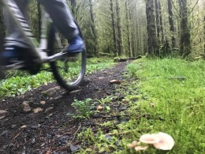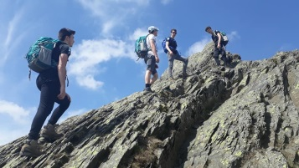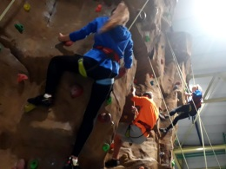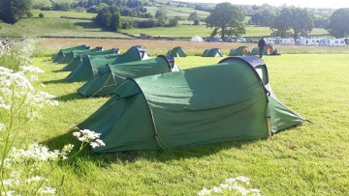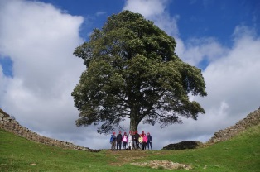

**Land Activities**

**Rock Climbing & Indoor Wall Climbing**

Simonside’s Outdoor Team recognises that rock climbing, like any other outdoor activities , involves a definite element of risk and must be properly organised. Reasonable precautions will be taken at all times to ensure that safe working procedures are in place without detracting from the spirit of adventure that is associated with climbing both on natural crags and artificial walls.

Climbing must only take place on artificial climbing structures and recognised single pitch crags, mobile climbing wall and bouldering venues with which the instructor is familiar.

There must be a qualified person responsible for the group at all times, the ratio of instructors to group members may not exceed 1:12 on artificial walls and 1:4 outdoors. The minimum qualifications required is the MT Climbing Wall Instructor (CWI) for mobile and manmade structures. For Single Pitch, then the minimum requirement is the MT Rock Climbing Instructor (RCI). Following on with Mountaineering and Rock Climbing Instructor, Winter Mountaineering and Rock Climbing Instructor, UIAGM Mountain Guide

On outdoor crags the climber must be tied onto the rope with a rethreaded figure 8, when climbing on manmade structures it may be suitable to clip in through a screwgate locking karabiner into the main top rope and abseil loop using a DMM Belay Master Karabiner. Normal practice though is to be tie in with a rethreaded figure 8 with stopper knot.

Abseiling from our platform in Simonside Climbing Wall, Instructors and participants are required to wear helmets at all times. When ascending to the top of the platform, instructors must either be belayed or use a ropeman on the fixed line on the right hand side of the wall.

Under 18’s/Novice belayers need to be supervised closely and backed up where necessary by either a suitable adult, qualified member of staff or another student. Belaying in a group of 3 until a time when deemed competant by instructor leading the session and they are happy that the belayer has demonstrated proficiency consistently.

Bell Ringing; when using this technique for group belaying the following must be observed.

* Ground Anchor used
* GRI GRI + only
* Follow ABC (anchor, belayer, climber)
* After first 2 metres put a overhand in dead rope
* Instructor to lower initially then supervise appropriately

We have eight Clip & Climb lines, these are split into three sections Cargo net (2 lines) tufa’s, speed walls and an simulate ice wall (4 lines) and adjacent two lines on side of boulder wall, all on TrueBlue auto belays.

There are 2 Sky Climb lines on auto belay which follow the same process as the Clip & Climb lines as below.

These can only be supervised by staff holding aforementioned qualifications and having been inducted by Head of Centre.

The walls have a connection system inplace use ground triangles holding autobelayer tapes in place. The diagram and text below shows how they need to be connected.

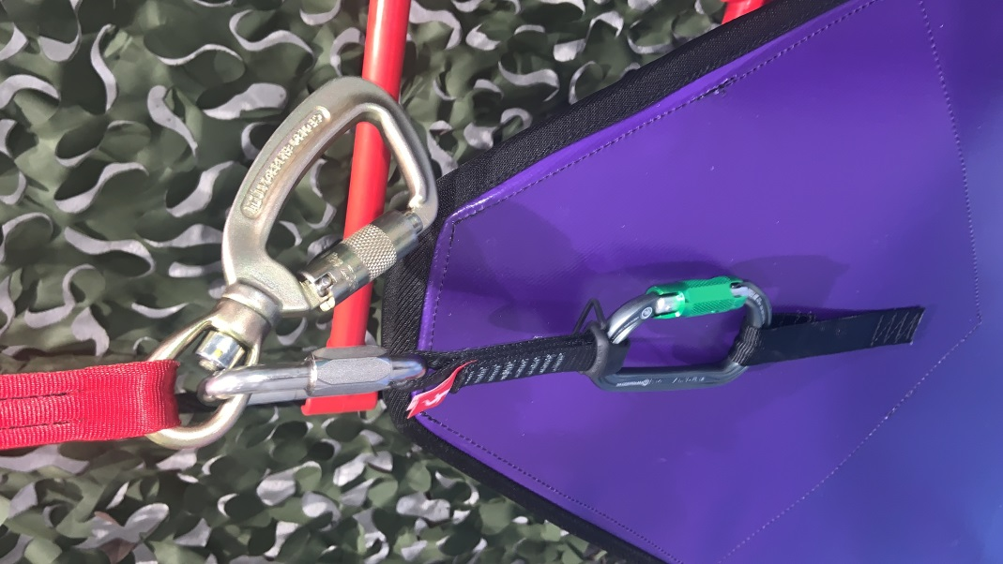

**A small locking key on lanyard is used to unlock green karabiner to release from ground anchor.**

**Staff to remain in control of locking key at all times to ensure correct connection of participants (similar to a knot check).**

**The locking Twistlock Karabiner (greengate) on end of extension is used to attach webbing to ground anchor triangle.**

**Gold Twistlock Karbiner is the main attachment point to harness when climbing.**

The Auto belay inspection regime is as follows;

|  |  |
| --- | --- |
| Webbing visual check | Pre Use. |
| Casing/Main body of unit/webbing  Points 1-9 pg 29 in TrueBlue Manual | Weekly  Complete Papertrail inspection |
| Full removal from anchor  Points 1-7 on pg 33-34 in TrueBlue Manual | 6 Monthly Check, Papertrail inspection |
| Manufacturers Recertification | Annually |

For staff inspecting webbing prior to use, use the following tables as a guide.

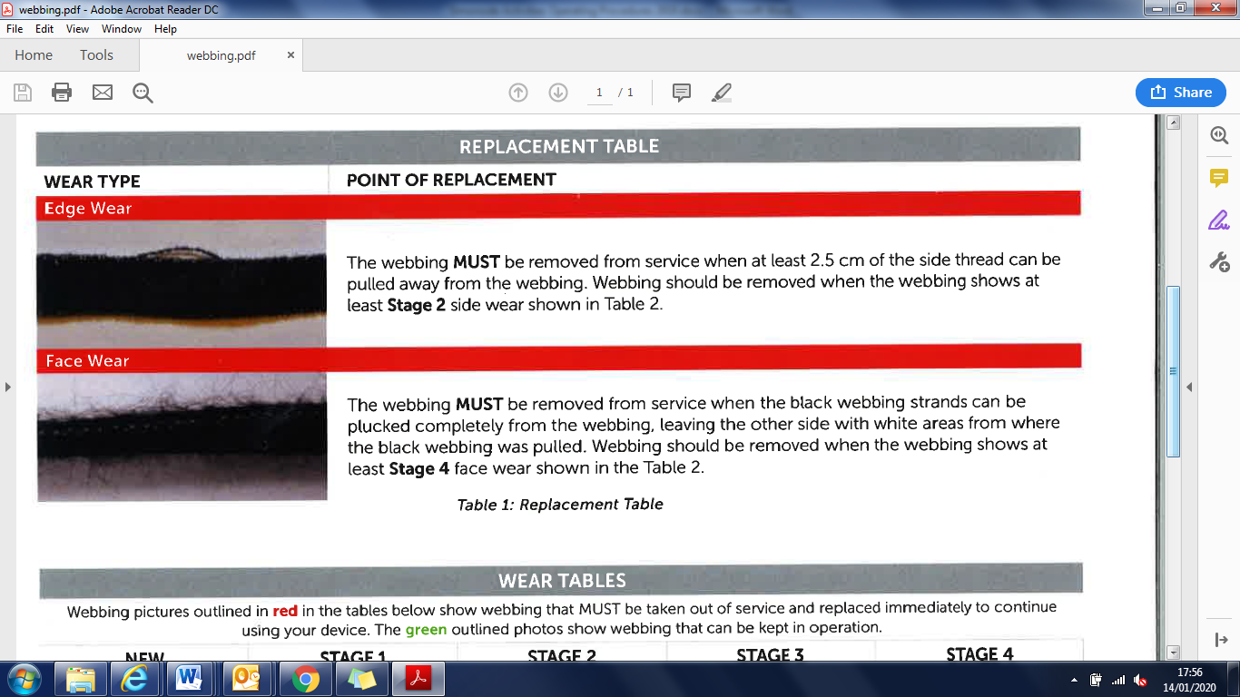

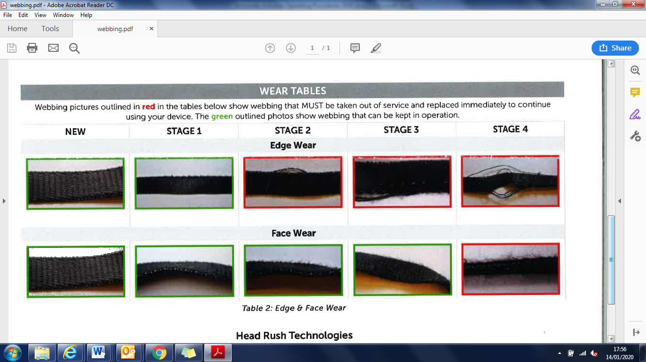

When rock climbing on natural crags, the group leader will carry; This will be in the staff grab bag for rock climbing which contains;

* a first aid kit
* appropriate instructor equipment
* leader rack (outdoors)
* bivi bag & group shelter
* spare warm top
* rope/s
* whistle
* knife
* guidebook for the crag.
* all leaders must hold a full first aid certificate.

Students must have;

* helmet (outdoors)
* harness
* appropriate clothing for the environment

The hazards associated with the above activity and the precautions to be taken are covered in our Risk Assessments.

**Orienteering**

Simonside’s Outdoor Team recognises that orienteering, like any other outdoor activities involve a definite element of risk and must be properly organised. Reasonable precautions will be taken at all times to ensure that safe working procedures are in place without detracting from the spirit of adventure that is associated with working in an outdoor environment.

Orienteering mainly takes place in local South Tyneside parks and other Tyne & Wear Country Parks. Orienteering also takes place at our Kielder site on the grounds of Akenshawburn Cottages.

There must be a qualified person responsible for the group at all times, the ratio of Staff to group members may not exceed 1:15.

The group leader will carry a mobile phone and the instructor grab bag which includes;

* a Simonside OA first aid kit
* group shelter
* bivi bag
* hat
* spare clothes

All leaders must hold a relevant first aid certificate.

Students must have an appropriate map and if appropriate a compass and whistle.

The hazards associated with the above activity and the precautions to be taken are covered in our Risk Assessments.

**Hill Walking and Mountaineering**

These require a higher degree of care and as such the ratio for staff is 1:12 (hillwalking) 1:3 (technical mountaineering). For the supervision of Duke of Edinburgh Awards groups walking independently then a member of staff can oversee 2 groups of 7 young people max. This is only when on parallel routes in Bronze and Silver terrain. When working in the hills, staff will leave a full route and group list with the designated contact back at the centre and inform them of any changes in the intended plan. For multi day trips such as Duke of Edinburgh’s Award expeditions, contact should be made daily with centre designated contact, unless pre arranged. For lowland walks within 30 minutes of a road, a Basic Expedition Leader/ MT Lowland Leader qualification is required. For walks further than 30 minutes from the road, more remote or mountainous technical terrain then a Mountain Leader Summer is the minimum qualification that needs to be held combined with . Any winter walking will require a Winter Mountain Leader to lead the walk. A current weather forecast for the duration of the walk/trip must be checked prior to heading out.

Staff will have local knowledge of an area before leading groups.

The group leader will carry appropriate instructor equipment including

* a Simonside OA first aid kit
* bivi bag & group shelter
* whistle
* map and compass
* a method of providing hot drinks
* spare clothes/hats/gloves
* A mobile phone
* Torch & spare batteries
* Spare food and drink
* A walking rope
* 120cm sling and karabiner

This may be in the staff grab bag or carried in staff personal bags

Freelance staff will be supplied with a dry bag containing;

First aid kit, group shelter, blizzard blanket, sun cream, note pad, pencil, inhaler and small ouch pouch (plasters, gloves, cleaning wipes) and a emergency action card.

**Mountain Biking/Off-Road Cycling**

Simonside’s Outdoor Team recognises that mountain biking, like any other outdoor activities, involves a definite element of risk and must be properly organised. Reasonable precautions will be taken at all times to ensure that safe working procedures are in place without detracting from the spirit of adventure that is associated with off road cycling

The ratio for instructor to student are 1:8 maximum dependant on group ability and nature & location of intended route. A recognised off road cycling or mountain biking qualification is required from British Cycling, Scottish Cycling, MBLA, CTC, British Schools Cycling Association or MIAS and the instructor is working within the remit of their award.

The group leader will carry;

* a Simonside OA first aid kit
* a group shelter
* survival bag
* spare clothes
* hat
* bike trail repair kit
* pump suitable for both car type and presta valves
* 2 x spare inner tubes
* a method of providing hot drinks (when working outside South Tyneside).
* a mobile telephone
* a whistle

This may be in the staff grab bag or carried in staff personal bags

Instructors and participants must wear an approved cycle helmet with chin strap fitted, full fingered gloves and on night rides or rides when there is heavy vegetation, cycling glasses. These can be provided by SOA but may also be the participants own equipment provided that they are in good working order and the session instructor has made an appropriate assessment of them.

**Archery**

Archery takes place at Simonside Climbing Wall and Akenshawburn Cottages in a controlled range environment. Staff who lead archery sessions hold the GNAS/Archery GB Archery Leaders Award and can deliver both Bare Bow and Freestyle techniques. Target and Field archery are the two main types covered. All staff are first aid qualified and the activity is controlled carefully due to the inherent dangers associated with projectiles. The staff to student ratio for Archery is 1:12. Appropriate signage will be used to ensure no throughfare. Rear netting to be used at Simonside Climbing Wall

**Problem Solving/Team Building**

This takes place mainly at Simonside Climbing Wall but also other venues as deemed appropriate and tasks are low key group exercises. All staff are experienced at managing groups and as the sessions take place within Simonside, first aid and support immediately accessible. If the activity takes takes place away from Simonside then the member of staff will carry a staff grab bag. The staff to student ratio is determined by the nature of the young people and their collective needs.

**First Aid Courses**

This normally takes place at Simonside Climbing Wall but can be delivered at other sites. All staff will be instructors working within the NUCO Training Ltd framework and be qualified instructors for that organisation. Appropriate learning environment including the delivery of outdoor first aid will need to be considered. All courses will be supplied with appropriate course materials, supporting information and resources. Due to the physical and practical nature of these courses then any issues regarding mobility and the particpants ability needs to be considered. This is in line with NUCO Training Ltd. reasonable adjustments policy.

**Bushcraft**

The activity takes place at Akenshawburn cottages. The activities that may take place are;

Shelter building

Cooking

Whittling/ Bush Craft skills

It is essential that these considerations are followed and that staff that are leading the group fully brief the group to pay attention to hazard warning information, remain in control of the activity and follow accredited tuition and activity progression. The specific hazards identified in risk assessment are not exhaustive and additional hazards or combinations may arise during the course of an activity necessitating ongoing attention to minimise or control the risk(s) to a manageable level.

There are no seasonal constraints but awareness of weather forecast and duration of session needs to be considered with time of year.

The maximum tuition ratios are: 1 instructor to 10 participants with staff holds a first aid certificate and holds a bush craft award or has a leadership NGB award e.g. mountain leader.

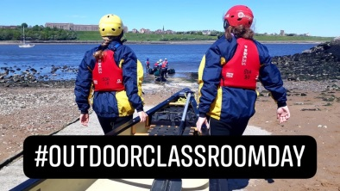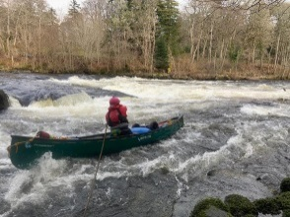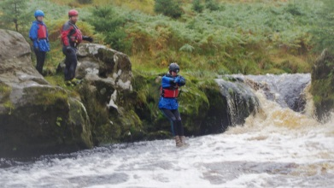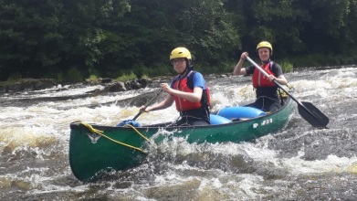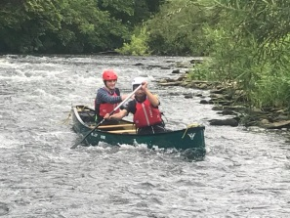

**Water Activities**

Normal working areas when working from the Water Activity Centre is depicted in appendix III

* Area 1: Littlehaven Beach to South Pier wall with the Groyne light to Herd Sands Port channel mark.
* Area 2: Starboard 1 channel mark to North Pier wall to North pier light.
* Area 3: Upstream, south side up to Ferry Landing, upstream north side up to Royal Quays Marina and in Marina through lock gate.

Other areas within the Harbour are acceptable depending on conditions present on the day. It is up to the Instructor present to carry out a dynmanic risk assessement based on those conditions prior to the session taking place and an ongoing risk assesssment taking into account the changing conditions of the weather, tide and sea state in particular including the groups ability to deal with them.

Staff must use the group (MS, KM, IA, TM) WhatsApp chat for an ‘off water’ notification when working alone at the Water Centre or from other locations.

Staff must inform Tyne VTS either by VHF channel 12 or by phoning 0191 257 2080 prior to going afloat and when off the water including size of party, intention and number of craft when;

* If you intend to cross the shipping channel via kayak/canoe
* Every time the Rib or the PWC is on the water (it is assumed that these craft will be more likely to cross or work near the shipping channel when on these craft)

All other kayak/canoe/SUP sessions then there is no requirement to notify Tyne VTS.

Areas outside the River Tyne Harbour whilst working from Water Centre

To work outside the Harbour the Beaufort scale will be force 4 or below. When working outside the Harbour area an ongoing assessment of conditions needs to be made by the instructor for the session. If sea state and weather present or forecast provides an element of doubt then the decision to return to the harbour needs to be made.

Sea state, river conditions and the weather

Before any activity, instructors must have knowledge of a current weather forecast apopropriate to the area. Met Office, XC Weather, Pocket GRIB or Magic Seaweed for coastal areas are good websites to visit for this information further checks can be made with <http://www.fishpal.com/England> or

[www.flood-warning-information.service.gov.uk](http://www.flood-warning-information.service.gov.uk) with the river location giving water heights and forecasts.

Options to work at Sea are shown on OS Explorer sheets 316/317. Heading North care should be taken in particular when entering Cullorcoats harbour, ensuring the use of the leading lights, approach bearing of 250 degrees.

**Instructors must ask Head of Centre/Lead Instructor’s advice and permission before leaving the harbour on each occaision.**

**Canoeing/Kayaking/Bellboating**

Simonside’s Outdoor Team recognises that paddlsports, like any other water borne activity, involves a definite element of risk and must be properly organised. Reasonable precautions will be taken at all times to ensure that safe working procedures are in place without detracting from the spirit of adventure that is associated with the handling of a small craft.

Paddlesport activities are carried out from the Water Activities Centre carried out in the harbour, the open sea and the Marine Park lake. Kielder Water is used for canoeing and bellboating activities. The River Wear, North & South River Tyne and River Tweed are used for open canoe journeys. For other venues, then a dynamic risk assessment will be carried out.

Sessions will take place in any of the pictured locations (appendix III) dependant on ability of group and conditions on the day. For groups that wish to paddle upstream, this can only be done on the South side of River Tyne. Any crossing of the shipping channel will take place once Tyne Harbour VTS channel 12 is monitored from river traffic and at its most practical point covering the shortest distance.

Group members will be under direct supervision at all times they are on the water. A ratio of 1:10 will be used on running or tidal waters and 1:14 on the Marine Park Lake or similar placid water.

Canoeists will be issued with and required to wear the necessary equipment for the activity, including a buoyancy aid, a wetsuit, a wind proof jacket which is essential to ensure warmth and protection from the elements and a helmet.

When working from the WAC staff must complete the activities board (main office) entering the details and number of students and staff in the group, the area they intend working, an ETA and contact information.

For visits to the Marine Park Lake, instructors must be fully prepared to take an active role on the water if necessary and will wear a bouyancy aid and helmet. They must also carry the Canoeing Instructor bag which contains a Simonside OA waterproof first aid kit, group shelter, bivi bag, warm clothes and a 20m throwline. Instructors must also carry a mobile phone.

On every expedition/session on the sea or river the group leader will carry; This will be the centres Canoeing staff grab bag either from the WAC or from Akenshawburn Cottages.

* a first aid kit
* a VHF Radio
* mobile phone
* distress flares
* group shelter
* spare paddles and spray deck
* a bivi bag
* Whistle
* Compass
* Knife
* Bailers (open canoe & bellboats)

All leaders must hold an appropriate first aid certificate, and must know how to recognise and treat hypothermia.

The hazards associated with the above activity and the precautions to be taken are covered in our Risk Assessments.

**Powerboating and Personal Watercraft**

The use of powerboats, and personal watercraft, involves a definite element of risk and must be properly organised. Reasonable precautions will be taken at all times to ensure that safe working procedures are in place without detracting from the spirit of adventure that is associated with the handling of a small craft.

Persons using the boats must have available necessary equipment required for the activity, including a lifejacket or a buoyancy aid, a wetsuit, a wind proof jacket or dry suit which is essential to ensure warmth and protection from the elements.

If a group is late off the water and has made no contact to to extend their time afloat then the flowchart in appendix II gives the process which must be followed. It is the responsibilty of all staff to carry this out. If working alone, then it is up to the instructor to contact a designated member of staff to say that they are off the water at a pre determined time. If no contact is made then the designated person must follow flowchat actions as quickly as possible.

The RIB must carry the minimum equipment before going afloat whether it is used as a training vessel or as a safety boat for other activities. Each RIB will carry;

* fuel & spare fuel
* compass
* a first aid kit
* a VHF Radio
* distress flares for open and sea waters
* throw lines
* tow line
* a means of reefing sails
* spare paddles or oars
* anchor
* an exposure bag
* a method of providing hot drinks (when based away from the centre)
* Carry offshore BDH if working outside piers and mobile phone
* Knife
* tool kit
* air pump
* Bailer or bucket
* Spare kill cord
* Fire Extinguisher
* Stowaway ladders
* Staff to carry mobile phone

At all times boats must observe Port of Tyne Authority speed limit (recommended 10 knots seaward of the Groyne Light & 6 knots in the river, mandatory).

If swimming or water confidence exercises are taking place it must be in an appropriate location considering tide, wind, group ability and time of session. The engine must be switched off and the kill cord removed. No man overboard drills/simulations to be completed using a real person. This must be carried out using the training aid body.

The leader of the group will also carry a whistle. All leaders must hold a full first aid certificate, and must know how to recognise and treat hypothermia and cold water shock.

The hazards associated with the above activity and the precautions to be taken are covered in our Risk Assessments.

Prior to going afloat in either the RIB or PWC the instructor will deliver a group briefing covering these factors;

* Aim of session
* Learning objectives
* Sea state and weather forecast
* Staffing
* Communication
* Working area
* Estimated time afloat
* In the event of an emergency
* Other water users
* What equipment is on board
* What clothing and PPE they are required to be wear.

**Launching & Recovery of powerboat & PWC**

Both craft need to be secured to their trailer using the winch in a locked position and the back up strap when moving them around on the tractor. Additionally the trailer must also have the back up strap attached in the event of hitch failure.

Ensure group are behind and to the side of the tractor when moving boat towards the water and in line of sight to tractor driver. No individuals to be behind the RIB/PWC at any times when they are moving.

When leaving the trailer, the rib can be launched using the tractor directly pushing the boat free of the trailer. Lifting the tractor arms can be used to assist and roll the boat free. Be aware of angle and any onshore waves that could swamp stern of boat.

On other occasions the boat can be pushed free by hand from the trailer once it is floating. No engine running if you are in water (staff to retain killcord)

**Leaving and approaching the slipway**

**The engine must be trimmed up when bringing the Rib ashore at all times.**

Only approach the slipway on a bearing of 1870 which is in direct line from the slipway (pictured below). This can be done at slow speed or by paddling in. Any other approach angles will increase the risk of the engine hitting rocks. When leaving the wave trap area, you must reverse out/paddle out until you are in a sufficient depth of water before turning and continue to stay in line with the slipway. Do not cut corners upstream towards jetty or seaward towards Groyne wall.

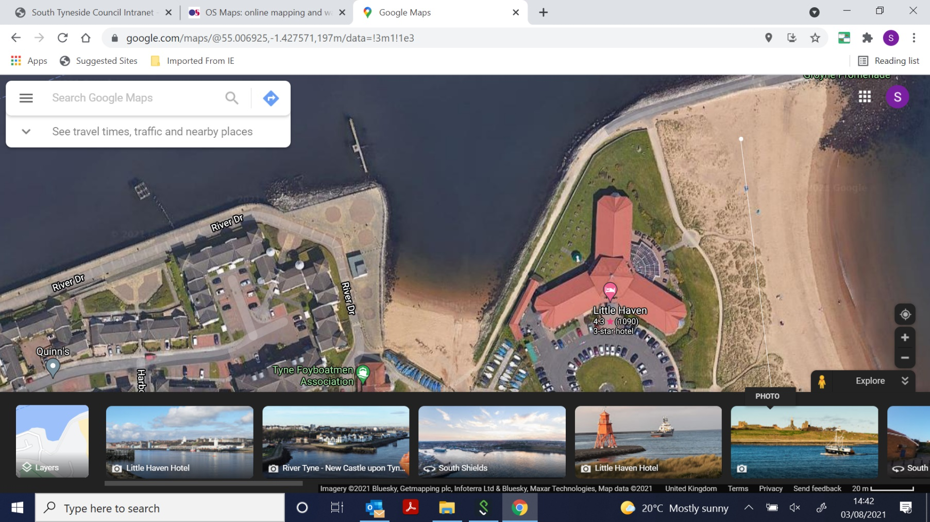

Red triangle areas show danger area and risk of striking rocks with engine and propeller or damaging bottom of boat. Approach only in blue highlighted zone

**Powerboating**

Powerboats may be used in the following roles;

* Acting as a safety boat escorting either sailing boats, kayaks or other craft
* As a means of transport to study the local environment
* To provide training in powerboat skills.
* To give an experience of powerboating

When teaching any RYA courses the instructor to pupil ratio should not exceed 1:3. At no times must the number of persons in the Humber RIB to exceed 12. It must not have the CE Plated limits exceeded for carraige of passengers.

During instruction, helm’s are to be supervised closely by staff, with staff using 2nd training kill cord for those under 12 years and be in a position to control throttle if necessary. Minimum qualification to helm the boat is RYA level 2 powerboat. Minimum Qualifiation to teach on the craft is RYA Powerboat Instructor.

**Personal Water Craft (PWC)**

Students must be under supervision of a PWC instructor at all times they are on the water. The maximum number of students on the PWC at any time is 2. A safety boat must always be on the water when the PWC is being used. For RYA courses the maximum instructor/student ratio may not exceed 1:2

Students may helm the PWC under the direct (on craft) or indirect (from safety boat) supervision of a PWC instructor after appropriate skill levels have been demonstrated.

PWC instructors must be aware of the impact they have on the environment and other water users and should plan sessions and operating areas accordingly

**Water Safety Management Programme**

The National Water Safety Management Programme is designed to respond to the water safety needs of anyone working near, in or on the water. Our course content is designed to be varied to meet the participants needs and includes up to level 3. For this we use the River Wear, near Finchale Abbey, the Wave Trap, Littlehaven beach and Sandhaven Beach. Open Water swimming with swim tests will be carried out with 2 NWSMP Instructors present. One of which will be providing safety cover whilst the other delivers session.

With this is mind we will have a maximum of 2:10 participant on the course.

A first aid kit, rescue equipment, group shelter, bivi bag, detailed plan on activity board at Water Centre including ETA and VHF with mobile phone must be carried by instructor.

Theory sessions and landbased acivities take place at Simonside Climbing Wall.

**Stand Up Paddle Boarding**

This takes place in the wave trap at high tide, Littlehaven Beach with no surf present. A weather forecast, including offshore winds risk will be checked. The instructor ratio will be 1:6. Participants must be wearing a full wet suit, bouyancy aid and suitable footwear. A helmet may also be considered. Staff must hold a first aid certificate, RLSS open water lifesaving award, a paddlesport or Surfing GB coaching award and have suitable group leadership experience combined with a good skill level in SUP boarding.

The group must be informed of the hazards of moving your board around in the wind, working togther, use of leash, padlle, how to entre the water, climb on board, stance, how to hold a paddle, basic techniques and group awareness. Boards need to be sized to the correct height of the paddle boarder.

**Secret Pool**

Located on the Lewisburn in Kielder Forest (Grid NY619873) the river pool is used for open water swimming and small water jumps. There are 4 jumps ranging from 1.5 metres to 3.5m above the water into an open pool. The pool is filled by a waterfall and it drains into two lines of the burn. Both shallow to a depth of 30cm’s when river slack and 1 m when in spate. Staff must hold a minimum of a BEL award, RLSS Water Safety Management Programme level 3 or a BC White Water Safety & Rescue Test and a first aid certificate. Instructors must have also worked the session numerous times with other Simonside OA staff. Staff to participant ratio is 1:8. Instructors need make an assessment of conditions before going into the water. A statement of competence is also completed annually for each staff member.

Participants and instructors must wear a wetsuit, helmet, buoyancy aid, windproof cag and long sleeved top and sturdy footwear. Staff will carry the instructor grab bag which will include a group shelter, bivi bag, hats, fleece jumper, 20m throwline, walking pole and a Simonside OA waterproof first aid kit.

**Refueling of RIB’s/PWC/Tractor**

The centre boats and PWC use unleaded petrol. The fuel for these are kept in an Tyne & Wear Fire & Rescue Service approved and checked fuel store, which must be kept locked when not in use, (the store must not be opened unless the alarms have been unset). The centre tractor uses gas oil or diesel

All fuel containers must be of an approved type and be clearly marked. Labelled on jerry can and within fuel store.

* Refueling must take place in a well ventilated area.
* Refueling may only be under taken by an adult.
* Only those persons approved by the Head of Centre may have access to the fuel store
* Reasonable precautions will be taken at all times to ensure that safe working procedures are in place.
* Fire extinguishers on board Humber as well as inside building

The hazards associated with the above activity and the precautions to be taken are covered in our Risk Assessments.

**Tractor Driving**

The tractor at the Water Activities Centre is used for launching & recovering boats from the wave trap slipway and moving equipment trailers around the WAC compounds. The vehicle is taxed for use on the public roads and when driving on roads the seatbelt needs to be used. Reasonable precautions will be taken at all times to ensure that safe working procedures are in place. Refuelling of tractor needs to be done outside next to roller shutter door in proximity of a fire extinguisher. The tractor uses diesel or gas oil (red diesel) only.

Only those persons approved by the Head of Centre may drive the vehicle and hold a category B licence.

When launching boats the tractor must not be immersed in the water any deeper than half way up the front wheel

The hazards associated with the above activity and the precautions to be taken are covered in our Risk Assessments.

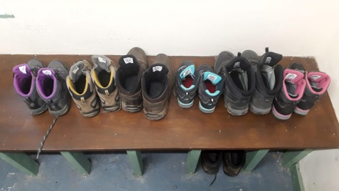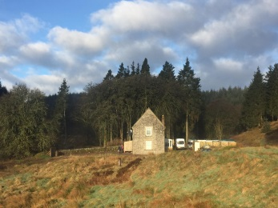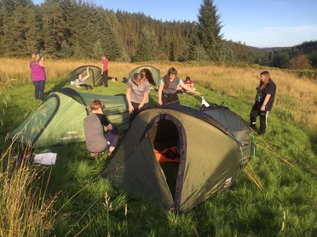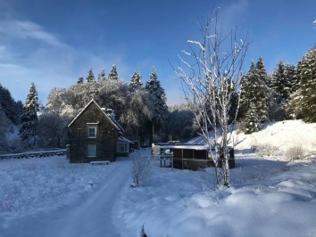

**Residential**

This includes camping, Duke of Edinburghs’ Award expeditions and multi activity residentials which are usualy based at Akenshawburn Cottages. There will be an appropriate number of staff to suitabily supervise the young people based on gender and/or needs. Staff will have access to spare tents, sleeping bags and mats including spare clothes in the event of adverse conditions or damage to equipment in one of two expedition boxes.

Campsites, hostels, and hotels will be appropriately checked prior to use and overnight supervision will be suitable based on level of need and gender split within the group. Minimum ratio is 1:10 for overnight supervision with a minimum of 2 staff if number is less than 10 persons for those under 18 year of age.

All staff who work with the young people will hold a first aid qualification and an enhanced DBS.

First aid provision to be carried out by SOA staff on all participants and visiting/accompanying staff. We will be responsible for administering of medications either prescribed or PRN that have be supplied with the individual in line with their education health care plan. This information will be recorded and then given as evidence to organsiation for follow up and recording on Evolve. This must be completed on medication form. These are held online but also in document wallet at Akenshawburn Cottages in equipment store.

**Akenshawburn Cottages, Kielder**

Any residential or day visit to the cottages in Kielder will have SOA staff present on site at all times. The staff will have a full induction of the premises and be familiar with the buildings operating requirements. They will be first aid qualified, fire warden trained and hold a food hygiene certificate.

Fire drill to be carried out when new group arrives. The fire alarm panel is located in the entrance way to the West cottage. All fire doors are to have padlocks and bolts removed prior ot group entering. These are East cottage kitchen and bottom of stairs, West cottage living room and bottom of stairs. Fire evacuation plan on the reverse of all bedroom doors. Group briefing to be carried out upon arrival with regard to grounds, which areas are restricted and also reduced environment impact. Group briefings to be had regarding log burning stoves in East cottage dining room and West cottage living room to be operated by staff only and have fire guards in place.

A weather forecast must be obtained daily and used to plan the days activities to best suit needs of group.

The emergency procedures for Akenshawburn Cottages due to its remoteness has a separate emergency action plan when urgent medical care is required. Staff are aware, this is placed on the notice board in the equipment store in the East Cottage. A larger more robust and stocked first aid provision including an , AED (defib)catastrophic bleed and airway management is included along with staff training.

Mobile Phone signal is patchy and sometimes unreliable in Kielder Forest, however, staff maps and centre master maps have mobile phone signal points marked on them, staff are also able to wifi or whatsapp call through the satellite internet at the cottages. Staff should contact designated contact back at Simonside OA in South Tyneside to let them know ‘off water’ or ‘off hill’ so that in the event of no communication designated contact should contact other residential staff present initilly or secondary contact emergency services. Designated contact must be informed of any changes to planned itenerary with new updated timescales, activities and locations. This must be done through mobile communication and not email.

In the event of a failure of internet service the closest and most reliable location of mobile signal service which is accessible is GRID REF **NY 655887**, the layby on the crest of the hill overlooking Leaplish Waterside Park. This is 5 miles away from the cottages. This point also allows us to be on the road and guide any emergency services to the cottages location if required.

SOA staff accomodation is on the first floor of the East cottage, on an evening the east cottage door is to be locked to prevent access by group into kitchen area or store. Accompanying staff to have key to this door in the event of an issue.

The front door to the cottages is to be locked overnight with both SOA staff and accompanying visiting staff to have a key to this door. Emergency access is to be through fire exits when young people are staying inside. For thise who are camping the main door remains open for access to toilets and staff support if requird.

West cottage bedrooms are located;

Bedroom 1 – ground floor, sleeps 11.

Bedroom 2 – first floor sleeps 11

Bedroom 3 – accompanying staff sleeps 4 (key code entry)

Bedroom 4 – accompanying staff sleeps 4 (key code entry)

**Akenshawburn Cottages Food Safety**

The cottages will maintain a Food Standards Agency, Food Hygiene Rating and comply with all current legislation regarding storage, preparation, handling and serving of both hot and cold foods for our clients. Staff will be overseen by a competent person who holds a level 3 Award in supervising food safety in catering. All staff involved in the handling of food will maintain a level 2 food hygiene certificate. All supporting information relating to the centre’s management of food will be contained in the ‘safer food, better business file held at the cottages.

**Akenshawburn cottages building management.**

## Water is drawn from a borehole “well” chamber at the foot of the orchard path from the carpark and pumped to a storage tank in the loft of the shower block via a 2 stage filter (in girls WC) and UV steriliser (in loft). From here, an automatic pump (girls WC) boosts the pressure when either hot or cold taps are opened. Hot water is heated in a 250 litre unvented cylinder fed by the heating boiler in the drying room. The borehole pump is controlled by a level switch on the cold storage tank which holds around 2000 litres.

|  |  |
| --- | --- |
| Maintenance | Monthly – flush all outlets thoroughly until water runs hot (taps and showers) or cold (cold taps). Annual – check / replace cartridge filters and UV tube |
| Shut down | If the house is to be unoccupied for several days, turn off the bore hole pump (fused spur in toilet entrance) boost pump (fused spur in girls WC) & heating system (heating controls in drying room). |
| Complete draindown  (e.g. for several winter weeks) | Turn off bore hole pump. Open basin taps in toilets and allow water to be pumped for about 5 – 10mins until water flow reduces (as the tank empties) and the pump note changes. Turn off the boost pump. Leave taps open and open kitchen and outside taps. Press shower buttons to empty these. Connect hose to drain valve on bottom of hot water cylinder and run to drain or outside. Open drain valve until water ceases. Open the filter cartridge drain valves and empty water into a bucket. Flush all toilets to empty cisterns. Leave all taps open. To refill the system complete these steps in reverse. |

Gas central heating is fitted throughout fed from a LPG boiler in the drying room. The entire system is filled with water/antifreeze (Fernox Alphi II) mixture which should provide frost protection to -15’C.

The system is split into three controlled zones – hot water, east cottage & west cottage. Time switches for these zones are in the drying room adjacent to the boiler. Thermostats in the lounge (West) and kit store landing (East) control the temperature and individual rooms can be set using the thermostatic radiator valves (TRVs). TRV setting No. 1 is approx. 180C and will keep the room aired, 3 approx 200C, 5 approx 250C. Once the room is up to temperature the flow is reduced and the radiator will feel cooler to maintain the temperature. If it is too cool, turn it up slightly and allow 1/2hr or so before checking again; the idea is to set the valve at a comfort temperature and let it regulate; you should not need to keep adjusting them manually.

Hot water temperature is set on the cylinder. Once this is up to set point (55’C) the circulation pump comes on to pump the water round the hot pipe loop to reduce waiting time for the showers etc. Cylinder heat up time is about 30 mins, but can take longer if the weather is cold and the heating is on. The thermostats and boiler have low level frost protection and will fire the system if the temperature drops to <70C to prevent frost damage. Note this requires the electricity supply.

Electricity is stored in a 48 volt battery fed by 6 solar panels on the hill above the carpark. This is converted to 230V ac (as conventional mains power) by the inverter in the battery room and powers the “DB-PV” circuits 24/7. This DB feeds lighting, emergency lighting, heating and water systems and any PV designated sockets (e.g. fridge, TV, Wifi, landing sockets) etc. The inverter is rated at 5kVA (about 4.5kW) and is fully protected against overload. The front panel switch has three positions – 1 inverter on (normal position), 0 (off; e.g. for maintenance, resetting etc) and charger only. The system should not need any maintenance other than a monthly check on the battery electrolyte levels; top up with distilled water as needed.

Backup power is from the 16kVA generator. This feeds the “DB-Gen” sockets when running and will also recharge the batteries. The inverter control system will automatically start the generator when the batteries have low charge and switch it off when they are recharged. Note for this to work the generator must be set to auto position (display lit up).

If you anticipate using a lot of electricity, e.g. using a lot of electric cooking appliances, it is wise to run the generator for these periods. This will also add charge to the batteries for later use. Start the generator in the normal manual start process (press green button, press again, wait for hourglass) or using the Color Control GX manual start menu (more complicated, not advised for the uninitiated but allows a timed e.g. 2hr run period).

All the circuits have RCD and MCB protection; these are easily reset if they trip by pushing the toggle upwards. As an off grid system, it is more susceptible to surges and trips especially if reactive appliances like large motor loads are used.

The PV system should keep the batteries charged all year, provided all non-essential electric loads are turned off when not in use e.g. when the building is unoccupied. The PV should be capable of running the fridge, lighting and small power for most of the summer without the generator but clearly this is dependent on daylight levels and the amount of electricity used. As a general rule, do not use any electric heating appliances unless the generator is running. The GX Color Control displays the energy flows in the system and the charge status of the battery similar to this:

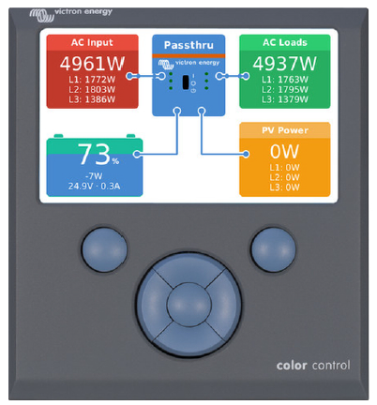

## Sewage & waste water; All water drainage runs into a septic tank located behind the archery range. The septic tank is an anaerobic bacterial environment that decomposes the waste into solid matter and basically treated run off water. The run-off water seeps into a surrounding reed bed and the solids are periodically collected by truck for disposal in a treatment plant elsewhere.

The system relies on bacteria for successful operation and this is reduced by excessive use of anti-bacterial products such as bleach and conventional detergents which will reduce the bacteria concentration, even in some cases to prevent the digester from operating.

Given the proximity to Kielder reservoir it is vital the septic tank bacteria is maintained and we ask that bleach based cleaning agents are not used for routine cleaning and that only mild solutions are used for washing up and other cleaning purposes. To avoid blockages, no wet wipes, sanitary products etc may be flushed down the toilets; please use the bins provided and the old adage applies: “If it hasn’t previously passed through you, don’t flush it down the loo”!

**Staff Acknowledgement**

**Please sign below to say that you have read & understand the above procedures that relate to your area of work within or on behalf of Simonside Outdoor Adventure**

|  |  |  |
| --- | --- | --- |
| **Print Name** | **Signature** | **Date** |
|  |  |  |
|  |  |  |
|  |  |  |
|  |  |  |
|  |  |  |
|  |  |  |
|  |  |  |
|  |  |  |
|  |  |  |
|  |  |  |
|  |  |  |
|  |  |  |
|  |  |  |
|  |  |  |
|  |  |  |
|  |  |  |
|  |  |  |
|  |  |  |
|  |  |  |

**Appendix I**

**Beaufort** [**scale**](http://www.peardrop.co.uk/beaufort.htm)**, Probable Wave Height**

|  |  |  |  |  |  |  |
| --- | --- | --- | --- | --- | --- | --- |
| **Beaufort  number** | **Description term** | | **Wind speed** | **Wave Height (m)** | | |
| **Wind** | **Wave** | **knots** | **probable** | **maximum** |
| **0** | **Calm** | **-** | **< 1** | **-** | **-** |
| **1** | **Light air** | **Ripples** | **1 - 3** | **0.1** | **0.1** |
| **2** | **Light breeze** | **Small wavelets** | **4 - 6** | **0.2** | **0.3** |
| **3** | **Gentle breeze** | **Large wavelets** | **7 - 10** | **0.6** | **1.0** |
| **4** | **Moderate breeze** | **Small waves** | **11 - 16** | **1.0** | **1.5** |
| **5** | **Fresh breeze** | **Moderate waves** | **17 - 21** | **2.0** | **2.5** |
| **6** | **Strong breeze** | **Large waves** | **22 - 27** | **3.0** | **4.0** |
| **7** | **Near gale** | **Large waves** | **28 - 33** | **4.0** | **5.5** |
| **8** | **Gale** | **Moderately** [**high**](http://www.peardrop.co.uk/beaufort.htm) **waves** | **34 - 40** | **6.0** | **7.5** |
| **9** | **Strong gale** | **High waves** | **41 - 47** | **7.0** | **10.0** |
| **10** | **Storm** | **Very high waves** | **48 - 55** | **9.0** | **12.5** |
| **11** | **Violent storm** | **Exceptionally high waves** | **56 - 63** | **11.5** | **16.0** |
| **12** | **Hurricane** | **Exceptionally high waves** | **64 - 71** | **14.0** | **> 16** |
| **13** | **Hurricane** | **Exceptionally high waves** | **72 - 80** | **> 14** | **> 16** |
| **14** | **Hurricane** | **Exceptionally high waves** | **81 - 89** | **> 14** | **> 16** |
| **15** | **Hurricane** | **Exceptionally high waves** | **90 - 99** | **> 14** | **> 16** |
| **16** | **Hurricane** | **Exceptionally high waves** | **100 - 109** | **> 14** | **> 16** |
| **17** | **Hurricane** | **Exceptionally high waves** | **109 - 118** | **> 14** | **> 16** |

**Appendix II**

**Inform group of actions in event of YOU being unable to carry out your duties and where to find the emergency kit and information.**

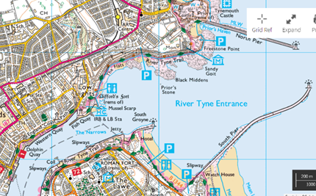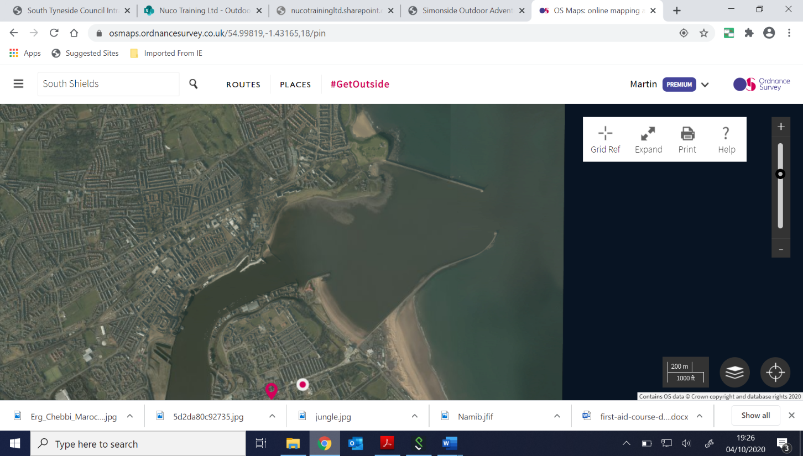

**Emergency evacuation point; public slipway River Drive, NE33 1LH.**

**Grid: NZ 367 681 - Lat/long: N550 00.42’ W0010 25.66’ - W3W: washed.moved.card**

**Channel 16, VHF Call Sign: ‘Water Activities Centre’ then vessel name.**

**Or 999 and ask for coastguard**

|  |  |
| --- | --- |
| **RIB Briefing** | **PWC Briefing** |
| 1. If you are not happy, shout out 2. Remain seated when moving where staff ask you too, no bow 3. Keep both feet on deck 4. Keep 2 hands on strong point 5. If you are unwell, shout out 6. If you are on helm, follow instructions from staff 7. Staff will always wear a kill cord with novices on helm 8. Staff will always be within reach of power when novice is on helm 9. What questions do you have? | 1. If you are not happy, shout out 2. Staff to wear kill cord whilst novice is in control of PWC 3. Remain seated, with hands in position shown by staff 4. Follow instructions from staff 5. Staff to brief students on how to get onto craft shallow water 6. Staff to brief students on how to get onto craft deep water 7. Staff to explain controls 8. Staff to explain what happens if you fall off, letting go. 9. Explain that students do not right a capsized ski, wait for staff 10. What questions do you have? |

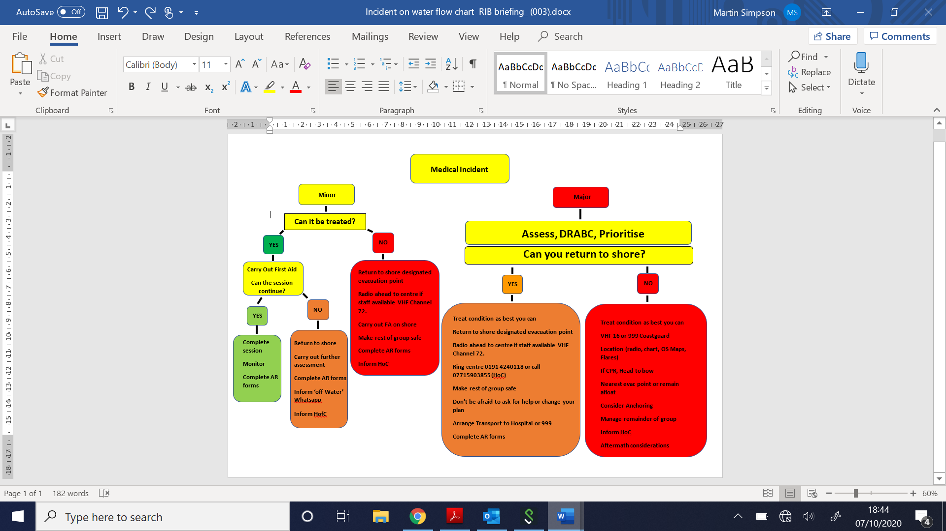

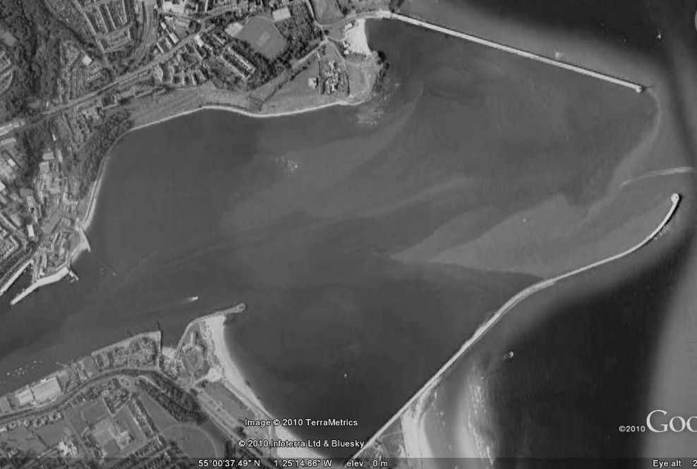

**Appendix III Working Area 1 & 2**

**TYNEMOUTH BEACH**

**Area 1**

**Area 2**

**NORTH SHIELDS PIER**

**LOWER HARBOUR SOUTH**

**LITTLE HAVEN BEACH**

**HS – HERD SANDS CHANNEL BOUY. No1 – No1 STARBOARD CHANNEL BOUY. No2 – No2 STARBOARD CHANNEL BOUY, GL – GROYNE LIGHT**

**WAVE TRAP**

**WAC**

**SOUTH SHIELDS PIER**

**HS**

**TYNE HARBOUR RADIO - CHANNEL 12. WAC CHANNEL 72 – CALL SIGN ‘WATER ACTIVITY CENTRE’**

**BLACK MIDDENS**

**No.2**

**No.1**

**GL**

**Appendix IV, COVID 19 strategy**

**Appendix III, working area 3**

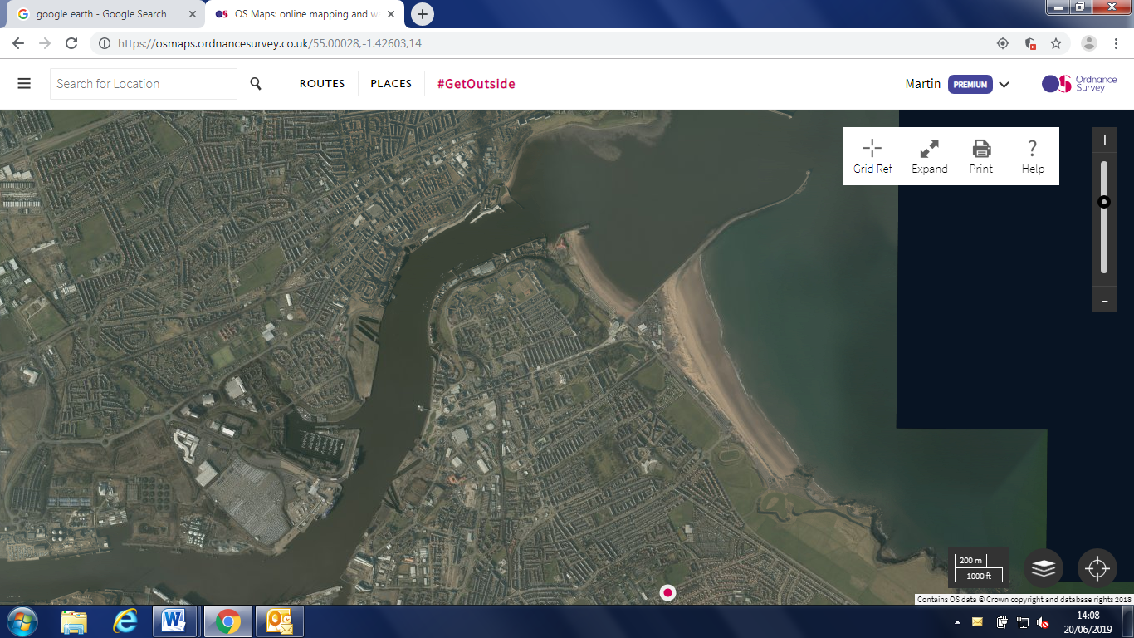

For PB & PWC, River North side, Starboard, from Lloyds Hailing jetty to Royal Quays Marina, Return River South side, port,

With the effect that the COVID 19 (SARS-CoV-2) virus has had internationally we are responding appropriately and taking the following actions to help prevent this and other transmissible infections. We have in place a series of specific COVID 19 risk assessments which are specific to our three buildings, our delivery of activities and the use of equipment and how we can mitigate the risk of communicability within our staff and clients. These changes to operating procedures and risk assessments will be reviewed regularly to stay up to date with current best practice.

**Normal Working Area & kayak crossing point**

Our social media and web page give advice on staying safe and what to expect when visiting our centres

We have amended our consent form to reflect changes that COVID 19 may affect

Our admissions policy also reflects changes, these are;

* We retain the right to refuse entry to our premises or activities based on suspected health related concerns related to COVID 19.
* We will carry out checks prior to your visit by using information on your registration/consent form.

The following links provide further information and guidance relating to COVID 19.

<https://www.gov.uk/coronavirus>

<https://www.gov.uk/government/collections/coronavirus-covid-19-list-of-guidance>

<https://www.nhs.uk/conditions/coronavirus-covid-19/>

#### 

Every Local Authority is required to produce a publicly available plan to outline how we intend to prevent and control community outbreaks of COVID-19 in South Tyneside.

This is a working plan that will be responsive to the evolving nature of the pandemic.

Read the [South Tyneside Outbreak Management Plan](https://publications.southtyneside.gov.uk/plans/south-tyneside-outbreak-management-plan/).

**Report suspected or confirmed cases**

As individuals, we can all play our part in South Tyneside’s response. To help us prevent and manage possible cases and outbreaks, please email any questions, suspected or confirmed cases to [COVID@southtyneside.gov.uk](mailto:COVID@southtyneside.gov.uk).

**Appendix V**

**Simonside Climbing Wall, NE34 9SD, 0191 4240118**

**admit.scare.waters**



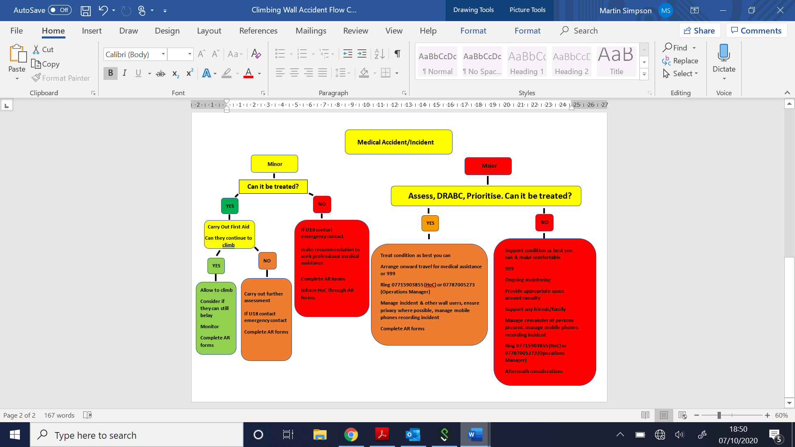

|  |  |
| --- | --- |
| **D** | **DANGER**  **Environment**, scene survey, MOI, predicted injuries,  self-team-victim, group management |
| **R** | **RESPONSE**  AVPU, appearance, colour (circulation), effort of breathing |
| **C** | **CATASTROPHIC BLEED**  Pressure, Tourniquet, Haemostatic packing/dressing |
| **A** | **AIRWAY**  Obstructions, Spinal injuries |
| **B** | **BREATHING**  LLF 10 Secs: Rate, Depth, Efficiency, Sound  Breathing Normal → Secondary Survey  Breathing Absnormal/Absent → 999/CPR/AED |
| **C** | **CIRCULATION**  Pulse (Radial/Carotid), capillary refill, temperature  **Blood on floor**: Expose/examine, direct pressure, elevate  **4 more**: Chest, abdomen, pelvis, long bones  **Shock**: Casualty positioning, elevate legs |
| **D** | **DISABILITY**  **History, Signs and Symptoms**  **Head injury**: PERRL, AVPU, behaviour, blood/bruising  **Spinal**: Support head, other injuries  **Fractures**: Open/closed, immobilise, treat for shock  **Illness:** IHP/EHC, medications |
| **E** | **ENVIRONMENT**  Expose - evaluate – evacuate/stay put - reassess |