Managing Social Anxiety When Leaving Lockdown
The Department for Education and the government have established Key Themes as specific topics that aim to enrich your learning by improving your wider skills and understanding above and beyond the course you are taking. Skills South Tyneside and your training provider want you to gain the most from your programme of learning and these activities will help to embed those Key Themes. The Key Themes are:
M-  Maths | E-  English | ILT- Information Learning Technology | EDI- Equality, Diversity Inclusion | S-  Safeguarding | P- Prevent | C-  Climate | HS- Health and Safety | BV-  British Values
For many of us, the gradual easing of lockdown brings longed for opportunities (even if at a social distance) to see friends, play sports, resume contact with wider family and enjoy time at restaurants and bars. But for many others, even the happy and much anticipated changes can be difficult for our mental health.


The Mental Health Foundation says that we should be prepared for the fact that the end of lockdown might be as hard for some as the start was. Just as it took time to find ways of coping during lockdown it will take time to adjust to these new freedoms. Here are some easy to adopt strategies you can use to reduce any anxieties you may have:
- Go slowly - start by connecting with those in your closest inner circle of family and friends first. Then, when you’re ready, try expanding your circle to include people and situations that can make you anxious. By approaching these situations slowly you’re more likely to feel calmer and help your anxiety to come down.
- Visualise situations in your head - prepare for upcoming social events by role-playing specific worries or concerns with someone you trust, by writing it down on paper or just in your own head. By ‘practicing’ social activities in this way it can reduce the fear of the unknown.
- Look after your wellbeing - take time to prioritise feeling good physically and emotionally will help to reduce any worries you may have. Try to eat a healthy diet, limit alcohol, exercise regularly and prioritise sleep. Remember to take time for yourself and try new things such as keeping a diary, talking to friends or family, going for walks, watching a favourite film, enjoying a hobby such as crafting or learning a new skill.
- Focus on the positives - try to focus on the positives and take pleasure from the little things you can enjoy again. Maybe you’re looking forward to getting a takeaway coffee again or even having a socially distanced garden visit with a loved one you’ve been missing.

If you find that none of these strategies help reduce your anxiety around leaving lockdown it may be time to reach out to a mental health professional who can help support you further:

If you are in need of urgent mental health care, call the crisis Crisis Team on 03031231145 or via 111.

You can self-refer to South Tyneside Lifecycle Primary Care Mental Health Service on 0191 2832937 or visit the website https://www.southtynesidelifecyclementalhealth.nhs.uk/

You can also contact your own GP Practice directly for support.
You can choose to do any or all of the suggested activities below and your tutor will support you with any help you may need:
Question: what did you learn from this article?
Click here to enter text.
Research Online: what are the signs and symptoms of social anxiety?
Click here to enter text.
Discuss: what are the first ways that you are safely going to start socialising again? How do you feel about this?Click here to enter text.

E-Safety and Social Media Awareness
The Department for Education and the government have established Key Themes as specific topics that aim to enrich your learning by improving your wider skills and understanding above and beyond the course you are taking. Skills South Tyneside and your training provider want you to gain the most from your programme of learning and these activities will help to embed those Key Themes. The Key Themes are:
M-  Maths | E-  English | ILT- Information Learning Technology | EDI- Equality, Diversity Inclusion | S-  Safeguarding | P- Prevent | C-  Climate | HS- Health and Safety | BV-  British Values
Since COVID-19 and lockdown Ofcom have reported that adults are spending on average 4 hours a day online with twice as many video calls being used to keep in touch during lockdown. But with these changes 9 in every 10 adults surveyed expressed concerns around video-sharing sites, social media and websites they access being legitimate.

staysafeonline.org have provided some tips so anyone is able to safely enjoy social media and the web.
- Privacy and security settings exist for a reason: learn about and use the privacy and security settings on your social media. Ensure your passwords are long and not easily
- Once posted, always posted: Protect your reputation on social networks because what you post online stays online. Always think twice before posting pictures you wouldn’t be happy for future employers to see. Recent research found that 70% of employers reject candidates based on information they found online.

- Keep personal info personal: Be cautious about how much personal information you provide on social networking sites. The more information you post, the easier it may be for a hacker or someone else to use that information to steal your identity, access your date or commit other crimes such as theft or stalking.
- Know and manage your friends: Social networks can be used for a variety of purposes. Some of the fun is creating a large pool of friends from many aspects of your life - that doesn’t mean that all friends are created equal. If you don’t know the person in real life, be careful about friending them online. Extremist and terrorist groups use social media to recruit and prey on vulnerable people - use the block and delete options to manage your online relationships if you need to.
- When in doubt, throw it out: links in emails, tweets, posts and online advertising are often how cybercriminals try to steal your personal information. Even if you know the source, if something looks suspicious, delete it.

If you are worried about a friend, relative or even yourself around extremist influences online, please go the Prevent “Let’s Talk About It” website https://www.ltai.info/ or if you have immediate concerns please contact 101 where you can access discreet and tailored support from a trained professional.

For local Prevent contacts you can speak with South Tyneside Council Community Safety Team on 0191 424 7935 or Northumbria Police Prevent Team on 101 ext. 63855.
You can choose to do any or all of the suggested activities below and your tutor will support you with any help you may need:
Question: how did this article make you feel?
Click here to enter text.
Read online: https://www.ncsc.gov.uk/guidance/social-media-how-to-use-it-safely this article by the National Cyber Security Centre, a Government body, explain how to use privacy setting across social media platforms to manage your digital footprint. Click here to enter text.
True or False: Criminals use fake social media accounts of real people to target victims?
Click here to enter text.

World Water Week at Home 24-28 August 2020
The Department for Education and the government have established Key Themes as specific topics that aim to enrich your learning by improving your wider skills and understanding above and beyond the course you are taking. Skills South Tyneside and your training provider want you to gain the most from your programme of learning and these activities will help to embed those Key Themes. The Key Themes are:
M-  Maths | E-  English | ILT- Information Learning Technology | EDI- Equality, Diversity Inclusion | S-  Safeguarding | P- Prevent | C-  Climate | HS- Health and Safety | BV-  British Values

For nearly 30 years SIWI (Stockholm International Water Institute) has organised the global World Water Week Event to bring attention to the importance of water to us as individuals, communities and the environment. Some key facts about water:
- 2.2 billion people in the world don’t have access to clean, running water in their own homes
- Of those people, 144 million collect untreated surface water from lakes, ponds, rivers and streams
- Contaminated water and poor sanitation are linked to transmission of diseases such as cholera, diarrhea, dysentery, typhoid and polio.
- Climate change and increasing water scarcity means that by 2025 half of the world’s population will be living in water-stressed areas.
- In the worlds least developed countries 22% of health care facilities have no water service, no sanitation service and 22% have no waste management service.

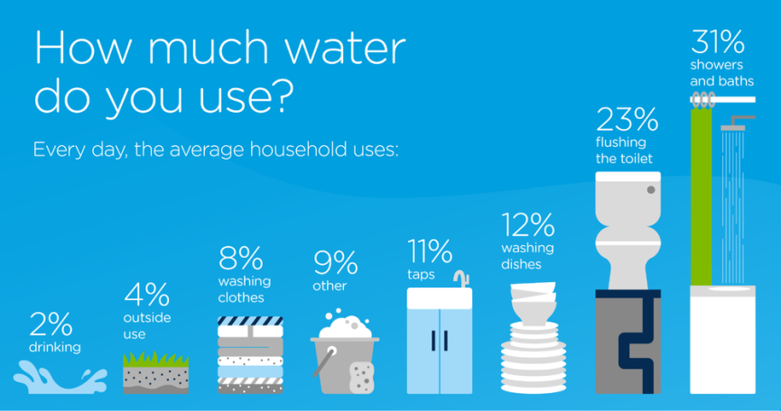
Although creating lasting change in communities who don’t have access to water is a global initiative we can as individuals help to protect water by using less and wasting less. This image shows how a typical household uses their everyday water:

What can you do?
- Take shorter showers - set an alarm for 4 minutes - it could save you around £50 a year on your energy bills!
- Save leftover cooking water from pasta, rice and vegetables and use it on your garden - the water will be packed full of helpful nutrients which your plants will love!
- Keep cold water in your fridge - instead of running the tap until it turns cold, just fill a reusable bottle or jug of water and pop it into your fridge.
You can choose to do any or all of the suggested activities below and your tutor will support you with any help you may need:
Question: what interested you most about this article?Click here to enter text.
Question: There are 7.8 billion people in the world and 2.2 billion have limited access to clean, safe water. What percentage is that?Click here to enter text.
Quick Activity: List ways can you reduce your water usage this week. Describe which ways you can make a permanent change of wasting less water. Click here to enter text.
Longer Activity: Research online about what ways a lack of clean water can impact community’s health, economically and socially. https://water.org/our-impact/water-crisis/ and https://www.un.org/en/sections/issues-depth/water/ have reliable, statistically backed information.

