County Lines and Cuckooing
The Department for Education and the government have established Key Themes as specific topics that aim to enrich your learning by improving your wider skills and understanding above and beyond the course you are taking. Skills South Tyneside and your training provider want you to gain the most from your programme of learning and these activities will help to embed those Key Themes. The Key Themes are:
M-  Maths | E-  English | ILT- Information Learning Technology | EDI- Equality, Diversity Inclusion | S-  Safeguarding | P- Prevent | C-  Climate | HS- Health and Safety | BV-  British Values

County Lines is where illegal drugs are transported from one area to another, often across police and local authority boundaries (although not exclusively), usually by children or vulnerable people who are coerced into it by gangs. The ‘County Line’ is the mobile phone line used to take the orders of drugs. Importing areas (areas where the drugs are taken to) are reporting increased levels of violence and weapons-related crimes as a result of this trend.

Exploitation of Young and Vulnerable People
A common feature in county lines drug supply is the exploitation of young and vulnerable people. The dealers will frequently target children and adults – often with mental health or addiction problems – to act as drug runners or move cash so they can stay under the radar of law enforcement.

In some cases the dealers will take over a local property, normally belonging to a vulnerable person, and use it to operate their criminal activity from. This is known as cuckooing.

People exploited in this way will quite often be exposed to physical, mental and sexual abuse and in some instances will be trafficked to areas a long way from home as part of the networks drug dealing business. Often victims will not realise that they have been groomed to get involved in criminality so it’s important we all play our part to understand county lines and speak out if we have concerns.

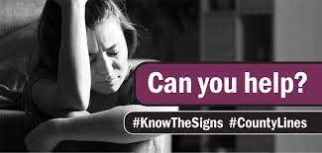
What are the signs of exploitation and cuckooing?
- Changes in behaviour (e.g. secretive/withdrawn/ aggressive/emotional)
- Access to numerous phones
- Use of unusual terms e.g. ‘going country’
- Associating with gangs
- Unexplained bus or train tickets
- School truancy or going missing
- Unexplained gifts e.g. clothing, trainers, cash
- An increase in visitors and cars to a house or flat

What to do if you have concerns
The best advice is to trust your instincts. Even if someone isn’t involved in county lines drug dealing, they may be being exploited in some other way, so it’s always worth speaking out. You can speak to your local police by dialling 101, or in an emergency 999. If you would rather remain anonymous you can contact the independent charity Crimestoppers on 0800 555 111. Another good option if you are someone who is worried about your own involvement, or a friend’s involvement in county lines, is to speak to a responsible person in your life such as a colleague, teacher or tutor.
True or False: When a gang takes over a person’s home for the purposes of committing a crime it is known as cuckooing. Click here to enter text.
Research Online: Read the latest news articles about County Lines on BBC Online, how did the article make you feel? Click here to enter text.
Mental Health Awareness Week 2021
The Department for Education and the government have established Key Themes as specific topics that aim to enrich your learning by improving your wider skills and understanding above and beyond the course you are taking. Skills South Tyneside and your training provider want you to gain the most from your programme of learning and these activities will help to embed those Key Themes. The Key Themes are:
M-  Maths | E-  English | ILT- Information Learning Technology | EDI- Equality, Diversity Inclusion | S-  Safeguarding | P- Prevent | C-  Climate | HS- Health and Safety | BV-  British Values
Hosted by the Mental Health Foundation, Mental Health Awareness Week 2021 will take place from 10th – 16th May 2021. The Week has been run by the Foundation since 2001 and the theme is ‘Nature’.

During the long months of the pandemic, millions of us turned to nature to find comfort. The Foundations research on the mental health impacts of the pandemic showed going for walks outside was one of our top coping strategies and 45% of us reported being in green spaces has been vital for our mental health. Websites which showed footage from webcams of wildlife saw his increase over 2000%. Wider studies also found that during lockdowns people not only spent more time in nature but were noticing it more.
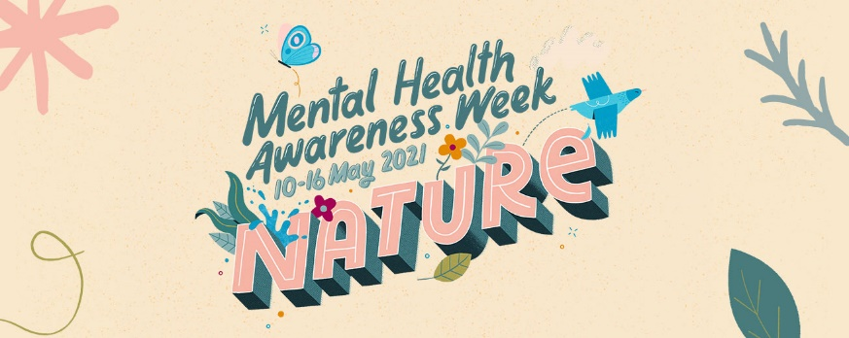
There are two aims of Mental Health Awareness Week 2021. Firstly, to inspire more people to connect with nature in new ways and notice the impact that this connection can have for their mental health. Secondly, to convince decision makers at all levels that access to and quality of nature is a mental health and social justice issue as well as an environmental one.

What can you do?
- Experience nature: take time to recognise and grow your connection with nature during the week. Take a moment to notice and celebrate nature in your daily life.
- Share nature: take a photo, video of sound recording and share the connections you’ve made during the week to inspire others. Join the discussion on how you’re connecting with nature by using the hashtags #ConnectWithNature #MentalHealthAwarenessWeek
- Talk about nature: use the Foundation’s tips, school packs, research and policy guides to discuss in your family, school, workplace and community how you can help encourage people to find new ways to connect with nature in your local environment.

Do you need help?
If your mental or emotional state quickly gets worse, or you’re worried about someone you know help is available. You’re not alone; talk to someone your trust like a friend, colleague or tutor. Sharing a problem is often the first step to recovery. There are also services and organisations that can offer help and support if you feel as though you’re struggling:
- The Samaritans offer emotional support 24 hours a day in full confidence. Call 116123 - it’s free.
- For support in a crisis text Shout to 85258.
- You can call Rethink 0300 5000 927 advice and information line Monday to Friday 10am-2pm for advice on different types of therapy, benefits, debts, money issues, police, courts and prison as well as your rights under the Mental Health Act.
You can choose to do any or all the suggested activities below and your tutor will support you with any help you may need:
True or False: One in four adults will experience a mental illness at some point each year in the UK. Click here to enter text.
Question: 2,500 males who’ve experienced mental health problems were surveyed, with only one quarter having told a friend or a family member what they had been going through. Approximately how many is this? Click here to enter text.

Spotlight on Hospitality and Customer Service Week – Information Sheet
The Department for Education and the government have established Key Themes as specific topics that aim to enrich your learning by improving your wider skills and understanding above and beyond the course you are taking. Skills South Tyneside and your training provider want you to gain the most from your programme of learning and these activities will help to embed those Key Themes. The Key Themes are:
M-  Maths | E-  English | ILT- Information Learning Technology | EDI- Equality, Diversity Inclusion | S-  Safeguarding | P- Prevent | C-  Climate | HS- Health and Safety | BV-  British Values
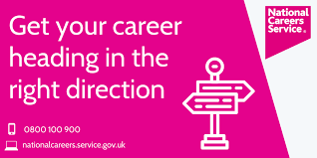
Customer Service and Collaboration were the most in demand skills from employers across South Tyneside and The North East in April and demand for roles in Customer Service increased 100% from March as the sector prepares for more opening as lockdown restrictions ease. This included roles retail, tourism and hospitality as well as culture and arts.

National Careers Service will be delivering a virtual session on Tuesday 18th May at 10am.

The Hospitality and Customer Service Sector Event Week workshop will help attendees to:
- Understand the types of roles in hospitality and customer service sectors
- Understand different routes into hospitality/customer service including future progression
- Understand the skills and qualities required to work in hospitality and customer service
- Find current local training and employment opportunities and support with applications
- Tailor your CV and job applications

Other workshops that are available include:
- New Directions – Your Career Pathway out of Lockdown – 12th May @ 10am
- Creating a Winning CV – 11th & 25th May at 10am
- Interview Skills – 4th & 20th May @ 10am

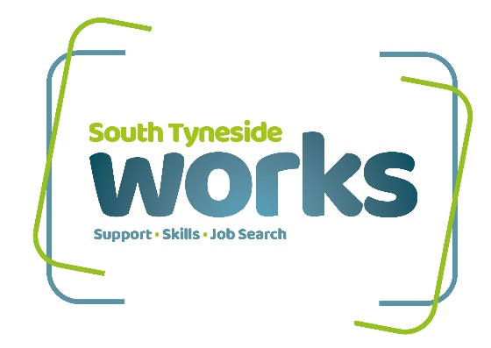
If you’re interested in taking part in the workshops, then you can call 0800 100 900 to request joining instructions. You will need an email address to register.

The event will be promoted on the Skills South Tyneside Facebook page as well as promoting any job vacancies daily plus other training opportunities throughout the week so be sure to like the page and check in daily.

More information can be found at the National Careers Service website well as more local information at the NCS Facebook page.

