Climate Change Affects Everything
The Department for Education and the government have established Key Themes as specific topics that aim to enrich your learning by improving your wider skills and understanding above and beyond the course you are taking. Skills South Tyneside and your training provider want you to gain the most from your programme of learning and these activities will help to embed those Key Themes. The Key Themes are:
M-  Maths | E-  English | ILT- Information Learning Technology | EDI- Equality, Diversity Inclusion | S-  Safeguarding | P- Prevent | C-  Climate | HS- Health and Safety | BV-  British Values

As a result of climate change, we are seeing more frequent and intense extreme weather*. But the story doesn’t end there. As our climate changes at a rapid pace, it has far-reaching ramifications on almost everything we do. Our society, economy, health and wellbeing are all underpinned by our environment. We rely on it being healthy and stable. So, as we push our planetary boundaries further, we are increasingly seeing system-wide consequences:

- TRANSPORT & INFRASTRUCTURE
Extreme weather in the UK is damaging our roads, railways, electricity networks, and internet infrastructure – disrupting supply chains, travel and day-to-day living. Earlier this month, rail lines between Sunderland and Newcastle buckled due to heat.
- FOOD PRODUCTION
A loss of biodiversity is impacting our ability to produce food as pollinator numbers fall and agricultural resilience declines. Increased carbon dioxide in the air is also making our food less nutritious.
- PUBLIC HEALTH
Climate Change is harming our health, deemed as the greatest threat to human health in recorded history. It will increase our exposure to infectious diseases, exacerbate existing illnesses, cause pregnancy complications, and compromise access to safe water.
- ECONOMIC PRODUCTIVITY
Temperature rises are limiting economic output. Studies show that workforce productivity falls and absenteeism increases with every degree rise in ambient temperature.
- CONFLICT & MIGRATION
Extreme weather is intensifying global conflict and migration. In Afghanistan, recent droughts and flash flooding have amplified instability and poverty and acted as a catalyst for conflict.
- FUTURE PANDEMICS
Climate change, deforestation, biodiversity loss and intensive animal agriculture are increasing the likelihood of future pandemics.

TAKE PART – Climate Change and COP 26 – Moment of Truth
In recent weeks, news coverage has reported extreme weather events such as storms, floods and huge forest fires which are devastating many different parts of the world and seasonal changes such as more persistent droughts. At the end of October, the UK is hosting COP 26 in Glasgow bringing together countries from across the world to discuss future action to tackle climate change. Come and join us on Oct 6th 11.30am – 1pm on Zoom to learn more about the urgency of the challenge confronting us in South Tyneside, and beyond, and discuss practical ways of responding. Our speakers are Kate Osborne MP, Cllr David Francis and Ellen Teague, journalist, activist and campaigner. Register for this event here.
- Listen: Podcast For What’s It’s Earth
- Read: Science Times Climate Change Could Trigger Tsunamis in the UK
- Watch: BBC Series Life at 50 Degrees
You can choose to do any or all the suggested activities below and your tutor will support you with any help you may need:
Question: what have you learned from this article? Click here to enter text.
Research Online: Plastic pollution affects climate change too. How can you reduce your plastic usage? Click here to enter text.
Growth Mindset – How Can it Help You?
The Department for Education and the government have established Key Themes as specific topics that aim to enrich your learning by improving your wider skills and understanding above and beyond the course you are taking. Skills South Tyneside and your training provider want you to gain the most from your programme of learning and these activities will help to embed those Key Themes. The Key Themes are:
M-  Maths | E-  English | ILT- Information Learning Technology | EDI- Equality, Diversity Inclusion | S-  Safeguarding | P- Prevent | C-  Climate | HS- Health and Safety | BV-  British Values
What is Growth Mindset?
Psychologist Carol Dweck states that your mindset can determine a person’s success in any situation whether it be in learning, family life, work or health. Using her research, she identified that there are two main mindsets which we would consider to be our personality. A ‘fixed’ mindset assumes that our character, intelligence and creative abilities are all set in stone and can’t be changed in any meaningful way and therefore any success we achieve (or not) is not in our control, but merely down to our talent (or lack therefore). The ‘growth’ mindset is where individuals believe their talents can be developed through hard work, good strategies, practice and input from others. People with a growth mindset tend to achieve more than those with a fixed mindset because they worry less about looking smart and they put more energy into learning.
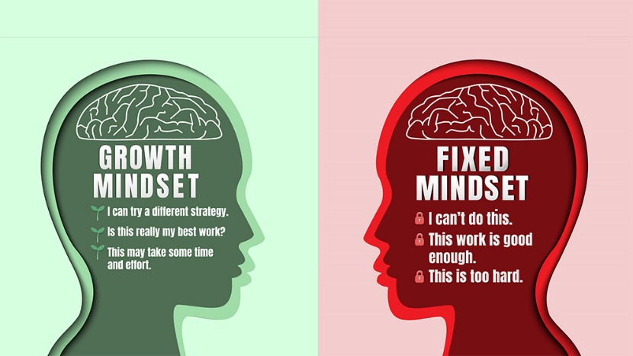
Advantages of a Growth Mindset
Research has linked growth mindset with lots of benefits including:
- Greater comfort taking risks
- Striving for more challenging goals
- Higher motivation
- Enhanced brain development across a wider range of tasks
- Lower stress, anxiety and depression
- Better work relationships
- Higher performance levels

How to Develop a Growth Mindset
There’s clearly lots of advantages to having a growth mindset that will help you in achieving more in learning, your work life and your personal life so how can you change your mindset to a growth mindset?
- Acknowledge and embrace imperfections – hiding from your weaknesses means you’ll never overcome them.
- Try different learning tactics. There’s no one-size-fits-all model for learning and what works for one person may not work for you. Speak with your tutor who will help support you with different ways that you can learn.
- Replace the word ‘failing’ with the word ‘learning’ – when you make a mistake or fall short of a goal, you haven’t failed; you’ve learned!
- Look at criticism as a positive – what can you learn from it? What can you do differently next time?
Look for regular opportunities for reflection – reflect on your learning at least once a day and remind yourself that learning is brain training. The brain is like a muscle that needs to work out just like your body!
You can choose to do any or all the suggested activities below and your tutor will support you with any help you may need:
Question: what did you learn from this article? Click here to enter text.
Read Online: reading the article on Growth Mindset, what can you do personally to change your mindset. Click here to enter text.
Question: Do you consider yourself to have a fixed mindset or a growth mindset about your learning? Click here to enter text.

World Mental Health Day – 10th October 2021
The Department for Education and the government have established Key Themes as specific topics that aim to enrich your learning by improving your wider skills and understanding above and beyond the course you are taking. Skills South Tyneside and your training provider want you to gain the most from your programme of learning and these activities will help to embed those Key Themes. The Key Themes are:
M-  Maths | E-  English | ILT- Information Learning Technology | EDI- Equality, Diversity Inclusion | S-  Safeguarding | P- Prevent | C-  Climate | HS- Health and Safety | BV-  British Values
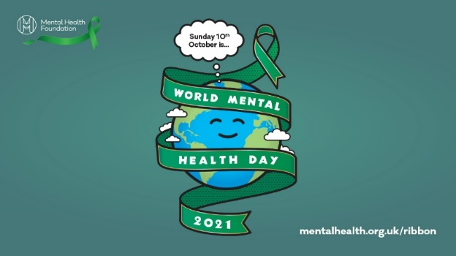
World Mental Health Day is a day for global mental health education, awareness and advocacy against social stigma. It was first celebrated in 1992 at the initiative of the World Federation for Mental Health, a global mental health organisation with members in more than 150 countries. This day, each October, thousands of supporters come to celebrate this annual awareness program to bring attention to mental illness and its major effects on peoples' lives worldwide

The Mental Health Foundation promote tea and talk sessions https://www.mentalhealth.org.uk/get-involved/tea-and-talk. Although this may not be suitable in terms of social distancing considering COVID-19 you can virtually hang out with friends, family and colleagues by holding a tea and talk to fundraise for the Mental Health Foundation. Over 9 million people in the UK – almost a fifth of the population – say they are always or often lonely, but almost two thirds feel uncomfortable admitting to it. Over half (51%) of all people aged 75 and over live alone.

By taking part in the fundraising for Tea and Talk, or just including your social circle in a virtual catch up you will be acting altruistically. Altruism has been proven to be good for your wellbeing and is defined as caring about other people and/or acting in someone else’s interests. For example, we may be acting altruistically by offering to pick up some shopping for elderly neighbours or by volunteering in our community. Altruism:

- promotes positive physiological changes in the brain associated with happiness
- brings a sense of belonging and reduces isolation
- helps to keep things in perspective
- reduces stress and improves our health
- helps reduce negative feelings
- help us live longer

To find out more about how you can take part in Tea and Talk and further reading on mental health and
services you can access check out these links below:
https://www.mind.org.uk/
https://www.mentalhealth.org.uk/get-involved/tea-and-talk
https://www.nhs.uk/using-the-nhs/nhs-services/mental-health-services/how-to-access-mental-health-services/
You can choose to do any or all the suggested activities below and your tutor will support you with any help you may need:
Question: can you give any examples of altruistic behaviours that could support elderly, isolated people? Click here to enter text.
Question: If there are 9 million people in the UK, and 1/5th say they always or often feel lonely, how would you work out how many people this is? Click here to enter text.

