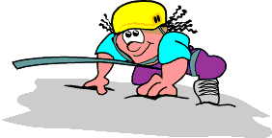
My Outdoor Education Diary
My name is:
My Instructor is:
My Teacher / Leader is:
My Dormitory is:
The Date is:
Why Am I Here?

On your residential Outdoor Education course you will have the opportunity to take part in new activities, gain new friends, meet new people and have lots of new experiences whilst taking part in all the exciting activities on offer.

During your stay at Thurston Outdoor Education Centre you will have the opportunity to take part in a wide range of activities and challenges that will require and enable you to use and develop many new skills.

These skills may include:

COMMUNICATION
To speak, listen, respond to and understand others.

CONSIDERATION
To show concern and respect for others in your actions and words, and to show you have patience and are willing to help others.

CO-OPERATION
To work with and get along with other people around you.

DECISION MAKING
To weigh up all the available information and reach a decision.

DETERMINATION
To show that you can complete what you set out to do.

PLANNING
To work out (in advance) how to go about or solve something.

REVIEWING
Look back at what you have done, where it has gone well and how you can improve.

RISK TAKING
Able to identify and manage risks in order to do things that are uncertain.

TEAM WORK
An ability to co-operate with and tolerate other people.

PERSONAL SKILLS 

Below is a list of different personal skills. Score yourself (honestly!) as to how well you think you score for each personal skill. 1 is the lowest score (you are very bad at that skill) and 5 is the highest score (you are always excellent at it).
Remember – BE HONEST!!

(Circle appropriate number)
Low High
1. Courtesy 1 2 3 4 5

2. Punctuality / Time Keeping 1 2 3 4 5

3. Enthusiasm 1 2 3 4 5

4. Determination 1 2 3 4 5

5. Self Confidence 1 2 3 4 5

6. Decision Making 1 2 3 4 5

7. Personal Organisation 1 2 3 4 5

8. A Sense of Adventure! 1 2 3 4 5

9. Risk Taking 1 2 3 4 5

10. Reacting Positively to Challenges 1 2 3 4 5

GROUPWORK SKILLS

Below is a list of different group skills. Score yourself (honestly!) as to how well you think you score for each group skill. 1 is the lowest score (you are very bad at that skill) and 5 is the highest score (you are always excellent at it).
Remember – BE HONEST!!

(Circle appropriate number)
Low High
1. Leadership 1 2 3 4 5

2. Communication 1 2 3 4 5

3. Listening 1 2 3 4 5

4. Motivation 1 2 3 4 5

5. Consideration of Others 1 2 3 4 5

6. Trust 1 2 3 4 5

7. Tolerance of Others 1 2 3 4 5

8. Co-operation 1 2 3 4 5

9. Teamwork 1 2 3 4 5

10. Reviewing 1 2 3 4 5

THURSTON CENTRE RULES 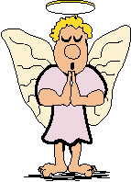

Thurston Outdoor Education Centre has many different groups that use it throughout the year. This includes primary schools, secondary schools, youth groups, scouts/guides, adult courses, skills courses and management training.

In order to keep the Centre clean, tidy and safe for all of its’ guests we ask you to please follow the simple rules below that are designed to make it a pleasant experience for everyone:

- No going in to the dormitory of any other person (you can meet friends in the lounge or hall, but the dormitories are private places for those who are sleeping in them.)

- Place any wet clothes or equipment in the drying room (if hung up neatly in the drying room wet items will dry and the rest of the centre won’t get wet & messy.)

- No food or drinks in the dormitory (any accidental spillages or mess from food will ruin the dormitories. Food, sweets & drinks should be stored in the class room.)

- No cameras or mobile phones in the dormitories (the dormitories are a private area that are unsuitable for cameras and mobile phones. These should be stored in the class room and mobile phones handed in.)

- Change into slippers or indoor shoes inside the centre (we want to keep the centre clean and tidy so that it is pleasant for all who stay in it.)

- Do not use aerosols in the centre (they can trigger the smoke detectors, resulting in a very expensive visit by the Fire Brigade)

- Respect and look after the centre and its’ surroundings

- Have consideration for other pupils / guests / staff & local residents

- Enjoy yourself!!

Thanks
TARGETS & GOALS 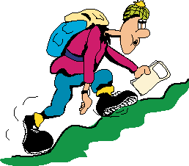DURING YOUR STAY!

Below is a list of some goals for you to achieve during your stay at Thurston.
Tick the box of each one you think you can do and add any additional goals to the list:

- I will try to be organised, keep my dormitory clean & tidy and put any rubbish in the bins

- I will listen carefully when staff and instructors are speaking

- I will remind myself of all the things I did well each day (before I go to sleep)

- I will try to get to know 3 people who I wouldn’t normally talk to

- I will try all the activities and attempt to do my best, even though I may be concerned

- I will take an active part in my group and contribute to the decisions made

- I will express my views or thoughts appropriately and also listen to others in my group

- I will compliment others if they do something well and not be critical if they get things wrong

- I will help others during the activities & in the centre and I will also accept help from others

- I will always try to be on time and organised with my clothing and equipment for the activities

- ……………………………………………………………………………………………………………………………………………………………………………………………………………………………………………………………………………………

- ……………………………………………………………………………………………………………………………………………………………………………………………………………………………………………………………………………………
DAILY RECORD 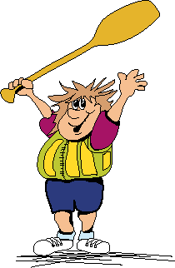

 |  | Activity & Where It Took Place | The Weather | Describe the Activity
MONDAY | AFTERNOON
MONDAY | EVENING
TUESDAY | MORNING
TUESDAY | AFTERNOON
TUESDAY | EVENING
WEDNESDAY | MORNING
WEDNESDAY | AFTERNOON
WEDNESDAY | EVENING
THURSDAY | MORNING
THURSDAY | AFTERNOON
THURSDAY | EVENING
FRIDAY | MORNING
WORD BANK 

Positive Words

Interested Determined Appreciated

Challenged Happy Excited

Sympathetic Energetic Curious

Proud Team Work Achievement

Triumphant Confident Safe

Grateful Eager Cheerful

Pleased Exhilarating Trust

In Control Contented Satisfied

Helpful

Negative or Less Positive Words

Frustrated Annoyed Needed Support

Nervous Isolated Bored

Disappointed Confused Self Conscious

Upset Tired Worried

Uncomfortable Impatient Under Pressure

Frightened Uncertain Sad

Reluctant Miserable
Activity Review

Activity: Date:

Instructor: Location:

My Personal Skills

Choose a word from the WORD BANK or use your own to best describe how you felt:

BEFORE the activity

DURING the activity

AFTER the activity

Complete the following sentences:

The things that I enjoyed MOST about the activity were
The things that I enjoyed LEAST about the activity were
The activity has TAUGHT ME
What I will REMEMBER most about the activity is
Team Skills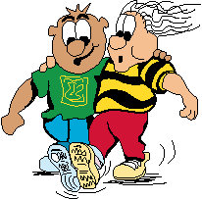

After reading each of the following statements, circle the score that best describes how you feel about each statement. Think about how your team really did, and your contribution to the team, before you answer.

Activity:
Low High
1. The group worked well together 1 2 3 4 5
2. Everyone in the group helped to make decisions 1 2 3 4 5
3. We talked and listened to each other 1 2 3 4 5
4. We safely stayed together during the activity 1 2 3 4 5
5. Other group members listened to my ideas 1 2 3 4 5
6. I really felt part of the group 1 2 3 4 5
7. I took charge of the group 1 2 3 4 5
8. We all listened to the safety instructions 1 2 3 4 5
9. I was happy with my role in the group 1 2 3 4 5
10. We supported each other when things got hard 1 2 3 4 5
11. Other people in the group helped me (if needed) 1 2 3 4 5
12. I motivated other people in the group 1 2 3 4 5

Complete the following sentences:

The BEST thing about working in a group is
The MOST IMORTANT thing I have learnt about working in a group is
I HELPED someone during the activity when
I ACCEPTED HELP during the activity when
Activity Review

Activity: Date:

Instructor: Location:

My Personal Skills

Choose a word from the WORD BANK or use your own to best describe how you felt:

BEFORE the activity

DURING the activity

AFTER the activity

Complete the following sentences:

The things that I enjoyed MOST abut the activity were
The things that I enjoyed LEAST about the activity were
The activity has TAUGHT ME
What I will REMEMBER most about the activity is
Team Skills

After reading each of the following statements, circle the score that best describes how you feel about each statement. Think about how your team really did, and your contribution to the team, before you answer.

Activity:
Low High
1. The group worked well together 1 2 3 4 5
2. Everyone in the group helped to make decisions 1 2 3 4 5
3. We talked and listened to each other 1 2 3 4 5
4. We safely stayed together during the activity 1 2 3 4 5
5. Other group members listened to my ideas 1 2 3 4 5
6. I really felt part of the group 1 2 3 4 5
7. I took charge of the group 1 2 3 4 5
8. We all listened to the safety instructions 1 2 3 4 5
9. I was happy with my role in the group 1 2 3 4 5
10. We supported each other when things got hard 1 2 3 4 5
11. Other people in the group helped me (if needed) 1 2 3 4 5
12. I motivated other people in the group 1 2 3 4 5

Complete the following sentences:

The BEST thing about working in a group is
The MOST IMORTANT thing I have learnt about working in a group is
I HELPED someone during the activity when
I ACCEPTED HELP during the activity when
Activity Safety Rules


Write down any of the SAFETY RULES that were given by an instructor during an activity, or any you think should be followed for that activity:

Activity:

Safety Rules:

1
2
3
4
5
What Should be in Your Rucksack?

Circle the items that you should have with you, in order to stay safe, on your chosen activity:

Activity:

Waterproof Coat Waterproof Trousers Slippers Camera
Walking Boots Money Warm Hat Map
Helmet Swimming Costume Gloves DVD
Spare Jumper Water Bottle Sun Cream Towel
Cuddly Toy Medication Whistle Helmet
Buoyancy Aid Complete Change of Clothing Compass Lipstick
Old Trainers Sunglasses Wetsuit Ropes
Harness Computer Paddle iPod
- New Things 

ONE person I would like to thank is:

TWO new places I have been are:

THREE things I have learnt about Coniston or the Lake District are:

FOUR new words I have learnt are:

FIVE new things I can do are:

SIX things I know about working in a team are:

Picture Page

Draw a picture of an activity, a piece of equipment or something interesting you have seen:

Outdoor Word Search
L | K | M | E | L | D | D | A | P | C | Y | T
D | A | G | R | I | S | E | D | A | L | E | I
P | Y | K | E | A | L | C | N | D | A | W | N
K | A | S | E | B | I | O | E | V | N | D | S
R | K | N | T | D | E | N | L | E | G | A | T
O | C | I | N | F | I | I | R | N | D | L | R
W | L | A | E | M | A | S | G | T | A | E | U
M | I | T | I | S | E | T | T | U | L | L | C
A | M | N | R | J | C | O | R | R | E | C | T
E | B | U | O | Y | H | N | P | E | I | Y | O
T | G | O | R | G | E | W | A | L | K | C | R
B | S | M | A | E | T | H | E | L | M | E | T
Can you find the following words?

ADVENTURE
CANOE
CLIMB
CONISTON
CYCLE
GORGE WALK
GRISEDALE
HELMET
INSTRUCTOR
KAYAK
LANGDALE
LAKE DISTRICT
MAP
MINE
MOUNTAIN
ORIENTEER
PADDLE
RAIN
SAIL
TEAMWORK
YEWDALE

Facing Challenges
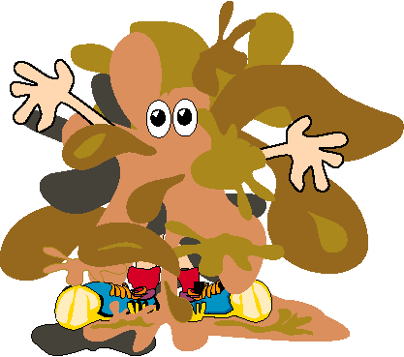
Think of all the different things you have done today and write them in the spaces on the ladder. Try and put the most challenging at the top, descending to the least challenging at the bottom.

For each of the challenges you have put on the ladder, use the space by the side to describe how you felt before, during and after each challenge. Use the WORD BANK to help if required.

For the most challenging thing you did, what helped you to do it?

Who Were You?

On the following page is a picture of a tree with various people with different characters on or around it.

Carefully read the questions below and then look at the actions of each person.

Pick three people from the picture that represent you during your course.
Number each jelly person and colour them in.

The people you choose on the tree can represent your emotions, your feelings about the group, your feelings about the activities or different times during the course.

Before you choose your three people, ask yourself the following questions:

Were you happy or unhappy?
Did you achieve any of your targets and goals?
Did you feel part of the group?
Did you help others or were you helped?
How much effort did you put into the activity?
What did you learn about yourself?
Did your feelings change during the course?

Write one sentence for each of the three people you have chosen, to explain why or how they represent you:

Person 1:
Person 2:
Person 3:
The People Tree
Final Review
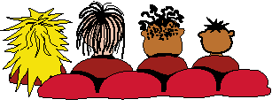

How I got on…
Honestly grade yourself by circling the number that represents your overall performance:
Low High
1. I was confident at completing all the activities 1 2 3 4 5
2. I was determined to achieve all the activities or tasks given 1 2 3 4 5
3. I thought and planned out what had to be done before starting 1 2 3 4 5
4. I communicated effectively and listened to others in the group 1 2 3 4 5
5. I made sure the group worked together 1 2 3 4 5
6. I was a helpful and trusting person during the activities 1 2 3 4 5
7. I happily completed all my duties around the centre 1 2 3 4 5
8. I was organised and kept my clothes neat and tidy 1 2 3 4 5
9. I was willing to help any of my group if they needed me 1 2 3 4 5
10. I always tried to smile and be cheerful to others around me 1 2 3 4 5

My proudest moments…
Finish the sentences below:

I felt very proud when I
Something that I did that I thought I couldn’t do was
I felt very proud of my friend when

I was good at…

List 5 things that you think you did well or were good at during your course:
(They can be activities, centre duties, the way you dealt with a situation or how you behaved with other people)

My feelings were…

List 4 words that describe your feelings when you did something well or were good at it. You can use the WORD BANK to help.

I want to improve at…

List 3 skills, actions or types of behaviour that you would like to improve after this course:



