
APPLICATION FOR
√
THE GRANT or,
√
RENEWAL of a

SCRAP METAL COLLECTOR LICENCE

Applications to be sent to The Licensing Section, South Tyneside Council, Town Hall & Civic Offices, Westoe Road, South Shields, Tyne and Wear, NE33 2RL. Tel: 0191 424 7695 or email licensing@southtyneside.gov.uk
PLEASE NOTE THAT ALL SECTIONS OF THIS APPLICATION FORM MUST BE COMPLETED. SHOULD AN APPLICANT(S) FAIL TO COMPLETE ALL SECTIONS THE APPLICATION MAY BE REFUSED.
From 4th April 2022 a Tax Conditionality check code is required, You will not be granted a licence if you do not supply a tax check code with this application.
www.gov.uk/guidance/changes-for-taxi-private-hire-or-scrap-metal-licence-applications-from-april-2022
Please mark each box with the appropriate tick. Guidance notes included.
SECTION 1.

Are you applying as:

An individual Company Partnership
Please state your trading name:

SECTION 2. PERMITS, REGISTRATIONS AND LICENCES IN FORCE

Please provide details of any relevant environmental permit, exemption or registration (such as a scrap metal dealers licence in relation to this application:
Type: Identifying number: Date of issue:
Type: Identifying number: Date of issue:
Continue on a separate sheet if necessary
Have you applied for a scrap metal licence(s) (Site or Collector) in any other Local Authority area:

Yes No

If Yes, which Authority(s)?

Are you registered as a waste carrier? Yes No

If ‘YES’ please provide your carrier’s registration number:

Please Note - You must be registered with the Environment Agency for waste carrying.
SECTION 3. DETAILS OF PROPOSED LICENCE HOLDER

A Collector Licence authorises the applicant to carry out business as a mobile collector in the Borough of South Tyneside area only. See Map

Title:  Mr Mrs Miss Ms  Other (please state): |  |  |  | I am 18 years old or over:  Yes No  Date of Birth:  National Insurance No:
Surname: |  |  |  | Forenames:
Please also state your maiden name or any other surnames you have previously been known by:

Please include your Tax conditionality check code (9 digits) Failure to include this number will result in refusal of the application. First-time applicants must confirm that they are aware of the guidance about their tax obligations.

I attach a Basic Disclosure Certificate issued for the applicant by the Disclosure and Barring Service.
Yes No
If you do not provide a disclosure certificate your application will be delayed and/or refused.
Contact details (we will use your business address and E-mail to correspond with you unless you indicate we should use your home address)
Business Address:  House name or number:  First line of address:  Town/City:  Postcode: |  |  |  | Telephone numbers:  Daytime:  Evening:  Mobile:
Home address:  House name or number:  First line of address:  Town/City:  Postcode:  Please use my home address for correspondence |  |  |  | Email address:  Please note that you must still provide us with a postal address
Will you be assisted by any person(s) in the collection of scrap metal: Yes No

If Yes, will this person be formally/legally employed by yourself: Yes No

Please be aware that if you are assisted by any person(s) in the collection of scrap metal then this person(s) must also have a Scrap Metal Collector Licence. The only circumstances in which they will not be required to have a Collector Licence is if this person(s) is directly employed by yourself. Should you be stopped by Police and/or Licensing Officers whilst in the process of collecting/transporting scrap metal each person (in or around the vehicle) will be asked to show their Collector’s Licence and/or proof of employment (eg pay slips etc). Should this information not be provided then legal action will be taken under Section 10(5) of the Scrap Metal Dealers Act 2013.
VEHICLE DETAILS:  Registration:  Make:  Model:  Type:  Date of DVLA Registration:  Current Mileage:  Colour: |  |  | VEHICLE DETAILS:  Registration:  Make:  Model:  Type:  Date of DVLA Registration:  Current Mileage:  Colour:
Where will the vehicle(s) be stored/kept when
not being used:

DRIVING LICENCE DETAILS:

Driving licence number:

Date of expiry:

Have you ever been convicted of driving without insurance? Yes No
If YES, on what date and what were the circumstances? Were you undertaking Scrap Metal business?

Have you ever been convicted of a drink driving offence? Yes No
If YES, on what date and what were the circumstances? Were you undertaking Scrap Metal business?

Have you ever been convicted of driving a vehicle with an unsecured load: Yes No

If YES, on what date and what were the circumstances?

SECTION 4. MOTOR SALVAGE

Will your business consist of acting as a motor salvage operator? Yes No

A motor salvage operator is defined as a business that:

• wholly or in part recovers salvageable parts from motor vehicles for re-use or re-sale, and then sells the rest of the vehicle for scrap;
• wholly or mainly involves buying written-off vehicles and then repairing and selling them off; and,
• wholly or mainly buys or sells motor vehicles for the purpose of salvaging parts from them or repairing them and selling them off.

To operate as a motor salvage operator you will need to apply for a Site Licence.

SECTION 5. BANK ACCOUNTS THAT WILL BE USED FOR PAYMENTS TO SUPPLIERS

Please provide details of the bank account(s) that will be used to make payment to suppliers (in accordance with s12 of the Scrap Metal Dealers Act 2013). If more than two bank accounts will be used, please use a continuation sheet.

Account name:  Sort code:  Account number: |  |  |  | Account name:  Sort code:  Account number:
SECTION 6. LICENCE PAYMENT

How will you make payment to South Tyneside Council for your Scrap Metal Dealer Collector Licence:

Cheque Debit/Credit Card Cash

Cheques must be made payable to South Tyneside Council

Please note that the Council will not accept Direct Debit monthly payments. All payments must be made in full on application.

SECTION 7. CRIMINAL CONVICTIONS

Have you ever :-
- been convicted or cautioned of a relevant offence? or
- are you currently being prosecuted for a relevant offence?

Yes No

(Please see the BACK PAGE for relevant offences).

If ‘YES’, you must provide full details including the date of the offence, conviction or charge, the name and location of the convicting court offence and the sentence imposed or the trail date set for the offence charged :

Date of when offence/ charge was committed | Court / Police Station attended and date | Nature of Conviction and/or Caution or offence charged |  |  | Fine /Sentence/ Penalty imposed or date of trial
SECTION 8. DECLARATION

The information contained in this form is true and accurate to the best of my knowledge and belief. I understand that if I make a material statement knowing it to be false, or if I recklessly make a material statement which is false, I will be committing an offence under Schedule 1 Para 5 of the Scrap Metal Dealers Act 2013, for which I may be prosecuted, and if convicted, fined.

I understand that South Tyneside Council may consult other agencies about my suitability to be licensed as a scrap metal dealer, as per section 3(7) of the Scrap Metal Dealers Act 2013, and that those other agencies may include other local authorities, the Environment Agency, the Natural Resources Body for Wales, Planning Authority, Information Commissioner’s Office, Security Industry Authority, and the police. I understand that the purpose of the sharing of this data is to form a full assessment of my suitability to be licensed as a scrap metal dealer. I also understand that the sharing of information about me may extend to sensitive personal data, such as data about any previous criminal offences. Some details will also be displayed on a national register, as required by the Scrap Metal Dealers Act 2013. I hereby expressly consent to this processing of my data and display of relevant information on the public register.

I am aware that by holding a Scrap Metal Dealer Collector Licence if I am arrested, bailed, charged, cautioned or convicted of any offence I must notify the arresting/ investigating officer that I am a Licensed Scrap Metal Dealer and hereby consent to the relevant police force disclosing any information and documentation obtained in the course of the investigation to South Tyneside Council's Licensing Section for the purposes of determining my suitability to continue to hold that licence. I will also advise South Tyneside Council’s Licensing Section within 7 days if I am arrested, bailed, charged, cautioned or convicted of any offence.

South Tyneside Council must protect the public funds it handles and it must use the information you have provided on this form to prevent and detect fraud. South Tyneside Council may also share this information with other enforcement agencies including those organisations which handle public funds. South Tyneside Council will not disclose information about you unless the law permits. South Tyneside Council is the Data Controller for the purposes of the Data Protection Act. If you want to know the information the Authority holds about you please contact the Information Team, at informationteam@southtyneside.gov.uk.

PLEASE CONFIRM THAT YOU HAVE PROVIDED THE FOLLOWING INFORMATION WITH THIS APPLICATION:

Basic criminal record check Yes No
Fee Yes No
Two Passport Photographs Yes No
Vehicle V5 Log Book (Original) Yes No
2 forms of ID (passport/driving licence/utility bill) Yes No

If information/documentation is not provided please advise WHY?

Signed: Date:

Signed: Date:

Do you agree to have my company information displayed on the Council’s website Yes No

First time applicants only
From 4 April 2022, the rules are changing for applications for:
- scrap metal site licences
- scrap metal collector licences
Licensing authorities must carry out extra checks if an individual, company or any type of partnership applies for a licence:
- for the first time
- of the same type they have already held but which has not been valid for a year or more
First-time applicants must confirm that they are aware of the guidance about their tax obligations.
If the applicant is a partner in a partnership, they can give confirmation on behalf of all the other partners.
This confirmation must be included with your application form. (FIRST TIME APPLICANTS ONLY)

I …………………………………………………… Full Name
Of …………………………………………………..
………………………………………………………
………………………………………………………
………………………………………………………..Address
confirm that I am aware of the guidance about my tax obligations which can be found at

https://www.gov.uk/guidance/changes-for-taxi-private-hire-or-scrap-metal-licence-applications-from-april-2022

……………………………………………………..Signature
………………………… Date

The Borough of South Tyneside

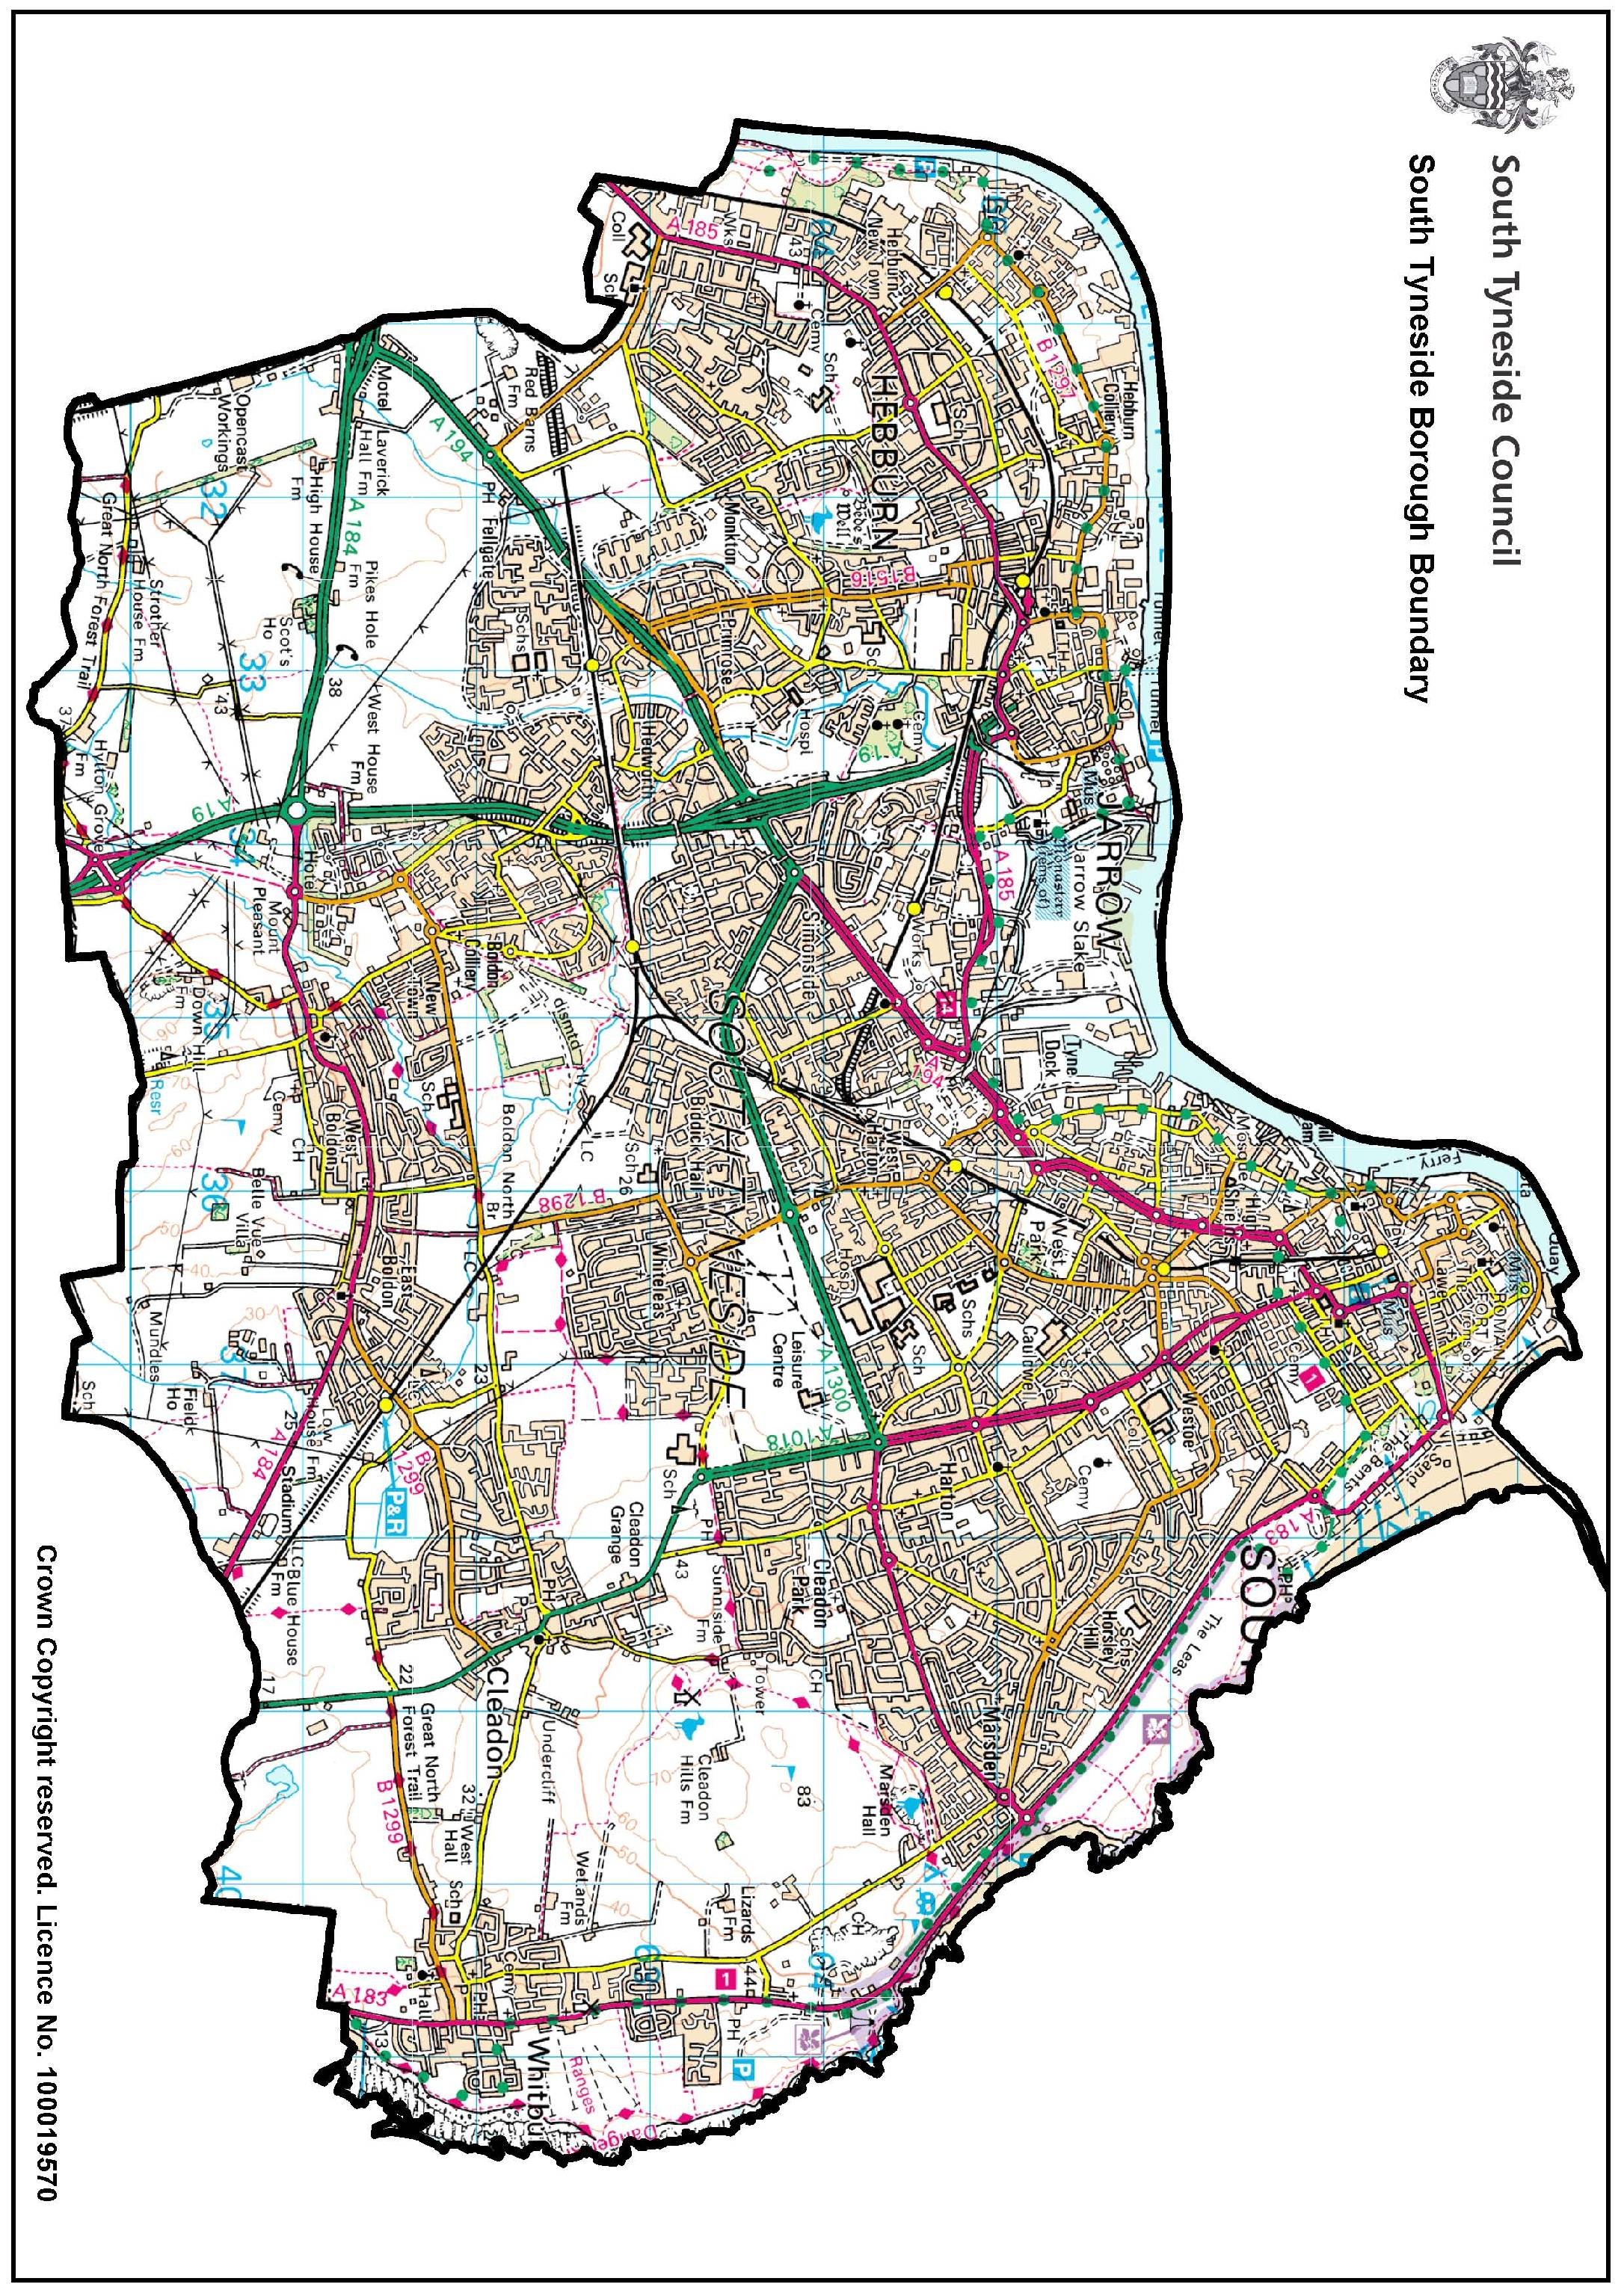

A mobile Collector Licence is only authorised within the Borough of South Tyneside (boundary marked above) to collect scrap metal. Any collection of scrap metal outside of this area will require the authorisation of the appropriate Local Authority.

Blank Page

SCRAP METAL DEALERS ACT 2013

Application guidance notes – COLLECTOR LICENCE

If you need more help in completing the application then please contact South Tyneside Council’s Licensing Section on 0191 424 7695.

Section 1
This section asks in what legal capacity/entity you are making the application, and for your trading name.

Section 2
In order to carry on your business you may need to hold other environmental permits or licences that we should know about. For instance, if you carry waste as part of your business it is a legal requirement to register as a waste carrier. This includes transporting waste while travelling from job to job, to a storage place for disposal later, or to a waste disposal company or waste site. For more information on this, or to register call: 03708 506506 or visit: www.environment-agency.gov.uk/wastecarriers

Section 3
This section should be completed in the name of the person who will hold the Collector Licence. It should be completed by the person who will hold the Collector Licence. You are asked to provide contact details, including the place where you live, so that the council can get in touch with you if necessary.

You need to submit a Basic Disclosure Certificate along with the application form. You can apply for this certificate at
https://www.gov.uk/request-copy-criminal-record. This is because the Home Office has decided that you need to tell South Tyneside Council if you have been convicted of certain crimes. Possessing a conviction may not automatically prevent you from having a Collector Licence if the offence was unrelated to being a scrap metal dealer or a long time ago, and you can convince the Council that you are a suitable person.

A Basic Disclosure Certificate is considered to be only valid for 3 months, but can be used to apply to other Councils.

You will need to ensure that all your vehicles are roadworthy and are properly taxed, insured and otherwise meet the legal requirements to be on the road.

Please be aware that if you are assisted by any person(s) in the collection of scrap metal then this person(s) must also have a Scrap Metal Collector Licence. The only circumstances in which they will not be required to have a Collector Licence is if this person(s) is directly employed by yourself. Should you be stopped by Police and/or Licensing Officers whilst in the process of collecting/transporting scrap metal each person (in or around the vehicle) will be asked to show their Collector’s Licence and/or proof of employment (eg pay slips etc). Should this information not be provided then legal action will be taken under Section 10(5) of the Scrap Metal Dealers Act 2013.

Section 4 – Motor salvage operator
This section asks if you will be salvaging motor vehicles as part of your work. The Scrap Metal Dealers Act 2013 brings together the Scrap Metal Dealers Act 1964 together with Part 1 of the Vehicles (Crime) Act 2001, which means you now only need a Scrap Metal Dealer Site Licence. You will need to apply for a Site Licence to operate as a motor salvage operator.

Section 5 – Bank accounts that will be used for payments to suppliers
This section asks you for the bank details which you will use to pay people for the scrap metal you receive or sell. This is to check that you are not selling the metal for cash, which is illegal. These details will be kept securely by South Tyneside Council.

Section 6 – Payment
South Tyneside Council has set a fee for a Collector Licence and how you can pay. The fee reflects the cost of processing the application and checking that people are undertaking what the Collector Licence requires. Applications cannot be accepted unless the correct fee has been paid.

Section 7 – Criminal convictions
This section asks you to set out any relevant convictions or enforcement activity that has been undertaken against you by Police, the Environment Agency or Natural Resources Wales. It is an offence under the Scrap Metal Dealers Act 2013 to make or recklessly make a false statement. The information listed here will be checked against the Basic Disclosure Certificate from the Disclosure and Barring Service that you are required to submit with the application, along with information retained by the police and the Environment Agency or Natural Resources Wales etc.

Section 8 – Declaration
The person who will hold the Scrap Metal Dealer Collector Licence will need to sign and date the declaration, as do the other people named on the form. This section also explains that South Tyneside Council has to share some of these details with the police, Environment Agency, or Natural Resources Wales etc when checking whether the applicant(s) is a suitable person to hold a Collector Licence. Some of the information will also be displayed on a public register.

If you do not agree to this use of your information then you should not sign the form. If you are in any doubt about what this section means then speak to South Tyneside Council’s Licensing Section or consult a Solicitor. Please note however that failure to sign the form may result in the application being refused.

Relevant offences

The following relevant offences are those matters listed in The Scrap Metal Dealers Act 2013 (Prescribed Relevant Offences and Relevant Enforcement Action) regulations 2013

Primary Legislation
(a) An offence under section 1, 5, or 7 of the Control of Pollution (Amendment) Act 1989(1)
(b) An offence under section 170 or 170B of the Customs and Excise Management Act 1979(2), where the specific offence concerned relates to scrap metal
(c) An offence under section 110 of the Environment Act 1995(3)
(d) An offence under sections 33, 34 or 34B of the Environmental Protection Act 1990(4)
(e) An offence under section 9 of the Food and Environment Protection Act 1985(5)
(f) An offence under section 1 of the Fraud Act 2006(6), where the specific offence concerned relates to scrap metal, or is an environment-related offence
(g) An offence under section 146 of the Legal Aid, Sentencing and Punishment of Offenders Act 2012(7)
(h) An offence under sections 327, 328 or 330 to 332 of the Proceeds of Crime Act 2002(8)
(i) Any offence under the Scrap Metal Dealers Act 1964(9)
(j) Any offence under the Scrap Metal Dealers Act 2013
(k) An offence under sections 1, 8,9,10, 11, 17, 18, 22 or 25 of the Theft Act 1968(10), where the specific offence concerned relates to scrap metal, or is an environment-related offence
(l) Any offence under Part 1 of the Vehicles (Crime) Act 2001(11)
(m) An offence under sections 85, 202, or 206 of the Water Resources Act 1991(12).

Secondary Legislation
(a) An offence under regulation 38 of the Environmental Permitting (England and Wales) Regulations 2007(13)
(b) An offence under regulation 38 of the Environmental Permitting (England and Wales) Regulations 2010(14)
(c) Any offence under the Hazardous Waste (England and Wales) Regulations 2005(15)
(d) Any offence under the Hazardous Waste (Wales) Regulations 2005(16)
(e) An offence under regulation 17(1) of the Landfill (England and Wales) Regulations 2002(17)
(f) Any offence under the Pollution Prevention and Control (England and Wales) Regulations 2000(18)
(g) Any offence under the Producer Responsibility (Packaging Waste) Regulations 2007(19)
(h) Any offence under the Transfrontier Shipment of Waste Regulations 1994(20)
(i) Any offence under the Transfrontier Shipment of Waste Regulations 2007(21)
(j) Any offence under the Waste (Electrical and Electronic Equipment) Regulations 2006(22)
(k) An offence under regulation 42 of the Waste (England and Wales) Regulations 2011(23).

Scrap Metal Dealers Act 2013 - Fees and Charges 2023/2025

Licence Type | Fee (from 1st Nov 2023)
New Application (Site) | £475.50
Renewal (Site) | £356.50
Variation (Site) | £197.50
New Application (Collector) | £254
Renewal (Collector) | £134
Variation (Collector) | £159.00
Administration Fee (COD etc and associated checks, admin) | £26.00
New Permit or additional permits | £21.00

