**PLAYING IN A DIFFICULT KEY.**

What happens when you are asked to play in a key you are not familiar with?

Do keys like Bb and Ab leave you confused about what other chords to play next?

Using the knowledge, we have gained in familiar keys earlier in the series we are going to use this to gain confidence in a key rarely used by guitarists and pianists.

Using the cycle of 5th that you should be growing familiar with we are going to work out the 1,4,5 and relative minor in the key of Ab.

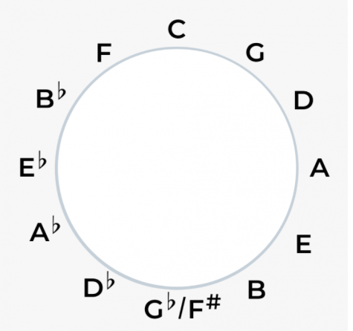

**PERFECT – ED SHEERAN**

Ab. Fm

I found a love for me

Db Eb  
Oh darling, just dive right in and follow my lead

Ab. Fm   
Well, I found a girl, beautiful and sweet

Db Eb  
Oh, I never knew you were the someone waiting for me

Ab.

'Cause we were just kids when we fell in love

Fm   
Not knowing what it was

Db Ab Eb  
I will not give you up this time

Ab. Fm   
But darling, just kiss me slow, your heart is all I own

Db Eb  
And in your eyes, you're holding mine

Fm. Db. Ab Eb Fm

Baby, I'm dancing in the dark with you between my arms

Db. Ab Eb Fm

Barefoot on the grass, listening to our favourite song

Db. Ab Eb Fm  
When you said you looked a mess, I whispered underneath my breath

Db. Ab Eb Ab  
But you heard it, darling, you look perfect tonight

Ab. Fm

Well I found a woman, stronger than anyone I know

Db Eb  
She shares my dreams, I hope that someday I'll share her home

Ab. Fm   
I found a love, to carry more than just my secrets

Db Eb  
To carry love, to carry children of our own

Ab.

We are still kids, but we're so in love

Fm   
Fighting against all odds

Db Ab Eb  
I know we'll be alright this time

Ab.

Darling, just hold my hand

Fm   
Be my girl, I'll be your man

Db Ab Eb  
I see my future in your eyes

Fm. Db. Ab Eb Fm

Baby, I'm dancing in the dark, with you between my arms

Db. Ab Eb Fm  
Barefoot on the grass, listening to our favorite song

Db. Ab Eb   
When I saw you in that dress, looking so beautiful

Fm. Db. Ab Eb Ab   
I don't deserve this, darling, you look perfect tonight

Fm. Db. Ab Eb Fm

Baby, I'm dancing in the dark, with you between my arms

Db. Ab Eb Fm  
Barefoot on the grass, listening to our favorite song

Db. Ab   
I have faith in what I see

Eb Fm. Db.   
Now I know I have met an angel in person

Ab Eb Ab   
And she looks perfect

Fm. Db  
I don't deserve this

Ab Eb Ab   
You look perfect tonight