**Time signatures and layering time signatures.** 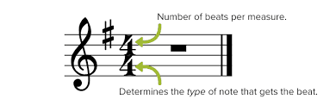

**Polyrhythm** is the rhythms that are the same but can be layered over each other.

This week we are layering the time signature 6/8 over ¾. This gives the rhythm a different **PULSE t**hat can be called **Syncopation.**

 The **syncopated rhythms** are usually easy to sing, since they often match speech better than straight **rhythms**.

Listen to the song and try and count out both ¾ and 6/8/ rhythms. 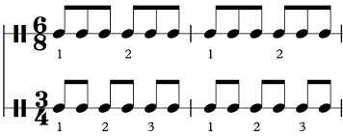

LOVER – TAYLOR SWIFT>

We could leave the Christmas lights up 'til January  
And this is our place, we make the rules  
And there's a dazzling haze, a mysterious way about you dear  
Have I known you 20 seconds or 20 years?

Can I go where you go?  
Can we always be this close forever and ever?  
And ah, take me out, and take me home  
You're my, my, my, my  
Lover

We could let our friends crash in the living room  
This is our place, we make the call  
And I'm highly suspicious that everyone who sees you wants you  
I've loved you three summers now, honey, but I want 'em all

Can I go where you go?  
Can we always be this close forever and ever?  
And ah, take me out, and take me home (forever and ever)  
You're my, my, my, my  
Lover

Ladies and gentlemen, will you please stand?  
With every guitar string scar on my hand  
I take this magnetic force of a man to be my lover  
My heart's been borrowed and yours has been blue  
All's well that ends well to end up with you  
Swear to be overdramatic and true to my lover  
And you'll save all your dirtiest jokes for me  
And at every table, I'll save you a seat, lover

Can I go where you go?  
Can we always be this close forever and ever?  
And ah, take me out, and take me home (forever and ever)  
You're my, my, my, my  
Oh, you're my, my, my, my  
Darling, you're my, my, my, my  
Lover